AI ASSISTED PROBLEM SOLVING USING PYTHON

Name : Rimsha Mujeeb
Roll-number : 2503B05138
Batch : CSE(MTECH)-Regular

Task 1:
Installed Git Hub Copilot and configured with vs code(connected copilot with Git Hub account ).


Task 2: Prime() function using copilot
Code:
import math
import sys
"""prime_number.py
Defines _prime(n) to check primality and reads a number from user input.
"""
def _prime(n: int) -> bool:
"""Return True if n is a prime number, otherwise False.
n must be an integer.
"""
if n <= 1:
return False
if n <= 3:
return True
if n % 2 == 0:
return False
limit = int(math.isqrt(n))
i = 3
while i <= limit:
if n % i == 0:
return False
i += 2
return True
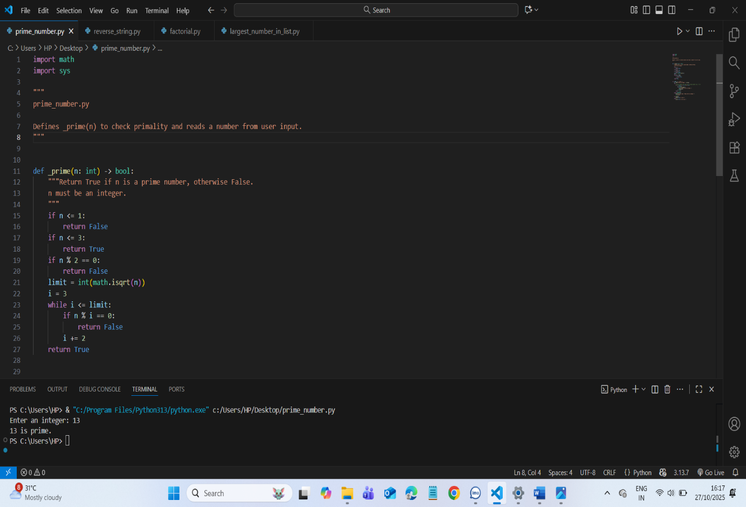
TASK 3: REVERSE STRING PROGRAM WRITTEN BY COPILOT
Code:
#Function to reverse a string . read the input string from the User
def reverse_string():
input_string = input("Enter a string to reverse: ")
reversed_string = input_string[::-1]
print("Reversed string:", reversed_string)
reverse_string()
output:
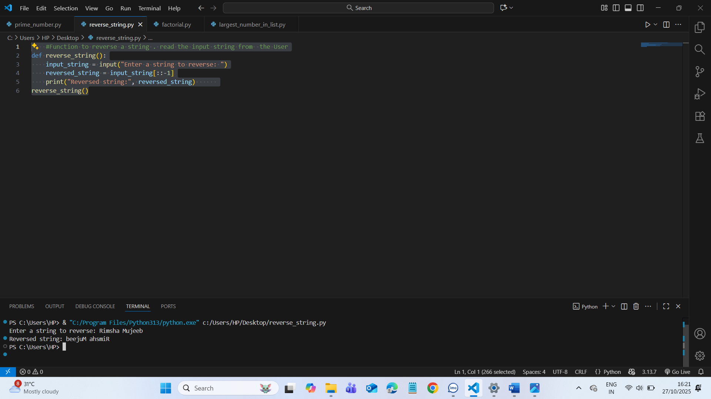

TASK 4: Factorial using Recursive and Iterative Versions

CODE:
import sys
#!/usr/bin/env python3
# Recursive and iterative factorial implementations.
# Reads a non-negative integer from the user and prints both results.

def factorial_recursive(n): #using recursion
# Recursive factorial: n! = n * (n-1)! with 0! = 1
if n < 0:
raise ValueError("factorial undefined for negative values")
if n <= 1:
return 1
return n * factorial_recursive(n - 1)

def factorial_iterative(n): #using iteration
# Iterative factorial using a loop
if n < 0:
raise ValueError("factorial undefined for negative values")
result = 1
for i in range(2, n + 1):
result *= i
return result

if __name__ == "__main__":
try:
s = input("Enter a non-negative integer: ").strip()
n = int(s)
if n < 0:
print("Error: please enter a non-negative integer.")
sys.exit(1)
except ValueError:
print("Error: invalid integer input.")
sys.exit(1)

# Compute and display results
try:
print("Recursive:", factorial_recursive(n))
except RecursionError:
print("Recursive: recursion depth exceeded for", n)
print("Iterative:", factorial_iterative(n))

OUTPUT:
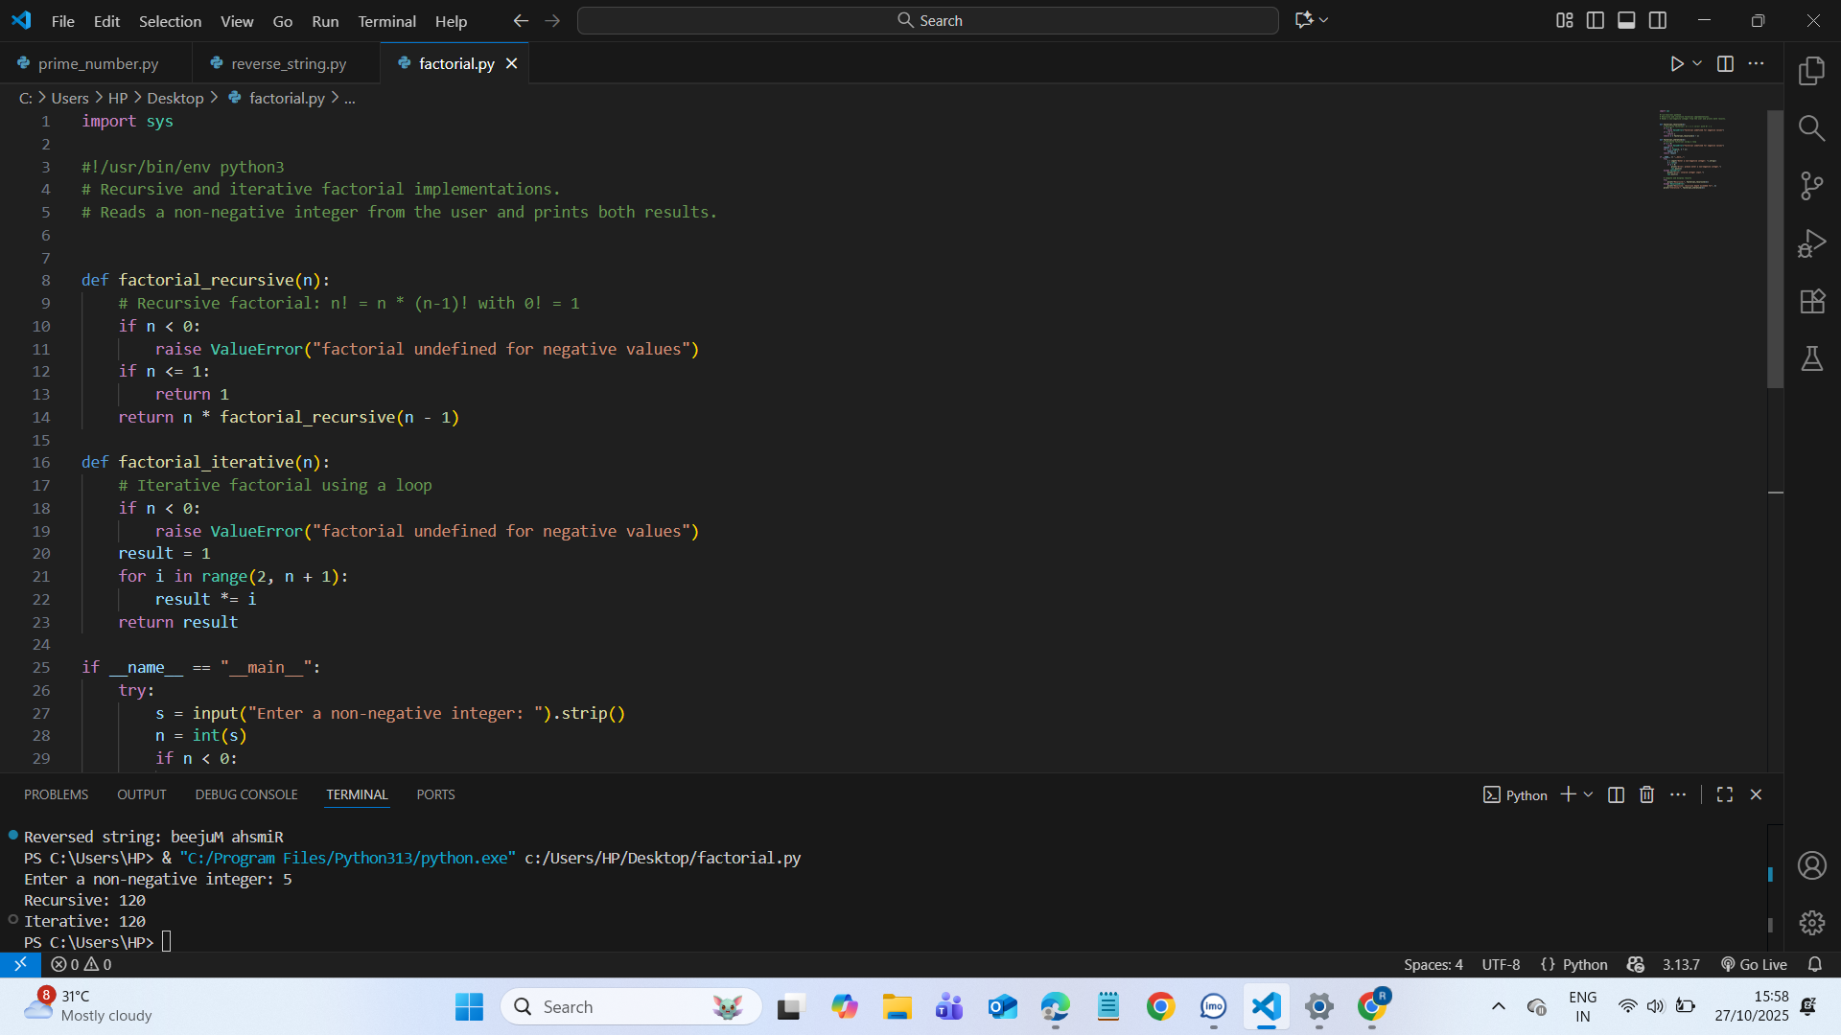

TASK 5: Largest element in list
code:
from typing import List, Optional

# /C:/Users/HP/Desktop/largest_number_in_list.py
"""
Read a list of numbers from user input and print the largest.
Input format: numbers separated by spaces and/or commas, e.g.:
1 2 3
1,2,3
1, 2, 3.5, -4
"""

def parse_numbers(text: str) -> List[float]:
"""Parse numbers from a string (spaces and/or commas allowed)."""
tokens = [t for t in text.replace(",", " ").split() if t]
if not tokens:
return []
numbers = []
for t in tokens:
try:
numbers.append(float(t))
except ValueError as e:
raise ValueError(f"Invalid numeric token: {t!r}") from e
return numbers

def find_largest(numbers: List[float]) -> Optional[float]:
"""Return the largest number in the list, or None if the list is empty.
Uses a single-pass O(n) algorithm with O(1) extra space.
"""
if not numbers:
return None
max_val = numbers[0]
for x in numbers[1:]:
if x > max_val:
max_val = x
return max_val

def _format_number(x: float) -> str:
"""Format float as int if it is integral, otherwise keep float representation."""
if x is None:
return "None"
if float(x).is_integer():
return str(int(x))
return str(x)

def main() -> None:
try:
s = input("Enter numbers (separated by spaces or commas): ").strip()
nums = parse_numbers(s)
except ValueError as err:
print("Error:", err)
return

if not nums:
print("No numbers provided.")
return

largest = find_largest(nums)
print("Largest number:", _format_number(largest))

if __name__ == "__main__":
main()

OUTPUT:

