**Project Title:**

Food Mart

**Grocer app:**

"Affordable items delivered at your doorstep"

**Description:**

A grocery app provides all the grocery you need at your doorstep including vegetables, fresh fruits and meat from your favorite shops. A grocery shopping mobile application for busy people who don't have time to visit the supermarket.

**App functions:**

1. Search your desired items by categories.
2. User can go pay for their items online using mobile banking.
3. Give location manually or through google maps.
4. you can rate the product they have purchased

**Target User groups:**

The target users are people of all age groups who don't have time to go to grocery store.

* House wives
* Busy employee
* Students
* Disabled people

**Sample User Profile/Persona:**

Mark,30 years old,

* Married, no children
* copy writer in a large firm
* Needs to go to buy grocery for her house
* Has so much work load and no vehicle to ride to a grocery store
* Stuck in a situation when she does not have enough time

**Client/designer goals:**

* Build an intuitive app so that users can search for their desired products easily and efficiently.
* Make shopping easy for everyone
* Provide users with detailed step-by-step instructions of selecting products and going to check out

**Related apps/products:**

**Cheetay:**

Cheetay is an delivery platform that provides delivery services across major cities of Pakistan. Through Cheetay, customers can order food, groceries, beauty, baby care, and healthcare products and get them delivered right at their doorsteps through delivery providers.

**Panda mart:**

Providea all the essential products from the stores you already shop at. You can find exclusive deals on popular products delivered straight to your front door!

**Air lift:**

With Airlift Express, you will receive your grocery or pharmacy order in 30 minutes or less regardless of your location. Airlift's online grocery store aims to make the process of online grocery shopping in Pakistan hassle-less and thus maintains a rich inventory of all the essential items and much more.

**Prototype Summary:**

In the clickable prototype, users will be prompted to complete the following functions:

1. Search for their desired products
2. Go to check out to pay for your grocery

**Site Map:**

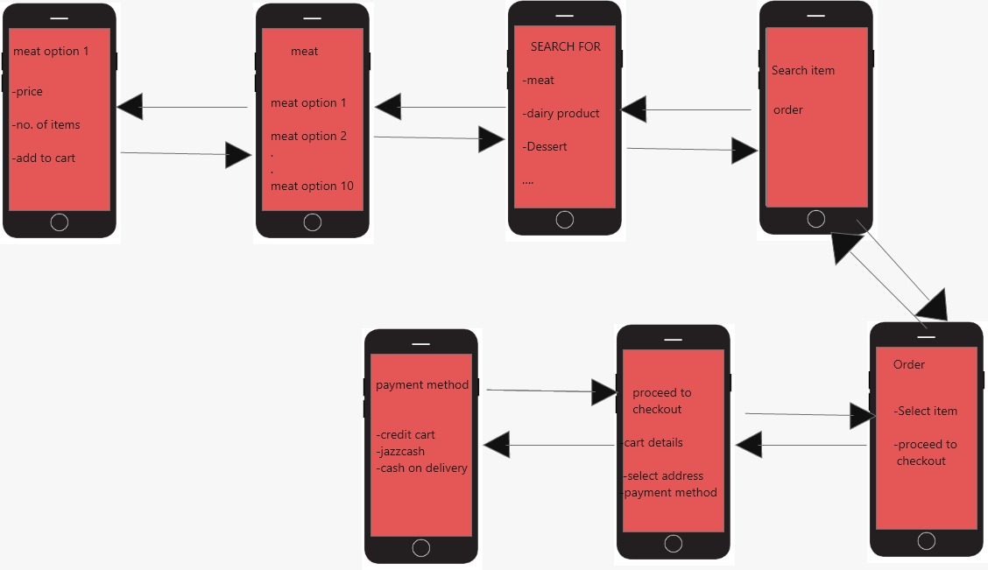

**Wireframes:**

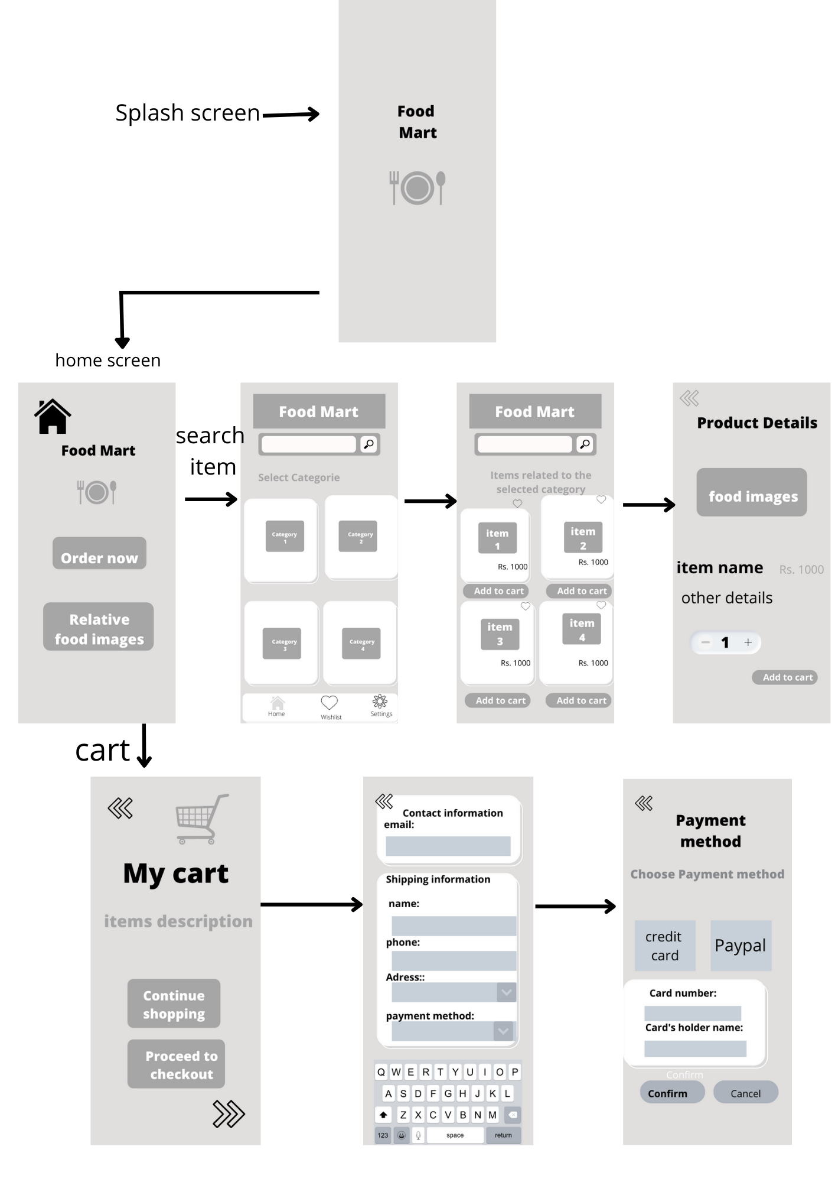

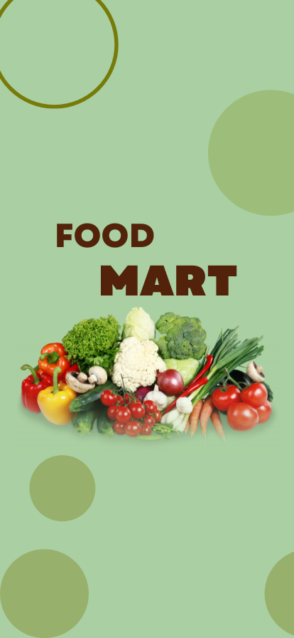

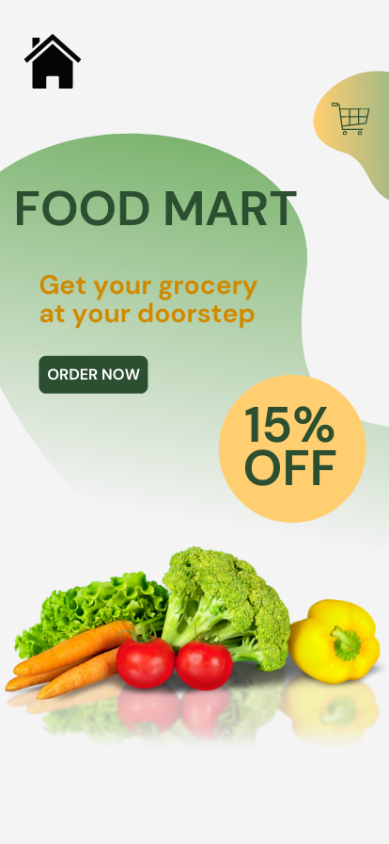

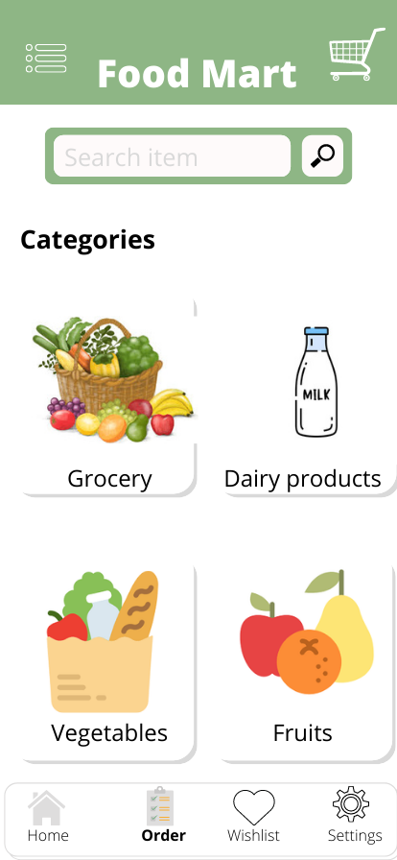 **.** 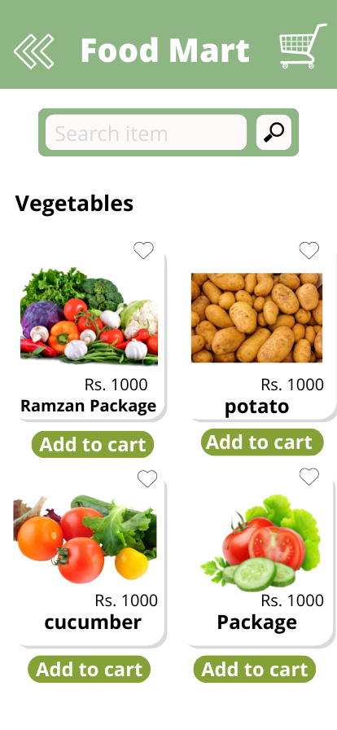

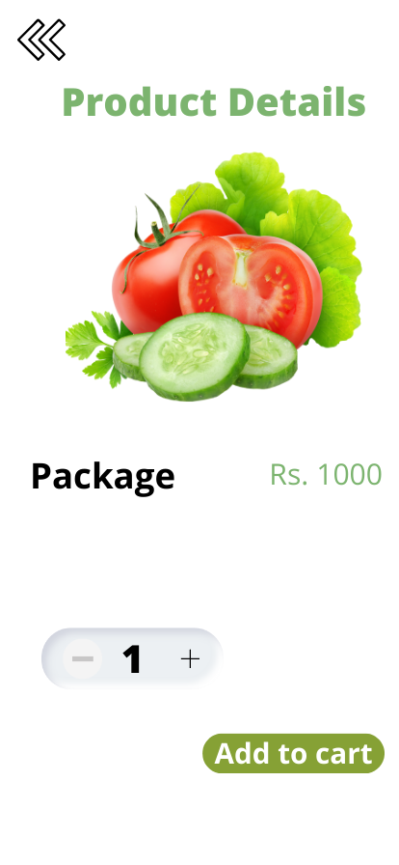

**Summary of functions:**

In this clickable prototype ,user will be prompted to completed the following functions:

1. Search different categories of food
2. Search items in the categories
3. Place order
4. May proceed to checkout

**Link to prototype:**

**https://www.canva.com/design/DAE95XcJ3Hk/QWqj_CZv20xPU42yIfk61Q/edit?utm_content=DAE95XcJ3Hk&utm_campaign=designshare&utm_medium=link2&utm_source=sharebutton**