RetailCo 360
Retail Analytics - on Microsoft Fabric
Project Report
Prepared by | Ahamed Rimzan
Date | 2026-11-11
GitHub repository | [https://github.com/your-name/your-repo]
LinkedIn | https://www.linkedin.com/in/ahamed-rimzan-36483720/
Email | rimzanmha@gmail.com

1. Summary
RetailCo 360 is an end-to-end retail analytics platform that I built on Microsoft Fabric. It takes messy sales data through a medallion lakehouse, serves it from a T-SQL star-schema warehouse and a Power BI report, adds a real-time operations dashboard, and promotes the solution from a Dev to a Test workspace with a deployment pipeline.
Highlights
- Cleaned a 6,120-row sales file to 6,000 trusted orders, and explained every difference.
- Investigated the blank values before deleting anything: a pricing formula held on all 5,596 complete rows, so I rebuilt 404 incomplete rows instead of discarding real sales.
- Orchestrated the load with a Fabric data pipeline and diagnosed two real failures (a file-format error and a stored-procedure recursion error).
- Row Level Security/Column Level Security/Data Masking was not included
- [Add one more highlight: for example the real-time dashboard, the security setup, or the Power BI report.]

2. About this project
This project is based on a Microsoft Fabric training capstone brief, which provides a synthetic dataset and a five-phase implementation outline. I used my personal Fabric trial workspace to develop the solution, applying practical data investigation, data cleaning, troubleshooting, and implementation techniques throughout the project.
Type | Training capstone, built individually
Data | Synthetic retail data (5 stores, 27 products, 200 customers, about 6,000 orders) and a synthetic event file
Duration | 3 Days
Tools | Microsoft Fabric (Lakehouse, Data Pipelines, Warehouse, Eventstream, Eventhouse and KQL, Real-Time Dashboard, Deployment Pipelines), PySpark, Spark SQL, Delta Lake, T-SQL, KQL, Power BI (DAX)

3. Business problem and goals
RetailCo runs five stores and an online channel. Its raw sales file arrives with duplicate orders, blank quantities and amounts, missing customer IDs, two date formats and inconsistent text casing. Leadership wants one trusted version of the numbers for daily reporting, and a live view of orders as they happen.
Goals
- Ingest and clean the raw data in layers (bronze, silver, gold) so every number can be traced.
- Load the cleaned data into a warehouse star schema for reporting.
- Automate the load with a scheduled, monitored pipeline.
- Show live order activity in a real-time dashboard.
- Promote the solution between environments without editing production by hand.

4. Solution architecture
Data flows left to right: raw files land in the lakehouse, notebooks refine them through silver and gold tables, a pipeline loads the warehouse, and Power BI reads from it. A separate real-time path sends events to an Eventhouse and a dashboard.

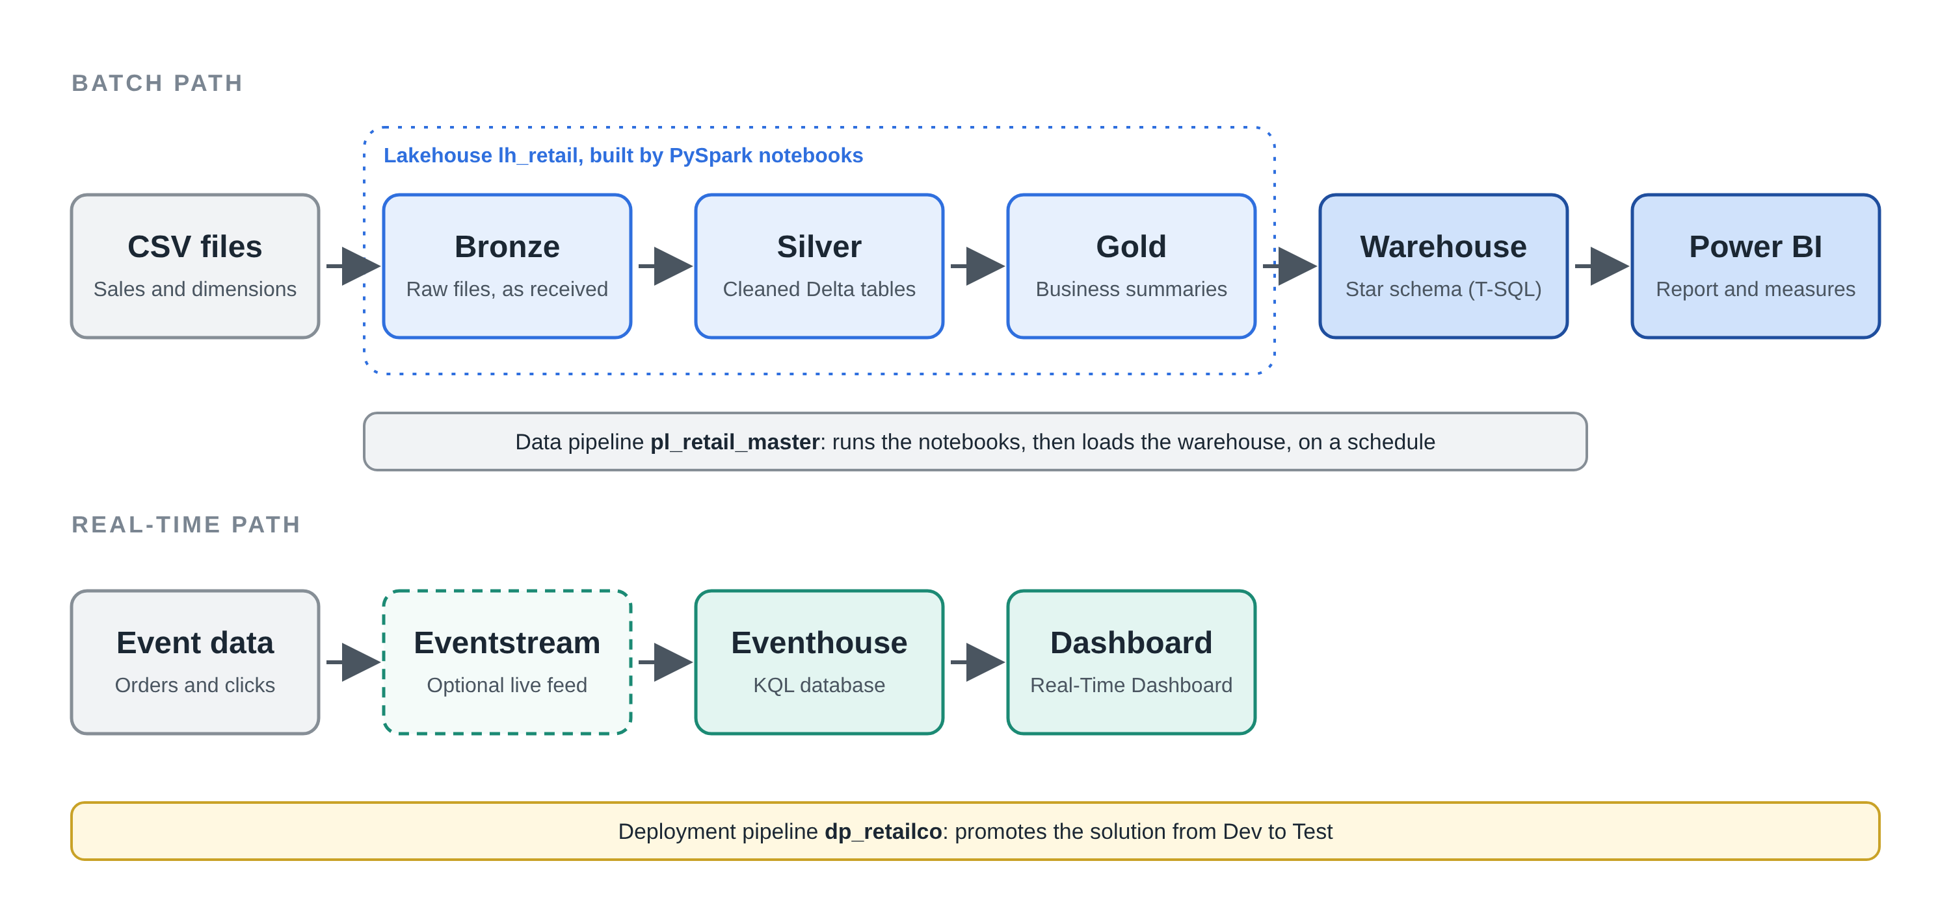

Layer | Fabric component | What it does
Bronze | Lakehouse lh_retail, Files area | Holds the raw CSV files exactly as received
Silver | Delta tables, built by PySpark notebooks | Cleaned and standardised sales and dimension tables
Gold | Delta tables, built with Spark SQL | Business-ready summaries such as sales by day, region and category
Orchestration | Data pipeline pl_retail_master | Runs the notebooks and the warehouse load in order, on a schedule
Serving | Warehouse wh_retail | Star schema: fact_sales with date, store, product and customer dimensions
Reporting | Power BI semantic model and report | Revenue, Revenue by month/city, orders and margin by region, category and channel
Real-time | Eventstream, Eventhouse (KQL), Real-Time Dashboard | Live event analytics and a conversion-rate tile
Promotion | Deployment pipeline dp_retailco | Moves the solution from Dev to Test

4.1 Fabric Workspace

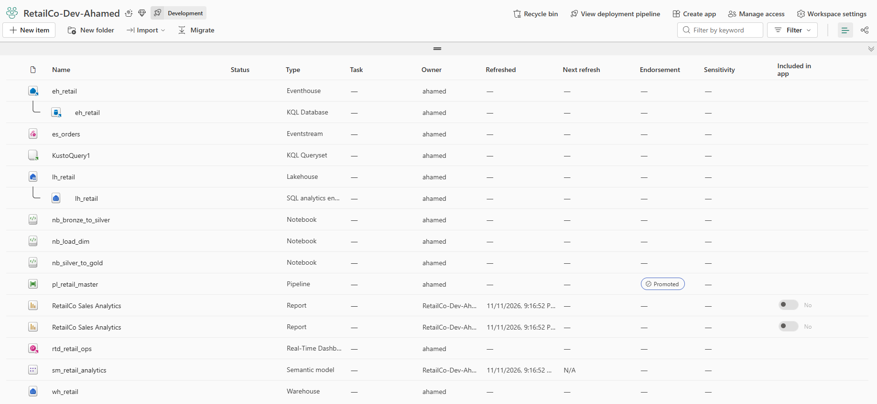

5. Data and data cleaning

5.1 What the data looked like
The sales file had 6,120 rows. Before changing anything, I counted the blank values in each column and checked for duplicate order IDs.
Finding | Result
Raw sales rows | 6,120
Duplicate orders removed (first occurrence kept) | 120
Rows after removing duplicates | 6,000
Blank quantity | 246
Blank net_amount | 158
Blank customer_id | 213
Rows with more than one blank field | 0 (the three counts add up to exactly 617 incomplete rows)

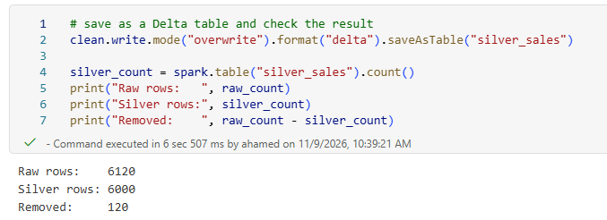

5.2 Key decision: repair instead of discard
My first cleaning pass followed the brief literally and dropped every incomplete row. That left 5,383 orders, about 600 fewer than the 6,000 distinct orders in the source. Rather than accept the gap, I looked for what the missing values had in common.
Every order follows the same pricing rule: net_amount = quantity x unit_price x (1 - discount_pct / 100). I tested that rule on all rows that had both values. It matched every one of them, with zero exceptions.
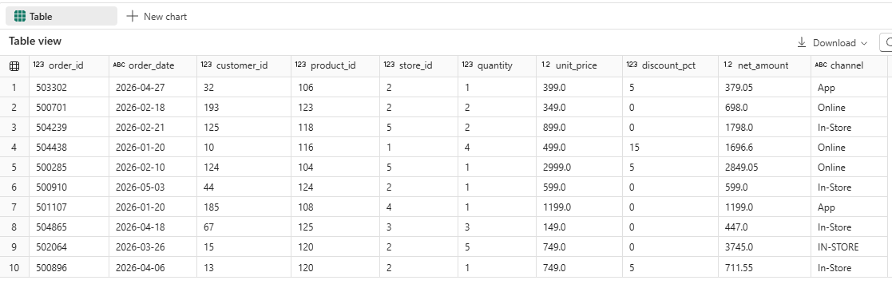

6. How I built it

Phase 1: Lakehouse and Delta tables
- Created lakehouse lh_retail with bronze, silver, gold and config folders.
- nb_load_dim loads each dimension (store, product, customer) into a Delta table; one parameterised notebook serves all three.
- nb_bronze_to_silver fixes types, whitespace, casing and the two date formats, removes duplicate orders, repairs blanks and adds a revenue band.
- nb_silver_to_gold builds the gold summary tables, a top-20 customers table and a date table, then runs OPTIMIZE.
[Screenshot: lakehouse Tables list showing the silver and gold tables]

Phase 2: Orchestration pipeline
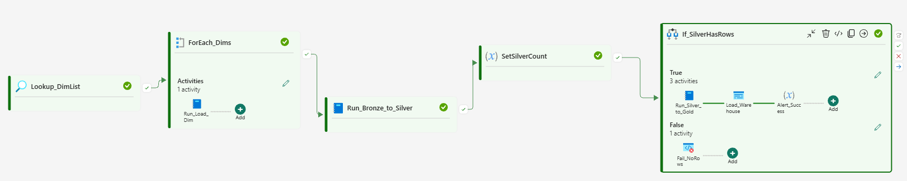
- pl_retail_master reads a small config file (dims.csv) and uses a ForEach loop to load each dimension.
- It then runs the Bronze-to-Silver notebook, stores the row count in a pipeline variable, checks that Silver is not empty, runs Silver-to-Gold, and calls the warehouse load procedure.
- Retry logic : it was set to 3 retries with 30 sec fixed retry intervals.
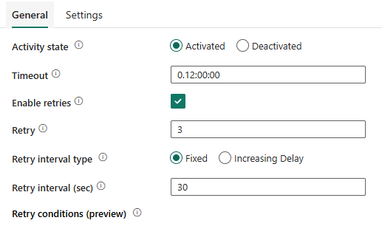
- Schedule : set to monthly, Every month on the 1st day - 12:00 PM
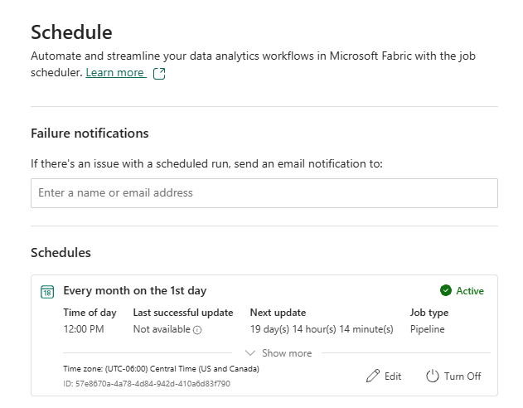

Phase 3: Warehouse
- Star schema in wh_retail: fact_sales (6,000 rows) with dim_date, dim_store, dim_product and dim_customer. Guest orders keep a blank customer key.
- The load is a stored procedure (usp_load_warehouse) that empties and refills the tables, so it can be re-run safely.
- For now none of the security rules were not applied
- Monthly revenue by region is a T-SQL query joining the fact table to the store and date dimensions.

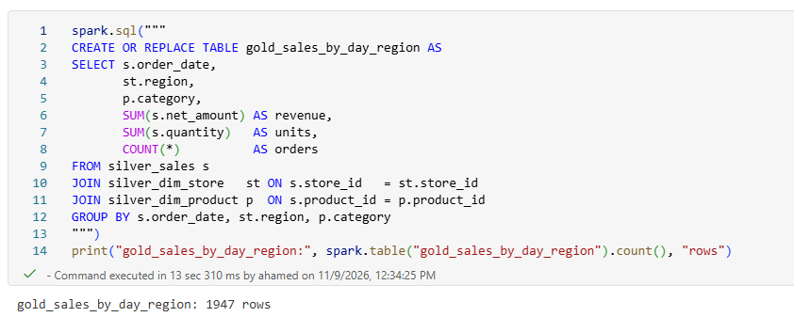

3.1 Semantic Model
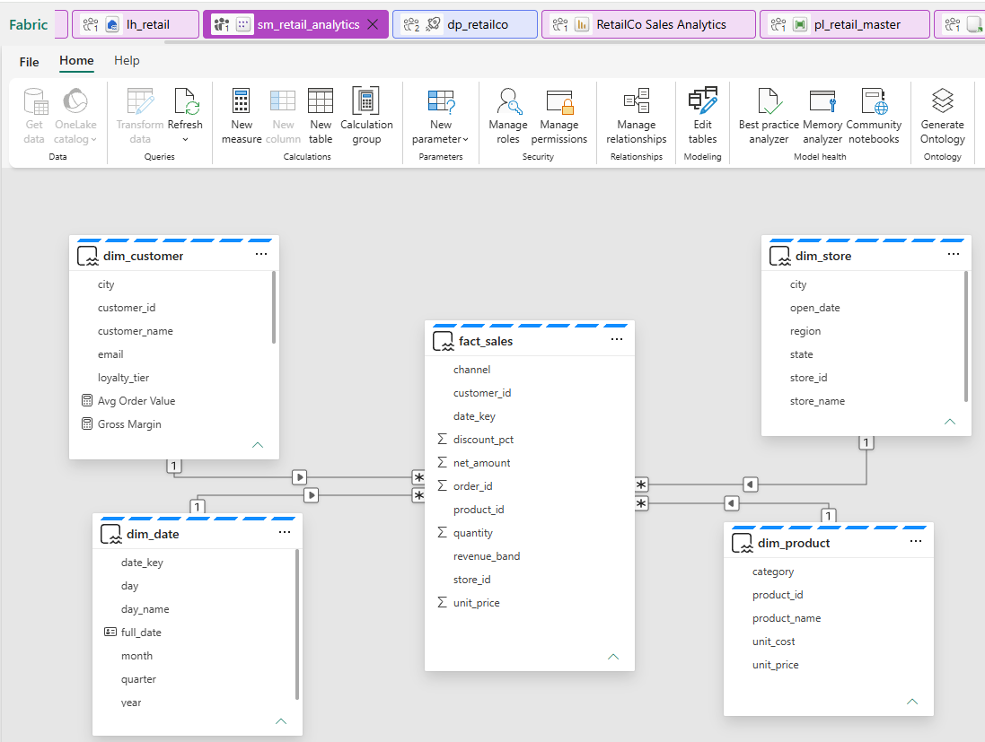

Phase 4: Real-time analytics
- Created Eventhouse eh_retail and loaded the event file into table events_raw.
Live Event : 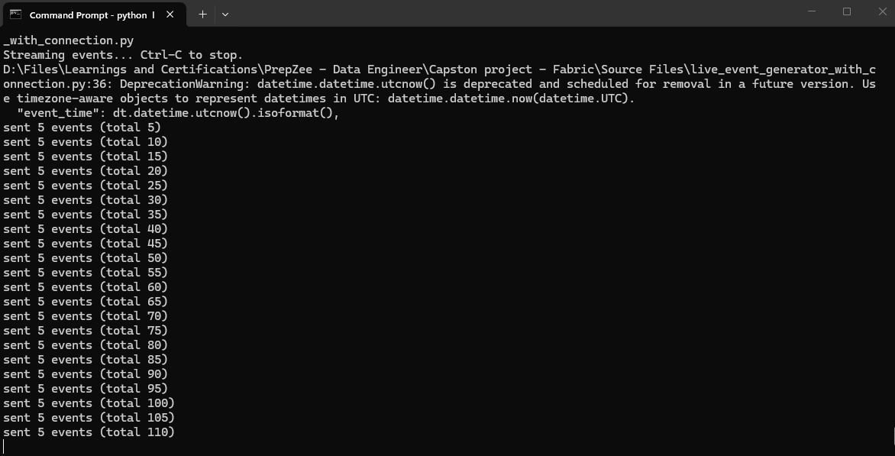
- KQL queries cover events by type, revenue per minute, and the cart-to-purchase conversion rate per channel.
- A materialized view keeps running revenue per category, and a Real-Time Dashboard shows the conversion rate.

Eventstream:
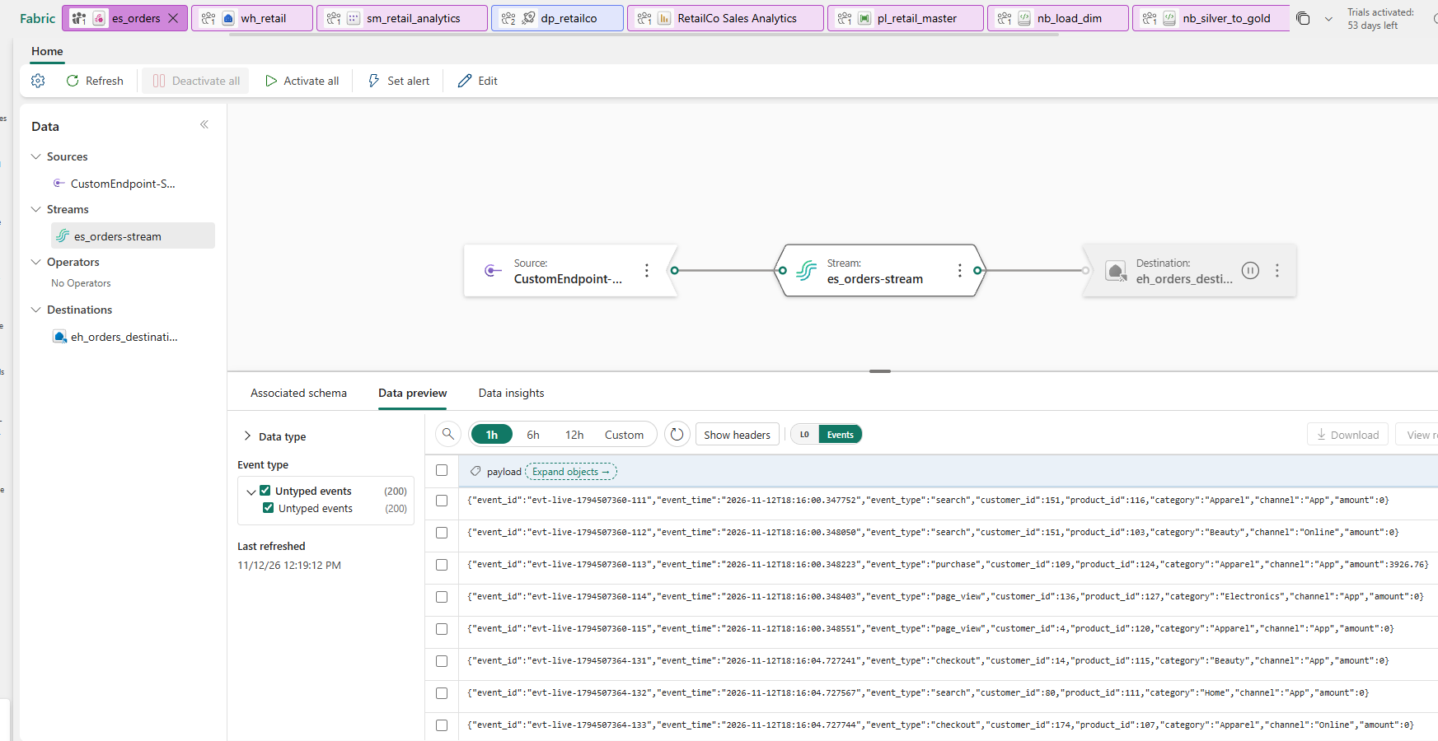

KQL : 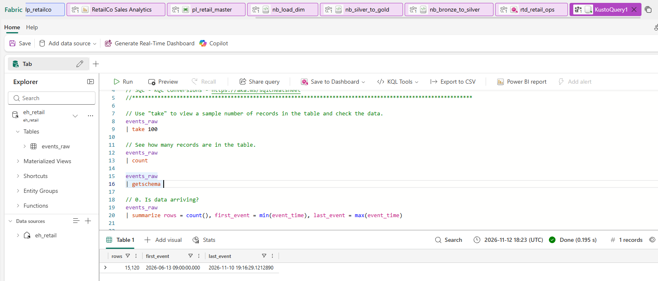

Real-Tme Dashboard:
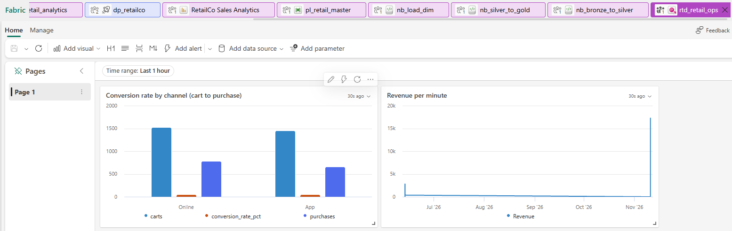

Phase 5: Deployment pipeline
- Created deployment pipeline dp_retailco with Dev and Test stages and deployed the solution from Dev to Test.
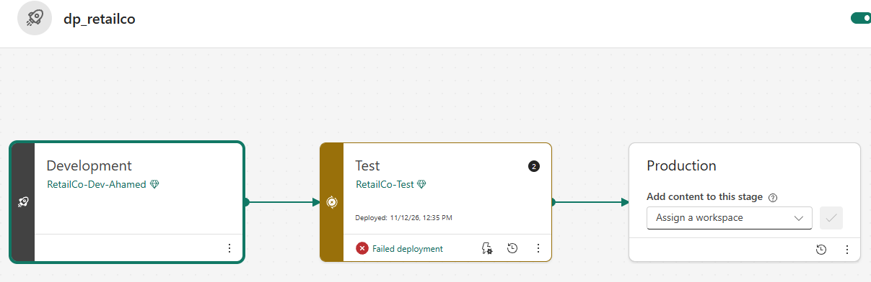
- Git integration was not available on my trial tenant, so workspace items are not version-controlled in Git. The brief allows this.
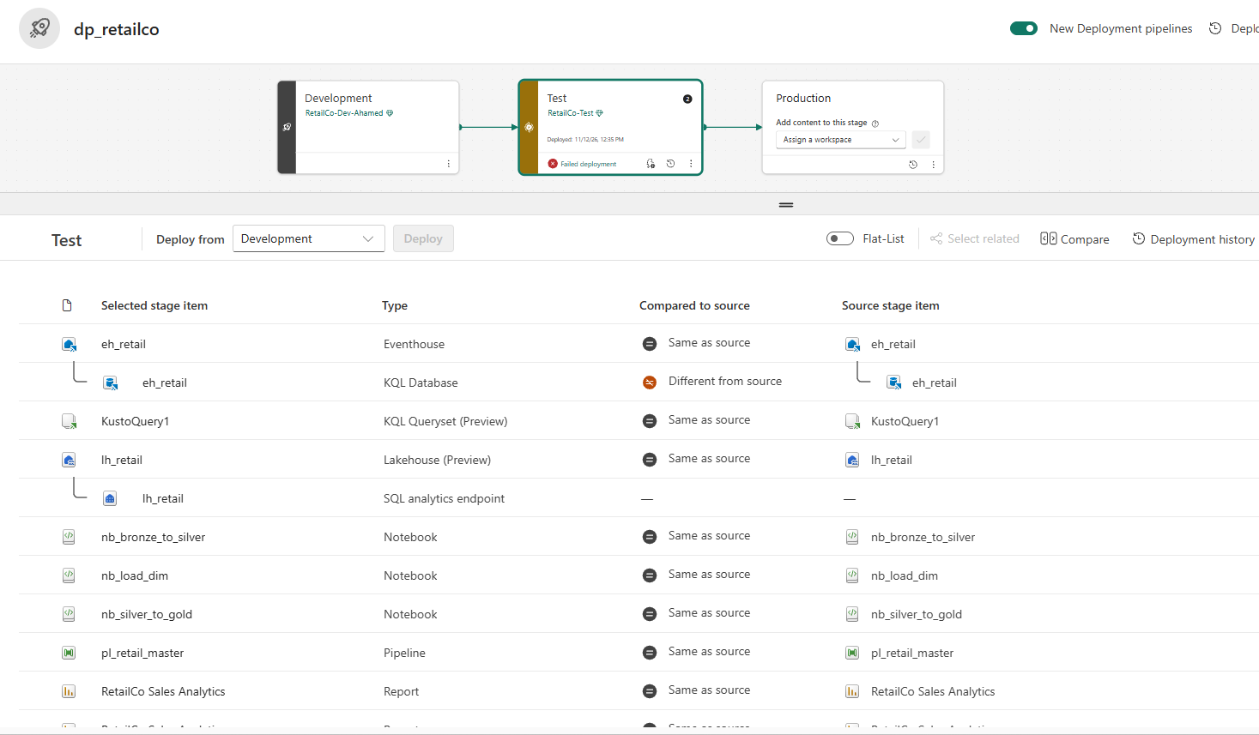

7. Problems I solved

The row count was 600 short
After the first cleaning pass, Silver held 5,383 rows against an expected 6,000. I counted blanks per column, confirmed that no row was missing more than one value, and tested the pricing rule on the complete rows. The rule held on every row, so I rebuilt the missing values and kept the guest orders. Silver then reconciled with the source.

The pipeline could not read its config file
The Lookup activity kept treating my JSON config file as delimited text and failed. The error showed the number of characters it had read, which matched the old JSON file and not the new one, so I knew which file it was really opening. I switched the config to a one-column CSV with a header row, which the activity handles reliably, and the ForEach loop worked without any other change.

The warehouse load failed with error 217
The load procedure failed with "maximum stored procedure nesting level exceeded (limit 32)". The error log held 320 statements, but only 10 distinct queries, each repeated exactly 32 times. That matched the procedure's 10 statements and the nesting limit, which showed the procedure was calling itself. The cause was a line that ran the procedure, placed directly after its definition, so it became part of the procedure body. I separated the definition from the call, confirmed the stored definition with a query, and the load then finished in seconds.
Retries could not have fixed this, because the same logic error repeats every time. I set the activity's retries to 3.

8. Results
Measure | Result | Where to see it
Silver rows after cleaning | 6000 | Lakehouse, silver_sales
Warehouse fact_sales rows |  | Validation query, warehouse
Lakehouse vs warehouse revenue difference | 0 | Validation query, warehouse
Pipeline end-to-end duration | 5 min | Monitor hub
Warehouse load procedure runtime | 2 min | Query execution time

9. Skills demonstrated
Skill | Evidence in this project
PySpark and Delta Lake | Parameterised notebooks, medallion layers, OPTIMIZE, repeatable overwrites
Data quality | Profiling before cleaning, a verified repair rule, no silent row loss, documented reconciliation
Pipeline orchestration | Config-driven ForEach, parameters, row-count gate, stored procedure activity
Warehouse modelling and T-SQL | Star schema, idempotent load procedure, analytic queries
Real-time analytics | Eventhouse, KQL queries, materialized view, Real-Time Dashboard
Reporting | Power BI semantic model and DAX measures
Deployment | Dev to Test deployment pipeline and re-binding of environment-specific items
Troubleshooting | Diagnosed a file-format error and a recursion error from their error messages

10. Limitations and next steps
- The data is small and synthetic. At scale I would load incrementally (using a watermark or Delta MERGE) and partition large tables.
- Rebuilt quantities and amounts are derived values. I verified the rule on every complete row, but in a real project I would flag repaired rows in a column and confirm the rule with the data owner.
- There are no automated tests yet. Next step: tests for the notebooks and a check that compares Silver and warehouse totals after every run.
- Git integration was not available on my trial tenant. With access, I would connect the workspace to a repository and promote changes through pull requests.
- The date table covers a fixed range and must be extended as new data arrives.
- Need to implement Security concepts – RLS, CLS, OLS, Dynamic data masking

11. About the author
Aspiring Data Engineer with 4+ years of professional experience across data analytics, quality assurance, and business-critical reporting, complemented by hands-on experience building end-to-end data solutions using Microsoft Fabric. Skilled in SQL, Python, PySpark, and Power BI, with practical experience developing data pipelines, implementing Bronze-Silver-Gold architecture, transforming and validating datasets, and building analytical data models using Fabric Lakehouse and Warehouse. Familiar with Dataflow Gen2, OneLake, Delta Lake, Eventstream, Eventhouse, and Direct Lake. Microsoft Certified: Fabric Analytics Engineer Associate (DP-600), with a Post-Graduate Diploma in Business Analytics from SAIT (GPA 4.0) and a strong focus on data quality, reliable data processing, and scalable analytics solutions.

Contact: Calgary, AB | Rimzanmha@gmail.com | https://www.linkedin.com/in/ahamed-rimzan-36483720/ | https://github.com/rimzanmha

Appendix A: Evidence checklist
# | Screenshot | Section | Done
1 | Lakehouse tables (silver and gold) | 6, Phase 1
2 | Null-count profiling and pricing-formula test | 5
3 | Pipeline canvas and successful Monitor hub run | 6, Phase 2
4 | Monthly revenue by region (T-SQL result) | 6, Phase 3
5 | Masking or row-level security proof | 6, Phase 3
6 | KQL conversion-rate query | 6, Phase 4
7 | Real-Time Dashboard | 6, Phase 4
8 | Deployment pipeline, Dev and Test | 6, Phase 5
9 | Power BI report | 6 / 9

Appendix B: Repository contents
- README.md: project overview, architecture diagram and results
- sql/: warehouse schema, load procedure, validation, security and analytic queries
- kql/: Eventhouse queries, materialized view and functions
- config/: pipeline configuration file (dims.csv)
- notebooks/: exported Fabric notebooks
- powerbi/: DAX measures and report layout
- docs/: build notes and screenshots

