

Latent view analytics

# Founder of Latent View analytics:

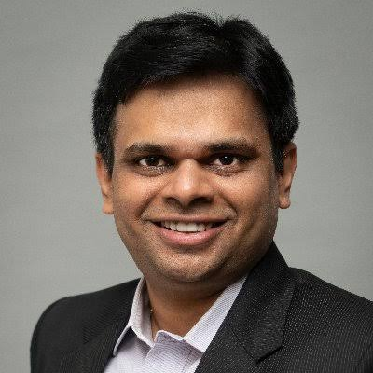

Venkat Viswanathan is the co-founder and chairman of Latent View Analytics, a global analytics and digital solutions provider with offices in the United States, Canada, Singapore, and India, including Chennai. He is a visionary leader with over 25 years of experience in the analytics industry.

Prior to co-founding Latent View Analytics in 2006, Viswanathan held leadership roles at several top tier consulting firms, including McKinsey & Company and Booz Allen Hamilton. He is a recognized expert in the fields of analytics and digital solutions and has authored several articles on the subject.

As chairman of Latent View Analytics, Viswanathan is responsible for driving the company's strategy and vision, and for ensuring that the company stays at the forefront of the analytics industry. Under his leadership, the company has grown from a small startup to a global leader in the analytics space, with a strong presence in Chennai and other major cities around the world.

Overall, Venkat Viswanathan's leadership and vision have been instrumental in the success of Latent View Analytics, and his expertise in the analytics industry has helped position the company as a leader in the field.

# About Latent View analytics:

Latent View Analytics is a global analytics and digital solutions provider with offices in the United States, Canada, Singapore, and India

In Chennai, Latent View Analytics has established a strong presence, boasting a team of experts who work on cutting-edge analytics projects. The team in Chennai is highly skilled in the latest analytics tools and techniques, with a deep understanding of the local market and business needs.

The company's services in Chennai include data analytics, machine learning, digital analytics, and marketing analytics. They work with clients in various industries, such as retail, finance, healthcare, and technology, to provide customized solutions that meet their specific business needs.

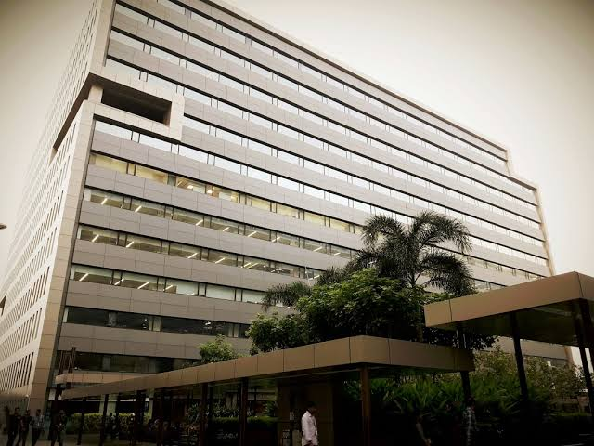

.

# What does the company Latent View Analytics do?

The company's services in Chennai include:

1. Data Analytics: Latent View Analytics in Chennai provides data analytics solutions that help businesses make informed decisions based on data insights. This includes data exploration, data modeling, and data visualization.
2. Machine Learning: Latent View Analytics in Chennai uses machine learning algorithms to help businesses automate decision-making processes and gain a competitive edge. This includes predictive analytics, natural language processing, and computer vision.
3. Digital Analytics: Latent View Analytics in Chennai offers digital analytics solutions that help businesses optimize their digital assets and campaigns. This includes web analytics, social media analytics, and mobile app analytics.
4. Marketing Analytics: Latent View Analytics in Chennai helps businesses measure the effectiveness of their marketing campaigns and optimize their marketing spend. This includes customer segmentation, customer lifetime value analysis, and campaign attribution.

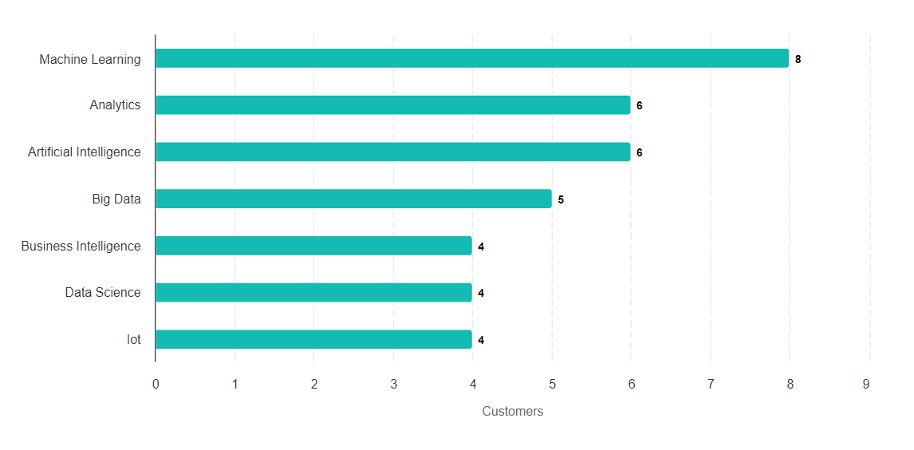

# What is the salary of Data Analyst in Latent View Analytics Chennai?

The typical Latent View Analytics Data Analyst salary is ₹6,12,556 per year. Data Analyst salaries at Latent View Analytics can range from ₹2,74,355 - ₹14,19,532 per year.

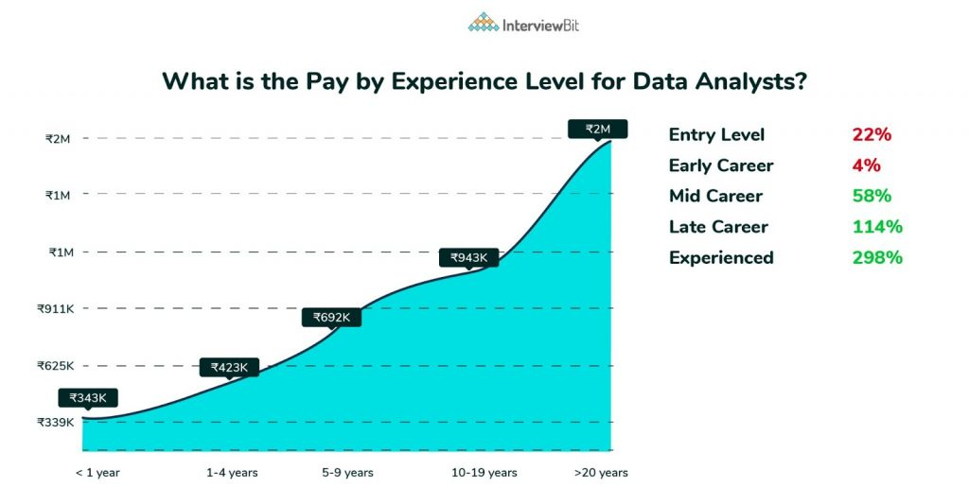

# Top industries that use Latent View:

Top industries that use Latent View for predictive-analytics are as follows:

* Retail: The retail industry relies heavily on data analytics to drive sales and optimize operations. Latent View Analytics provides data-driven solutions that help retailers gain insights into customer behavior, improve supply chain efficiency, and optimize pricing strategies.
* Financial services: Financial services companies such as banks and insurance firms use Latent View Analytics' services to manage risk, optimize investment strategies, and improve customer experience. The company's solutions help financial services firms make informed decisions based on data insights.
* Healthcare: The healthcare industry is increasingly turning to data analytics to improve patient outcomes and reduce costs. Latent View Analytics provides solutions that help healthcare providers optimize patient care, manage costs, and improve operational efficiency.
* Consumer packaged goods (CPG): CPG companies use Latent View Analytics' services to gain insights into consumer behavior and preferences, optimize product development and marketing strategies, and improve supply chain efficiency.

Architecture of latent view analytics:

some of the key aspects of the architecture used by the company:

* Cloud-based infrastructure: Latent View Analytics leverages cloud-based infrastructure, primarily on Amazon Web Services (AWS) and Microsoft Azure, to provide scalability and flexibility in its operations. The company uses a range of cloud services including computing, storage, and networking to support its analytics and digital solutions.
* Big data processing: To support its data analytics operations, Latent View Analytics uses a range of big data processing technologies such as Hadoop, Spark, and NoSQL databases. These technologies allow the company to process large volumes of data in real-time and generate insights that drive business value for its clients.
* Analytics platforms: Latent View Analytics uses a range of analytics platforms such as R, Python, and SAS to support its data analytics operations. These platforms allow the company to perform statistical analysis, predictive modeling, and machine learning to generate insights from data.
* Visualization tools: The company uses visualization tools such as Tableau and Power BI to create interactive dashboards and reports that help clients visualize and understand complex data insights.

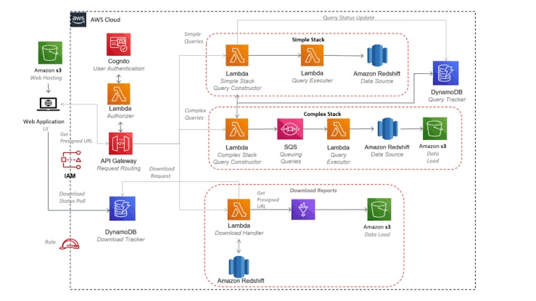

# Conclusion:

Overall, Latent View Analytics in Chennai is a reliable analytics partner for businesses seeking to gain insights into their data and leverage them for better decision-making. The company's team of experts is dedicated to staying ahead of the curve in the ever-evolving world of analytics, ensuring that their clients receive the most up-to-date solutions.