**Shifa Tameer-e-Millat University**  

lab#9

**Operating System**

Topics:

Deadlock avoidance algorithm

Submitted to:

Dr. Majid

Submitted by:

Rinad Anwar

Roll# 0012

BS Artificial Intelligence - 5th Semester

Department of Computing

**TASK 1**

Input .c file code:

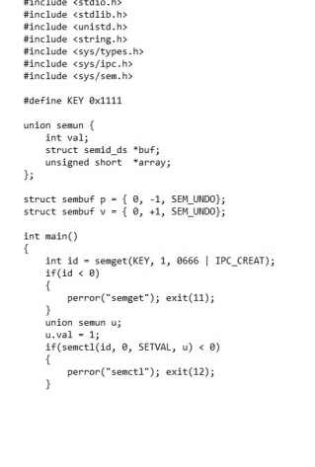

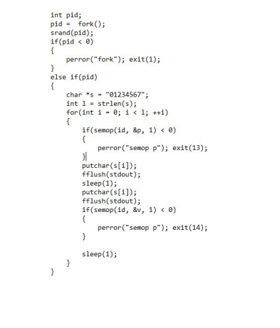

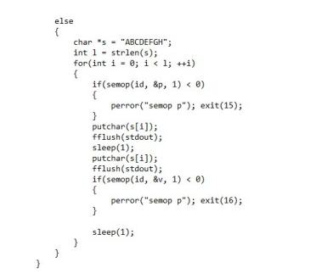

Output :

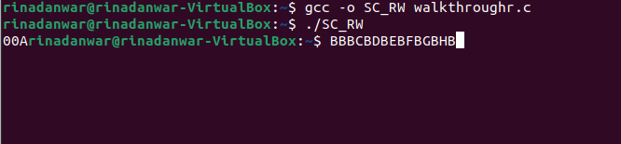

**Walkthrough Task**

Input .c file code:

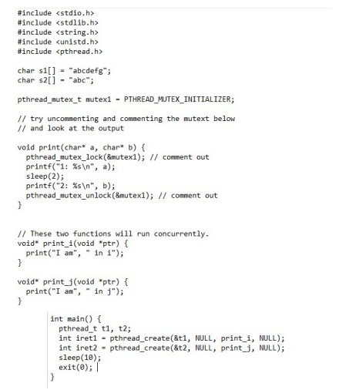

Output:

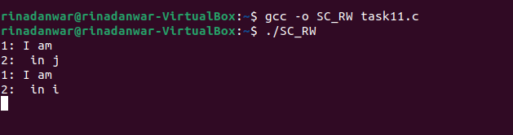

**Practice Task:**

Run on three different datasets and output your findings.

cpp file Bankers_implementation.cpp on github.

Output of dataset 1:

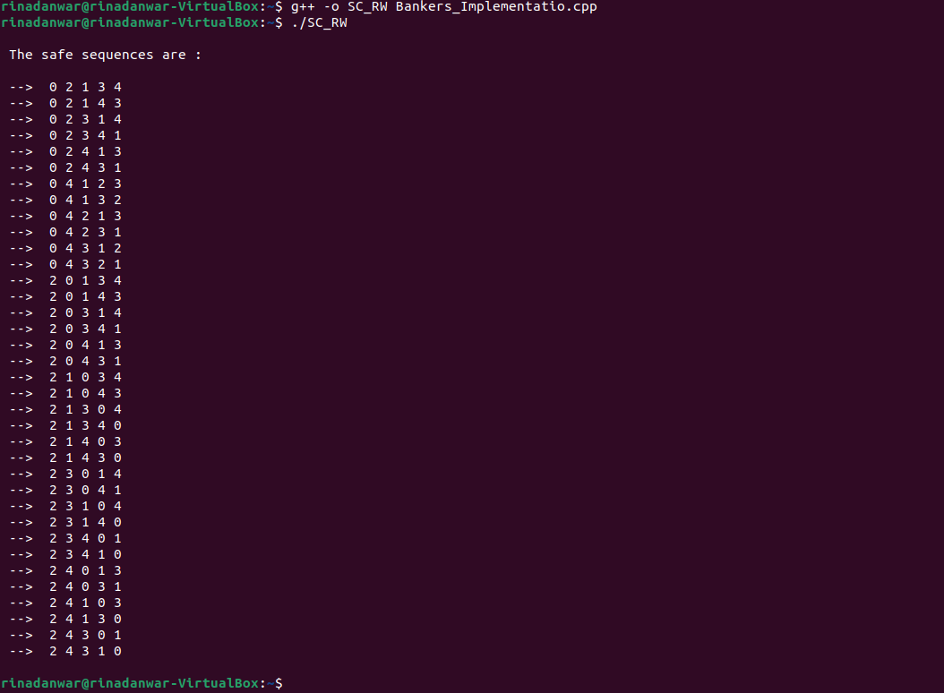

Output of dataset 2:

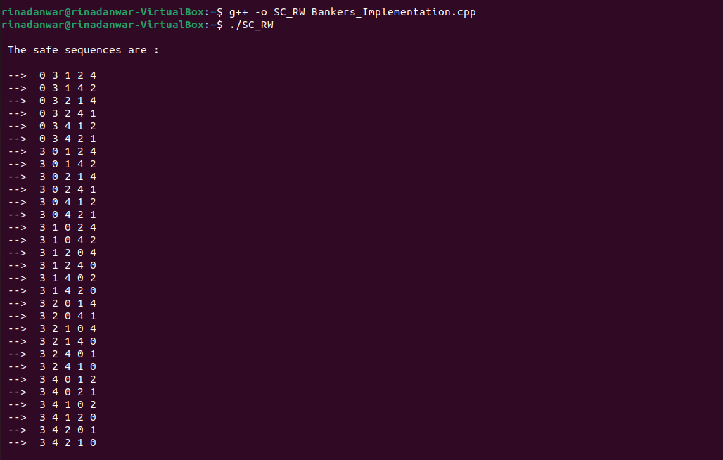

Output of dataset 3:

