**Shifa Tameer-e-Millat University**  

Quiz

**Operating System**

Submitted to:

Sir Majid

Submitted by:

Rinad Anwar

Roll# 0012

BS Artificial Intelligence - 5th Semester

Department of Computing

**TASK 1: FIRST COME FIRST SERVE**

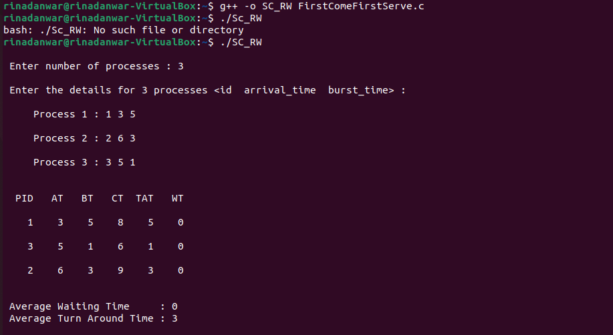

**TASK 2: Priority with IO**

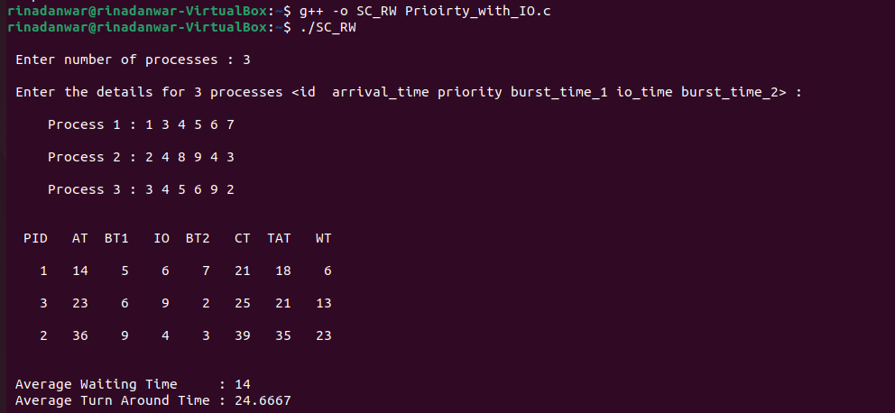

**TASK 3: Round robin**

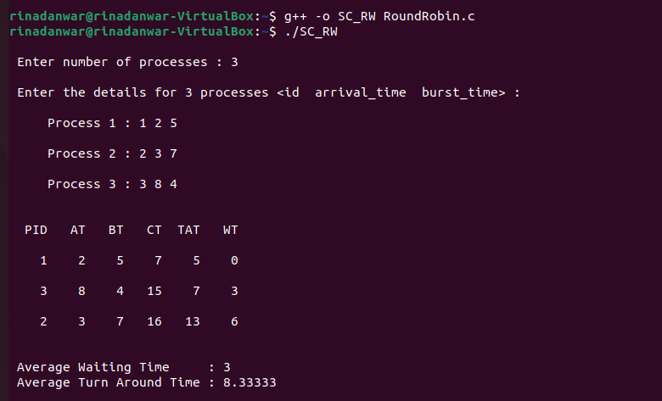

**TASK 4: Shortest Remaining Job first**

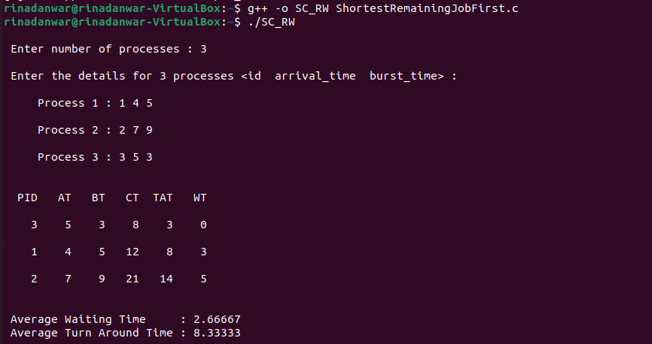

**TASK 5 SRTF with IO:** 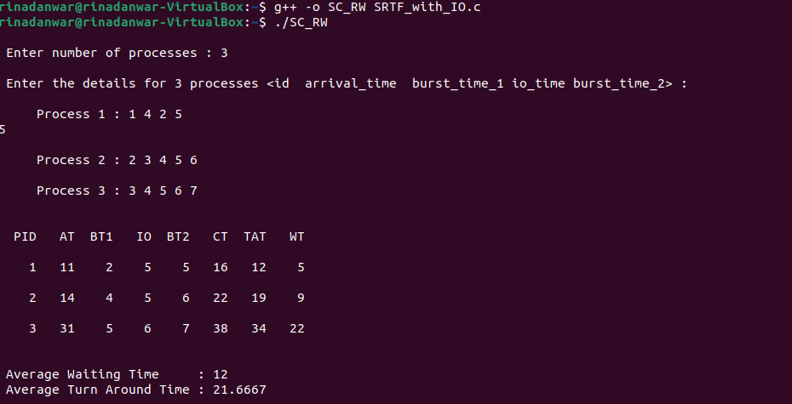

**TASK 6 Priority scheduling:**

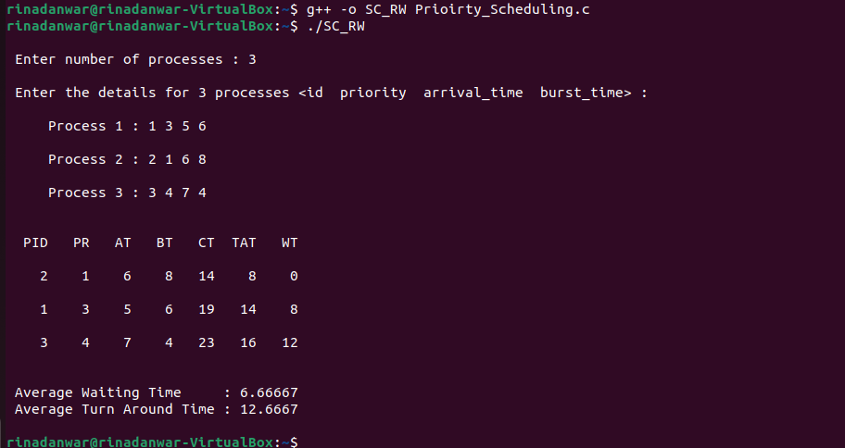

**TASK 7 SJF:**

