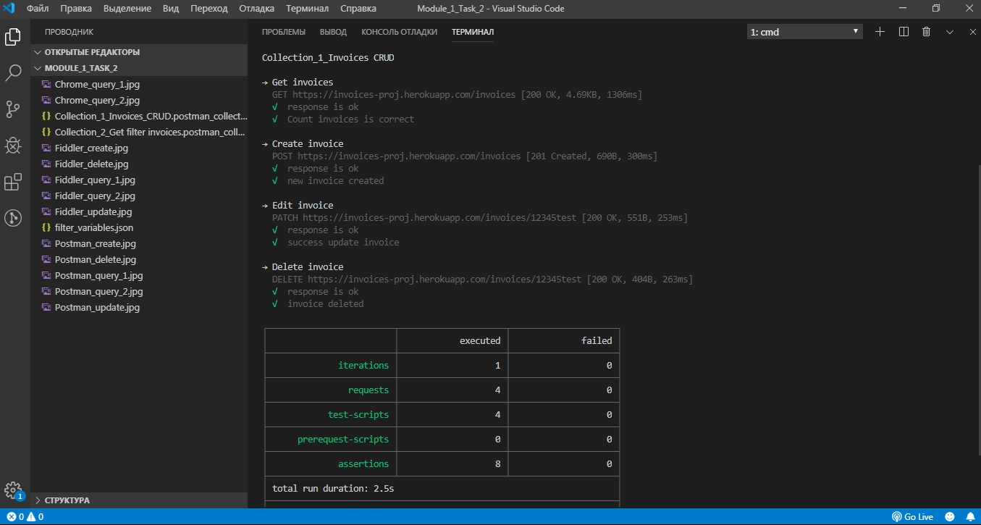

**Newman run collection 1**

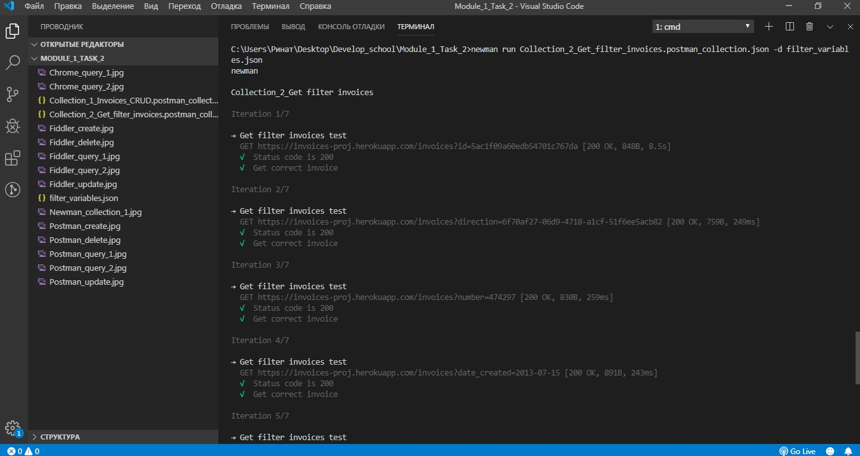

**Newman run collection 2 screen 1**

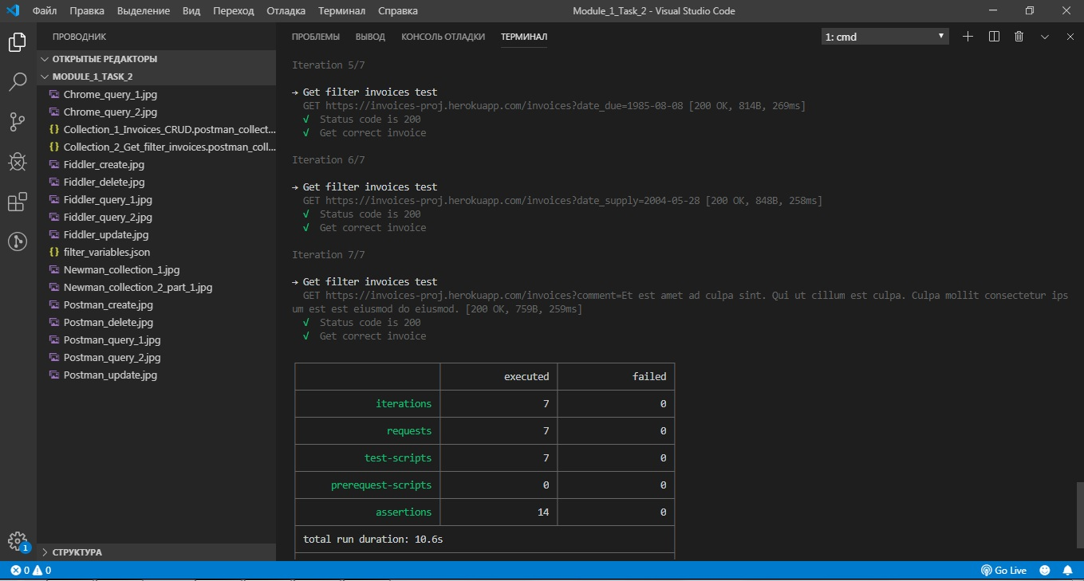

**Newman run collection 2 screen 2**