1. What is the major year of birth or age of bike users in February 2019 and 2020?

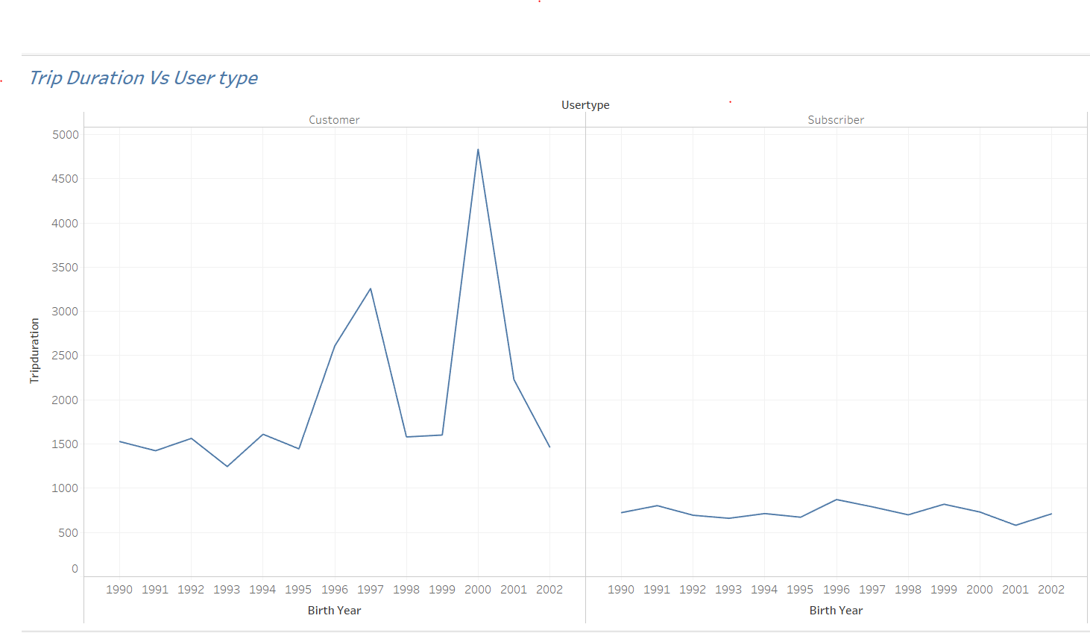

1. Jfjfjkdfj
2. 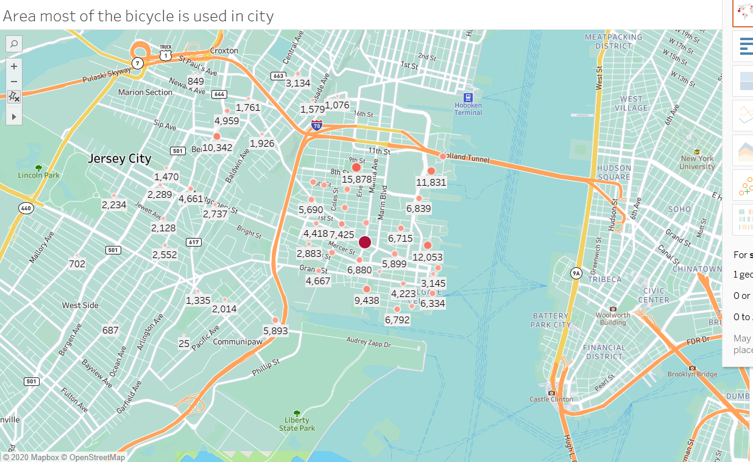
3. Area most of the bikes are used in 2019.
4. 