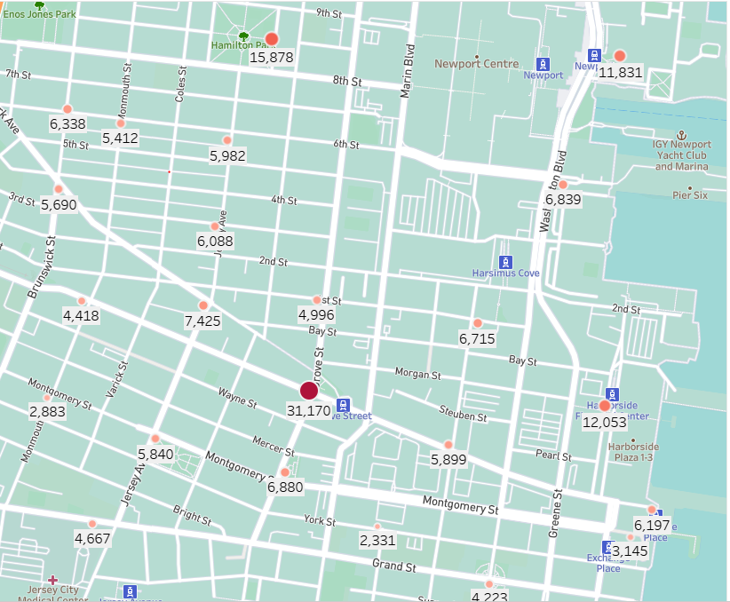Story: Use of Bicycle in Jersey City in 2019.

<= Many people used bicycle in the downtown Jersey City. More than 30,000 people used bicycle from Grove St Path bicycle station to ride an average half a mile distance. Second busiest station is Hamiltion Park where 15,878 bicycles were used. Other two were Harborside and Newport path stations where no of users were 12,053 and 11,831 respectively. Rest of the other stations has users less than 10,000 per year.

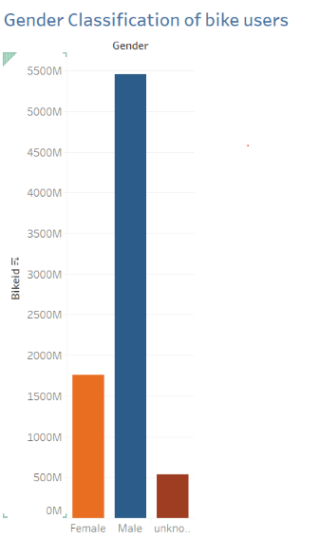

Most of these bike users in Jersey city were male. The total ratio between female and male was 1:5. Although some bicycle rider’s gender was unknown, the chart clearly shows that total female bike users in the whole city in 2019 were less than 2000M where as male were 5500M.