<https://www.fool.com/investing/2019/04/09/going-for-great-returns-and-the-greater-good-fools.aspx>

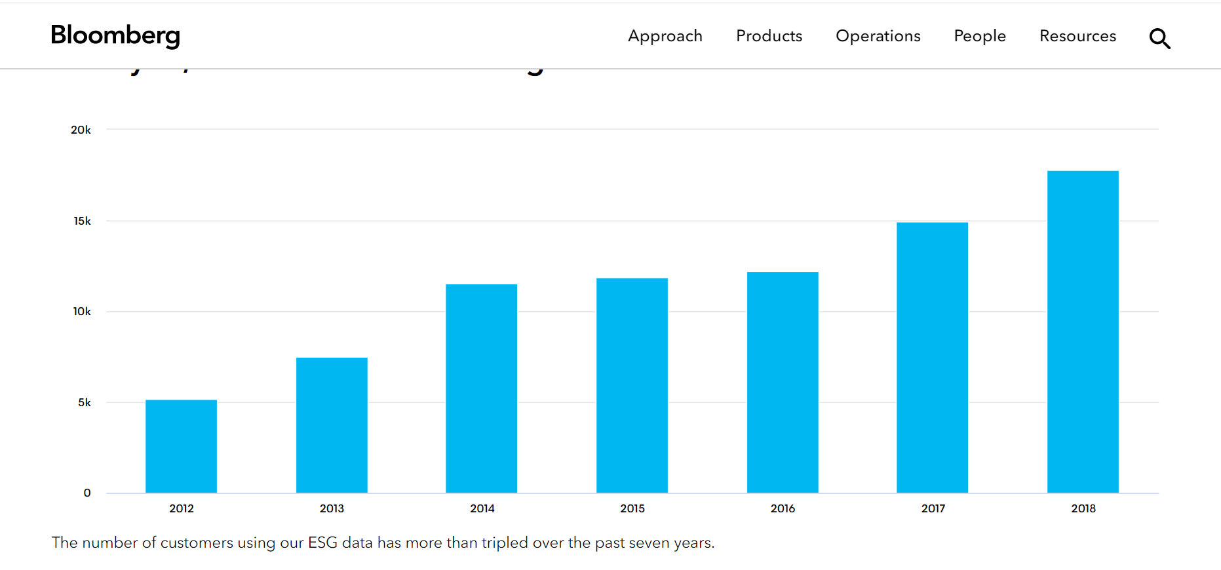

<https://www.youtube.com/watch?v=G1eW3Oi6uoc>

<https://www.youtube.com/watch?v=HgvIox6ehkM>

<https://www.youtube.com/watch?v=T0Q0kEyEK_k-dynamic> server dependent SQL table