Seq2Lead: Sequence-Based Compound Ranking with Historical Bioactivity Evaluation
  - Rinat Rizvanov
  - Boston University, Boston, MA, USA
Scientific manuscript draft · 5 October 2026 · Not submitted or peer reviewed

Abstract
Seq2Lead is scientific software for protein-sequence-based prioritisation of compounds from an existing library: given one protein sequence and a frozen library of compounds that already exist, it orders that library by predicted pKi. Sequence-based ranking requires a clear boundary between historical training evidence and later evaluation evidence, so we built a provenance-preserving BindingDB pipeline around a command-line ranking tool and evaluated it in an exploratory historical snapshot study. January and September 2026 snapshots were curated under an identical pinned pipeline. Counted matching distinguished unchanged observations, additions, removals and constrained correction candidates. Training used January evidence alone; increment labels and complete September consistency checks remained separate. Models fitted exact-Ki regression targets and were evaluated with tie-aware per-target ranking metrics. In the primary cohort of pairs new to fitting, 22,221 pairs covered 992 targets, with 123 meeting the five-positive/five-negative scoring floor. Mean macro AUROC was 0.788873 for a concatenated-feature MLP and 0.781229 for an affine-cosine dual encoder. A separate carbonic-anhydrase-2 docking protocol failed its declared ranking gate despite successful known-pose recovery. The contribution is an auditable implementation and measured case study. Prior corpus exposure and provisional assay pooling preclude a confirmatory interpretation.

1. Introduction
Therapeutics Data Commons organises datasets, tasks and benchmarks for therapeutic machine learning [4]. ConPLex established protein-language-model coembedding [1]; Papyrus addresses bioactivity curation [2], and PLINDER addresses protein–ligand evaluation resources [3]. Seq2Lead connects these concerns in a release-aware BindingDB study. It ranks existing compounds from a protein sequence. The aim is to compare a dual encoder with simpler predictors under explicit evidence visibility, while recording how cohort construction and artifact integrity affect interpretation.
What exists today is a command-line prototype together with an auditable benchmark of it. The prototype takes one FASTA and a frozen library and returns a ranked list; there is no web interface, hosted service or API. The benchmark is the historical evaluation reported here, whose predictions, labels, provenance and verification records are published so the reported numbers can be recomputed independently. The benchmark is the contribution of this report, and the prototype is what the benchmark measures. Seq2Lead prioritises existing compounds; it does not design or generate molecules, and a predicted ranking is a triage hypothesis rather than evidence of binding.
The practical question is whether a screening result can be traced to the evidence, feature content and model selection that produced it. Seq2Lead makes these boundaries inspectable and preserves negative results. It demonstrates that familiar pairs can have substantially different ranking performance from later pairs, and that recovering a crystal pose does not establish useful affinity ranking. These findings support careful evaluation of sequence-based screening tools before experimental prioritisation.

2. Methods

2.1 Data and evidence design
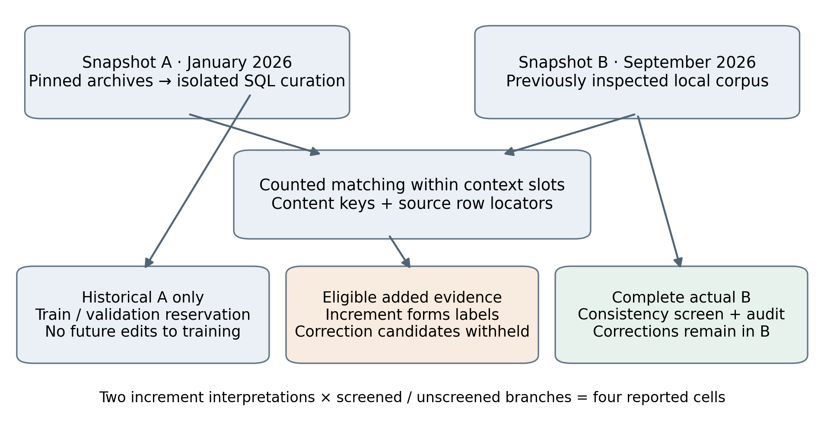
Figure 1. Release-aware evidence flow. Historical training, added evaluation evidence and complete later-snapshot consistency are separate readings. Two increment interpretations and two consistency branches are retained; the primary cell is declared increment with screening.
The local September archive loaded 3,237,046 of 3,237,052 data lines, quarantining six with original bytes retained. Curation produced 3,233,963 activity records. Ki, IC50, Kd and EC50 remained distinct. PostgreSQL stored source provenance and curated entities; pinned RDKit processing preserved stated stereochemistry. BindingDB provides the underlying measured affinity evidence [5]. The January deposit (DOI 10.6075/J0V40W61) was ingested and curated in an isolated schema, with read-only exports and source-release/row locators on both sides.
$pKi = 9 − log₁₀(Ki in nM) ; active if pKi ≥ 6$
Only exact Ki observations supplied regression targets, using the median exact pKi per pair. Censored measurements retained their relation and inclusivity and could decide a class without becoming a numerical target. Empty bound intersections, exact–bound conflicts, ambiguity and discordance were retained in the audit. Exact spread greater than one pKi unit excluded ranking and validation selection under their declared policies; training could retain an exact median. Ki assay poolability was not established, so pooling remained provisional.
The full-B consistency screen reads actual September evidence, including removals and replacements. It does not reconstruct B by appending additions to A. Later corrections and contradictions affect evaluation eligibility and audit records without editing historical training evidence.

2.2 Representation and model architecture
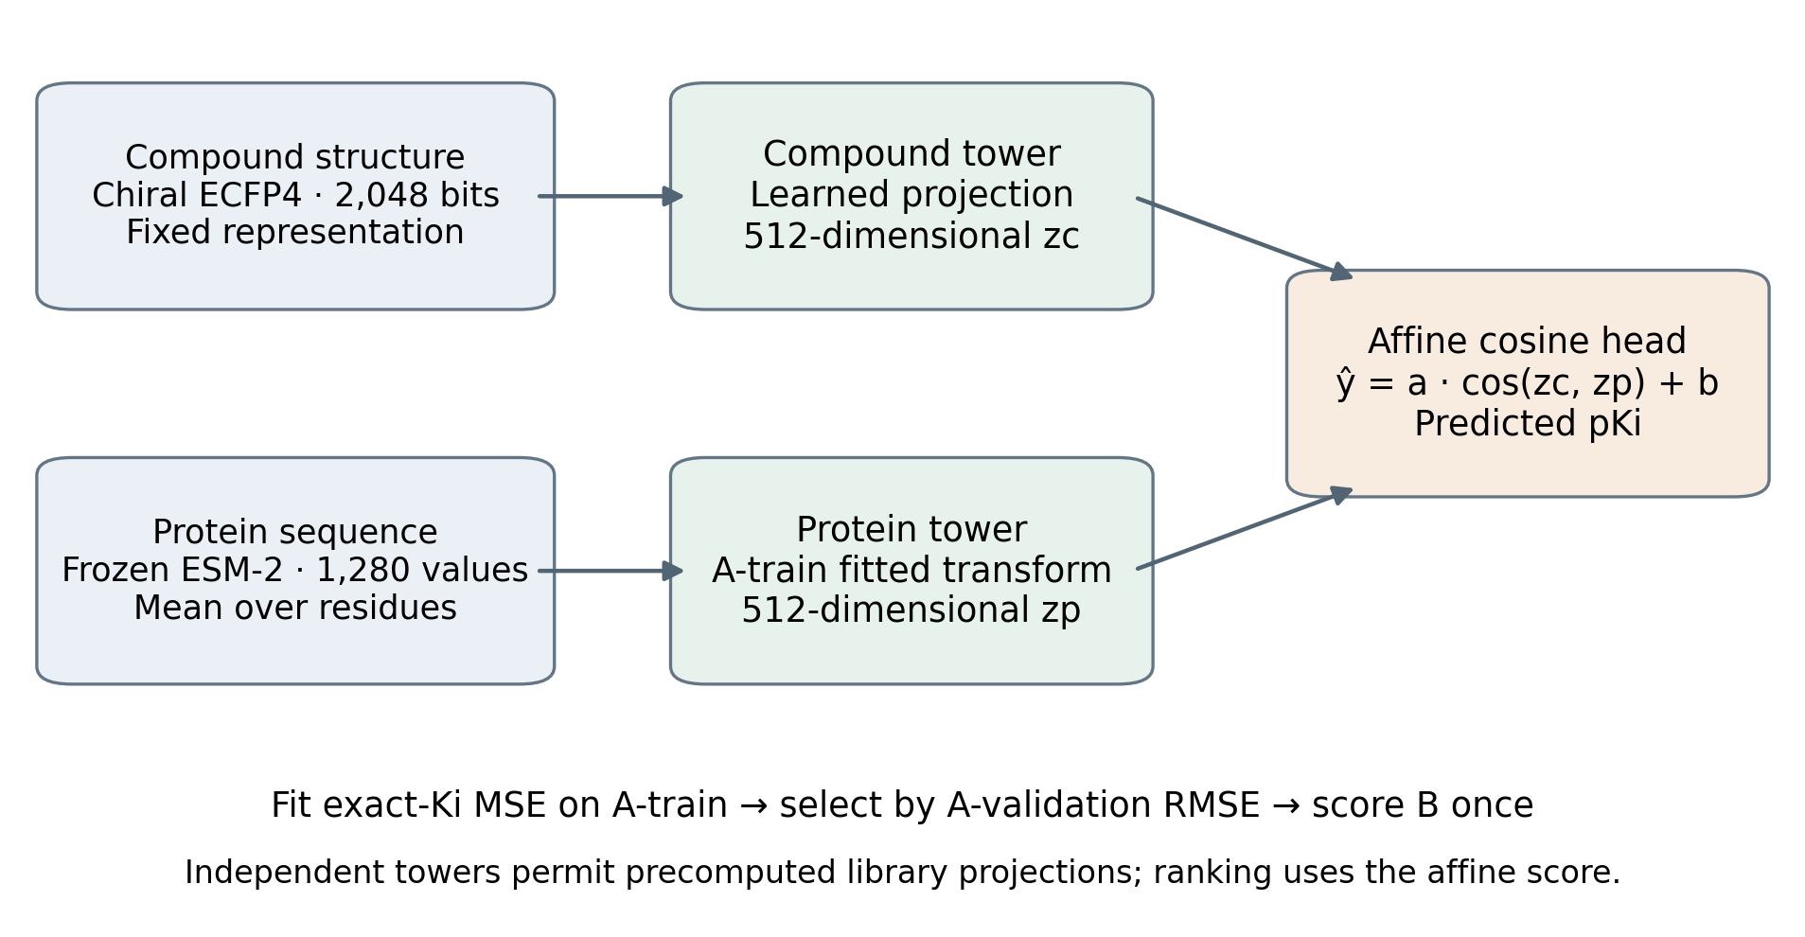
Figure 2. Independent compound and protein towers with a trainable affine cosine head. Frozen molecular/protein representations may be computed for every role; learned transforms and model parameters use A-training only. The schematic omits internal layer widths and activation details.
Compounds used chiral ECFP4 fingerprints [6]: 2,048 logical bits stored as 256 packed uint8 values. Proteins used the frozen ESM-2 t33 650M model [7], with mean pooling over residues excluding special tokens and a pinned model commit. Full-length encoding was retained beyond the 1,022-residue training window, flagged as provisional; 40,000 residues was a refusal point. A cache identity combined the computation specification with content manifests. Historical-only feature extensions had separate identities and did not overwrite accepted caches.
$ŷ = a · cos(zc, zp) + b ; L = (1/N) Σᵢ (ŷᵢ − pKiᵢ)²$
The dual encoder projected both modalities into 512 dimensions and learned scale a and offset b in pKi units. Ranking used the affine score, including the possibility of negative a. Independent towers allow compound projections to be computed before a sequence query. The bounded cosine head limits expressiveness; contrastive training and cross-attention were not implemented. PyTorch neural-network runs used Apple’s MPS GPU backend. CUDA support in the code is not evidence of NVIDIA execution.

2.3 Baselines and what each one isolates
Each baseline answers one question, and several are deliberately weak so that a strong aggregate cannot be mistaken for a working model. A predictor that is constant within a target ties every compound of that target and therefore scores AUROC 0.5000 by construction, whatever its regression error.
ID | What it computes | What it isolates | Baseline study | Historical evaluation
B0-target-mean | training mean pKi of the target; global mean for an unseen target | the floor a target-specific constant reaches | yes | yes, 1 fit
B1-ligand-ecfp4-lgbm | chiral ECFP4 to LightGBM, no protein input | the ligand-only bias gate: how far chemistry alone goes | yes | yes, 5 seeds
B2-protein-esm2-lgbm | mean-pooled ESM-2 to LightGBM, no ligand input | the target prior alone; constant within a target | yes | yes, 5 seeds
B3L-ligand-1nn | nearest training compound *measured against the same target*, by ECFP4 Tanimoto | within-target chemical-similarity lookup. It is target-conditioned and does not isolate ligand memorisation, despite reading no protein features | yes | yes, 1 fit
B3P-protein-1nn | nearest training target by ESM-2 cosine; predicts its mean training pKi | the nearest-target prior; constant within a target | yes | no
B4-concat-mlp | concatenated ECFP4 and ESM-2 to a two-hidden-layer MLP | a simple joint model with no architectural separation of modalities | yes | yes, 5 seeds
dual-encoder | independent towers with a trainable affine cosine head | whether the separable architecture improves on the simple joint model | no | yes, 5 seeds
Three separate experiments produced these numbers and they are not comparable with one another. The baseline leaderboard study scored the six baselines above over leakage-controlled splits of a single corpus, and is where the floors were established. The dual-encoder selection study introduced the dual encoder and chose its projection width from 256 and 512 on validation alone; the 512-dimensional choice was carried forward without a further sweep. The historical snapshot evaluation, reported here, is the release-to-release comparison: six families and 22 predictors, being the seven rows above minus the protein nearest-neighbour baseline, which was not carried forward and which, being constant within a target, had scored AUROC 0.5000 in the baseline study. Results from the three are reported separately and are never pooled.

2.4 Snapshot matching and fitting protocol
Context slots contained compound, target, normalised publication reference, pH, temperature and source. Canonical measurement values contained type, relation and value. Matching was count-aware: identical rows were indistinguishable observations rather than proof of duplicate experiments. A one-to-one removal/addition could be linked only under the declared identifier rule; ambiguous sets remained unresolved. Entry DOI was entry-level provenance, not a measurement identifier. Equal-valued observations at different slots were correspondence candidates, not proof of one experiment.
Deterministic BLAKE2b slot sharding invoked the same tested matcher for each shard. The recorded full comparison peaked at 0.90 GB RSS, compared with an estimated 25.3 GB unsharded requirement. Pair sharding was used for endpoint aggregation, keeping all evidence for a compound–target pair together. Ki yielded 585,978 unchanged, 33,953 added and 28,777 removed observations. Of the additions, 33,941 entered the declared increment and 12 linked correction after-values were withheld; all stayed in complete B.

2.5 Evidence selection
1 Curate and export A and B under the pinned rules.
2 Match counted observations within context slots.
3 Derive A train/validation membership without reading B.
4 Label eligible additions; withhold linked correction occurrences.
5 Read actual B for the consistency screen and audit.
6 Derive recurrence from rows supplied to fitting.
7 Fit on A-train, restore the A-validation-selected model.
8 Score all declared cells and strata; verify before publishing.
Role or cohort | Pairs | Purpose
A-train exact regression | 353,957 | Transform and parameter fitting
A-validation clean regression | 60,981 | Checkpoint RMSE selection
Primary new to fitting | 22,221 | Headline ranking evaluation
Strictly absent from A | 19,517 | Separate exposure stratum
A deterministic 15% pair reservation supplied validation. The 512-dimensional projection was carried from the validation choice made in the dual-encoder selection study, with no new sweep. The dual encoder used learning rate 0.001, batch size 512, at most 20 epochs and patience five, restoring the best validation checkpoint. No train-plus-validation refit was performed. Architecture-specific stopping rules were retained; comparisons do not isolate architecture alone. LightGBM [8] runs reached the declared 400-round cap.

2.6 Cohort flow
The steps above say what was done; the counts below say to how much, in one place. Each line is a population, not a filter applied to the previous line's output, except where stated.
Stage | Population | Count
A evidence | compound-target pairs with Ki evidence in A | 482,196
A partition, B unread | train pairs / validation pairs | 409,610 / 72,586
A-only training | train pairs carrying an exact-Ki regression target, supplied to fitting | 353,957
A-validation selection | validation pairs clean enough to select a checkpoint by RMSE | 60,981
Snapshot match, Ki | unchanged / added / removed observations | 585,978 / 33,953 / 28,777
Eligible additions | additions entering the declared increment | 33,941
Correction withholding | linked correction after-values withheld from the increment, all retained in complete B | 12
Complete-B screening | pairs eligible in the primary cell after the consistency screen (26,421 unscreened) | 26,320
Primary stratum | of those, new to fitting; targets covered; targets clearing the scoring floor | 22,221 / 992 / 123
Recurrence against the fitting set | recurrent, i.e. actually supplied to fitting / strictly absent from A / reserved for validation | 4,099 / 19,517 / 1,018
Two checks on the arithmetic. The primary cell's eligible pairs split exactly into the new-to-fitting and recurrent populations: 22,221 plus 4,099 is 26,320, which is the check that those two strata exhaust the cell. And the evaluation table itself carries 26,444 scored pairs; the four declared cells are different eligibility filters over that table rather than disjoint parts of it, so no cell equals the table. The largest is the declared increment × unscreened consistency branch cell, which admits 26,421 eligible pairs; the primary cell differs from it only in applying the complete-September consistency screen.
A 15% deterministic pair reservation produced the validation split, realised at 0.150532. Recurrence is defined against the exact rows emitted to fitting, not against mere presence in A: a pair can appear in January and still be new to fitting because it was reserved for validation or carried no regression target. Of the 22,221 new-to-fitting pairs, 19,517 are strictly absent from A and 1,018 were reserved for validation; the remaining 1,686 were present in A but not supplied to fitting for another reason. That last figure is implied by the reported totals rather than separately tabulated, and the validation-reserved subgroup clears the floor for only six targets, which supports little interpretation.

2.7 Ranking and regression accuracy are different measures
The models are fitted and selected on one quantity and evaluated on another, deliberately. Fitting minimises squared error against exact pKi, and checkpoints are chosen by validation RMSE. Evaluation is per-target ranking: AUROC, average precision, recall at k and enrichment factors. These measure different things and can disagree in both directions.
Regression accuracy asks how close a predicted pKi is to the measured value, on an absolute scale. Ranking accuracy asks only whether, within one target, actives are ordered above inactives; it is invariant to any order-preserving rescaling of the scores and ignores between-target differences entirely. Prioritisation consumes the ranking, because the decision is which compounds to take forward first, not what the affinity is.
The recorded baselines show the gap concretely. On the random_pair-v3 split, the target-mean baseline attains a lower macro RMSE than the ligand-only LightGBM model, 1.049 against 1.261 over the 2,606 targets with eligible exact measurements, while its macro AUROC is 0.5000 against the ligand-only model's 0.6889 over the 583 targets that clear the ranking floor. The two comparisons use different denominators because the ranking floor of five actives and five inactives excludes most targets, and they are not interchangeable. Predicting each target's training mean is a reasonable guess in absolute pKi and carries no within-target information at all, so it is simultaneously the better regressor and useless for prioritisation. The converse also holds: a monotone rescaling of any model's scores would leave every ranking metric unchanged while moving its RMSE arbitrarily.
Two consequences for reading this report. A good RMSE is not evidence of useful prioritisation, and the headline AUROC figures are not statements about calibrated affinity prediction. Predicted pKi here is neither a calibrated probability nor a validated affinity estimate, and no reliability diagram or expected-calibration-error analysis was computed, so the scores are reported as ranking scores only.

2.8 Docking assessment protocol
The settings below were frozen in configs/experiments/m10-docking-v1.yaml before the gate cohort was docked, and are reproduced here so the failure can be attributed.
Setting | Recorded value
Engine | AutoDock Vina 1.2.7, mac_aarch64 build, pinned by SHA-256
Structure | PDB 3K34, X-ray, 0.90 Å; construct identical to the curated 260-residue sequence, 0 mutations
Receptor preparation | meeko 0.8.0 mk_prepare_receptor; altloc A kept and 27 altloc-B atoms dropped; 2,060 atoms retained
Cofactors and heteroatoms | catalytic Zn kept; the SUA reference ligand, 3 glycerols, a mercury-benzoate surface adduct and 249 waters removed
Ligand preparation | meeko 0.8.0 MoleculePreparation; one ETKDGv3 conformer, MMFF-optimised, seed 20261001
Protonation and tautomers | RDKit neutral form as curated, no pH model applied, no tautomers enumerated, stereocentres left as curated
Flexible side chains, waters | none; docked dry and rigid
Box | 20 Å cube centred on the centre of mass of SUA in chain A, at (-5.560, 5.030, 13.030); contains the Zn
Search | exhaustiveness 8, 9 modes, seed 20261001, 1 CPU per ligand
Ranking score | negated best-pose affinity, so a higher score always means predicted tighter binding
Uncertainty | stratified percentile bootstrap, 10,000 resamples, 95%, seed 20261001
Attrition rule | a compound failing preparation or docking is dropped and reported by class, never scored as worst
Sensitivity | box side scaled by 0.75 and 1.25, run and reported only after the primary result
Exhaustiveness 8 was Vina's default and was fixed before any active-inactive comparison existed, from reference-ligand redocking at 8, 16 and 32 that recovered the SUA pose at 1.54, 1.54 and 1.51 Å, and from a 24-ligand runtime pilot drawn entirely from actives. Neither probe could see discrimination, so the choice cannot have been tuned to the outcome.
Four limitations of this protocol, declared rather than inferred afterwards. The catalytic Zn is coordinated directly by the sulfonamide warhead most carbonic-anhydrase ligands carry, and Vina's empirical function represents metal coordination crudely, so a failing gate may reflect the scoring function rather than docking as such; this risk was recorded in the frozen config before scoring. Docking dry and rigid omits both structural water and side-chain flexibility. No pH or tautomer model was applied, so the docked species is the curated neutral form rather than a predicted physiological one. And a per-ligand provenance binding from the frozen cohort structure to the prepared PDBQT was not recorded for these runs, so recomputing the published metrics shows the saved scores and labels are mutually consistent without establishing that the recorded SMILES were the structures actually docked.

3. Results

3.1 Ranking results
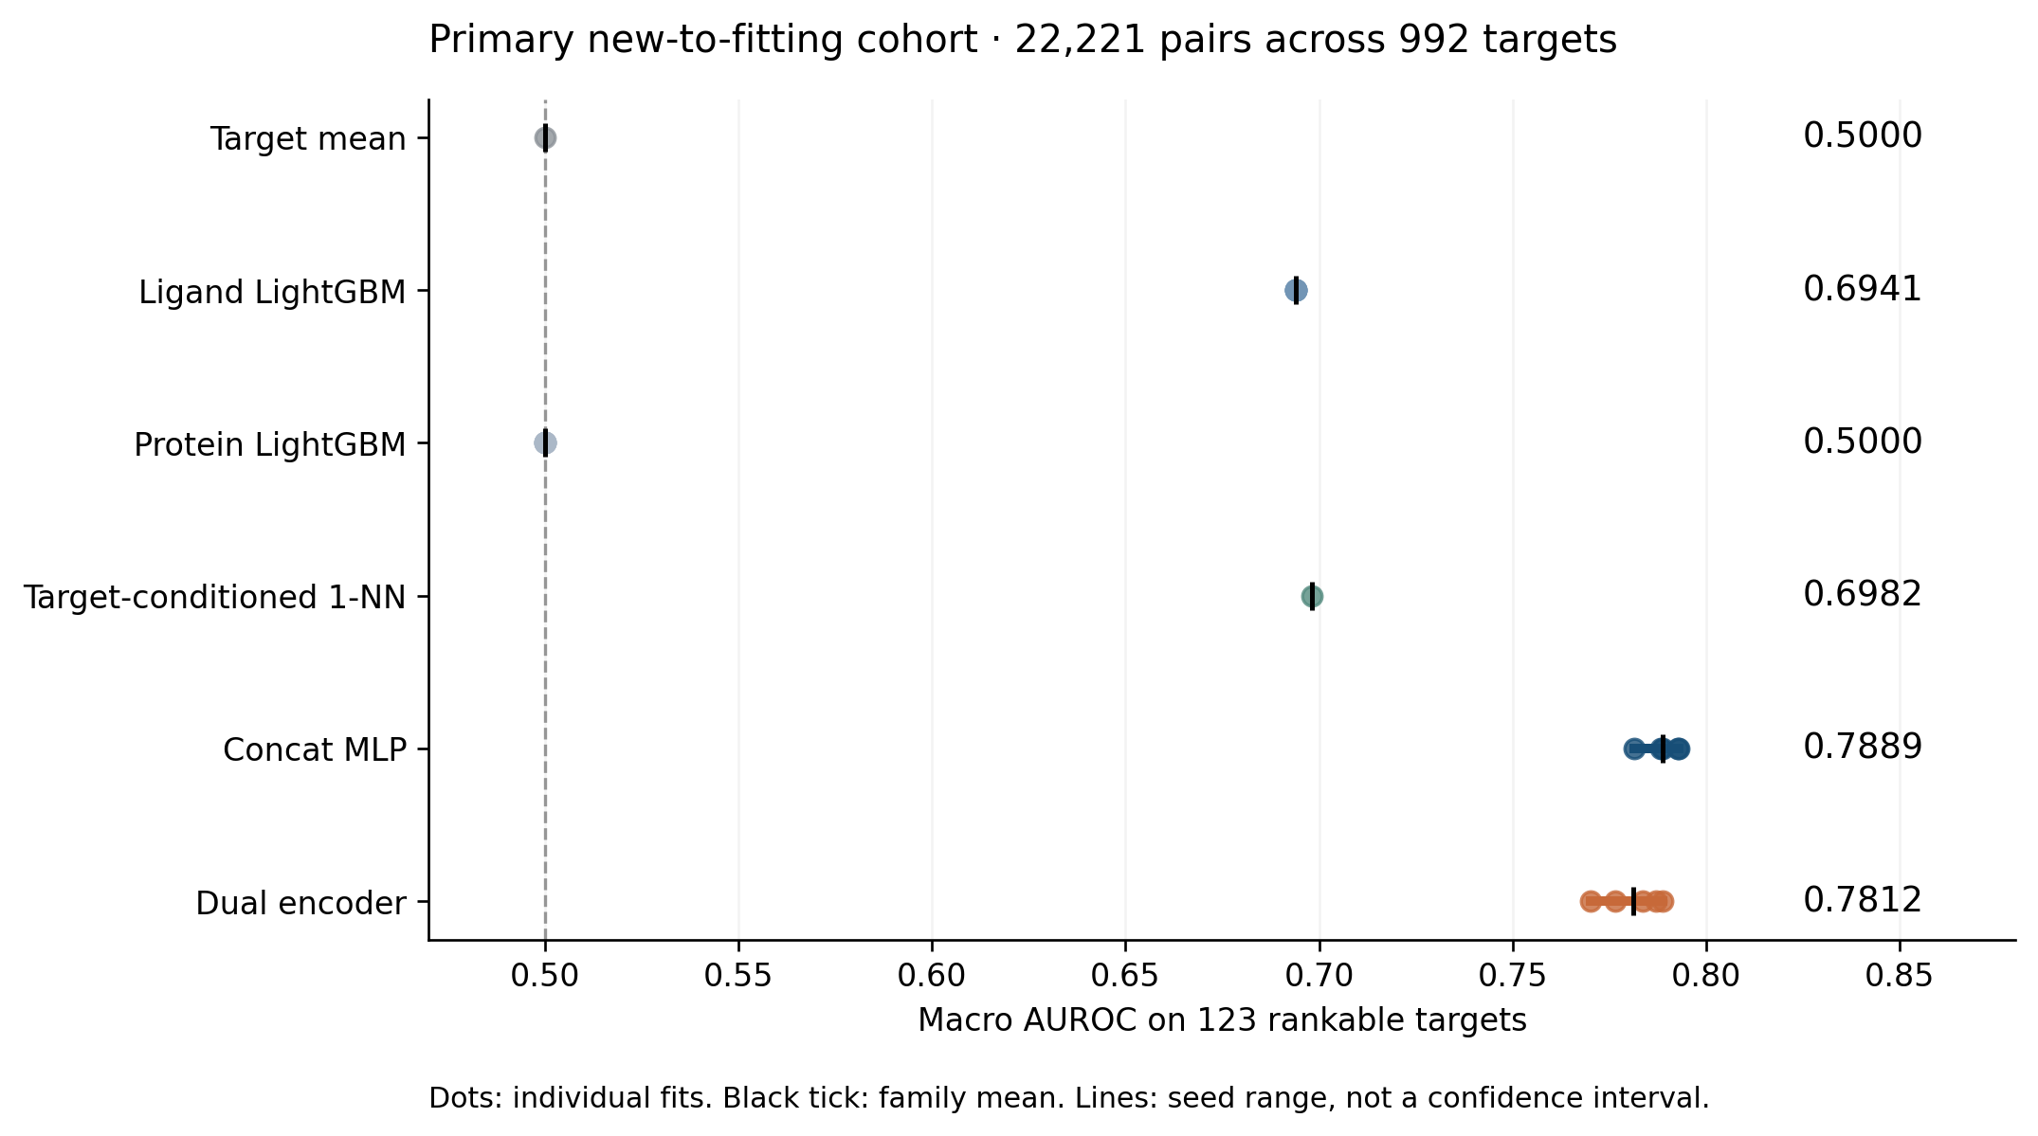
Figure 3. Primary macro AUROC reproduced from saved predictions and labels. Each target contributes equally after meeting the minimum of five active and five inactive pairs. Family means summarise five seeded fits for LightGBM, concat MLP and dual encoder; target mean and target-conditioned 1-NN were fitted once. Seed ranges represent training variation only.
The concatenated-feature MLP reached mean AUROC 0.788873 and the dual encoder 0.781229, an observed difference of 0.007644. The dual encoder did not improve the observed mean, and no paired target-level interval or test was computed, so the difference supports neither a difference nor an equivalence claim. Both joint configurations exceeded the observed single-modality configurations, but the comparison does not isolate a causal protein-feature effect.
Only 123 of 992 targets cleared the ranking floor; 869 did not. Macro AUROC therefore describes a selected subset with both classes and sufficient observations, not all targets. Pair prevalence was 0.697493, and average target prevalence in the scored subset was 0.543509. Average precision used entire tied threshold blocks, and AUROC gave ties half credit. A protein-only predictor is constant within a target and consequently gives AUROC 0.5 regardless of between-target score differences.
Six families produced 22 predictors. Distinct seeds did not produce identical prediction arrays, even where ranking aggregates were identical. B1 prediction differences were small; B2 predictions differed across seeds while all within-target rankings remained tied. The recorded fits cannot separate stochastic and numerical causes without same-seed repeats. No refits or tuning were undertaken in response to these results.

3.2 Target diagnostics and evaluation strata
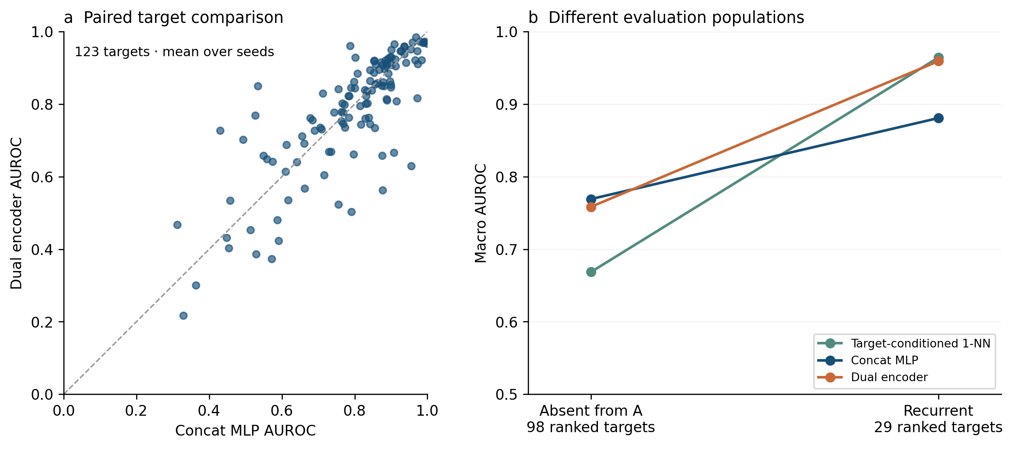
Figure 4. (a) Independent rank-sum AUROC calculations for each of the 123 headline targets, averaged across five seeds per family. The dashed line is equality, not a statistical test. (b) Descriptive contrasts between absent-from-A and recurrent populations; the 98 and 29 rankable-target sets differ. Lines connect summaries of different populations rather than longitudinal target trajectories.
The target-conditioned ligand 1-NN searched compounds measured against the same target. It was not a purely ligand-only predictor. Its macro AUROC was 0.964204 on recurrent pairs and 0.668510 on pairs absent from A, a descriptive difference of 0.295694. The dual encoder also performed better on the recurrent population. Chemistry, coverage, label balance and exposure were not independently controlled, so these gaps are not causal estimates of memorisation.
Recurrence was defined against the exact rows emitted to model fitting. Historical presence alone was insufficient: pairs could be reserved for validation, lack regression targets or otherwise be absent from fitting. New-to-fitting includes validation-reserved pairs whose historical evidence participated in model selection. The stricter absent-from-A stratum is therefore reported separately. The validation-reserved subgroup had only six rankable targets and supports little interpretation.
The other three increment/screening cells remain in the saved results. Cross-slot sensitivity removes unambiguous correspondence candidates without calling them the same experiment. These alternatives were declared before eligibility reporting. The paper does not choose an arm retrospectively because it performs better. Feasibility floors are pragmatic requirements, not a statistical power calculation.

3.3 Docking assessment outcome
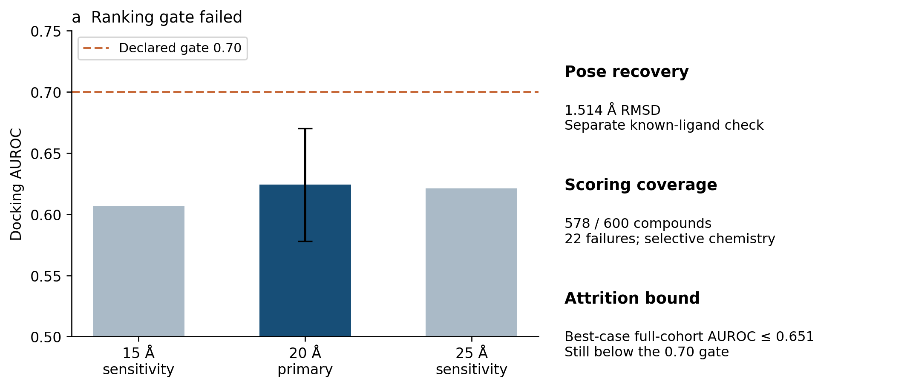
Figure 5. Separate CA2 docking assessment. The 20 Å primary box failed the declared AUROC 0.70 gate. Its bar shows the recorded compound-bootstrap 95% interval; sensitivity bars are rounded summaries and show no inferred interval. The bootstrap does not account for analogue dependence, and its calibration under that dependence is unknown. Pose recovery is a separate check, not a structural image or ranking validation.
AutoDock Vina 1.2.7 [9] used CA2 structure 3K34, whose recorded target sequence matched the curated sequence. A balanced cohort of 600 compounds was frozen before scoring. Of these, 286 actives and 292 inactives scored. Primary AUROC was 0.624060 with recorded interval [0.578108, 0.670241]. Even maximising every unknown active–inactive comparison involving attrition gave a full-cohort upper bound of approximately 0.651, below the gate.
Both sensitivity boxes also failed: the 15 Å box gave AUROC 0.607422 with 95% interval [0.561235, 0.653326], and the 25 Å box 0.621003 with [0.573000, 0.666156]. Every interval lies wholly below the pre-registered 0.70 threshold.
Failures were chemically selective. Nineteen unique compounds contained Se, Te or B implicated by the recorded atom-typing errors; per-element counts would double-count two Se/Te compounds. The cohort was overwhelmingly aryl sulfonamides, so generalisation to other chemistry or targets is unsupported. The recorded Mann–Whitney p-value is not a practical effect-size criterion and does not account for analogue dependence.
Known-ligand pose recovery reached 1.514 Å RMSD, independently recalculated from saved pose and crystal evidence in the full local tree. A per-ligand provenance binding from cohort structure to prepared PDBQT was not recorded for existing runs. This assessment does not show whether adding docking to the ML ranking would help; that requires a separate comparison controlling for the model’s existing information.

4. Discussion
The contribution is an integrated, auditable implementation and case study: counted historical release changes, three explicit evidence readings, content-bound feature resolution, deterministic memory-bounded processing and publication checks that reject drift. The 28-fold comparison is measured peak RSS against an unsharded estimate, not a benchmark against competing systems. The software also supplies a sequence-query library-ranking demonstration, with model and representation bindings.
The underlying components have established precedents. ConPLex already supports protein-language-model coembedding [1], Papyrus already addresses bioactivity curation [2], and TDC and PLINDER already provide benchmark infrastructure [3,4]. ECFP, ESM-2, LightGBM and Vina are existing methods [6–9]. Seq2Lead introduces no claimed encoder architecture or state-of-the-art method. Its defensible novelty is the specific integration and measured release-aware evaluation, whose broader methodological originality would require further literature review.
Seq2Lead makes evidence visibility and recorded-artifact consistency inspectable in sequence-based protein–ligand ranking. In the tested historical configurations, the dual encoder did not improve the observed mean over the concat MLP. The separate CA2 docking protocol failed its declared ranking gate despite satisfactory pose recovery. Preserving these bounded findings is a useful result of the evaluation design.

4.1 Reproducibility and publication integrity
Saved prediction arrays and the consumed evaluation table are checked against fit-recorded digests. The table digest covers labels, strata, eligibility and branch membership, not just pair identity and order. Verification records carry the digests they checked; publication re-hashes current inputs and refuses stale records. Expected input digests remain unchanged, while only derived outputs receive fresh hashes. Fresh scoring must match the published results bytes. Independent rank-sum AUROC provides a second calculation. These controls establish artifact consistency, not independent attestation of the original run.

5. Limitations
September labels and prior benchmark results were already inspected, and the prospective freeze is unsigned. The historical experiment is exploratory. Poolability across Ki assays, correspondence of cross-slot reports, and long-sequence embedding quality remain unresolved. Retrieval is unbuilt; evaluation evidence display is disabled; the label-reversal split is unscored. Rankability excludes most targets, and no prospective wet-lab validation or external-method comparison was performed. Seed spread is not uncertainty over the target population. A future confirmatory experiment requires a complete dated specification followed by an unseen release or independently withheld labels.

6. Availability and reproduction
The GitHub repository is private pending owner review. The published copy contains code, contracts, the saved predictions of the historical evaluation, evaluation labels, results and verification records. It excludes raw source archives, databases, cache vectors, checkpoints and the training membership export.
Seq2Lead can be run in three ways, and exactly one of them is supported from a published copy. Saved-prediction reproduction needs no model fit and no download; checks that would require excluded artifacts are reported unavailable rather than passed. Live sequence-query ranking additionally needs a trained checkpoint, a registered frozen library in a local PostgreSQL corpus, the exact bound feature caches and the pinned ESM-2 weights, which are stored separately; the recorded example output is included instead. Raw-to-fit rebuilding needs the raw archives and the full intermediate set, and is additionally limited by provenance outside this project's control: the September snapshot is a rolling monthly BindingDB release that is not archived at a stable URL, so the exact bytes may be unobtainable by a third party, while the January snapshot is re-fetchable from its archival deposit. The pinned digest detects a substitution rather than tolerating one.
uv sync --frozen
uv run python -m seq2lead.asof.recompute \
data/asof/m11h/run-20261005T134842Z
uv run python -m seq2lead.asof.verify_results \
data/asof/m11h/run-20261005T134842Z
The final contributor list, repository URL and any persistent release identifier remain to be confirmed before circulation. AI coding and review assistants were used extensively during implementation, auditing and drafting. The human author is responsible for the final code, evidence, interpretation and manuscript. This document is a draft technical report, not a submitted or peer-reviewed publication.

References
1. Singh R, Sledzieski S, Bryson B, Cowen L, Berger B. Contrastive learning in protein language space predicts interactions between drugs and protein targets. PNAS. 2023. https://doi.org/10.1073/pnas.2220778120
2. Béquignon OJM et al. Papyrus: a large-scale curated dataset aimed at bioactivity predictions. Journal of Cheminformatics. 2023;15:3. https://doi.org/10.1186/s13321-022-00672-x
3. Durairaj J et al. PLINDER: The protein-ligand interactions dataset and evaluation resource. Preprint. 2024. https://doi.org/10.1101/2024.07.17.603955
4. Huang K et al. Artificial intelligence foundation for therapeutic science. Nature Chemical Biology. 2022;18:1033–1036. https://doi.org/10.1038/s41589-022-01131-2
5. BindingDB in 2024: a FAIR knowledgebase of protein-small molecule binding data. Nucleic Acids Research. 2025;53(D1):D1633–D1644. https://doi.org/10.1093/nar/gkae1075
6. Rogers D, Hahn M. Extended-connectivity fingerprints. Journal of Chemical Information and Modeling. 2010;50:742–754. https://doi.org/10.1021/ci100050t
7. Lin Z et al. Evolutionary-scale prediction of atomic-level protein structure with a language model. Science. 2023;379:1123–1130. https://doi.org/10.1126/science.ade2574
8. Ke G et al. LightGBM: A Highly Efficient Gradient Boosting Decision Tree. Advances in Neural Information Processing Systems. 2017;30. https://proceedings.neurips.cc/paper/2017/hash/6449f44a102fde848669bdd9eb6b76fa-Abstract.html
9. Eberhardt J et al. AutoDock Vina 1.2.0: New Docking Methods, Expanded Force Field, and Python Bindings. Journal of Chemical Information and Modeling. 2021;61:3891–3898. https://doi.org/10.1021/acs.jcim.1c00203

