<https://www.pexels.com/photo/tattoo-artist-in-black-gloves-drawing-a-tattoo-on-a-person-s-arm-1304468/>



<https://www.pexels.com/photo/man-in-black-top-wearing-headphones-showing-his-tattoos-838696/>

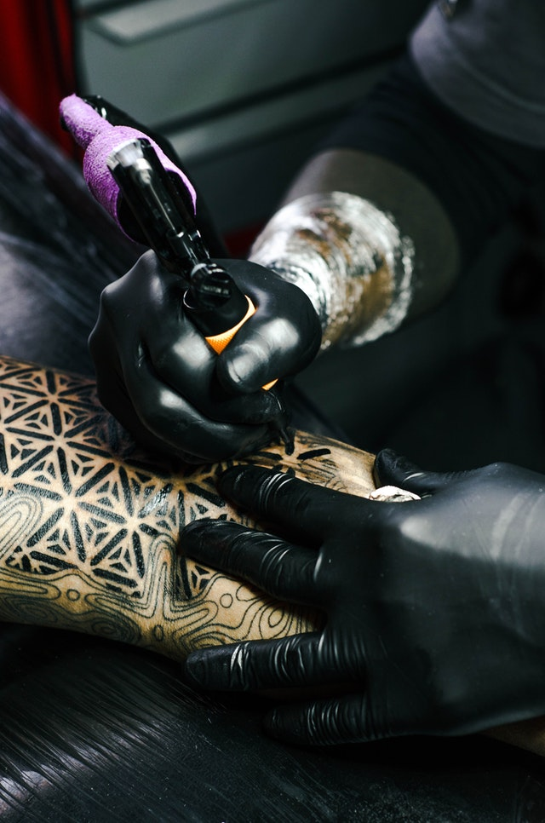

<https://www.pexels.com/photo/selective-focus-photography-of-tattoo-artist-drawing-a-tatoo-1304469/>

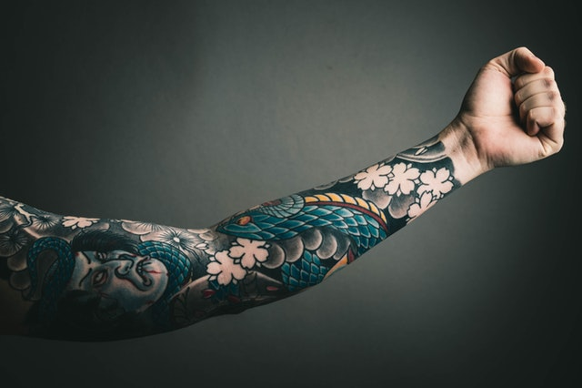

<https://www.pexels.com/photo/photo-of-left-arm-with-tattoo-2183131/>



<https://www.pexels.com/photo/man-wearing-silver-skull-ring-194087/>



<https://www.flickr.com/photos/182760226@N05/48379170111/in/photolist-6pwE7p-vqFLzj-69rdiM-95p5a4-7aB5fm-95s8K3-Vh9Zcq-5uBdp8-6p9uA7-9LvBtA-87rJB2-6pgNTa-dnHx5a-dnHs5Z-eTezwJ-QAbDq1-2gH6TLB-77ceYe-2em6aVh-6p2mys-2em6aYy-2em6aZW-2em6aXm-MnyH55-2hohUD9-24bpCbt-fUU69e-2iePBrg-f3NVWD-dKirWf-kUfjcz-eL6DgK-kUfjUr-cLErA9-kUfVSa-kUfhHn-kUfmw4-2gYQFHY-kUgWiu-kUfY7F-kUfg6e-S73CtU-3ie2cZ-uTmGWL-htJR9-kUgTPb-LKUoVP-MEghGf-2dqHhpi-MzW1H8>



<https://unsplash.com/photos/Ll1TDo_AQyM>