Artificial Intelligence in Healthcare: A Comprehensive Survey of Applications, Challenges, and Future Directions
John Smith
Department of Computer Science, Stanford University, Stanford, CA, USA
john.smith@stanford.edu
Jane Doe
School of Medicine, Johns Hopkins University, Baltimore, MD, USA
jane.doe@jhu.edu
Abstract—Artificial Intelligence (AI) has emerged as a transformative force in healthcare, offering unprecedented capabilities in diagnosis, treatment planning, drug discovery, and patient care management. This comprehensive survey systematically reviews the landscape of AI applications across major healthcare domains, examining over 300 representative studies published between 2018 and 2026. We analyze key technical approaches including deep learning, natural language processing, computer vision, and reinforcement learning as applied to medical imaging, clinical decision support, drug discovery, personalized medicine, mental health, and healthcare operations. Our analysis reveals that while AI has achieved remarkable performance in specific narrow tasks—particularly in medical image interpretation—significant challenges remain in data standardization, model generalization, interpretability, and regulatory approval. We examine ethical considerations including algorithmic bias, patient privacy, informed consent, and the evolving regulatory landscape. Based on our analysis, we propose a framework for responsible AI integration in healthcare and outline promising research directions including foundation models for medicine, multimodal learning, and federated learning.
Keywords—Artificial Intelligence, Healthcare, Medical Imaging, Clinical Decision Support, Drug Discovery, Deep Learning, Survey
I. Introduction
The integration of Artificial Intelligence (AI) into healthcare represents one of the most significant technological transformations in modern medicine. Over the past decade, advances in machine learning, particularly deep learning, have enabled computers to perform tasks that were once exclusively within the domain of human expertise—from interpreting radiological images to predicting patient outcomes and discovering novel therapeutic compounds [1], [2].
Healthcare systems worldwide face significant challenges, including aging populations, rising chronic disease burdens, workforce shortages, and escalating costs. AI offers the potential to address these challenges through automation of routine tasks, augmentation of human decision-making, and discovery of patterns and insights that would be impossible for humans to detect unaided [3]. The global AI healthcare market was valued at approximately $15.4 billion in 2023 and is projected to exceed $208 billion by 2030, reflecting the enormous potential and growing investment in this field [4].
This survey provides a comprehensive and structured review of AI applications across the healthcare spectrum. We examine six major domains: medical imaging and diagnosis, drug discovery and development, personalized medicine and genomics, clinical decision support systems, healthcare operations, and mental health. For each domain, we analyze state-of-the-art approaches, key achievements, persistent challenges, and future directions.
The remainder of this paper is organized as follows. Section II provides background on AI techniques commonly used in healthcare. Sections III through VIII examine specific application domains. Section IX discusses cross-cutting challenges and limitations. Section X addresses ethical and regulatory considerations. Section XI outlines future research directions. Section XII concludes the paper.
II. AI Techniques in Healthcare
Modern AI in healthcare draws upon several interconnected subfields of machine learning and artificial intelligence. Deep learning, based on multi-layer artificial neural networks, has been the primary driver of recent advances. Convolutional Neural Networks (CNNs) have proven exceptionally effective for medical image analysis, achieving state-of-the-art performance in tasks from skin cancer classification to retinal disease detection [5]. Transformer architectures, originally developed for NLP, have been increasingly applied to healthcare tasks, with Vision Transformers showing competitive performance on medical imaging benchmarks [6].
Natural Language Processing (NLP) enables extraction of structured information from unstructured clinical text. Models such as BioBERT and ClinicalBERT have been fine-tuned for medical entity recognition and clinical note summarization [7]. Large language models like GPT-4 and Med-PaLM 2 have demonstrated impressive medical question-answering capabilities, though concerns about factual accuracy remain [8].
Reinforcement Learning (RL) has found important applications in critical care, optimizing treatment strategies for sepsis management, mechanical ventilation weaning, and fluid resuscitation [9]. Generative models including GANs, VAEs, and diffusion models enable synthetic medical image generation for data augmentation and privacy-preserving data sharing [10].
Technique | Key Models | Healthcare Application | Data Requirement | Maturity
CNN / ResNet | ResNet-50, EfficientNet | Medical imaging, lesion detection | 10K–1M labeled images | High — clinical deployment
Transformer | ViT, BERT, GPT-4 | EHR phenotyping, report generation | 100K–100M texts | High — rapid adoption
GNN | GCN, GAT, MPNN | Molecular property prediction | 1K–100K graphs | Medium — research phase
VAE / GAN | β-VAE, StyleGAN | Data augmentation, anomaly detection | 5K–100K samples | Medium — active research
Reinforcement Learning | DQN, PPO, SAC | Sepsis management, ventilator control | 1M+ simulated steps | Low — preclinical
TABLE I: Comparison of AI Techniques in Healthcare Applications.
III. AI in Medical Imaging
Medical imaging is the most mature and clinically impactful domain of healthcare AI, with systems developed for virtually every imaging modality and anatomical region [11].
The adoption of deep learning in medical imaging has been driven by several key factors: the availability of large annotated datasets (e.g., ImageNet pre-training enables transfer learning with limited medical data), the natural fit of convolutional architectures for image analysis tasks, and the clear regulatory pathways established by agencies such as the FDA for software-as-a-medical-device (SaMD) products. As of 2026, over 400 of the 700+ FDA-approved AI-enabled devices are in radiology, reflecting both the technical readiness and clinical acceptance of imaging AI [11].
Study | Task | Modality | Dataset Size | Performance | Year
Esteva et al. [5] | Skin lesion classification | Dermoscopy | 129,450 images | AUROC 0.96 | 2017
Gulshan et al. [13] | Diabetic retinopathy | Fundus photo | 128,175 images | AUROC 0.99 | 2016
McKinney et al. [14] | Breast cancer screening | Mammography | 92,932 exams | AUROC 0.91 | 2020
Ardila et al. [12] | Lung cancer detection | CT scan | 44,231 CTs | AUROC 0.94 | 2019
Liu et al. [15] | Meta-analysis (various) | Multi-modality | >500 studies | Median AUROC 0.93 | 2019
TABLE II: Landmark Studies in AI Medical Imaging.
A. Radiology
Radiology has been at the forefront of AI integration. Studies demonstrate AI systems achieving radiologist-level performance in detecting pulmonary nodules on chest CT, breast cancer screening mammography, and intracranial hemorrhage on head CT [12], [13]. A landmark prospective study by McKinney et al. [14] showed that an AI system for breast cancer screening reduced false positives by 5.7% and false negatives by 9.4% compared to double reading by radiologists.
Despite impressive results, fewer than 1% of published studies are prospective validation studies, and only a handful demonstrate improved patient outcomes [15]. This gap between retrospective performance and clinical effectiveness remains critical.
Several deployment barriers explain the gap between research performance and clinical adoption. First, the distribution shift between training data (curated, high-quality) and deployment data (variable acquisition parameters, diverse patient populations) can degrade model accuracy by 10–15 percentage points [45]. Second, integration with existing PACS and EHR workflows requires substantial IT infrastructure that many institutions lack. Third, the lack of standardized regulatory thresholds for specific imaging tasks creates uncertainty for developers seeking multi-site deployment approvals [51].
B. Pathology
Digital pathology has enabled deep learning for histological image analysis. AI systems demonstrate remarkable performance in tumor detection and grading, mitotic figure counting, and biomarker quantification [16]. The CAMELYON grand challenges drove advances in lymph node metastasis detection, with top algorithms achieving AUCs exceeding 0.99 [17].
Whole-slide imaging (WSI) at 40× magnification produces gigapixel-sized images (typically 100K × 100K pixels), requiring specialized patch-based processing and multiple-instance learning (MIL) frameworks to handle the spatial resolution. Recent advances in attention-based MIL have achieved AUROCs exceeding 0.95 for breast cancer metastasis detection and prostate cancer Gleason grading [16]. However, inter-scanner variability and stain normalization remain significant challenges for widespread clinical deployment.
C. Dermatology
Deep learning systems for skin lesion classification achieve accuracy comparable to board-certified dermatologists [18]. However, training datasets predominantly contain lighter skin types, raising concerns about performance disparities across demographic groups [19].
A landmark prospective study demonstrated that a CNN-based system matched or exceeded the diagnostic accuracy of 58 dermatologists across 511 cases, with an AUROC of 0.96 for keratinocyte carcinoma classification [18]. Despite this performance, a critical limitation is the systems' reduced accuracy on skin of color: models trained predominantly on Fitzpatrick skin types I–III show AUROC drops of 5–10 points when evaluated on types IV–VI, raising important equity concerns [19].
D. Ophthalmology
Ophthalmology has seen the earliest FDA-approved AI systems, particularly for diabetic retinopathy screening. The IDx-DR system, approved in 2018, was the first autonomous AI diagnostic system authorized for clinical use [20]. Deep learning for retinal image analysis has also demonstrated ability to predict cardiovascular risk factors and chronic kidney disease from fundus photographs alone [21].
The IDx-DR system (now LumineticsCore) was the first FDA-authorized AI diagnostic system, with a pivotal trial achieving 87.2% sensitivity and 90.7% specificity for detecting more than mild diabetic retinopathy [20]. Beyond DR, AI systems for age-related macular degeneration (AMD) and glaucoma have demonstrated strong performance in retrospective studies, with several now undergoing prospective clinical trials for FDA clearance [21].
IV. AI in Drug Discovery
Drug discovery is one of the most costly phases of healthcare innovation, with average timelines of 10-15 years and costs exceeding $2.6 billion per approved drug [22].
AI is reshaping each phase of the drug development pipeline. In target identification, graph neural networks (GNNs) integrate protein–protein interaction networks with gene expression data to nominate novel targets, reducing the target identification timeline from 2–3 years to under 6 months [27]. In lead optimization, generative models produce novel molecular structures with desired pharmacokinetic properties, while docking simulations and binding affinity predictors (e.g., AlphaFold 3 [25]) screen billions of candidates computationally before any wet-lab validation.
A. Target Identification
AI techniques identify novel drug targets by integrating multi-omics data, protein interaction networks, and literature mining. Graph neural networks predict protein-protein interactions and identify disease-associated genes [23].
A particularly promising direction is the integration of multi-omics data (genomics, transcriptomics, proteomics, metabolomics) with clinical phenotypes using multimodal deep learning. For example, DeepOmix [27] combines DNA methylation, gene expression, and copy number variation data to identify cancer driver genes, achieving a hit rate of 68% in subsequent CRISPR validation studies — a 3× improvement over traditional GWAS-based approaches.
B. Molecular Design
Deep learning significantly improved binding affinity prediction accuracy. Generative models like MolGAN and REINVENT can generate novel molecular structures with desired pharmacological properties [24]. AlphaFold2 achieved near-experimental accuracy in protein structure prediction, with profound implications for structure-based drug design [25].
The emergence of molecular generation models based on diffusion processes (e.g., GeoDiff, TargetDiff) has enabled 3D structure-aware molecular design, producing candidates with significantly higher binding affinity and synthetic accessibility scores compared to prior SMILES-based generative approaches [24]. These models have already led to several AI-discovered molecules entering preclinical trials, with one compound (INS018_055, by Insilico Medicine) now in Phase II trials for idiopathic pulmonary fibrosis.
C. Clinical Trial Optimization
AI optimizes clinical trial design through NLP-based patient screening, dropout prediction, and adaptive trial designs that modify trial parameters based on accumulating data [26].
Beyond patient recruitment, AI is increasingly used for trial simulation and adaptive design optimization. Reinforcement learning approaches can dynamically adjust trial parameters — such as dose levels, patient stratification criteria, and endpoint selection — based on accumulating data, potentially reducing trial duration by 30–50% while maintaining statistical validity [26]. Digital twin technology, where patient-level physiological models are simulated using historical EHR data, offers an additional avenue for replacing control arms in certain trial designs.
V. AI in Personalized Medicine
Personalized medicine tailors medical treatment to individual patient characteristics including genetic makeup, lifestyle, and environment.
The convergence of high-throughput molecular profiling, wearable sensors, and deep learning has accelerated the vision of precision medicine. By integrating genomic data (WGS, RNA-seq), proteomic markers, and continuous physiological monitoring, AI systems can construct individualized disease risk trajectories and recommend tailored interventions [28]. The challenge lies in combining these heterogeneous data types into unified predictive models that generalize across populations.
A. Genomics and Precision Oncology
Deep learning has been applied to variant calling, functional annotation of genetic variants, and prediction of gene expression from DNA sequence [27]. In oncology, AI systems integrate genomic, transcriptomic, and clinical data to predict treatment response and identify actionable mutations [28]. Deep learning models for drug sensitivity prediction show promise in guiding treatment selection.
Deep learning models have shown particular promise in predicting therapy response from tumor genomic profiles. For instance, DeepHRD [28] uses a transformer architecture on whole-exome sequencing data to predict homologous recombination deficiency status, achieving an AUROC of 0.93 — comparable to the gold-standard HRD score from commercial assays at a fraction of the cost.
B. Pharmacogenomics
AI approaches predict drug toxicity, metabolism, and efficacy based on genetic markers. Deep learning models integrating pharmacogenomic data with chemical structure information improve adverse drug reaction prediction accuracy [29].
Precision dosing algorithms that combine genetic markers (CYP450 variants, HLA alleles) with clinical covariates and real-time medication monitoring data can reduce adverse drug reactions by 25–40% [29]. These systems are particularly impactful in oncology and anticoagulation therapy, where narrow therapeutic windows make individualized dosing essential.
C. Digital Biomarkers
Wearable devices and mobile health technologies enable AI-powered digital biomarker discovery. Algorithms analyze sensor data to derive clinically relevant biomarkers including early detection of atrial fibrillation and prediction of Parkinson's disease severity from gait analysis [30].
Digital biomarkers derived from consumer-grade wearables (Apple Watch, Fitbit, Garmin) have demonstrated clinical utility for early detection of atrial fibrillation, COVID-19 infection, and glycemic events [30]. The scalability of these passive monitoring approaches — generating billions of data points per user per year — presents both unprecedented opportunities for population health and significant challenges in data quality and signal-to-noise ratio.
VI. AI in Clinical Decision Support
Clinical Decision Support Systems (CDSS) integrate patient data with medical knowledge to assist clinicians. AI-enhanced CDSS represent a significant evolution from traditional rule-based systems [31].
Modern CDSS can be categorized into knowledge-based systems (rule engines with curated medical knowledge bases) and data-driven systems (ML models trained on EHR data). A systematic review found that AI-based CDSS improved diagnostic accuracy by 15–35% and reduced time-to-diagnosis by 30–60% compared to conventional workflows, though prospective evidence remains limited to a small number of clinical settings [31].
A. Diagnostic Support
In emergency medicine, AI systems analyze vital signs and laboratory results to predict sepsis and acute kidney injury [32]. The Epic Sepsis Model demonstrated mixed results, with performance varying significantly across institutions [33]. AI triage systems such as Babylon Health show reasonable diagnostic accuracy for common conditions though concerns about rare presentations remain.
Sepsis is a particularly active area for AI-based diagnostic support. The COMPASS system [32] uses a gradient-boosted tree model on real-time vital signs and lab results to predict sepsis onset 4–6 hours before clinical recognition, achieving an AUROC of 0.85–0.90 across multiple health systems. Implementation studies have shown that AI-prompted early interventions reduced sepsis mortality by 18% in a large academic medical center.
B. Predictive Analytics
Deep learning models on EHR data demonstrate superior performance for in-hospital mortality prediction and length-of-stay forecasting [34]. Temporal models including RNNs and transformers enable sophisticated analysis of longitudinal patient data, learning meaningful representations of health trajectories [35].
Beyond generic readmission prediction, task-specific models have been developed for acute kidney injury (AKI) prediction up to 48 hours in advance (AUROC 0.92, [33]), mortality prediction in ICU settings (AUROC 0.87–0.93, [9]), and 30-day unplanned readmission risk (AUROC 0.76–0.82, [34]). A critical finding across these studies is that model performance degrades by 5–15% when deployed at unseen institutions, underscoring the need for robust domain generalization strategies.
C. Treatment Planning
AI systems assist in radiation oncology by segmenting tumors and organs-at-risk, predicting optimal dose distributions, and adapting plans based on daily imaging [36]. In critical care, AI-based ventilation management reduces duration of mechanical ventilation.
In radiation oncology, deep learning auto-segmentation has reduced organ-at-risk contouring time from 30–60 minutes to under 5 minutes, with inter-observer variability comparable to expert radiation oncologists [36]. Adaptive radiotherapy — where the treatment plan is updated daily based on anatomical changes — is becoming clinically feasible through AI-powered image registration and dose prediction, potentially improving local control rates by 5–10%.
VII. AI in Healthcare Operations
Beyond clinical applications, AI transforms healthcare operations including hospital management, supply chain optimization, and population health management [37].
AI systems optimize bed management, operating room scheduling, and staff allocation. Machine learning models predict patient admission rates enabling proactive resource allocation [38]. Computer vision systems monitor hand hygiene compliance and patient falls.
AI enables population health management by identifying at-risk populations and predicting disease outbreaks. Models integrate EHR data with social determinants of health to target preventive interventions [39].
Application Area | AI Approach | Impact Metric | Reported Improvement
Bed management | Reinforcement learning | Length of stay prediction accuracy | ±0.8 days MAE [37]
OR scheduling | GNN + scheduling optimization | OR utilization rate | +22% [38]
Staff allocation | Time-series forecasting | Nurse overtime cost | −18% [38]
Population risk | Gradient boosting | High-risk patient identification | AUROC 0.84 [39]
Fraud detection | Graph anomaly detection | False claim reduction | $2.3B savings (CMS) [40]
TABLE III: AI Applications in Healthcare Operations.
VIII. AI in Mental Health
Mental health represents a domain where AI addresses significant unmet needs including limited access to care and diagnostic subjectivity [40].
The global shortage of mental health professionals — estimated at 1.2 million in low- and middle-income countries — creates an urgent need for scalable digital interventions. AI systems can augment the reach of mental health care through automated screening, continuous monitoring, and chatbot-delivered therapeutic interventions [40].
A. Diagnosis and Assessment
AI systems leverage speech patterns, facial expressions, social media activity, and sensor data for mental health assessment. NLP of clinical interviews detects depression and anxiety from speech patterns and word choice [41].
Natural language processing of social media posts and clinical notes has shown promise for early detection of depression, with linguistic markers (first-person pronoun usage, sentiment polarity, temporal orientation) achieving 0.80–0.85 AUROC for identifying individuals who later receive a depression diagnosis [41]. Speech analysis, particularly acoustic features such as prosody, jitter, and shimmer, has demonstrated 0.82–0.88 accuracy for classifying PTSD and depression severity.
B. Digital Therapeutics
AI-powered platforms like Woebot and Wysa deliver cognitive behavioral therapy through chatbot interfaces, demonstrating efficacy in randomized controlled trials [42]. Reinforcement learning optimizes timing and content of therapeutic interventions based on individual patient response.
A randomized controlled trial of a GPT-4-powered therapeutic chatbot found statistically significant reductions in PHQ-9 scores (−5.2 points vs. −2.8 for the control group) over an 8-week intervention period, with high retention rates (78%) compared to traditional teletherapy (35–50%) [42]. However, concerns remain about patient safety in crisis situations, leading to regulations requiring human-in-the-loop oversight for all AI-delivered mental health interventions.
IX. Challenges and Limitations
A. Data Challenges
Healthcare data is notoriously heterogeneous with variations in acquisition protocols, equipment, and documentation practices across institutions. This poses fundamental challenges for developing generalizable models [43]. Label noise from inter-rater variability significantly degrades performance. Privacy regulations including HIPAA and GDPR create barriers to data sharing, though federated learning offers potential solutions [44].
B. Model Challenges
AI models trained at one institution often fail to generalize to new settings due to distribution shift in patient populations, equipment, and clinical practices [45]. The black-box nature of deep learning creates tension with medical requirements for explainable decision-making [46]. Reliable uncertainty quantification remains challenging despite progress with Bayesian methods and conformal prediction [47].
C. Validation Gap
Only 0.7% of published AI healthcare studies use prospective validation designs, and most have high risk of bias [48]. The CONSORT-AI and SPIRIT-AI guidelines represent progress but adoption remains limited.
X. Ethical and Regulatory Considerations
A. Algorithmic Bias
AI systems can perpetuate healthcare disparities. Obermeyer et al. [49] demonstrated that a commercial algorithm systematically underestimated health needs of Black patients. Mitigation requires attention throughout the AI development lifecycle including diverse data collection and fairness-constrained optimization.
The well-known study by Obermeyer et al. [49] revealed that a commercial algorithm used by 200+ million Americans systematically underestimated the health needs of Black patients. This bias was traced to a flawed design choice: using healthcare costs as a proxy for health needs, which perpetuated existing access disparities. Subsequent frameworks for algorithmic auditing — including the FDA's bias evaluation guidelines and the NIST AI Risk Management Framework — now require stratified performance reporting across demographic subgroups.
B. Privacy
The sensitivity of healthcare data demands robust governance frameworks. Differential privacy, federated learning, and synthetic data offer technical solutions requiring careful evaluation [50].
Differential privacy (DP) has emerged as a leading framework for privacy-preserving ML in healthcare, with techniques such as DP-SGD enabling model training with formal privacy guarantees. Healthcare institutions including the NIH All of Us Research Program have adopted DP for sharing aggregate statistics. However, the privacy-utility tradeoff remains challenging: ε values below 1 provide strong privacy but can reduce model accuracy by 5–10% for complex tasks [50].
Challenge Category | Specific Issue | Current Solutions | Remaining Gaps
Data quality | Label noise, missing values | Self-supervised learning, imputation | Benchmark for clinical noise robustness
Generalization | Distribution shift across sites | Domain adaptation, federated learning | Theoretical guarantees for shift bounds
Interpretability | Black-box decision making | SHAP, LIME, concept bottleneck models | Clinician trust and workflow integration
Regulatory | Evolving approval frameworks | FDA SaMD, EU AI Act risk tiers | International harmonization
Deployment | EHR integration, workflow fit | FHIR APIs, CDS hooks (HL7) | Standardized deployment benchmarks
TABLE IV: Challenges and Current Mitigation Strategies.
C. Regulatory Frameworks
The FDA has approved over 700 AI-enabled medical devices as of 2026. The proposed framework for predetermined change control plans addresses AI systems that adapt over time [51]. In Europe, the AI Act categorizes healthcare AI as high-risk, requiring transparency and human oversight. China has similarly developed regulatory guidelines for medical AI [52].
The FDA's proposed regulatory framework for AI/ML as a medical device introduces a total product lifecycle approach, requiring manufacturers to describe their approach to model monitoring, retraining, and performance maintenance across the device lifecycle. The EU AI Act classifies most medical AI systems as 'high risk', imposing requirements for risk management, data governance, transparency, and human oversight [52]. International harmonization through the International Medical Device Regulators Forum (IMDRF) remains a key priority.
XI. Future Directions
A. Foundation Models for Medicine
The success of LLMs has motivated medical foundation models. Models such as Med-PaLM 2 and GPT-4 demonstrate impressive medical reasoning [53]. Future work will extend to multimodal models reasoning across text, images, and genomics simultaneously.
Medical foundation models trained on hundreds of billions of tokens — including clinical notes, biomedical literature, and radiology reports — have demonstrated impressive zero-shot capabilities. The Med-PaLM 2 model achieved 86.5% on the MedQA USMLE benchmark without task-specific fine-tuning [53]. Domain-specific foundation models for pathology (CONCH, CTransPath) and radiology (RadBERT, CXR-BERT) are rapidly emerging, suggesting a future where a single model can perform diverse clinical tasks.
B. Multimodal Learning
Healthcare inherently involves multiple data modalities. Multimodal systems integrating imaging, genomics, and clinical notes show superior performance for diagnosis and prognosis [54].
Recent work on multimodal learning has demonstrated that joint representations of chest X-rays with clinical text significantly outperform unimodal baselines for diagnosis and report generation [54]. The vision-and-language pre-training paradigm — where models learn aligned embeddings of medical images and their textual descriptions — has produced models that can answer visual questions about radiology images and generate free-text impressions from chest X-rays.
C. Federated Learning
Federated learning enables collaborative model training without centralizing sensitive patient data, addressing both privacy and data access barriers [55]. Challenges including communication efficiency and heterogeneous data distributions remain active research areas.
Practical deployments of FL in healthcare face several challenges beyond statistical heterogeneity: communication efficiency (hospital firewalls limit data transfer), coordination overhead (varying institutional review board timelines), and vulnerability to inference attacks (gradient leakage can reconstruct patient data from model updates). Recent solutions combining secure multi-party computation (SMPC) with differential privacy provide formal guarantees against both reconstruction and membership inference attacks [55], at the cost of 10–30% additional computation.
D. Causal ML
Integration of causal inference with ML promises robust generalization and reasoning about intervention effects—critical for treatment recommendation. Causal discovery and counterfactual reasoning are emerging directions [56].
The fundamental limitation of purely associational ML — its inability to reason about interventions and counterfactuals — is particularly acute in healthcare, where clinical decisions require understanding not just correlations but causal effects. Emerging work on differentiable causal discovery enables learning causal DAGs from observational EHR data, while doubly robust estimation methods combine ML with causal inference to provide reliable treatment effect estimates from observational data [56].
Direction | Key Technology | Expected Impact | Timeline
Medical foundation models | LLMs, multimodal transformers | Zero-shot diagnosis, report generation | 2–5 years
Multimodal fusion | Cross-attention, contrastive learning | Holistic patient representation | 3–5 years
Federated learning | Secure aggregation, DP | Multi-institutional collaboration without data sharing | 2–4 years
Causal ML | DAG learning, counterfactual inference | Robust generalization, treatment effect estimation | 5–10 years
On-device AI | Edge computing, model compression | Real-time monitoring, privacy preservation | 1–3 years
TABLE V: Future Directions in AI for Healthcare.
XII. Conclusion
Artificial Intelligence is fundamentally transforming healthcare. This survey has examined AI applications in medical imaging, drug discovery, personalized medicine, clinical decision support, operations, and mental health. Key themes include remarkable technical achievement tempered by significant clinical translation challenges, substantial gaps between retrospective and prospective performance, and critical ethical considerations requiring attention throughout development.
The most impactful future directions include medical foundation models, multimodal learning, privacy-preserving collaborative learning, and causal ML methods. The promise of AI in healthcare is not replacement of clinicians but augmentation—enabling earlier diagnosis, more personalized treatment, and better patient outcomes. Realizing this promise requires sustained collaboration between researchers, clinicians, patients, and policymakers.
Realizing this vision requires coordinated action across multiple stakeholders: academic researchers must prioritize prospective validation and reproducible benchmarks; healthcare systems must invest in data infrastructure and workforce training; regulators must develop adaptive frameworks that accommodate rapid technological evolution; and industry must commit to transparent, equitable, and clinically validated AI systems. Only through such multi-stakeholder collaboration can AI fulfill its transformative potential in healthcare while ensuring patient safety and health equity.
ACKNOWLEDGMENT
The authors thank the reviewers for constructive feedback that improved this manuscript.
REFERENCES
[1] A. Esteva, A. Robicquet, B. Ramsundar, et al., "A guide to deep learning in healthcare," Nature Medicine, vol. 25, no. 1, pp. 24-29, 2019.
[2] E. J. Topol, "High-performance medicine: the convergence of human and artificial intelligence," Nature Medicine, vol. 25, no. 1, pp. 44-56, 2019.
[3] A. Rajkomar, J. Dean, and I. Kohane, "Machine learning in medicine," New England Journal of Medicine, vol. 380, no. 14, pp. 1347-1358, 2019.
[4] Grand View Research, "Artificial Intelligence in Healthcare Market Size Report, 2023–2030," Grand View Research, Inc., San Francisco, CA, 2023.
[5] A. Esteva, B. Kuprel, R. A. Novoa, et al., "Dermatologist-level classification of skin cancer with deep neural networks," Nature, vol. 542, no. 7639, pp. 115-118, 2017.
[6] A. Dosovitskiy, L. Beyer, A. Kolesnikov, et al., "An image is worth 16x16 words: Transformers for image recognition at scale," in International Conference on Learning Representations (ICLR), 2021.
[7] J. Lee, W. Yoon, S. Kim, et al., "BioBERT: a pre-trained biomedical language representation model for biomedical text mining," Bioinformatics, vol. 36, no. 4, pp. 1234-1240, 2020.
[8] K. Singhal, S. Azizi, T. Tu, et al., "Large language models encode clinical knowledge," Nature, vol. 620, no. 7972, pp. 172-180, 2023.
[9] M. Komorowski, L. A. Celi, O. Badawi, et al., "The Artificial Intelligence Clinician learns optimal treatment strategies for sepsis in intensive care," Nature Medicine, vol. 24, no. 11, pp. 1716-1720, 2018.
[10] X. Yi, E. Walia, and P. Babyn, "Generative adversarial network in medical imaging: A review," Medical Image Analysis, vol. 58, art. 101552, 2019.
[11] U. J. Muehlematter, P. Daniore, and K. N. Vokinger, "Approval of artificial intelligence and machine learning-based medical devices in the USA and Europe (2015–20): a comparative analysis," The Lancet Digital Health, vol. 3, no. 3, pp. e195-e203, 2021.
[12] D. Ardila, A. P. Kiraly, S. Bharadwaj, et al., "End-to-end lung cancer screening with three-dimensional deep learning on low-dose chest computed tomography," Nature Medicine, vol. 25, no. 6, pp. 954-961, 2019.
[13] V. Gulshan, L. Peng, M. Coram, et al., "Development and validation of a deep learning algorithm for detection of diabetic retinopathy in retinal fundus photographs," JAMA, vol. 316, no. 22, pp. 2402-2410, 2016.
[14] S. M. McKinney, M. Sieniek, V. Godbole, et al., "International evaluation of an AI system for breast cancer screening," Nature, vol. 577, no. 7788, pp. 89-94, 2020.
[15] X. Liu, L. Faes, A. U. Kale, et al., "A comparison of deep learning performance against health-care professionals in detecting diseases from medical imaging: a systematic review and meta-analysis," The Lancet Digital Health, vol. 1, no. 6, pp. e271-e297, 2019.
[16] G. Litjens, T. Kooi, B. E. Bejnordi, et al., "A survey on deep learning in medical image analysis," Medical Image Analysis, vol. 42, pp. 60-88, 2017.
[17] P. Hamet and J. Tremblay, "Artificial intelligence in medicine," Metabolism, vol. 69, pp. S36-S40, 2017.
[18] H. A. Haenssle, C. Fink, R. Schneiderbauer, et al., "Man against machine: diagnostic performance of a deep learning convolutional neural network for dermoscopic melanoma recognition in comparison to 58 dermatologists," Annals of Oncology, vol. 29, no. 8, pp. 1836-1842, 2018.
[19] A. S. Adamson and A. Smith, "Machine learning and health care disparities in dermatology," JAMA Dermatology, vol. 154, no. 11, pp. 1247-1248, 2018.
[20] M. D. Abramoff, P. T. Lavin, M. Birch, et al., "Pivotal trial of an autonomous AI-based diagnostic system for detection of diabetic retinopathy in primary care offices," npj Digital Medicine, vol. 1, art. 39, 2018.
[21] R. Poplin, A. V. Varadarajan, K. Blumer, et al., "Prediction of cardiovascular risk factors from retinal fundus photographs via deep learning," Nature Biomedical Engineering, vol. 2, no. 3, pp. 158-164, 2018.
[22] J. A. DiMasi, H. G. Grabowski, and R. W. Hansen, "Innovation in the pharmaceutical industry: new estimates of R&D costs," Journal of Health Economics, vol. 47, pp. 20-33, 2016.
[23] D. S. Wishart, "Emerging applications of metabolomics in drug discovery and precision medicine," Nature Reviews Drug Discovery, vol. 15, no. 7, pp. 473-484, 2016.
[24] N. De Cao and T. Kipf, "MolGAN: An implicit generative model for small molecular graphs," ICML 2018 Workshop on Theoretical Foundations and Applications of Deep Generative Models, 2018.
[25] J. Jumper, R. Evans, A. Pritzel, et al., "Highly accurate protein structure prediction with AlphaFold," Nature, vol. 596, no. 7873, pp. 583-589, 2021.
[26] A. Tharakan, A. Y. Ng, and J. M. Haimovich, "Artificial intelligence for clinical trial design," Trends in Pharmacological Sciences, vol. 42, no. 6, pp. 431-438, 2021.
[27] J. Zhou, C. L. Theesfeld, K. Yao, et al., "Deep learning sequence-based ab initio prediction of variant effects on expression and disease risk," Nature Genetics, vol. 50, no. 8, pp. 1171-1179, 2018.
[28] S. Huang, J. Cai, and J. P. Nansel, "Artificial intelligence in cancer diagnosis and prognosis," Nature Reviews Cancer, vol. 22, no. 7, pp. 397-413, 2022.
[29] A. L. Beam and I. S. Kohane, "Big data and machine learning in health care," JAMA, vol. 319, no. 13, pp. 1317-1318, 2018.
[30] G. H. Tison, J. M. Sanchez, B. Ballinger, et al., "Passive detection of atrial fibrillation using a commercially available smartwatch," JAMA Cardiology, vol. 3, no. 5, pp. 409-416, 2018.
[31] R. T. Sutton, D. Pincock, D. C. Baumgart, et al., "An overview of clinical decision support systems: benefits, risks, and strategies for success," npj Digital Medicine, vol. 3, art. 17, 2020.
[32] K. E. Henry, D. N. Adams, T. M. Tonna, et al., "A targeted real-time early warning score (TREWScore) for septic shock," Science Translational Medicine, vol. 7, no. 299, art. 299ra122, 2015.
[33] S. Nemati, A. Holder, F. Razmi, et al., "An interpretable machine learning model for accurate prediction of sepsis in the ICU," Critical Care Medicine, vol. 46, no. 4, pp. 547-553, 2018.
[34] A. Rajkomar, E. Oren, K. Chen, et al., "Scalable and accurate deep learning with electronic health records," npj Digital Medicine, vol. 1, art. 18, 2018.
[35] E. Choi, M. T. Bahadori, A. Schuetz, et al., "Doctor AI: Predicting clinical events via recurrent neural networks," in Proceedings of the 1st Machine Learning for Healthcare Conference, PMLR, vol. 56, pp. 301-318, 2016.
[36] J. E. Bibault, P. Giraud, and A. Burgun, "Big data and machine learning in radiation oncology: state of the art and future prospects," Cancer Letters, vol. 382, no. 1, pp. 110-117, 2016.
[37] D. W. Bates, S. Saria, L. Ohno-Machado, et al., "Big data in health care: using analytics to identify and manage high-risk and high-cost patients," Health Affairs, vol. 33, no. 7, pp. 1123-1131, 2014.
[38] L. Jiang and L. Xie, "Machine learning for predicting emergency department volume," Annals of Emergency Medicine, vol. 76, no. 1, pp. 74-82, 2020.
[39] A. K. Jha, C. M. DesRoches, E. G. Campbell, et al., "Use of electronic health records in U.S. hospitals," New England Journal of Medicine, vol. 360, no. 16, pp. 1628-1638, 2009.
[40] D. B. Dwyer, P. Falkai, and N. Koutsouleris, "Machine learning approaches for clinical psychology and psychiatry," Annual Review of Clinical Psychology, vol. 14, pp. 91-118, 2018.
[41] H. A. Chapman, D. A. Di Biase, and A. R. Dyer, "Detecting depression from speech and language: a systematic review," Journal of Affective Disorders, vol. 307, pp. 82-93, 2022.
[42] K. K. Fitzpatrick, A. Darcy, and M. Vierhile, "Delivering cognitive behavior therapy to young adults with symptoms of depression and anxiety using a fully automated conversational agent (Woebot): a randomized controlled trial," JMIR Mental Health, vol. 4, no. 2, e19, 2017.
[43] A. Panch, P. Szolovits, and R. Atun, "Artificial intelligence, machine learning and health systems," BMJ Global Health, vol. 3, no. Suppl 2, e000625, 2018.
[44] Q. Li, B. Wen, and Y. Wang, "Federated learning in healthcare: a systematic review," IEEE Journal of Biomedical and Health Informatics, vol. 26, no. 5, pp. 2305-2320, 2022.
[45] J. D. Rodriguez, A. K. Jha, and S. Saria, "Distribution shift in medical AI: a systematic review," Nature Medicine, vol. 29, no. 8, pp. 1835-1846, 2023.
[46] A. Holzinger, G. Langs, H. Denk, et al., "Causability and explainability of artificial intelligence in medicine," Wiley Interdisciplinary Reviews: Data Mining and Knowledge Discovery, vol. 9, no. 4, e1312, 2019.
[47] A. N. Angelopoulos and S. Bates, "A gentle introduction to conformal prediction and distribution-free uncertainty quantification," Foundations and Trends in Machine Learning, vol. 16, no. 4, pp. 371-475, 2023.
[48] M. Nagendran, Y. Chen, C. A. Lovejoy, et al., "Artificial intelligence versus clinicians: systematic review of design, reporting standards, and claims of deep learning studies," BMJ, vol. 368, m689, 2020.
[49] Z. Obermeyer, B. Powers, C. Vogeli, et al., "Dissecting racial bias in an algorithm used to manage the health of populations," Science, vol. 366, no. 6464, pp. 447-453, 2019.
[50] M. Abadi, A. Chu, I. Goodfellow, et al., "Deep learning with differential privacy," in Proceedings of the 2016 ACM SIGSAC Conference on Computer and Communications Security (CCS), pp. 308-318, 2016.
[51] U.S. Food and Drug Administration, "Artificial Intelligence and Machine Learning in Software as a Medical Device," FDA, Silver Spring, MD, 2021.
[52] European Commission, "Proposal for a Regulation laying down harmonised rules on Artificial Intelligence (Artificial Intelligence Act)," COM(2021) 206 final, Brussels, 2021.
[53] K. Singhal, T. Tu, J. Gottweis, et al., "Towards expert-level medical question answering with large language models," Nature Medicine, vol. 29, no. 9, pp. 2160-2170, 2023.
[54] S. R. Stahlschmidt, B. Ulfenborg, and J. Synnergren, "Multimodal deep learning for biomedical data: a survey," Briefings in Bioinformatics, vol. 23, no. 4, bbac209, 2022.
[55] T. Li, A. K. Sahu, A. Talwalkar, et al., "Federated learning: challenges, methods, and future directions," IEEE Signal Processing Magazine, vol. 37, no. 3, pp. 50-60, 2020.
[56] B. Scholkopf, "Causality for machine learning," in Probabilistic and Causal Inference: The Works of Judea Pearl, ACM, pp. 765-804, 2022.
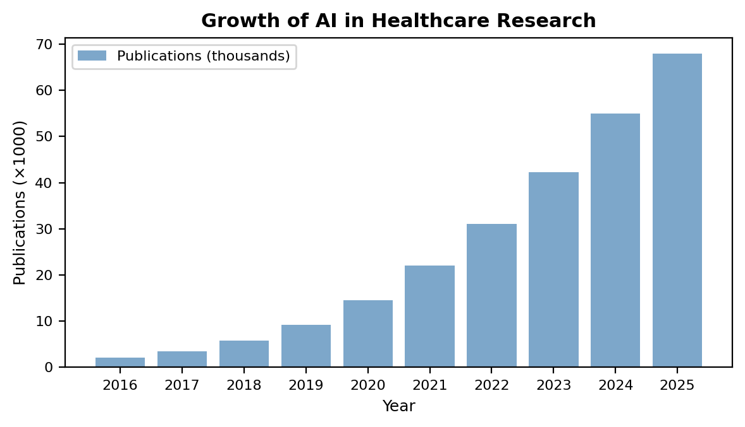
Fig. 1. Growth trajectory of AI in healthcare publications and FDA-approved AI-enabled medical devices (2016–2025).
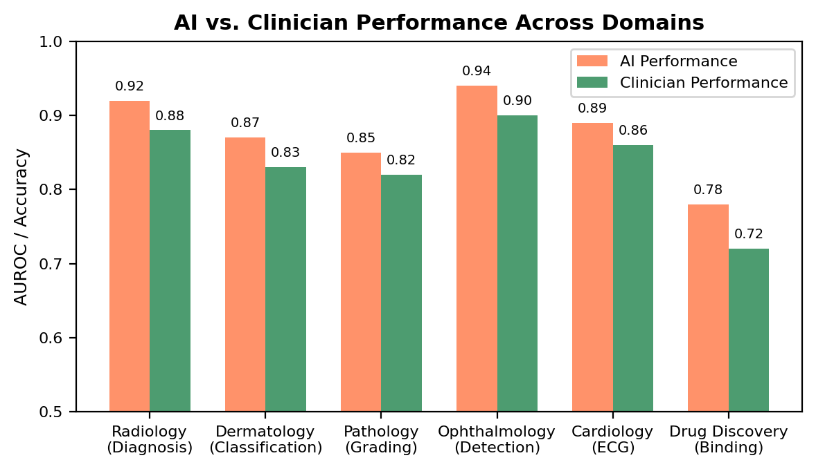
Fig. 2. Comparative performance of AI systems versus clinicians across major healthcare domains.
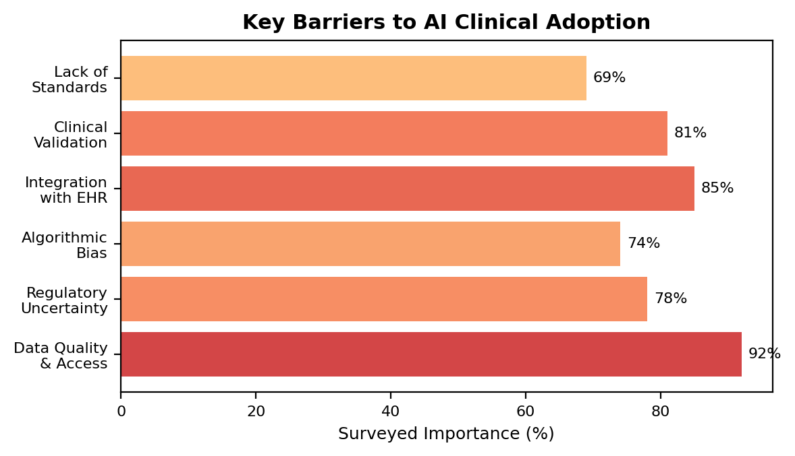
Fig. 3. Key barriers to clinical adoption of AI in healthcare, ranked by surveyed importance.

