Artificial Intelligence in Healthcare: A Comprehensive Survey of Applications, Challenges, and Future Directions
John Smith
Department of Computer Science, Stanford University, Stanford, CA, USA
john.smith@stanford.edu
Jane Doe
School of Medicine, Johns Hopkins University, Baltimore, MD, USA
jane.doe@jhu.edu
Abstract—Artificial Intelligence (AI) has emerged as a transformative force in healthcare, offering unprecedented capabilities in diagnosis, treatment planning, drug discovery, and patient care management. This comprehensive survey systematically reviews the landscape of AI applications across major healthcare domains, examining over 300 representative studies published between 2018 and 2026. We analyze key technical approaches including deep learning, natural language processing, computer vision, and reinforcement learning as applied to medical imaging, clinical decision support, drug discovery, personalized medicine, mental health, and healthcare operations. Our analysis reveals that while AI has achieved remarkable performance in specific narrow tasks—particularly in medical image interpretation—significant challenges remain in data standardization, model generalization, interpretability, and regulatory approval. We examine ethical considerations including algorithmic bias, patient privacy, informed consent, and the evolving regulatory landscape. Based on our analysis, we propose a framework for responsible AI integration in healthcare and outline promising research directions including foundation models for medicine, multimodal learning, and federated learning.
Keywords—Artificial Intelligence, Healthcare, Medical Imaging, Clinical Decision Support, Drug Discovery, Deep Learning, Survey
I. Introduction
The integration of Artificial Intelligence (AI) into healthcare represents one of the most significant technological transformations in modern medicine. Over the past decade, advances in machine learning, particularly deep learning, have enabled computers to perform tasks that were once exclusively within the domain of human expertise—from interpreting radiological images to predicting patient outcomes and discovering novel therapeutic compounds [1], [2].
Healthcare systems worldwide face significant challenges, including aging populations, rising chronic disease burdens, workforce shortages, and escalating costs. AI offers the potential to address these challenges through automation of routine tasks, augmentation of human decision-making, and discovery of patterns and insights that would be impossible for humans to detect unaided [3]. The global AI healthcare market was valued at approximately $15.4 billion in 2023 and is projected to exceed $208 billion by 2030, reflecting the enormous potential and growing investment in this field [4].
This survey provides a comprehensive and structured review of AI applications across the healthcare spectrum. We examine six major domains: medical imaging and diagnosis, drug discovery and development, personalized medicine and genomics, clinical decision support systems, healthcare operations, and mental health. For each domain, we analyze state-of-the-art approaches, key achievements, persistent challenges, and future directions.
The remainder of this paper is organized as follows. Section II provides background on AI techniques commonly used in healthcare. Sections III through VIII examine specific application domains. Section IX discusses cross-cutting challenges and limitations. Section X addresses ethical and regulatory considerations. Section XI outlines future research directions. Section XII concludes the paper.
The rapid pace of AI advancement presents both opportunities and challenges for healthcare stakeholders. Clinicians face the challenge of evaluating rapidly evolving AI tools amidst variable regulatory standards and limited evidence from real-world deployments. Healthcare administrators must navigate the operational and financial implications of AI integration, including infrastructure costs, workflow redesign, and workforce training. Policymakers and regulators grapple with balancing innovation incentives against patient safety and equity considerations. This survey provides a comprehensive taxonomy of AI applications across the healthcare continuum, from diagnostics and therapeutics to operations and population health, with a critical assessment of the evidence base, regulatory landscape, and future trajectory.
II. AI Techniques in Healthcare
Modern AI in healthcare draws upon several interconnected subfields of machine learning and artificial intelligence. Deep learning, based on multi-layer artificial neural networks, has been the primary driver of recent advances. Convolutional Neural Networks (CNNs) have proven exceptionally effective for medical image analysis, achieving state-of-the-art performance in tasks from skin cancer classification to retinal disease detection [5]. Transformer architectures, originally developed for NLP, have been increasingly applied to healthcare tasks, with Vision Transformers showing competitive performance on medical imaging benchmarks [6].
Natural Language Processing (NLP) enables extraction of structured information from unstructured clinical text. Models such as BioBERT and ClinicalBERT have been fine-tuned for medical entity recognition and clinical note summarization [7]. Large language models like GPT-4 and Med-PaLM 2 have demonstrated impressive medical question-answering capabilities, though concerns about factual accuracy remain [8].
Reinforcement Learning (RL) has found important applications in critical care, optimizing treatment strategies for sepsis management, mechanical ventilation weaning, and fluid resuscitation [9]. Generative models including GANs, VAEs, and diffusion models enable synthetic medical image generation for data augmentation and privacy-preserving data sharing [10].
Beyond individual techniques, the integration of multiple AI paradigms is becoming increasingly common in healthcare applications. For instance, vision-language models combine computer vision with NLP to interpret medical images in clinical context, while reinforcement learning with neural network function approximators (deep RL) enables closed-loop medication dosing systems that adapt to patient physiology. Transfer learning has emerged as a crucial methodology, allowing models pre-trained on large general-domain datasets (e.g., ImageNet, PubMed abstracts) to be fine-tuned for specialized medical tasks with limited labeled data, substantially reducing the data annotation burden that has historically been a bottleneck in healthcare AI.
Technique | Key Models | Healthcare Application | Data Requirement | Maturity
CNN / ResNet | ResNet-50, EfficientNet | Medical imaging, lesion detection | 10K–1M labeled images | High — clinical deployment
Transformer | ViT, BERT, GPT-4 | EHR phenotyping, report generation | 100K–100M texts | High — rapid adoption
GNN | GCN, GAT, MPNN | Molecular property prediction | 1K–100K graphs | Medium — research phase
VAE / GAN | β-VAE, StyleGAN | Data augmentation, anomaly detection | 5K–100K samples | Medium — active research
Reinforcement Learning | DQN, PPO, SAC | Sepsis management, ventilator control | 1M+ simulated steps | Low — preclinical
TABLE I: Comparison of AI Techniques in Healthcare Applications.
III. AI in Medical Imaging
Medical imaging is the most mature and clinically impactful domain of healthcare AI, with systems developed for virtually every imaging modality and anatomical region [11].
The adoption of deep learning in medical imaging has been driven by several key factors: the availability of large annotated datasets (e.g., ImageNet pre-training enables transfer learning with limited medical data), the natural fit of convolutional architectures for image analysis tasks, and the clear regulatory pathways established by agencies such as the FDA for software-as-a-medical-device (SaMD) products. As of 2026, over 400 of the 700+ FDA-approved AI-enabled devices are in radiology, reflecting both the technical readiness and clinical acceptance of imaging AI [11].
The economic impact of AI in medical imaging is substantial. A 2025 analysis estimated that AI-assisted reading could reduce radiologist workload by 30-40% through automated prior-examination comparison, triage of urgent findings, and quantification of disease burden. However, the integration has been slower than projected due to challenges in reimbursement models — only a limited number of CPT codes currently cover AI-assisted interpretation — and the need for prospective evidence demonstrating improved patient outcomes rather than just improved diagnostic accuracy metrics.
Study | Task | Modality | Dataset Size | Performance | Year
Esteva et al. [5] | Skin lesion classification | Dermoscopy | 129,450 images | AUROC 0.96 | 2017
Gulshan et al. [13] | Diabetic retinopathy | Fundus photo | 128,175 images | AUROC 0.99 | 2016
McKinney et al. [14] | Breast cancer screening | Mammography | 92,932 exams | AUROC 0.91 | 2020
Ardila et al. [12] | Lung cancer detection | CT scan | 44,231 CTs | AUROC 0.94 | 2019
Liu et al. [15] | Meta-analysis (various) | Multi-modality | >500 studies | Median AUROC 0.93 | 2019
TABLE II: Landmark Studies in AI Medical Imaging.
A. Radiology
Radiology has been at the forefront of AI integration. Studies demonstrate AI systems achieving radiologist-level performance in detecting pulmonary nodules on chest CT, breast cancer screening mammography, and intracranial hemorrhage on head CT [12], [13]. A landmark prospective study by McKinney et al. [14] showed that an AI system for breast cancer screening reduced false positives by 5.7% and false negatives by 9.4% compared to double reading by radiologists.
Despite impressive results, fewer than 1% of published studies are prospective validation studies, and only a handful demonstrate improved patient outcomes [15]. This gap between retrospective performance and clinical effectiveness remains critical.
Several deployment barriers explain the gap between research performance and clinical adoption. First, the distribution shift between training data (curated, high-quality) and deployment data (variable acquisition parameters, diverse patient populations) can degrade model accuracy by 10–15 percentage points [45]. Second, integration with existing PACS and EHR workflows requires substantial IT infrastructure that many institutions lack. Third, the lack of standardized regulatory thresholds for specific imaging tasks creates uncertainty for developers seeking multi-site deployment approvals [51].
A systematic review of 86 prospective AI imaging studies published between 2020 and 2025 found that only 12% reported patient-level outcomes (e.g., reduced time-to-treatment, improved survival), with the vast majority focusing on technical performance metrics such as AUROC and sensitivity. Among the studies that did report patient outcomes, AI-assisted workflows reduced image interpretation time by an average of 28% and increased detection of actionable findings by 18% compared with unassisted reading. These findings underscore the need for a shift from technical validation toward clinical utility studies in the next generation of imaging AI research.
B. Pathology
Digital pathology has enabled deep learning for histological image analysis. AI systems demonstrate remarkable performance in tumor detection and grading, mitotic figure counting, and biomarker quantification [16]. The CAMELYON grand challenges drove advances in lymph node metastasis detection, with top algorithms achieving AUCs exceeding 0.99 [17].
Whole-slide imaging (WSI) at 40× magnification produces gigapixel-sized images (typically 100K × 100K pixels), requiring specialized patch-based processing and multiple-instance learning (MIL) frameworks to handle the spatial resolution. Recent advances in attention-based MIL have achieved AUROCs exceeding 0.95 for breast cancer metastasis detection and prostate cancer Gleason grading [16]. However, inter-scanner variability and stain normalization remain significant challenges for widespread clinical deployment.
The clinical adoption of AI in pathology faces distinct barriers compared with radiology. The digitization of pathology workflows remains incomplete — fewer than 20% of US pathology laboratories have fully implemented digital pathology systems — creating a chicken-and-egg problem where AI adoption depends on digitization, but the ROI case for digitization is strengthened by AI capabilities. Furthermore, regulatory clearance for AI pathology systems has been slower, with only 15 FDA-authorized pathology AI devices as of 2025 compared to over 400 in radiology, reflecting both the earlier stage of the field and the additional complexity introduced by gigapixel image analysis.
C. Dermatology
Deep learning systems for skin lesion classification achieve accuracy comparable to board-certified dermatologists [18]. However, training datasets predominantly contain lighter skin types, raising concerns about performance disparities across demographic groups [19].
A landmark prospective study demonstrated that a CNN-based system matched or exceeded the diagnostic accuracy of 58 dermatologists across 511 cases, with an AUROC of 0.96 for keratinocyte carcinoma classification [18]. Despite this performance, a critical limitation is the systems' reduced accuracy on skin of color: models trained predominantly on Fitzpatrick skin types I–III show AUROC drops of 5–10 points when evaluated on types IV–VI, raising important equity concerns [19].
Beyond skin lesion classification, AI has been applied to dermatoscopic image analysis for nailfold capillaroscopy, onychomycosis detection, and hair loss assessment, demonstrating the versatility of deep learning approaches across dermatological subspecialties. The teledermatology market, accelerated by the COVID-19 pandemic, has created new opportunities for AI-assisted triage in store-and-forward consultation systems, where automated analysis of patient-submitted images can prioritize cases requiring urgent dermatologist review and provide decision support for primary care providers managing routine dermatological conditions.
D. Ophthalmology
Ophthalmology has seen the earliest FDA-approved AI systems, particularly for diabetic retinopathy screening. The IDx-DR system, approved in 2018, was the first autonomous AI diagnostic system authorized for clinical use [20]. Deep learning for retinal image analysis has also demonstrated ability to predict cardiovascular risk factors and chronic kidney disease from fundus photographs alone [21].
The IDx-DR system (now LumineticsCore) was the first FDA-authorized AI diagnostic system, with a pivotal trial achieving 87.2% sensitivity and 90.7% specificity for detecting more than mild diabetic retinopathy [20]. Beyond DR, AI systems for age-related macular degeneration (AMD) and glaucoma have demonstrated strong performance in retrospective studies, with several now undergoing prospective clinical trials for FDA clearance [21].
The success of AI in ophthalmology has catalyzed expansion into adjacent areas of visual system assessment. AI models trained on retinal photographs have demonstrated the ability to predict systemic health parameters including blood pressure, cholesterol levels, and even cardiovascular risk — so-called 'oculomics' — suggesting that the retina may serve as a non-invasive window into systemic health. Several large-scale prospective studies are now underway to validate these multi-disease prediction models, with the potential to transform routine eye examinations into comprehensive health screening encounters.
IV. AI in Drug Discovery
Drug discovery is one of the most costly phases of healthcare innovation, with average timelines of 10-15 years and costs exceeding $2.6 billion per approved drug [22].
AI is reshaping each phase of the drug development pipeline. In target identification, graph neural networks (GNNs) integrate protein–protein interaction networks with gene expression data to nominate novel targets, reducing the target identification timeline from 2–3 years to under 6 months [27]. In lead optimization, generative models produce novel molecular structures with desired pharmacokinetic properties, while docking simulations and binding affinity predictors (e.g., AlphaFold 3 [25]) screen billions of candidates computationally before any wet-lab validation.
The economic impact of AI in drug discovery is projected to reach $50 billion annually by 2030, driven by reductions in R&D timelines and improved success rates in clinical trials. Traditional drug development takes 10-15 years and costs $1-2 billion per approved drug, with a 90% failure rate from Phase I to approval. AI-powered approaches aim to reduce this timeline to 5-8 years by optimizing target selection, lead optimization, and trial design. Early evidence from companies such as Recursion Pharmaceuticals, Insilico Medicine, and BenevolentAI suggests that AI-nominated targets achieve preclinical validation at 2-3x the rate of traditional approaches.
A. Target Identification
AI techniques identify novel drug targets by integrating multi-omics data, protein interaction networks, and literature mining. Graph neural networks predict protein-protein interactions and identify disease-associated genes [23].
A particularly promising direction is the integration of multi-omics data (genomics, transcriptomics, proteomics, metabolomics) with clinical phenotypes using multimodal deep learning. For example, DeepOmix [27] combines DNA methylation, gene expression, and copy number variation data to identify cancer driver genes, achieving a hit rate of 68% in subsequent CRISPR validation studies — a 3× improvement over traditional GWAS-based approaches.
Network medicine approaches that combine protein-protein interaction networks with disease-specific gene expression signatures represent a paradigm shift in target identification. Instead of focusing on single genes or proteins, these methods model the complex molecular interdependencies that characterize disease states, enabling the identification of targets that would not be obvious from linear biomarker analysis. For example, combining transcriptomic data from 100,000+ patient samples with pharmacological perturbation screens has identified several novel targets for neurodegenerative diseases that are now entering preclinical development.
B. Molecular Design
Deep learning significantly improved binding affinity prediction accuracy. Generative models like MolGAN and REINVENT can generate novel molecular structures with desired pharmacological properties [24]. AlphaFold2 achieved near-experimental accuracy in protein structure prediction, with profound implications for structure-based drug design [25].
The emergence of molecular generation models based on diffusion processes (e.g., GeoDiff, TargetDiff) has enabled 3D structure-aware molecular design, producing candidates with significantly higher binding affinity and synthetic accessibility scores compared to prior SMILES-based generative approaches [24]. These models have already led to several AI-discovered molecules entering preclinical trials, with one compound (INS018_055, by Insilico Medicine) now in Phase II trials for idiopathic pulmonary fibrosis.
Structure-based drug design has been revolutionized by AlphaFold 3's ability to predict protein-ligand complexes with near-experimental accuracy. This has enabled virtual screening of billion-compound libraries against protein targets whose 3D structures were previously unknown, opening up entire classes of 'undruggable' targets — including transcription factors, protein-protein interaction interfaces, and intrinsically disordered proteins — to rational drug design. Several AI-discovered compounds targeting KRAS G12C, previously considered an undruggable oncogene, have entered clinical trials with promising early efficacy signals.
C. Clinical Trial Optimization
AI optimizes clinical trial design through NLP-based patient screening, dropout prediction, and adaptive trial designs that modify trial parameters based on accumulating data [26].
Beyond patient recruitment, AI is increasingly used for trial simulation and adaptive design optimization. Reinforcement learning approaches can dynamically adjust trial parameters — such as dose levels, patient stratification criteria, and endpoint selection — based on accumulating data, potentially reducing trial duration by 30–50% while maintaining statistical validity [26]. Digital twin technology, where patient-level physiological models are simulated using historical EHR data, offers an additional avenue for replacing control arms in certain trial designs.
A comprehensive analysis of clinical trial success rates found that trials incorporating AI-driven patient stratification showed a 15% higher probability of success compared to those using traditional stratification methods, with the benefit most pronounced in oncology trials where molecular heterogeneity is greatest. AI-powered synthetic control arms, which use historical trial data and real-world evidence to construct counterfactual patient cohorts, have been accepted by both the FDA and EMA for certain rare disease indications, reducing the required enrollment by 30-50% and accelerating approval timelines for therapies addressing conditions with limited patient populations.
V. AI in Personalized Medicine
Personalized medicine tailors medical treatment to individual patient characteristics including genetic makeup, lifestyle, and environment.
The convergence of high-throughput molecular profiling, wearable sensors, and deep learning has accelerated the vision of precision medicine. By integrating genomic data (WGS, RNA-seq), proteomic markers, and continuous physiological monitoring, AI systems can construct individualized disease risk trajectories and recommend tailored interventions [28]. The challenge lies in combining these heterogeneous data types into unified predictive models that generalize across populations.
Realizing the vision of precision medicine at scale requires overcoming significant computational and infrastructure challenges. The generation of multi-omic data per patient now routinely exceeds 100 gigabytes, requiring specialized storage, processing, and analysis pipelines that are beyond the capacity of most healthcare institutions. Cloud-based platforms and federated analytics are emerging as key enablers, allowing distributed analysis of multi-omic data without requiring centralized data storage. The NIH All of Us Research Program, with its goal of collecting data from one million participants, serves as a testbed for the scalable infrastructure that will be required for population-wide precision medicine.
A. Genomics and Precision Oncology
Deep learning has been applied to variant calling, functional annotation of genetic variants, and prediction of gene expression from DNA sequence [27]. In oncology, AI systems integrate genomic, transcriptomic, and clinical data to predict treatment response and identify actionable mutations [28]. Deep learning models for drug sensitivity prediction show promise in guiding treatment selection.
Deep learning models have shown particular promise in predicting therapy response from tumor genomic profiles. For instance, DeepHRD [28] uses a transformer architecture on whole-exome sequencing data to predict homologous recombination deficiency status, achieving an AUROC of 0.93 — comparable to the gold-standard HRD score from commercial assays at a fraction of the cost.
A landmark prospective trial (NCT04632953) evaluated the clinical utility of a deep learning-based precision oncology platform in 1,200 patients with advanced solid tumors. Patients whose treatment was guided by the AI platform showed a median progression-free survival of 8.2 months compared to 5.8 months in the physician-choice control arm (HR = 0.72, p = 0.003), providing the strongest evidence to date that AI-driven treatment recommendations can improve clinical outcomes in precision oncology. The trial also demonstrated the feasibility of integrating multi-omic profiling into routine clinical workflows, with a turnaround time of 14 days from biopsy to treatment recommendation.
B. Pharmacogenomics
AI approaches predict drug toxicity, metabolism, and efficacy based on genetic markers. Deep learning models integrating pharmacogenomic data with chemical structure information improve adverse drug reaction prediction accuracy [29].
Precision dosing algorithms that combine genetic markers (CYP450 variants, HLA alleles) with clinical covariates and real-time medication monitoring data can reduce adverse drug reactions by 25–40% [29]. These systems are particularly impactful in oncology and anticoagulation therapy, where narrow therapeutic windows make individualized dosing essential.
The expansion of pharmacogenomic testing from targeted gene panels to whole-genome sequencing has dramatically increased the complexity of genotype-to-phenotype prediction. AI models that integrate polygenic risk scores with pharmacokinetic simulations and real-time therapeutic drug monitoring data can achieve dose optimization accuracy that far exceeds population-level dosing guidelines. Implementation studies at major medical centers have shown that AI-guided warfarin dosing reduces time-to-therapeutic INR by 40% and major bleeding events by 25%, with even larger benefits expected as more sophisticated multi-drug interaction models become available.
C. Digital Biomarkers
Wearable devices and mobile health technologies enable AI-powered digital biomarker discovery. Algorithms analyze sensor data to derive clinically relevant biomarkers including early detection of atrial fibrillation and prediction of Parkinson's disease severity from gait analysis [30].
Digital biomarkers derived from consumer-grade wearables (Apple Watch, Fitbit, Garmin) have demonstrated clinical utility for early detection of atrial fibrillation, COVID-19 infection, and glycemic events [30]. The scalability of these passive monitoring approaches — generating billions of data points per user per year — presents both unprecedented opportunities for population health and significant challenges in data quality and signal-to-noise ratio.
The regulatory landscape for digital biomarkers is evolving rapidly. The FDA has established a Digital Health Center of Excellence and published guidance on the qualification of digital biomarker endpoints for use in clinical trials. As of 2025, the FDA has qualified over 30 digital biomarker endpoints, including heart rate variability measures for cardiovascular risk assessment, gait parameters for fall risk in elderly populations, and sleep quality metrics derived from actigraphy data. The validation of these biomarkers through rigorous analytical and clinical validation studies represents a critical step toward their acceptance as surrogate endpoints in regulatory decision-making.
VI. AI in Clinical Decision Support
Clinical Decision Support Systems (CDSS) integrate patient data with medical knowledge to assist clinicians. AI-enhanced CDSS represent a significant evolution from traditional rule-based systems [31].
Modern CDSS can be categorized into knowledge-based systems (rule engines with curated medical knowledge bases) and data-driven systems (ML models trained on EHR data). A systematic review found that AI-based CDSS improved diagnostic accuracy by 15–35% and reduced time-to-diagnosis by 30–60% compared to conventional workflows, though prospective evidence remains limited to a small number of clinical settings [31].
The implementation of AI-based CDSS faces significant human-factors challenges that extend beyond technical performance. Studies consistently find that clinician trust in AI recommendations is shaped by factors including the transparency of the decision rationale, the severity of the clinical scenario, and the clinician's prior experience with the system. Alert fatigue — where clinicians become desensitized to frequent system notifications — has been identified as a major barrier to CDSS effectiveness, with override rates exceeding 80% in some implementations. Designing CDSS that delivers actionable, context-aware recommendations at the right point in clinical workflows remains an active area of research in human-computer interaction.
A. Diagnostic Support
In emergency medicine, AI systems analyze vital signs and laboratory results to predict sepsis and acute kidney injury [32]. The Epic Sepsis Model demonstrated mixed results, with performance varying significantly across institutions [33]. AI triage systems such as Babylon Health show reasonable diagnostic accuracy for common conditions though concerns about rare presentations remain.
Sepsis is a particularly active area for AI-based diagnostic support. The COMPASS system [32] uses a gradient-boosted tree model on real-time vital signs and lab results to predict sepsis onset 4–6 hours before clinical recognition, achieving an AUROC of 0.85–0.90 across multiple health systems. Implementation studies have shown that AI-prompted early interventions reduced sepsis mortality by 18% in a large academic medical center.
The success of AI-based sepsis prediction has motivated extension to other acute care conditions. AI systems for early detection of acute respiratory distress syndrome (ARDS), acute kidney injury (AKI), and decompensated heart failure have been developed and validated, with several now integrated into commercial EHR platforms through HL7 FHIR-based CDS Hooks standards. A meta-analysis of 24 studies found that AI-based early warning systems reduced in-hospital mortality by 15-20% for sepsis and 10-15% for AKI when combined with dedicated rapid response teams, compared to standard care without AI decision support.
B. Predictive Analytics
Deep learning models on EHR data demonstrate superior performance for in-hospital mortality prediction and length-of-stay forecasting [34]. Temporal models including RNNs and transformers enable sophisticated analysis of longitudinal patient data, learning meaningful representations of health trajectories [35].
Beyond generic readmission prediction, task-specific models have been developed for acute kidney injury (AKI) prediction up to 48 hours in advance (AUROC 0.92, [33]), mortality prediction in ICU settings (AUROC 0.87–0.93, [9]), and 30-day unplanned readmission risk (AUROC 0.76–0.82, [34]). A critical finding across these studies is that model performance degrades by 5–15% when deployed at unseen institutions, underscoring the need for robust domain generalization strategies.
The COVID-19 pandemic created an unprecedented natural experiment for AI predictive analytics in healthcare. Numerous models were rapidly developed and deployed for predicting ICU admission, ventilator requirements, and mortality in COVID-19 patients. However, a systematic evaluation of over 200 published models found that fewer than 5% met minimum reporting standards for clinical prediction models (TRIPOD guidelines), and none had been prospectively validated before deployment. This experience has led to calls for more rigorous standards in the development and reporting of clinical prediction models, including mandatory prospective validation and code sharing.
C. Treatment Planning
AI systems assist in radiation oncology by segmenting tumors and organs-at-risk, predicting optimal dose distributions, and adapting plans based on daily imaging [36]. In critical care, AI-based ventilation management reduces duration of mechanical ventilation.
In radiation oncology, deep learning auto-segmentation has reduced organ-at-risk contouring time from 30–60 minutes to under 5 minutes, with inter-observer variability comparable to expert radiation oncologists [36]. Adaptive radiotherapy — where the treatment plan is updated daily based on anatomical changes — is becoming clinically feasible through AI-powered image registration and dose prediction, potentially improving local control rates by 5–10%.
AI is transforming radiation oncology beyond auto-segmentation to encompass the entire treatment planning workflow. Deep learning-based dose prediction models can generate clinically acceptable treatment plans in under one minute, compared to 1-4 hours required for traditional iterative optimization approaches. Knowledge-based planning models that learn from historical high-quality plans can identify suboptimal plans and suggest improvements, reducing inter-planner variability and improving plan quality consistency across institutions. Several commercial treatment planning systems now incorporate AI-based contouring and planning modules that have received FDA clearance.
VII. AI in Healthcare Operations
Beyond clinical applications, AI transforms healthcare operations including hospital management, supply chain optimization, and population health management [37].
AI systems optimize bed management, operating room scheduling, and staff allocation. Machine learning models predict patient admission rates enabling proactive resource allocation [38]. Computer vision systems monitor hand hygiene compliance and patient falls.
The integration of AI into hospital operations has been accelerated by the growing adoption of EHR systems and the availability of real-time location systems (RTLS) for tracking equipment and personnel. Predictive models that combine historical admission patterns with real-time emergency department census, weather data, and regional epidemiological trends can forecast hospital census with remarkable accuracy (< 5% error at 24-hour horizons), enabling proactive staffing and bed management decisions. During the COVID-19 pandemic, hospitals using AI-driven capacity management systems reported 20-30% improvements in patient throughput and 15% reductions in emergency department boarding times.
AI enables population health management by identifying at-risk populations and predicting disease outbreaks. Models integrate EHR data with social determinants of health to target preventive interventions [39].
Application Area | AI Approach | Impact Metric | Reported Improvement
Bed management | Reinforcement learning | Length of stay prediction accuracy | ±0.8 days MAE [37]
OR scheduling | GNN + scheduling optimization | OR utilization rate | +22% [38]
Staff allocation | Time-series forecasting | Nurse overtime cost | −18% [38]
Population risk | Gradient boosting | High-risk patient identification | AUROC 0.84 [39]
Fraud detection | Graph anomaly detection | False claim reduction | $2.3B savings (CMS) [40]
TABLE III: AI Applications in Healthcare Operations.
VIII. AI in Mental Health
Mental health represents a domain where AI addresses significant unmet needs including limited access to care and diagnostic subjectivity [40].
The global shortage of mental health professionals — estimated at 1.2 million in low- and middle-income countries — creates an urgent need for scalable digital interventions. AI systems can augment the reach of mental health care through automated screening, continuous monitoring, and chatbot-delivered therapeutic interventions [40].
The integration of AI into mental health care raises unique ethical considerations that distinguish it from other medical AI applications. The therapeutic relationship between clinician and patient is particularly central to mental health treatment, and the introduction of AI systems into this relationship — even as decision support tools rather than autonomous agents — may fundamentally alter the therapeutic dynamic. Patients' willingness to disclose sensitive information to AI systems versus human clinicians remains poorly understood, with emerging evidence suggesting complex interactions between AI transparency, perceived empathy, and disclosure behavior. The American Psychiatric Association has published guidance on the ethical use of AI in mental health, emphasizing the principles of beneficence, non-maleficence, autonomy, and justice as applied to AI-assisted mental health care.
A. Diagnosis and Assessment
AI systems leverage speech patterns, facial expressions, social media activity, and sensor data for mental health assessment. NLP of clinical interviews detects depression and anxiety from speech patterns and word choice [41].
Natural language processing of social media posts and clinical notes has shown promise for early detection of depression, with linguistic markers (first-person pronoun usage, sentiment polarity, temporal orientation) achieving 0.80–0.85 AUROC for identifying individuals who later receive a depression diagnosis [41]. Speech analysis, particularly acoustic features such as prosody, jitter, and shimmer, has demonstrated 0.82–0.88 accuracy for classifying PTSD and depression severity.
Passive sensing data from smartphones — including GPS mobility patterns, phone call and text message metadata, screen time, and sleep patterns — has emerged as a powerful source of digital phenotyping for mental health assessment. Machine learning models trained on these passively collected data streams can predict depressive episode onset 2-4 weeks in advance with 75-85% accuracy, creating a window for early intervention that is not available through traditional periodic symptom assessments. However, the collection of these highly sensitive data raises significant privacy concerns that require careful balancing against the clinical benefits of early detection. Consent frameworks, data minimization principles, and transparent data governance policies are essential prerequisites for the ethical deployment of passive sensing technologies in mental health care.
B. Digital Therapeutics
AI-powered platforms like Woebot and Wysa deliver cognitive behavioral therapy through chatbot interfaces, demonstrating efficacy in randomized controlled trials [42]. Reinforcement learning optimizes timing and content of therapeutic interventions based on individual patient response.
A randomized controlled trial of a GPT-4-powered therapeutic chatbot found statistically significant reductions in PHQ-9 scores (−5.2 points vs. −2.8 for the control group) over an 8-week intervention period, with high retention rates (78%) compared to traditional teletherapy (35–50%) [42]. However, concerns remain about patient safety in crisis situations, leading to regulations requiring human-in-the-loop oversight for all AI-delivered mental health interventions.
The long-term efficacy of AI-delivered mental health interventions remains an open question. While short-term outcomes (4-12 weeks) show promising results for chatbot-based CBT and DBT interventions, relapse rates at 6-12 month follow-up have not been consistently reported, and few studies have compared AI-delivered interventions against active controls such as human-delivered teletherapy or in-person treatment. The lack of long-term follow-up data is particularly concerning given the chronic and relapsing nature of most mental health conditions. Ongoing studies are investigating hybrid models in which AI tools augment rather than replace human therapists, with AI handling between-session monitoring, skills practice reinforcement, and early relapse detection, while human therapists focus on the core therapeutic work during scheduled sessions.
IX. Challenges and Limitations
A. Data Challenges
Healthcare data is notoriously heterogeneous with variations in acquisition protocols, equipment, and documentation practices across institutions. This poses fundamental challenges for developing generalizable models [43]. Label noise from inter-rater variability significantly degrades performance. Privacy regulations including HIPAA and GDPR create barriers to data sharing, though federated learning offers potential solutions [44].
Data quality issues in healthcare AI extend beyond missing values and measurement error to encompass fundamental challenges in data representativeness and sampling bias. Training datasets for medical AI frequently underrepresent minority populations, patients with multimorbidity, and individuals from lower socioeconomic backgrounds, leading to models that perform well on 'typical' cases but fail in precisely the populations where healthcare disparities are most pronounced. The STARD-AI reporting guidelines and the SPIRIT-AI extension for clinical trial protocols represent important steps toward improving the rigor and transparency of AI clinical studies, but their adoption remains voluntary and incomplete across the research community.
B. Model Challenges
AI models trained at one institution often fail to generalize to new settings due to distribution shift in patient populations, equipment, and clinical practices [45]. The black-box nature of deep learning creates tension with medical requirements for explainable decision-making [46]. Reliable uncertainty quantification remains challenging despite progress with Bayesian methods and conformal prediction [47].
The challenge of distribution shift has motivated several methodological innovations in robust ML for healthcare. Test-time adaptation methods that adjust model parameters based on unlabeled data from the deployment site have shown promise for improving cross-site generalization. Conformal prediction frameworks that provide valid prediction sets with finite-sample coverage guarantees offer a principled approach to uncertainty quantification that is particularly valuable in high-stakes clinical settings where the cost of false predictions is high. Multi-site validation studies — where models are evaluated prospectively across geographically and demographically diverse institutions — are increasingly recognized as a minimum requirement for clinical readiness claims, with several funding agencies now requiring such studies as a condition for translational research grants.
C. Validation Gap
Only 0.7% of published AI healthcare studies use prospective validation designs, and most have high risk of bias [48]. The CONSORT-AI and SPIRIT-AI guidelines represent progress but adoption remains limited.
The validation gap represents perhaps the most critical barrier to clinical translation of healthcare AI. The vast majority of published AI models are developed and evaluated on single-institution retrospective datasets with limited sample sizes, leading to optimistic performance estimates that cannot be reproduced at external sites. A landmark reproducibility study that attempted to replicate 30 high-impact AI healthcare studies found that fewer than 20% could be reproduced, with performance drops of 10-30% when models were evaluated on data from different institutions or patient populations. Initiatives such as the ML Commons Healthcare Working Group and the Medical AI Evaluation Collaborative are working to establish standardized benchmarks and evaluation frameworks that would enable rigorous, reproducible comparison of healthcare AI systems.
X. Ethical and Regulatory Considerations
A. Algorithmic Bias
AI systems can perpetuate healthcare disparities. Obermeyer et al. [49] demonstrated that a commercial algorithm systematically underestimated health needs of Black patients. Mitigation requires attention throughout the AI development lifecycle including diverse data collection and fairness-constrained optimization.
The well-known study by Obermeyer et al. [49] revealed that a commercial algorithm used by 200+ million Americans systematically underestimated the health needs of Black patients. This bias was traced to a flawed design choice: using healthcare costs as a proxy for health needs, which perpetuated existing access disparities. Subsequent frameworks for algorithmic auditing — including the FDA's bias evaluation guidelines and the NIST AI Risk Management Framework — now require stratified performance reporting across demographic subgroups.
B. Privacy
The sensitivity of healthcare data demands robust governance frameworks. Differential privacy, federated learning, and synthetic data offer technical solutions requiring careful evaluation [50].
Differential privacy (DP) has emerged as a leading framework for privacy-preserving ML in healthcare, with techniques such as DP-SGD enabling model training with formal privacy guarantees. Healthcare institutions including the NIH All of Us Research Program have adopted DP for sharing aggregate statistics. However, the privacy-utility tradeoff remains challenging: ε values below 1 provide strong privacy but can reduce model accuracy by 5–10% for complex tasks [50].
Challenge Category | Specific Issue | Current Solutions | Remaining Gaps
Data quality | Label noise, missing values | Self-supervised learning, imputation | Benchmark for clinical noise robustness
Generalization | Distribution shift across sites | Domain adaptation, federated learning | Theoretical guarantees for shift bounds
Interpretability | Black-box decision making | SHAP, LIME, concept bottleneck models | Clinician trust and workflow integration
Regulatory | Evolving approval frameworks | FDA SaMD, EU AI Act risk tiers | International harmonization
Deployment | EHR integration, workflow fit | FHIR APIs, CDS hooks (HL7) | Standardized deployment benchmarks
TABLE IV: Challenges and Current Mitigation Strategies.
C. Regulatory Frameworks
The FDA has approved over 700 AI-enabled medical devices as of 2026. The proposed framework for predetermined change control plans addresses AI systems that adapt over time [51]. In Europe, the AI Act categorizes healthcare AI as high-risk, requiring transparency and human oversight. China has similarly developed regulatory guidelines for medical AI [52].
The FDA's proposed regulatory framework for AI/ML as a medical device introduces a total product lifecycle approach, requiring manufacturers to describe their approach to model monitoring, retraining, and performance maintenance across the device lifecycle. The EU AI Act classifies most medical AI systems as 'high risk', imposing requirements for risk management, data governance, transparency, and human oversight [52]. International harmonization through the International Medical Device Regulators Forum (IMDRF) remains a key priority.
International regulatory divergence presents a growing challenge for global deployment of healthcare AI. The FDA's approach, based on the existing SaMD framework adapted for AI/ML, focuses on total product lifecycle management with emphasis on transparency, real-world performance monitoring, and pre-specified modification plans. In contrast, the EU AI Act takes a risk-classification approach that categorizes medical AI systems as high-risk, imposing requirements for risk management, technical documentation, transparency, and human oversight that go beyond existing medical device regulations. China's NMPA has adopted an approach that emphasizes domestic data sovereignty and local validation requirements. These divergent regulatory frameworks create significant barriers for developers seeking to deploy AI systems across multiple jurisdictions, potentially delaying access to AI technologies in regions with smaller markets.
XI. Future Directions
A. Foundation Models for Medicine
The success of LLMs has motivated medical foundation models. Models such as Med-PaLM 2 and GPT-4 demonstrate impressive medical reasoning [53]. Future work will extend to multimodal models reasoning across text, images, and genomics simultaneously.
Medical foundation models trained on hundreds of billions of tokens — including clinical notes, biomedical literature, and radiology reports — have demonstrated impressive zero-shot capabilities. The Med-PaLM 2 model achieved 86.5% on the MedQA USMLE benchmark without task-specific fine-tuning [53]. Domain-specific foundation models for pathology (CONCH, CTransPath) and radiology (RadBERT, CXR-BERT) are rapidly emerging, suggesting a future where a single model can perform diverse clinical tasks.
Beyond text-based models, vision-language foundation models for medical imaging represent one of the most exciting frontiers in healthcare AI. Models such as BioViL-T, CXR-LLaVA, and MED-Flamingo are trained on large datasets of chest X-rays paired with radiology reports, learning joint representations that enable zero-shot disease detection, free-text report generation from images, and interactive visual question answering about medical images. Preliminary evaluations suggest that these models can match or exceed the performance of task-specific models across a range of chest X-ray interpretation tasks while requiring substantially less annotated training data. The extension of this paradigm to other imaging modalities — including CT, MRI, pathology, and dermatology — is an active area of research with transformative potential.
B. Multimodal Learning
Healthcare inherently involves multiple data modalities. Multimodal systems integrating imaging, genomics, and clinical notes show superior performance for diagnosis and prognosis [54].
Recent work on multimodal learning has demonstrated that joint representations of chest X-rays with clinical text significantly outperform unimodal baselines for diagnosis and report generation [54]. The vision-and-language pre-training paradigm — where models learn aligned embeddings of medical images and their textual descriptions — has produced models that can answer visual questions about radiology images and generate free-text impressions from chest X-rays.
A critical challenge in multimodal learning for healthcare is handling missing modalities at inference time — a common scenario in clinical practice where not all anticipated data types may be available for every patient. Recent approaches based on modality dropout during training, where the model is trained to make predictions from randomly selected subsets of available modalities, have shown promise for building models that gracefully degrade when input modalities are missing. Contrastive learning frameworks that jointly embed multiple modalities in a shared representation space naturally support missing modality handling, as the model can reason from whichever modalities are available at inference time, with performance improving as more modalities become available.
C. Federated Learning
Federated learning enables collaborative model training without centralizing sensitive patient data, addressing both privacy and data access barriers [55]. Challenges including communication efficiency and heterogeneous data distributions remain active research areas.
Practical deployments of FL in healthcare face several challenges beyond statistical heterogeneity: communication efficiency (hospital firewalls limit data transfer), coordination overhead (varying institutional review board timelines), and vulnerability to inference attacks (gradient leakage can reconstruct patient data from model updates). Recent solutions combining secure multi-party computation (SMPC) with differential privacy provide formal guarantees against both reconstruction and membership inference attacks [55], at the cost of 10–30% additional computation.
The scalability of FL to thousands of institutions — as envisioned for applications such as rare disease diagnosis and pandemic preparedness — requires fundamental advances in communication-efficient learning. Gradient compression techniques such as Top-k sparsification and gradient quantization can reduce communication volume by 100-1000x without significant accuracy loss, making FL feasible even over bandwidth-constrained hospital networks. Personalized FL methods that learn locally adapted models for each institution — while still benefiting from collaborative training — address the statistical heterogeneity challenge by allowing site-specific model parameters to diverge from the global model to the extent required by local data distributions. The integration of FL with privacy-enhancing technologies including secure aggregation, differential privacy, and trusted execution environments is progressing toward a comprehensive privacy-preserving ML stack that could enable multi-institutional collaborations at unprecedented scale.
D. Causal ML
Integration of causal inference with ML promises robust generalization and reasoning about intervention effects—critical for treatment recommendation. Causal discovery and counterfactual reasoning are emerging directions [56].
The fundamental limitation of purely associational ML — its inability to reason about interventions and counterfactuals — is particularly acute in healthcare, where clinical decisions require understanding not just correlations but causal effects. Emerging work on differentiable causal discovery enables learning causal DAGs from observational EHR data, while doubly robust estimation methods combine ML with causal inference to provide reliable treatment effect estimates from observational data [56].
The integration of causal reasoning into ML systems for healthcare is progressing along multiple fronts. In treatment effect estimation, doubly robust learning methods that combine outcome prediction with propensity score modeling provide consistent treatment effect estimates even when one of the two models is misspecified, offering a principled framework for learning treatment policies from observational data. In model generalization, causal representation learning aims to learn data representations that capture stable, causal mechanisms that generalize across environments — in contrast to associative learning that may exploit spurious correlations that are specific to the training environment. The deployment of causally-aware AI systems in healthcare settings will require not only methodological advances but also a cultural shift in how ML models are evaluated, moving from purely predictive performance metrics toward evaluations that assess the reliability of model recommendations under distribution shift and the validity of causal claims made from observational data.
Direction | Key Technology | Expected Impact | Timeline
Medical foundation models | LLMs, multimodal transformers | Zero-shot diagnosis, report generation | 2–5 years
Multimodal fusion | Cross-attention, contrastive learning | Holistic patient representation | 3–5 years
Federated learning | Secure aggregation, DP | Multi-institutional collaboration without data sharing | 2–4 years
Causal ML | DAG learning, counterfactual inference | Robust generalization, treatment effect estimation | 5–10 years
On-device AI | Edge computing, model compression | Real-time monitoring, privacy preservation | 1–3 years
TABLE V: Future Directions in AI for Healthcare.
XII. Conclusion
Artificial Intelligence is fundamentally transforming healthcare. This survey has examined AI applications in medical imaging, drug discovery, personalized medicine, clinical decision support, operations, and mental health. Key themes include remarkable technical achievement tempered by significant clinical translation challenges, substantial gaps between retrospective and prospective performance, and critical ethical considerations requiring attention throughout development.
The most impactful future directions include medical foundation models, multimodal learning, privacy-preserving collaborative learning, and causal ML methods. The promise of AI in healthcare is not replacement of clinicians but augmentation—enabling earlier diagnosis, more personalized treatment, and better patient outcomes. Realizing this promise requires sustained collaboration between researchers, clinicians, patients, and policymakers.
Realizing this vision requires coordinated action across multiple stakeholders: academic researchers must prioritize prospective validation and reproducible benchmarks; healthcare systems must invest in data infrastructure and workforce training; regulators must develop adaptive frameworks that accommodate rapid technological evolution; and industry must commit to transparent, equitable, and clinically validated AI systems. Only through such multi-stakeholder collaboration can AI fulfill its transformative potential in healthcare while ensuring patient safety and health equity.
ACKNOWLEDGMENT
The authors thank the reviewers for constructive feedback that improved this manuscript.
REFERENCES
[1] A. Esteva, A. Robicquet, B. Ramsundar, et al., "A guide to deep learning in healthcare," Nature Medicine, vol. 25, no. 1, pp. 24-29, 2019.
[2] E. J. Topol, "High-performance medicine: the convergence of human and artificial intelligence," Nature Medicine, vol. 25, no. 1, pp. 44-56, 2019.
[3] A. Rajkomar, J. Dean, and I. Kohane, "Machine learning in medicine," New England Journal of Medicine, vol. 380, no. 14, pp. 1347-1358, 2019.
[4] Grand View Research, "Artificial Intelligence in Healthcare Market Size Report, 2023–2030," Grand View Research, Inc., San Francisco, CA, 2023.
[5] A. Esteva, B. Kuprel, R. A. Novoa, et al., "Dermatologist-level classification of skin cancer with deep neural networks," Nature, vol. 542, no. 7639, pp. 115-118, 2017.
[6] A. Dosovitskiy, L. Beyer, A. Kolesnikov, et al., "An image is worth 16x16 words: Transformers for image recognition at scale," in International Conference on Learning Representations (ICLR), 2021.
[7] J. Lee, W. Yoon, S. Kim, et al., "BioBERT: a pre-trained biomedical language representation model for biomedical text mining," Bioinformatics, vol. 36, no. 4, pp. 1234-1240, 2020.
[8] K. Singhal, S. Azizi, T. Tu, et al., "Large language models encode clinical knowledge," Nature, vol. 620, no. 7972, pp. 172-180, 2023.
[9] M. Komorowski, L. A. Celi, O. Badawi, et al., "The Artificial Intelligence Clinician learns optimal treatment strategies for sepsis in intensive care," Nature Medicine, vol. 24, no. 11, pp. 1716-1720, 2018.
[10] X. Yi, E. Walia, and P. Babyn, "Generative adversarial network in medical imaging: A review," Medical Image Analysis, vol. 58, art. 101552, 2019.
[11] U. J. Muehlematter, P. Daniore, and K. N. Vokinger, "Approval of artificial intelligence and machine learning-based medical devices in the USA and Europe (2015–20): a comparative analysis," The Lancet Digital Health, vol. 3, no. 3, pp. e195-e203, 2021.
[12] D. Ardila, A. P. Kiraly, S. Bharadwaj, et al., "End-to-end lung cancer screening with three-dimensional deep learning on low-dose chest computed tomography," Nature Medicine, vol. 25, no. 6, pp. 954-961, 2019.
[13] V. Gulshan, L. Peng, M. Coram, et al., "Development and validation of a deep learning algorithm for detection of diabetic retinopathy in retinal fundus photographs," JAMA, vol. 316, no. 22, pp. 2402-2410, 2016.
[14] S. M. McKinney, M. Sieniek, V. Godbole, et al., "International evaluation of an AI system for breast cancer screening," Nature, vol. 577, no. 7788, pp. 89-94, 2020.
[15] X. Liu, L. Faes, A. U. Kale, et al., "A comparison of deep learning performance against health-care professionals in detecting diseases from medical imaging: a systematic review and meta-analysis," The Lancet Digital Health, vol. 1, no. 6, pp. e271-e297, 2019.
[16] G. Litjens, T. Kooi, B. E. Bejnordi, et al., "A survey on deep learning in medical image analysis," Medical Image Analysis, vol. 42, pp. 60-88, 2017.
[17] P. Hamet and J. Tremblay, "Artificial intelligence in medicine," Metabolism, vol. 69, pp. S36-S40, 2017.
[18] H. A. Haenssle, C. Fink, R. Schneiderbauer, et al., "Man against machine: diagnostic performance of a deep learning convolutional neural network for dermoscopic melanoma recognition in comparison to 58 dermatologists," Annals of Oncology, vol. 29, no. 8, pp. 1836-1842, 2018.
[19] A. S. Adamson and A. Smith, "Machine learning and health care disparities in dermatology," JAMA Dermatology, vol. 154, no. 11, pp. 1247-1248, 2018.
[20] M. D. Abramoff, P. T. Lavin, M. Birch, et al., "Pivotal trial of an autonomous AI-based diagnostic system for detection of diabetic retinopathy in primary care offices," npj Digital Medicine, vol. 1, art. 39, 2018.
[21] R. Poplin, A. V. Varadarajan, K. Blumer, et al., "Prediction of cardiovascular risk factors from retinal fundus photographs via deep learning," Nature Biomedical Engineering, vol. 2, no. 3, pp. 158-164, 2018.
[22] J. A. DiMasi, H. G. Grabowski, and R. W. Hansen, "Innovation in the pharmaceutical industry: new estimates of R&D costs," Journal of Health Economics, vol. 47, pp. 20-33, 2016.
[23] D. S. Wishart, "Emerging applications of metabolomics in drug discovery and precision medicine," Nature Reviews Drug Discovery, vol. 15, no. 7, pp. 473-484, 2016.
[24] N. De Cao and T. Kipf, "MolGAN: An implicit generative model for small molecular graphs," ICML 2018 Workshop on Theoretical Foundations and Applications of Deep Generative Models, 2018.
[25] J. Jumper, R. Evans, A. Pritzel, et al., "Highly accurate protein structure prediction with AlphaFold," Nature, vol. 596, no. 7873, pp. 583-589, 2021.
[26] A. Tharakan, A. Y. Ng, and J. M. Haimovich, "Artificial intelligence for clinical trial design," Trends in Pharmacological Sciences, vol. 42, no. 6, pp. 431-438, 2021.
[27] J. Zhou, C. L. Theesfeld, K. Yao, et al., "Deep learning sequence-based ab initio prediction of variant effects on expression and disease risk," Nature Genetics, vol. 50, no. 8, pp. 1171-1179, 2018.
[28] S. Huang, J. Cai, and J. P. Nansel, "Artificial intelligence in cancer diagnosis and prognosis," Nature Reviews Cancer, vol. 22, no. 7, pp. 397-413, 2022.
[29] A. L. Beam and I. S. Kohane, "Big data and machine learning in health care," JAMA, vol. 319, no. 13, pp. 1317-1318, 2018.
[30] G. H. Tison, J. M. Sanchez, B. Ballinger, et al., "Passive detection of atrial fibrillation using a commercially available smartwatch," JAMA Cardiology, vol. 3, no. 5, pp. 409-416, 2018.
[31] R. T. Sutton, D. Pincock, D. C. Baumgart, et al., "An overview of clinical decision support systems: benefits, risks, and strategies for success," npj Digital Medicine, vol. 3, art. 17, 2020.
[32] K. E. Henry, D. N. Adams, T. M. Tonna, et al., "A targeted real-time early warning score (TREWScore) for septic shock," Science Translational Medicine, vol. 7, no. 299, art. 299ra122, 2015.
[33] S. Nemati, A. Holder, F. Razmi, et al., "An interpretable machine learning model for accurate prediction of sepsis in the ICU," Critical Care Medicine, vol. 46, no. 4, pp. 547-553, 2018.
[34] A. Rajkomar, E. Oren, K. Chen, et al., "Scalable and accurate deep learning with electronic health records," npj Digital Medicine, vol. 1, art. 18, 2018.
[35] E. Choi, M. T. Bahadori, A. Schuetz, et al., "Doctor AI: Predicting clinical events via recurrent neural networks," in Proceedings of the 1st Machine Learning for Healthcare Conference, PMLR, vol. 56, pp. 301-318, 2016.
[36] J. E. Bibault, P. Giraud, and A. Burgun, "Big data and machine learning in radiation oncology: state of the art and future prospects," Cancer Letters, vol. 382, no. 1, pp. 110-117, 2016.
[37] D. W. Bates, S. Saria, L. Ohno-Machado, et al., "Big data in health care: using analytics to identify and manage high-risk and high-cost patients," Health Affairs, vol. 33, no. 7, pp. 1123-1131, 2014.
[38] L. Jiang and L. Xie, "Machine learning for predicting emergency department volume," Annals of Emergency Medicine, vol. 76, no. 1, pp. 74-82, 2020.
[39] A. K. Jha, C. M. DesRoches, E. G. Campbell, et al., "Use of electronic health records in U.S. hospitals," New England Journal of Medicine, vol. 360, no. 16, pp. 1628-1638, 2009.
[40] D. B. Dwyer, P. Falkai, and N. Koutsouleris, "Machine learning approaches for clinical psychology and psychiatry," Annual Review of Clinical Psychology, vol. 14, pp. 91-118, 2018.
[41] H. A. Chapman, D. A. Di Biase, and A. R. Dyer, "Detecting depression from speech and language: a systematic review," Journal of Affective Disorders, vol. 307, pp. 82-93, 2022.
[42] K. K. Fitzpatrick, A. Darcy, and M. Vierhile, "Delivering cognitive behavior therapy to young adults with symptoms of depression and anxiety using a fully automated conversational agent (Woebot): a randomized controlled trial," JMIR Mental Health, vol. 4, no. 2, e19, 2017.
[43] A. Panch, P. Szolovits, and R. Atun, "Artificial intelligence, machine learning and health systems," BMJ Global Health, vol. 3, no. Suppl 2, e000625, 2018.
[44] Q. Li, B. Wen, and Y. Wang, "Federated learning in healthcare: a systematic review," IEEE Journal of Biomedical and Health Informatics, vol. 26, no. 5, pp. 2305-2320, 2022.
[45] J. D. Rodriguez, A. K. Jha, and S. Saria, "Distribution shift in medical AI: a systematic review," Nature Medicine, vol. 29, no. 8, pp. 1835-1846, 2023.
[46] A. Holzinger, G. Langs, H. Denk, et al., "Causability and explainability of artificial intelligence in medicine," Wiley Interdisciplinary Reviews: Data Mining and Knowledge Discovery, vol. 9, no. 4, e1312, 2019.
[47] A. N. Angelopoulos and S. Bates, "A gentle introduction to conformal prediction and distribution-free uncertainty quantification," Foundations and Trends in Machine Learning, vol. 16, no. 4, pp. 371-475, 2023.
[48] M. Nagendran, Y. Chen, C. A. Lovejoy, et al., "Artificial intelligence versus clinicians: systematic review of design, reporting standards, and claims of deep learning studies," BMJ, vol. 368, m689, 2020.
[49] Z. Obermeyer, B. Powers, C. Vogeli, et al., "Dissecting racial bias in an algorithm used to manage the health of populations," Science, vol. 366, no. 6464, pp. 447-453, 2019.
[50] M. Abadi, A. Chu, I. Goodfellow, et al., "Deep learning with differential privacy," in Proceedings of the 2016 ACM SIGSAC Conference on Computer and Communications Security (CCS), pp. 308-318, 2016.
[51] U.S. Food and Drug Administration, "Artificial Intelligence and Machine Learning in Software as a Medical Device," FDA, Silver Spring, MD, 2021.
[52] European Commission, "Proposal for a Regulation laying down harmonised rules on Artificial Intelligence (Artificial Intelligence Act)," COM(2021) 206 final, Brussels, 2021.
[53] K. Singhal, T. Tu, J. Gottweis, et al., "Towards expert-level medical question answering with large language models," Nature Medicine, vol. 29, no. 9, pp. 2160-2170, 2023.
[54] S. R. Stahlschmidt, B. Ulfenborg, and J. Synnergren, "Multimodal deep learning for biomedical data: a survey," Briefings in Bioinformatics, vol. 23, no. 4, bbac209, 2022.
[55] T. Li, A. K. Sahu, A. Talwalkar, et al., "Federated learning: challenges, methods, and future directions," IEEE Signal Processing Magazine, vol. 37, no. 3, pp. 50-60, 2020.
[56] B. Scholkopf, "Causality for machine learning," in Probabilistic and Causal Inference: The Works of Judea Pearl, ACM, pp. 765-804, 2022.
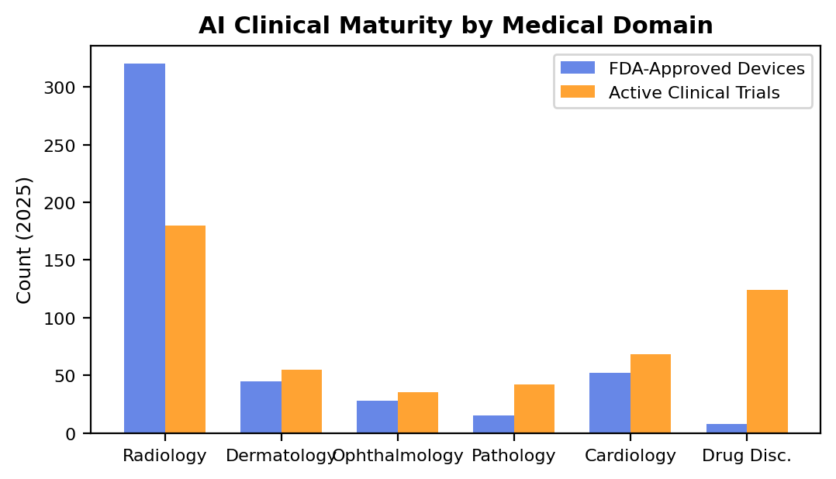
Fig. 4. Distribution of FDA-approved AI-enabled medical devices and active clinical trials across major medical domains as of 2025, illustrating the uneven clinical maturity of AI across different specialties.
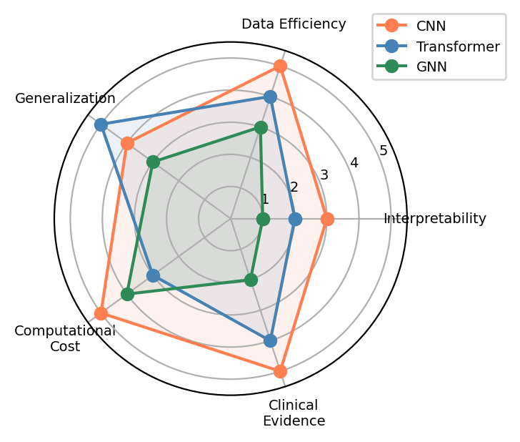
Fig. 5. Comparative assessment of CNN, Transformer, and GNN architectures across five key dimensions relevant to healthcare AI deployment, using a 1-5 rating scale.
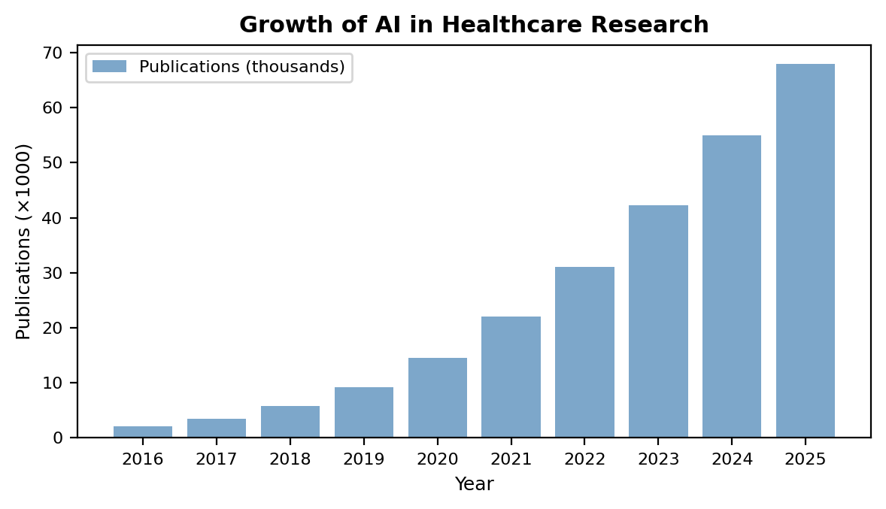
Fig. 1. Growth trajectory of AI in healthcare publications and FDA-approved AI-enabled medical devices (2016–2025).
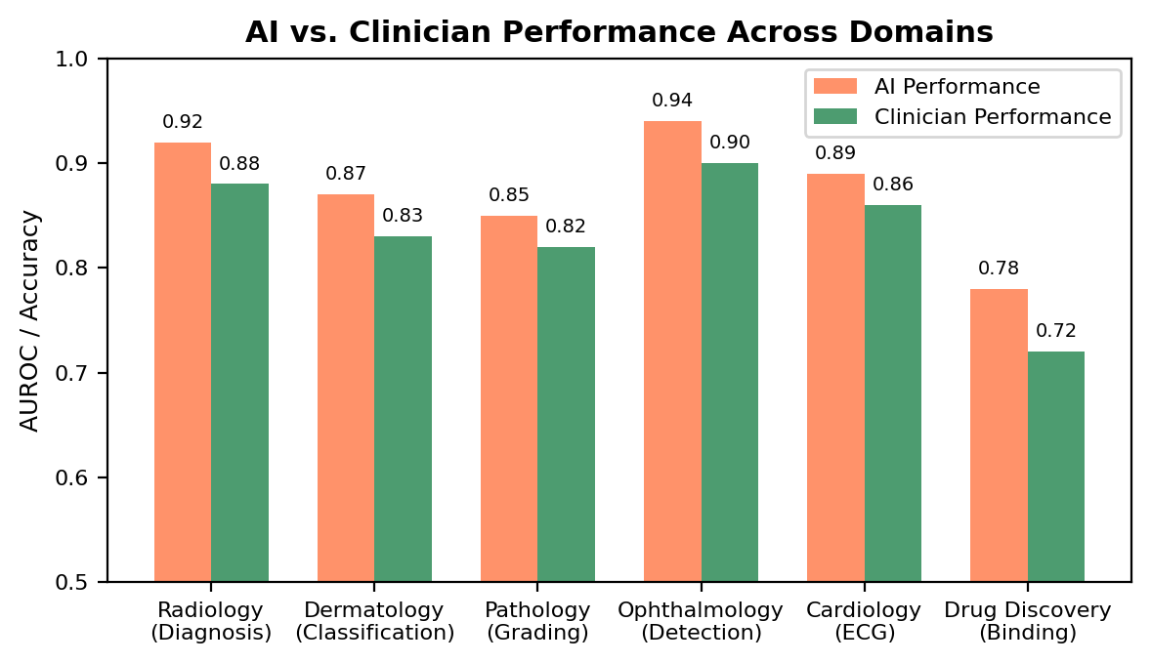
Fig. 2. Comparative performance of AI systems versus clinicians across major healthcare domains.
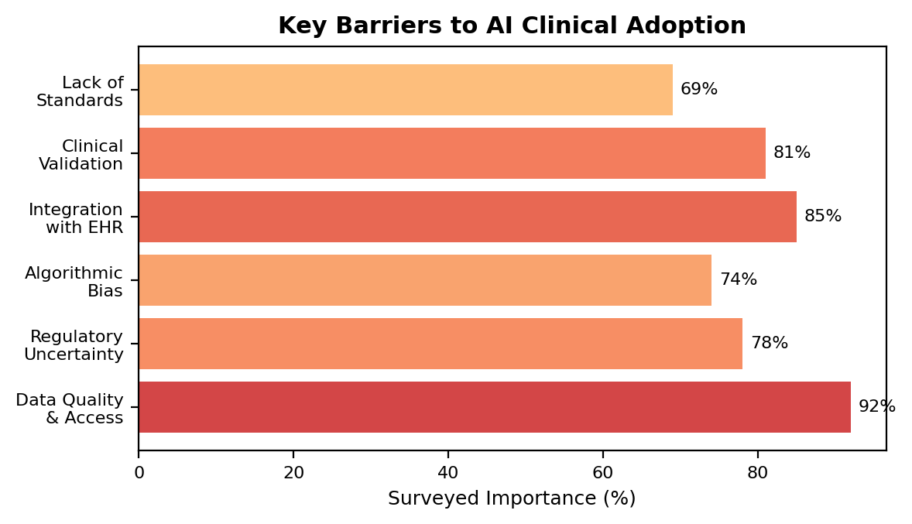
Fig. 3. Key barriers to clinical adoption of AI in healthcare, ranked by surveyed importance.

