**Exercise 2: E-commerce Platform Search Function**

Output Screen:

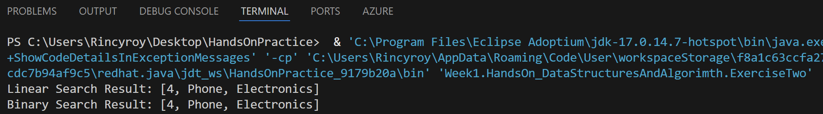

**Exercise 7: Financial Forecasting**

Output Screen:

