**Exercise 1: Inventory Management System**

Output Screen:

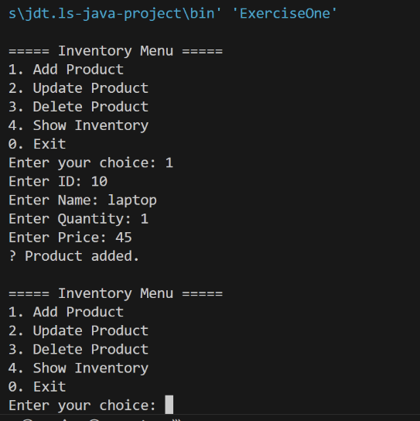

**Exercise 2: E-commerce Platform Search Function**

Output Screen:

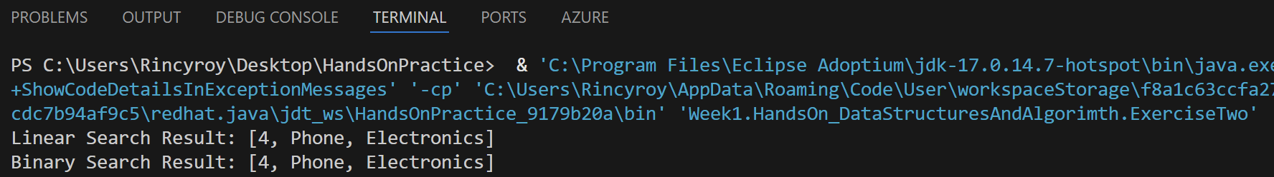

**Exercise 3: Sorting Customer Orders**

Output Screen:

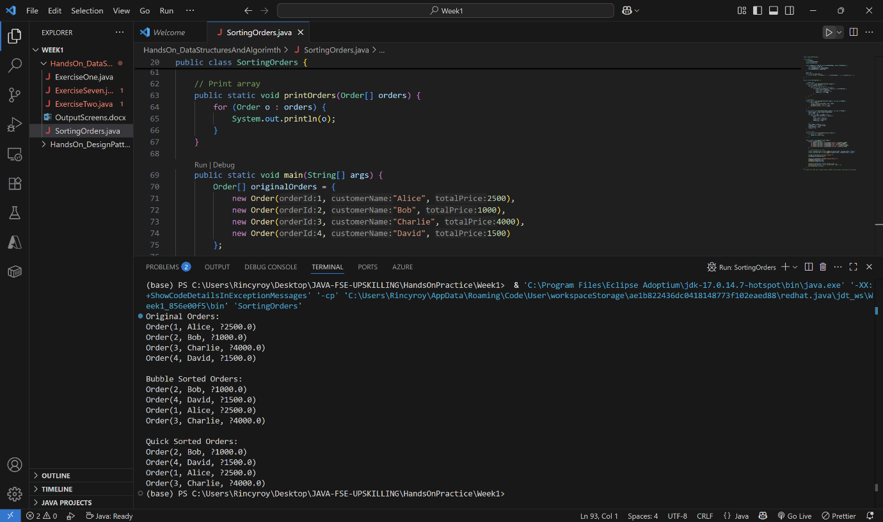

**Exercise 4: Employee Management System**

Output Screen:

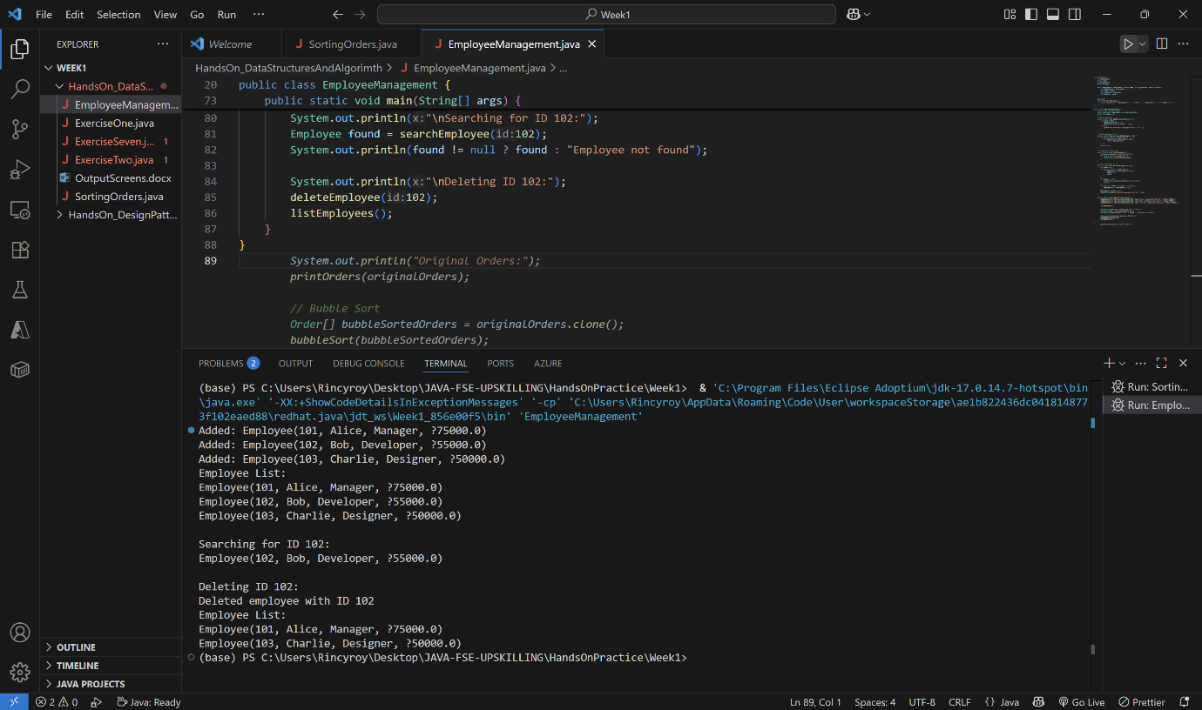

**Exercise 5: Task Management System**

Output Screen:

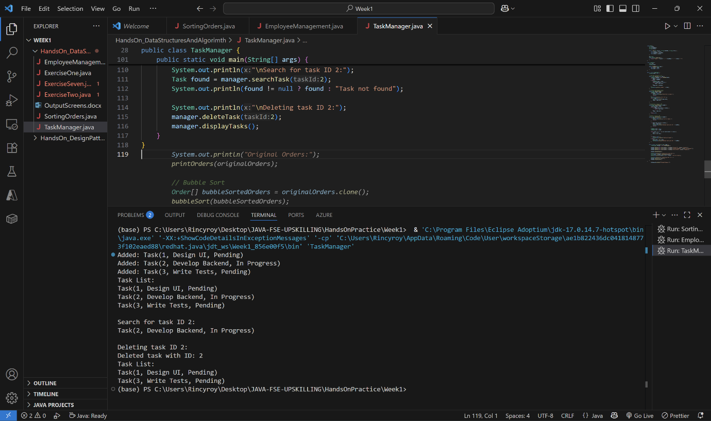

**Exercise 6: Library Management System**

Output Screen:

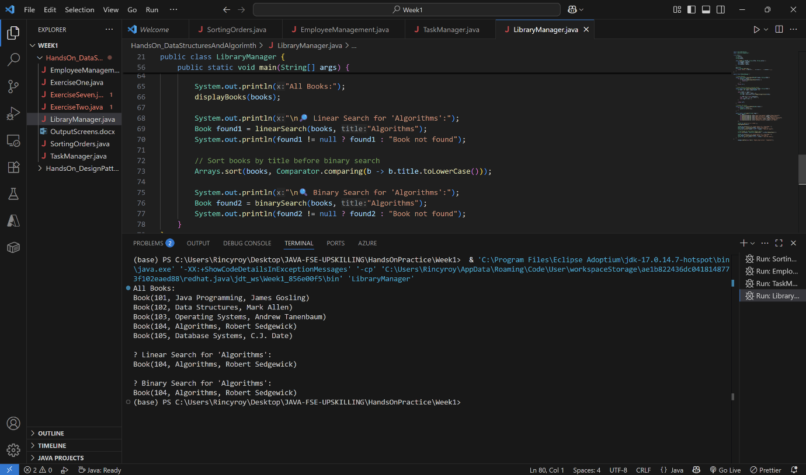

**Exercise 7: Financial Forecasting**

Output Screen:

