**Exercise 1: Parameterized Tests**

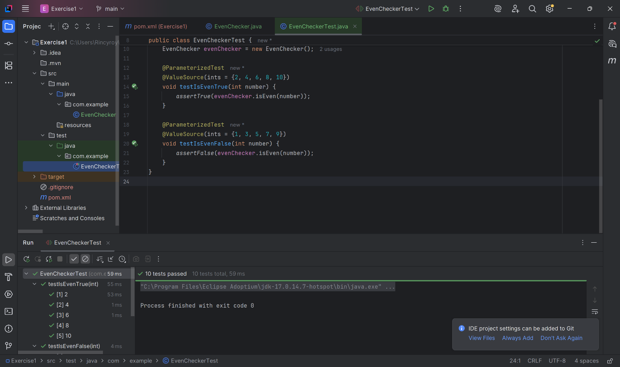**Exercise 2: Test Suites and Categories** 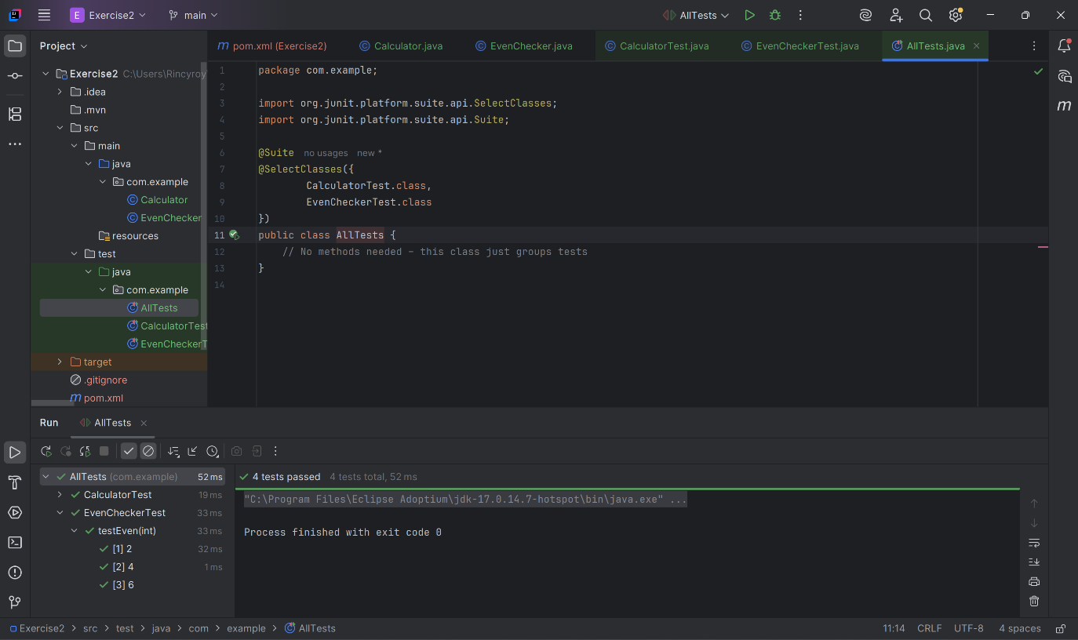

**Exercise 3: Test Execution Order**

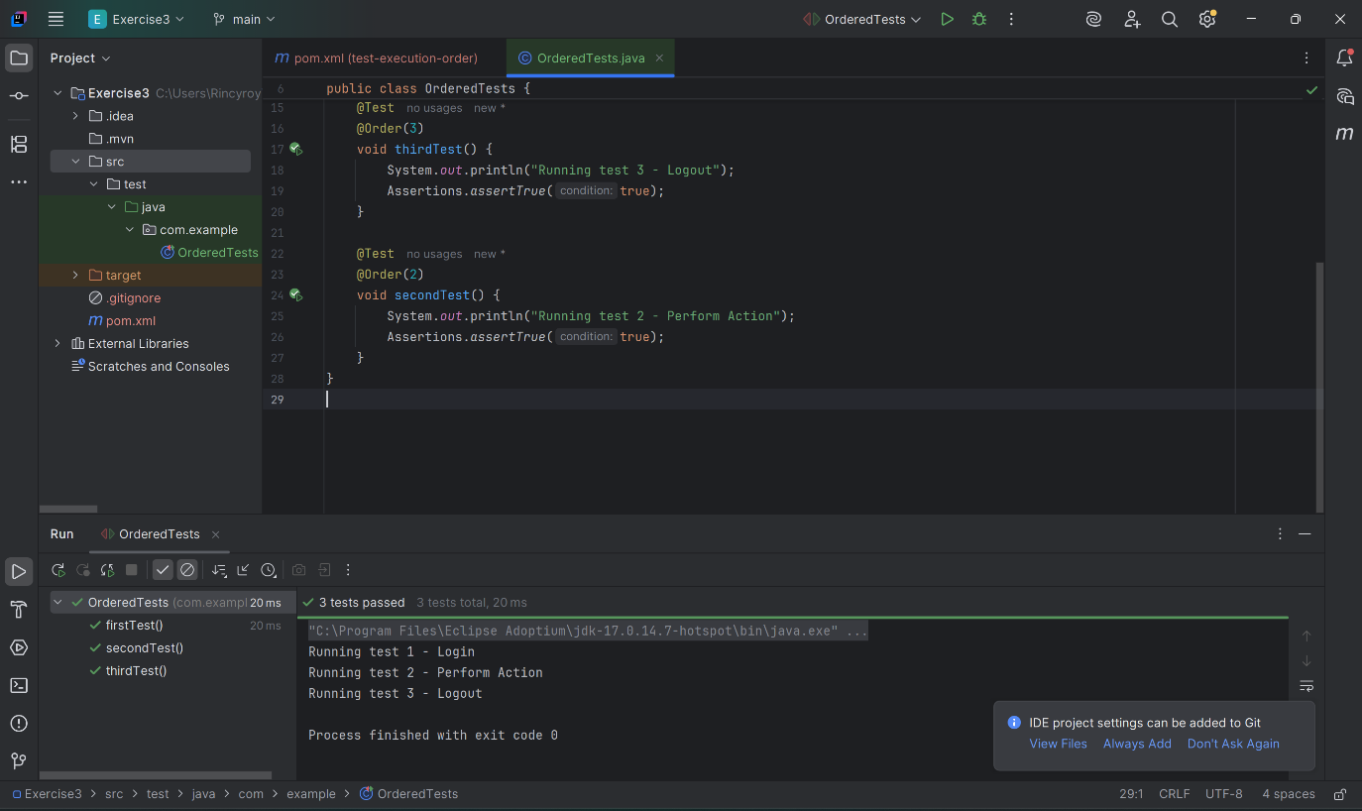

**Exercise 4: Exception Testing**

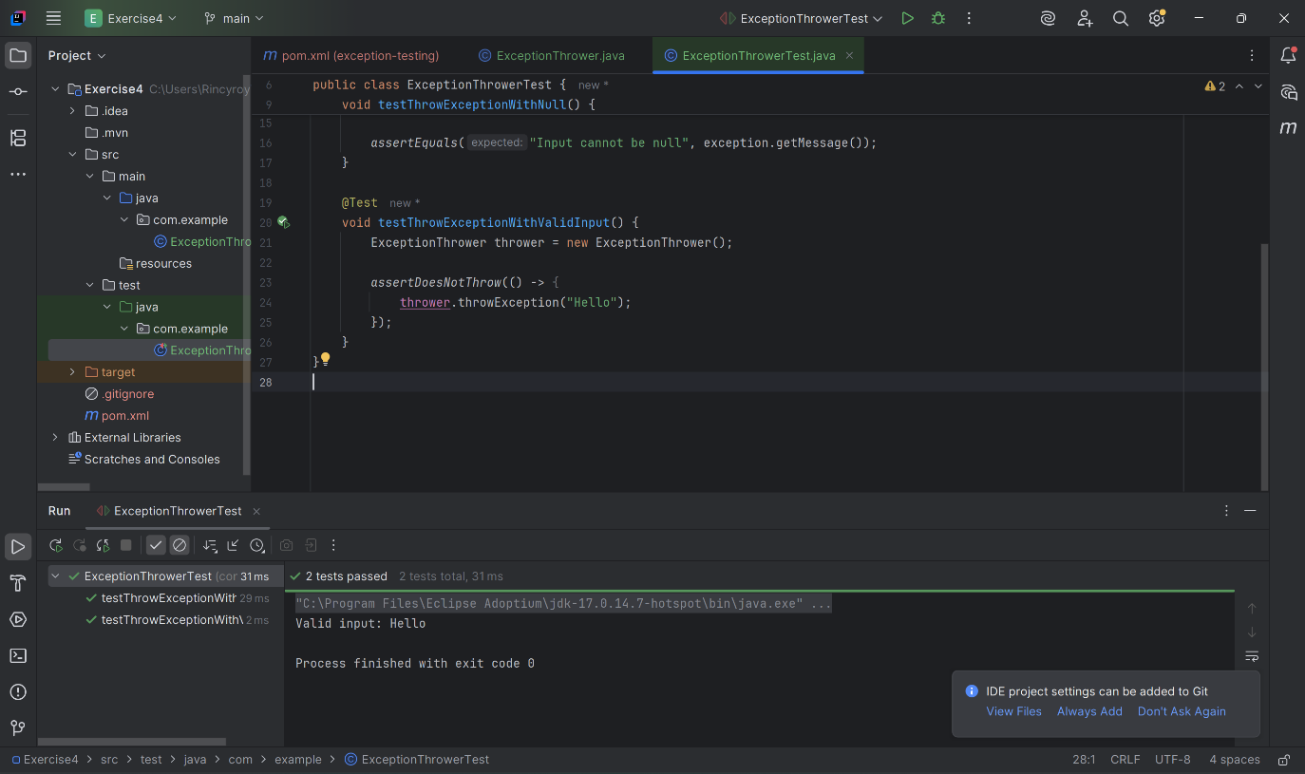

**Exercise 5: Timeout and Performance Testing**

