**Exercise 1: Setting Up Junit**

Output:

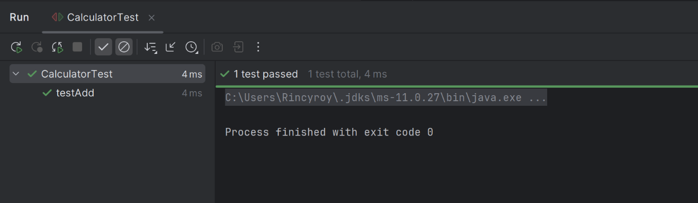

**Exercise 2: Writing Basic JUnit Tests**

Output:

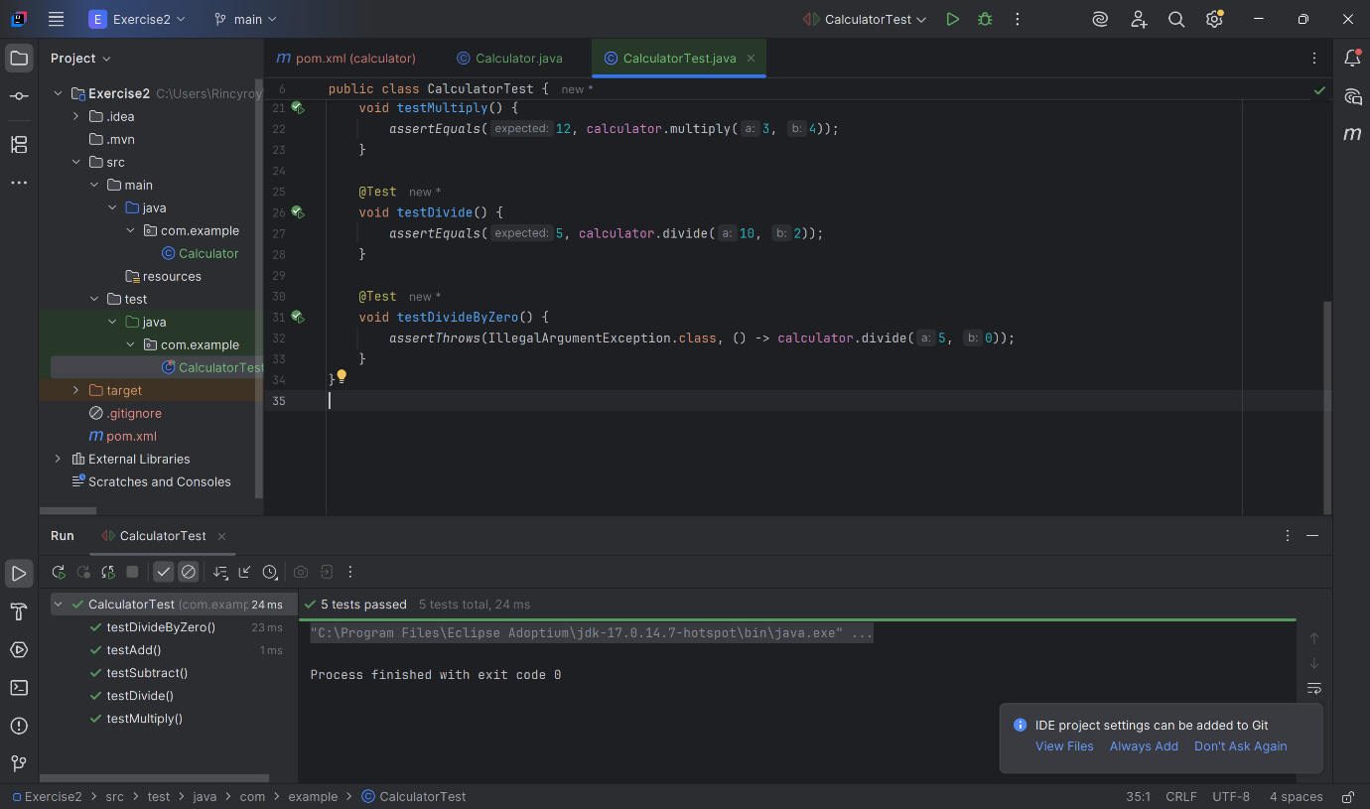

**Exercise 3: Assertions in Junit**

Output:

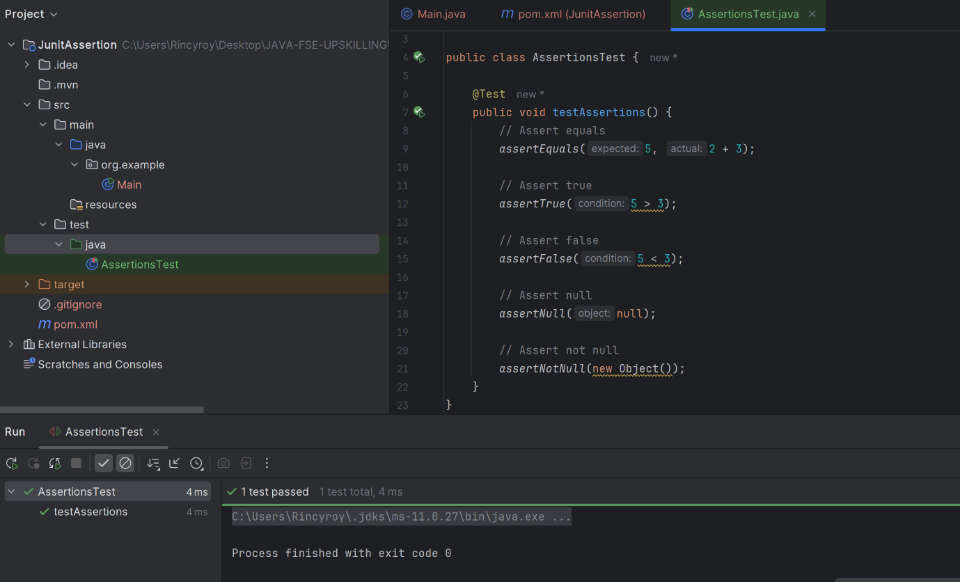

**Exercise 4: Arrange-Act-Assert (AAA) Pattern, Test Fixtures, Setup and Teardown Methods in Junit**

Output: