**Exercise 1: Basic Unit Test for a Service Method**

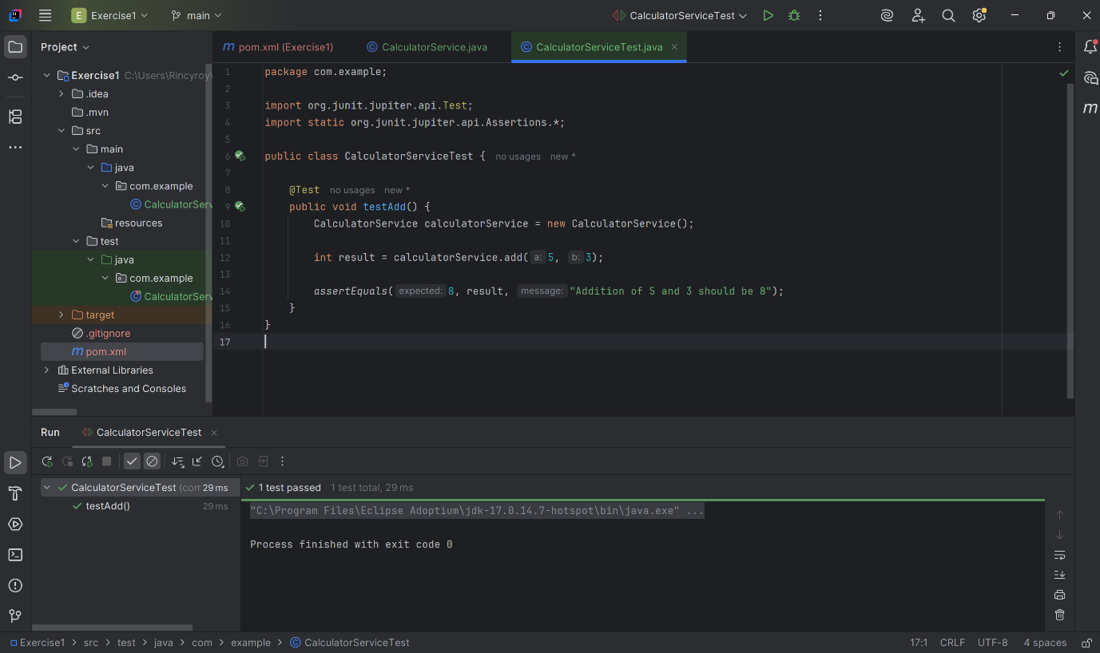

**Exercise 2: Mocking a Repository in a Service Test**

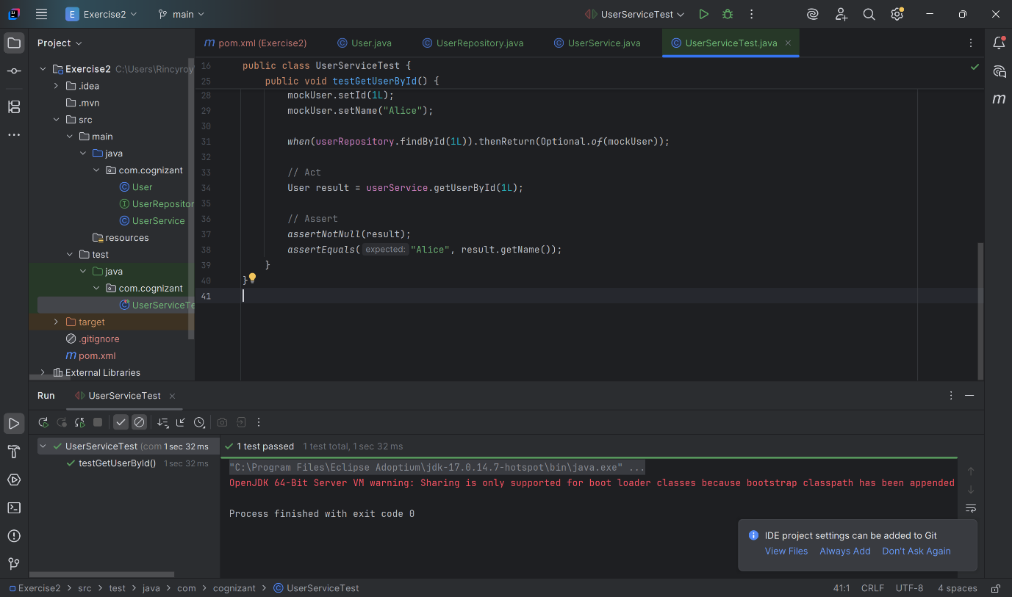

**Exercise 3: Testing a REST Controller with MockMvc**

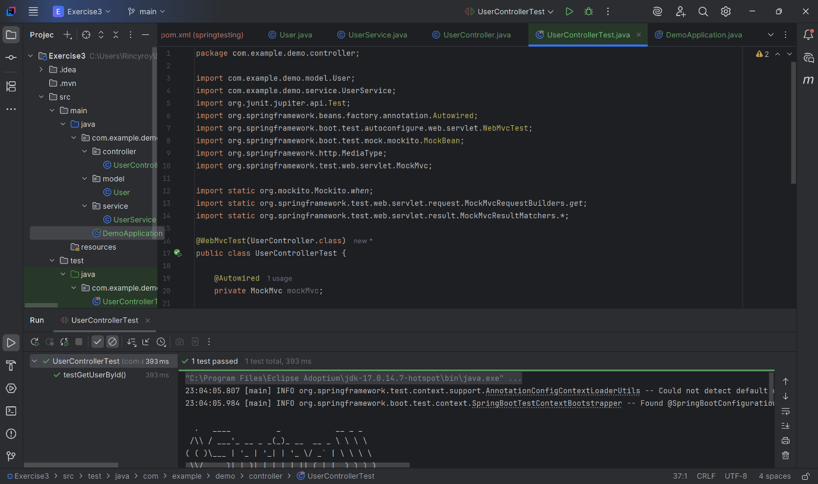

**Exercise 4: Integration Test with Spring Boot**

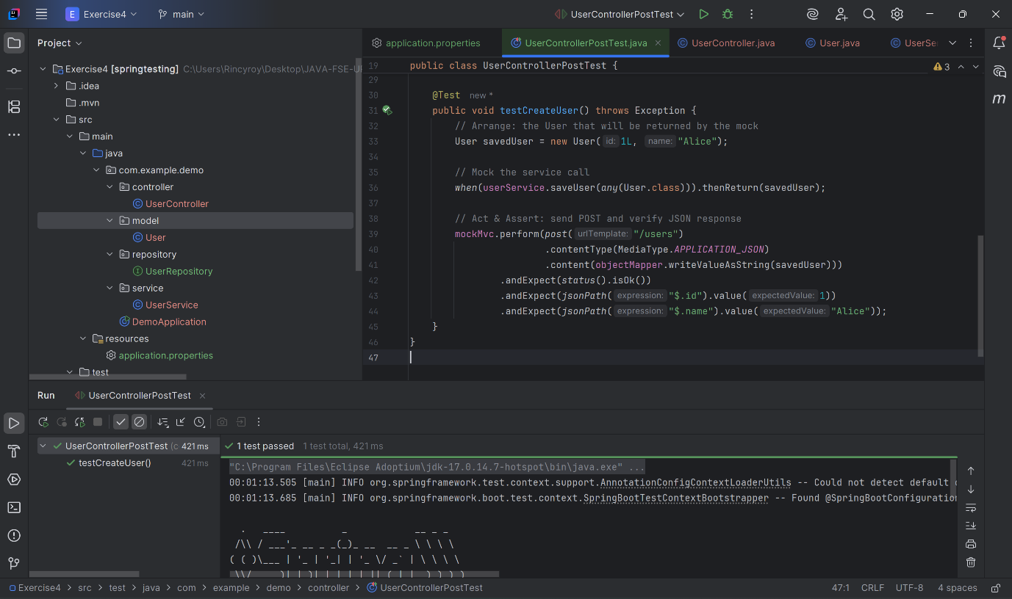

**Exercise 5: Test Controller POST Endpoint**

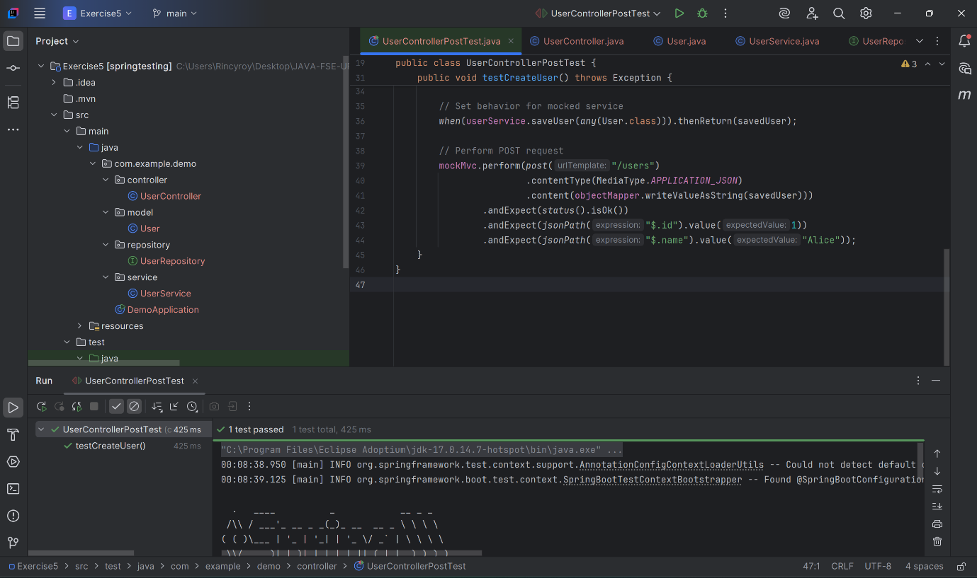

**Exercise 6: Test Service Exception Handling**

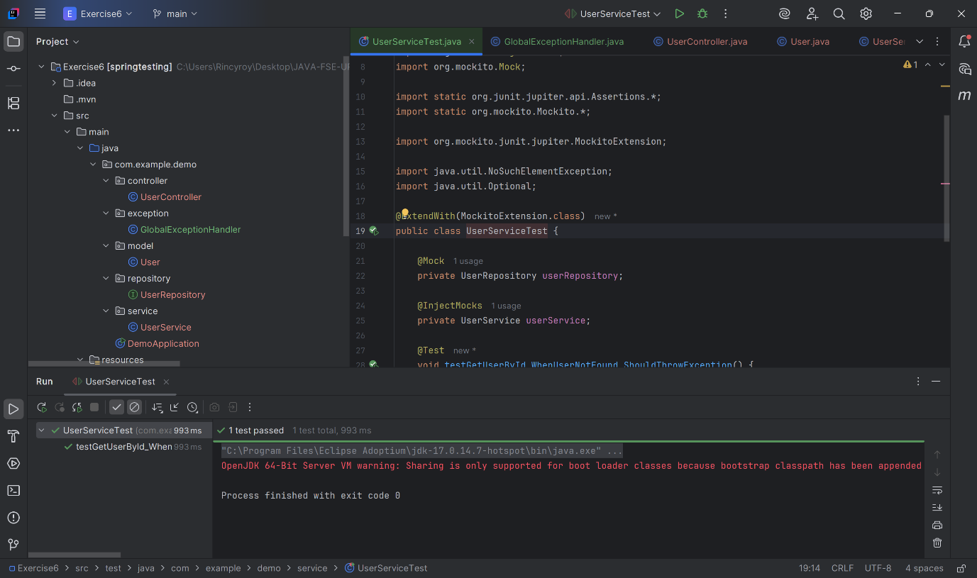

**Exercise 7: Test Custom Repository Query**

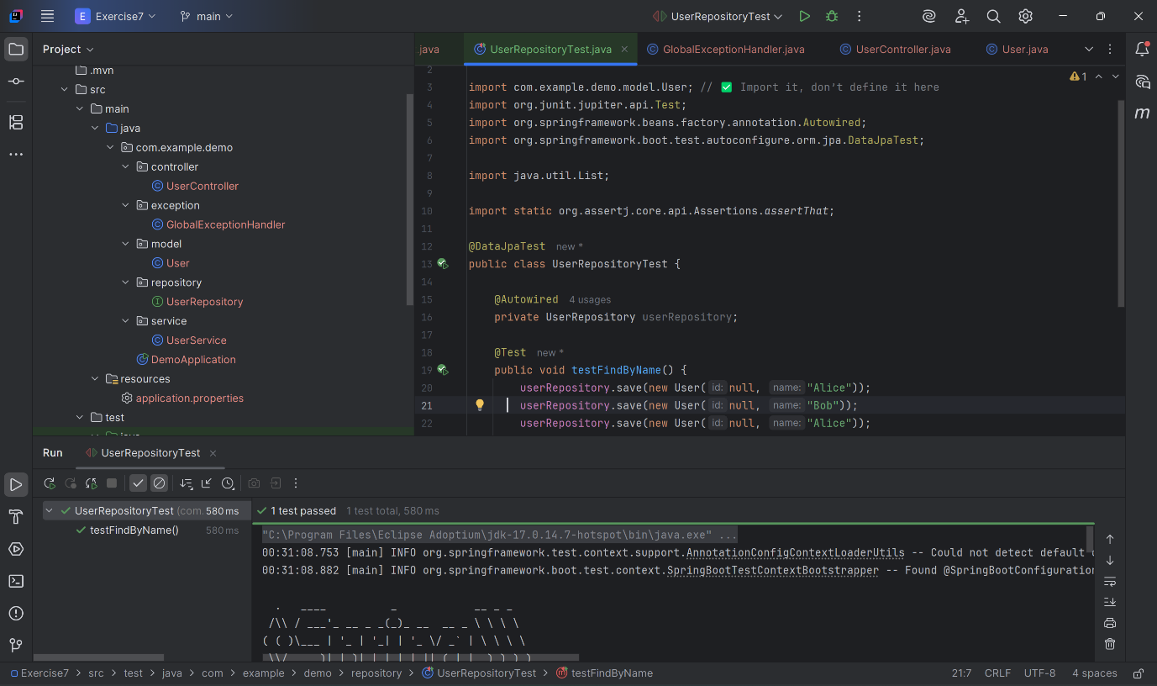

**Exercise 8: Test Controller Exception Handling**

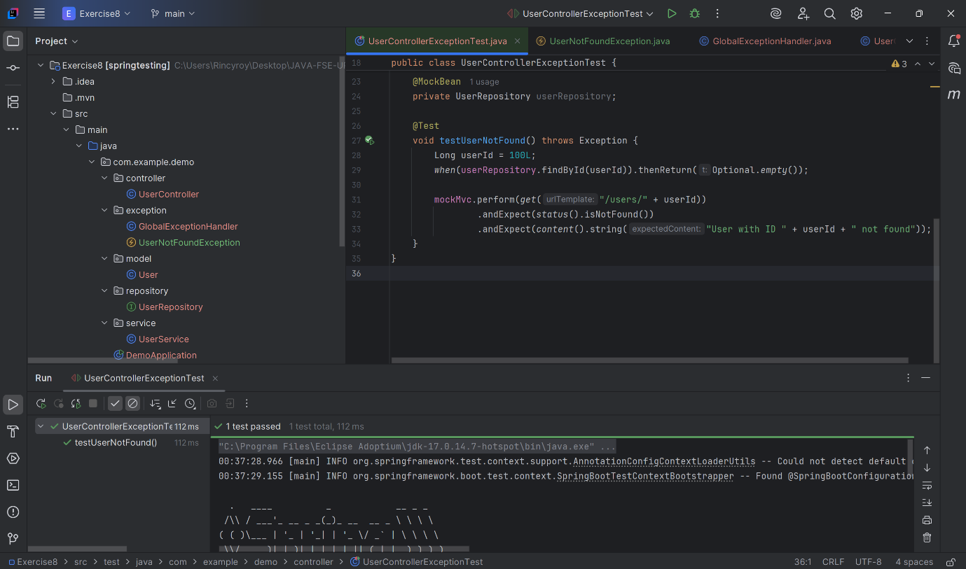

**Exercise 9: Parameterized Test with JUnit**