**Exercise 1: Logging Error Messages and Warning Levels**

**Output:**

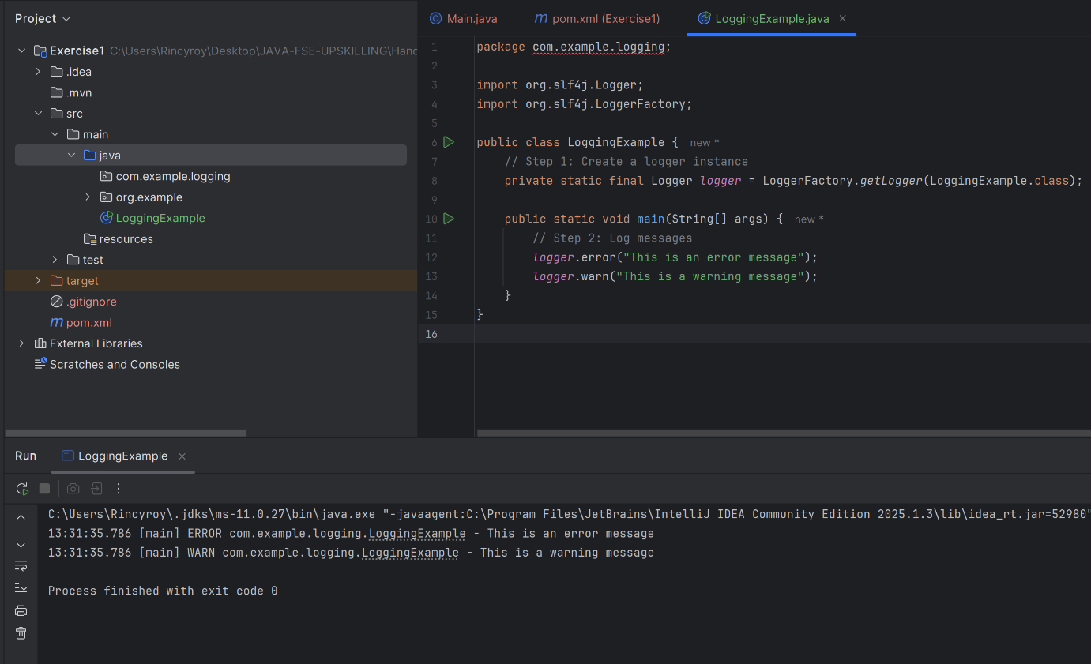

**Exercise 2: Parameterized Logging**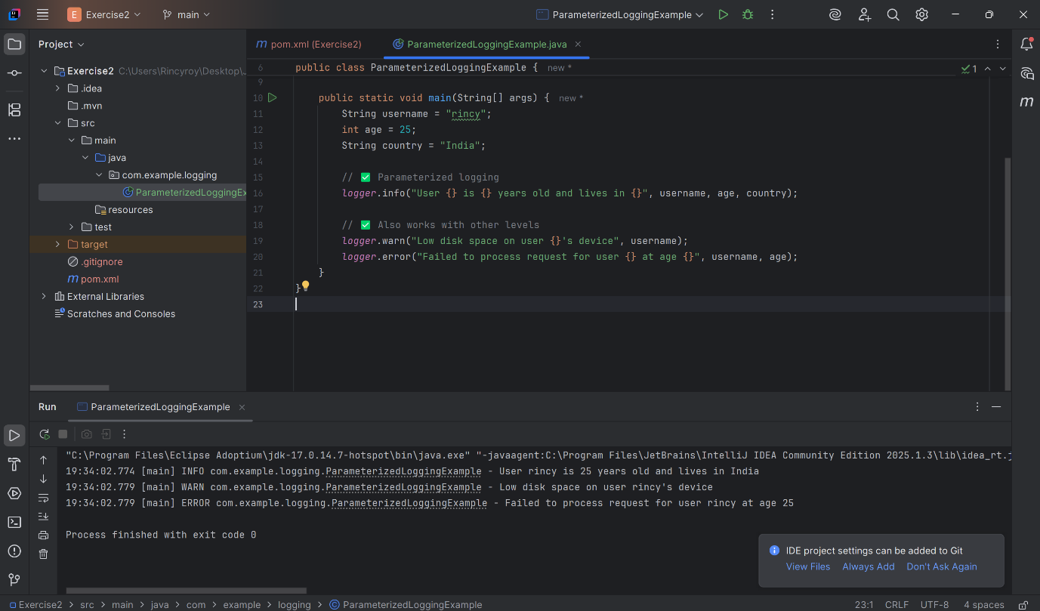

**Exercise 3: Using Different Appenders**