**Exercise 1: Mocking and Stubbing**

**Output:**

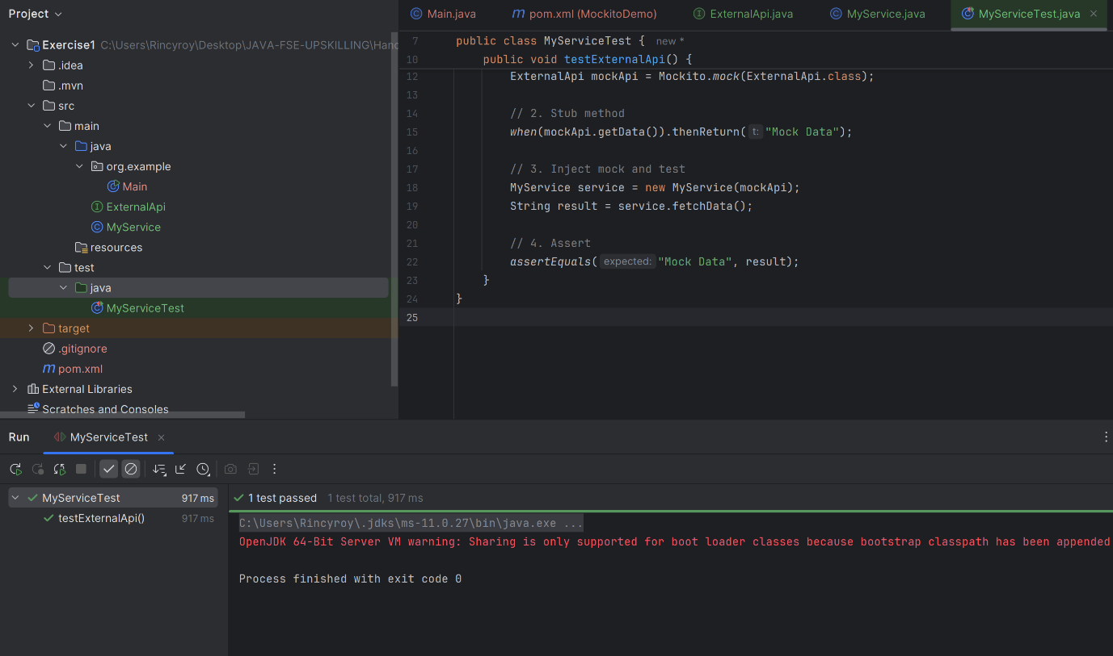

**Exercise 2: Verifying Interactions**

**Output:**

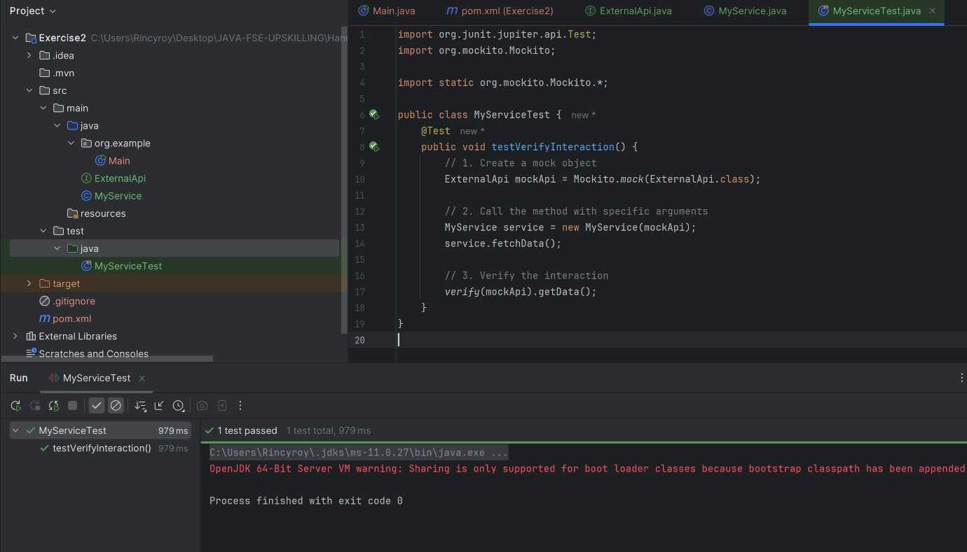

**Exercise 3: Argument Matching**

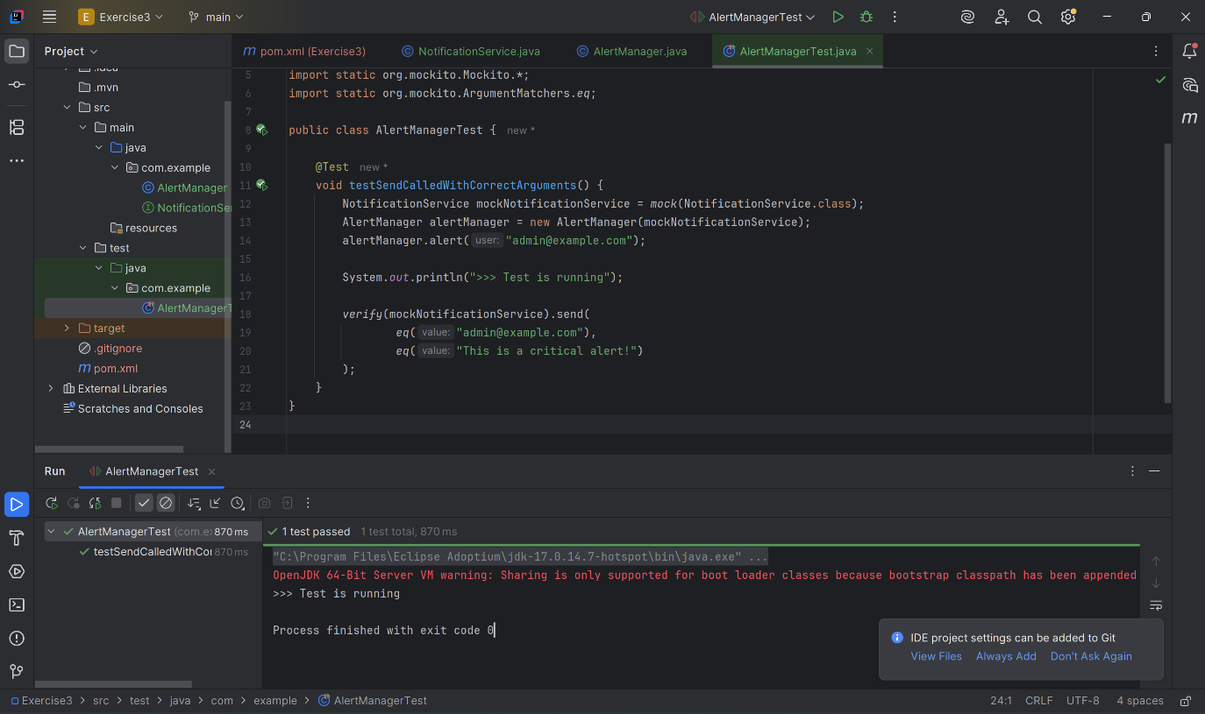

**Exercise 4: Handling Void Methods**

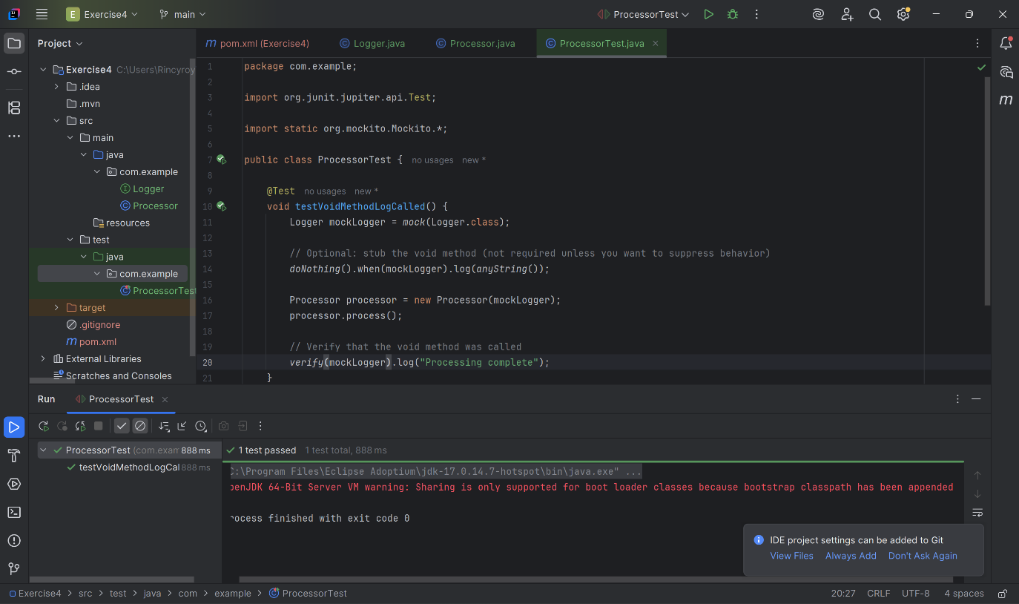

**Exercise 5: Mocking and Stubbing with Multiple Returns**

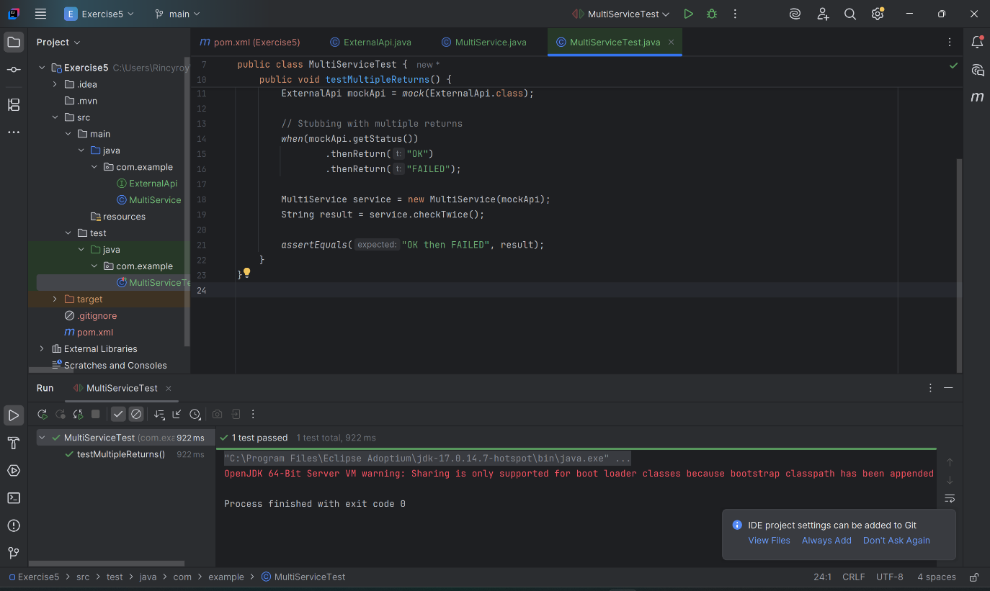

**Exercise 6: Verifying Interaction Order**

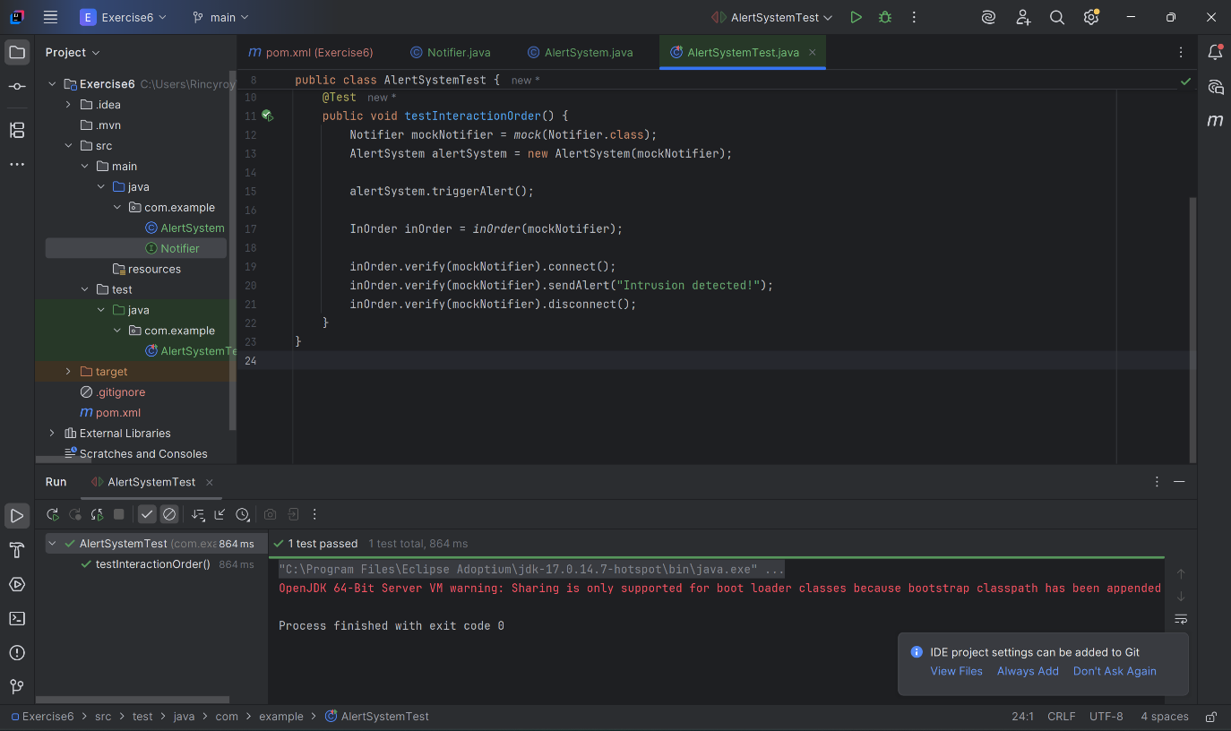

**Exercise 7: Handling Void Methods with Exceptions**

