**Exercise 1: Mocking a Service Dependency in a Controller Test**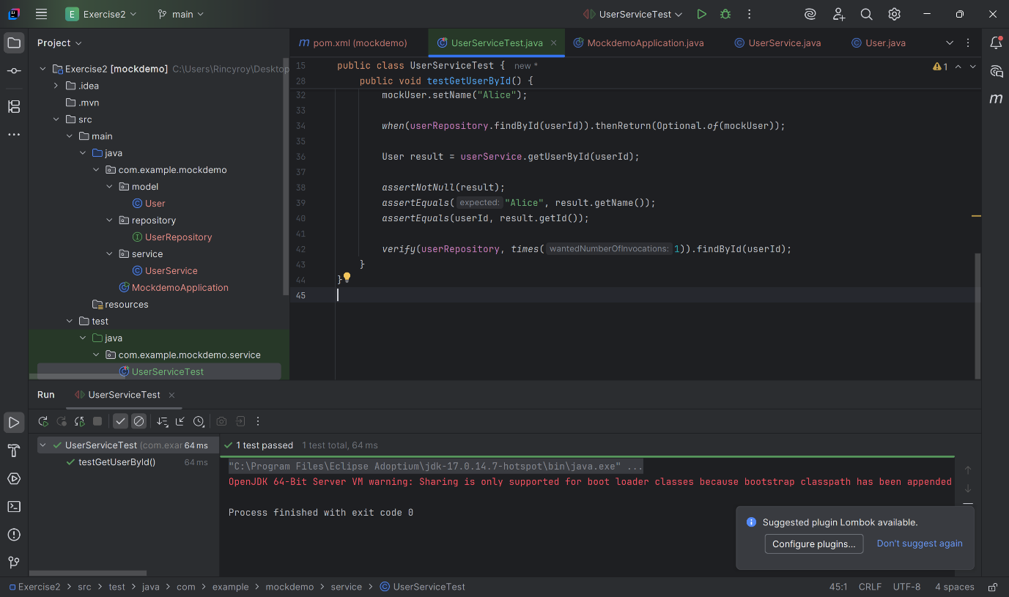

**Exercise 2: Mocking a Repository in a Service Test**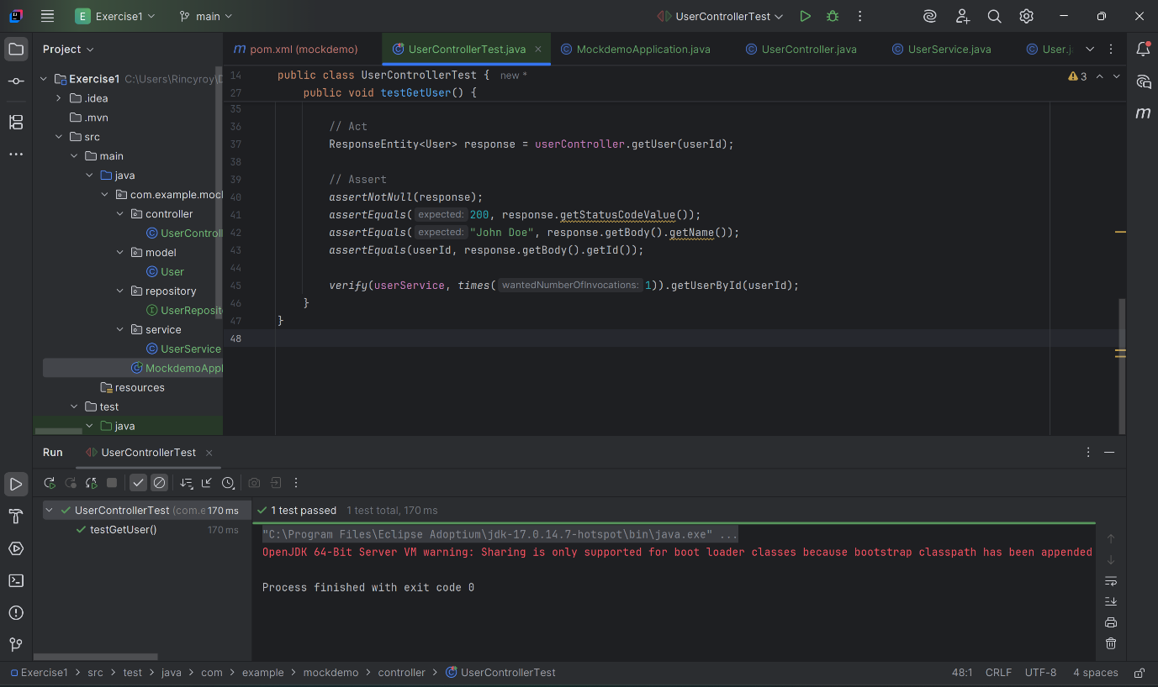

**Exercise 3: Mocking a Service Dependency in an Integration Test**