**Exercise 1: Mocking and Stubbing**

**Output:**

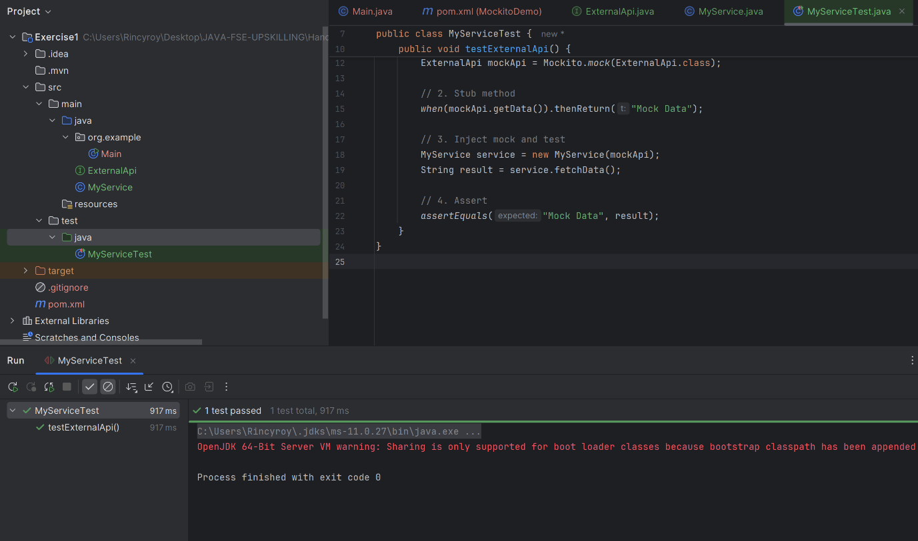

**Exercise 2: Verifying Interactions**

**Output:**

