**Exercise 1: Control Structures**

Output:

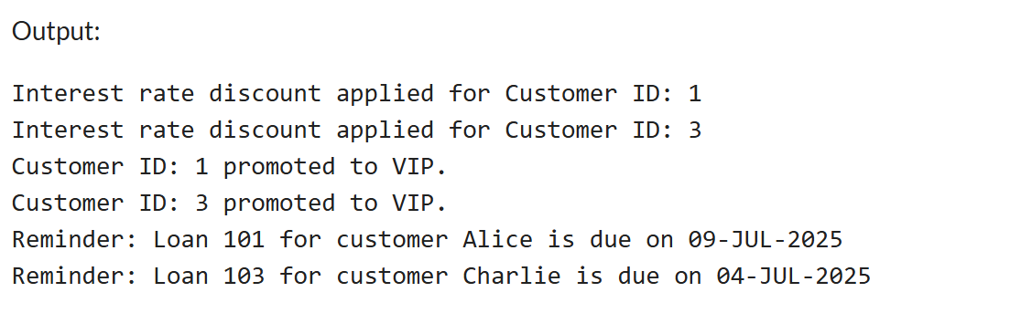

**Exercise 2: Error Handling**

Output:

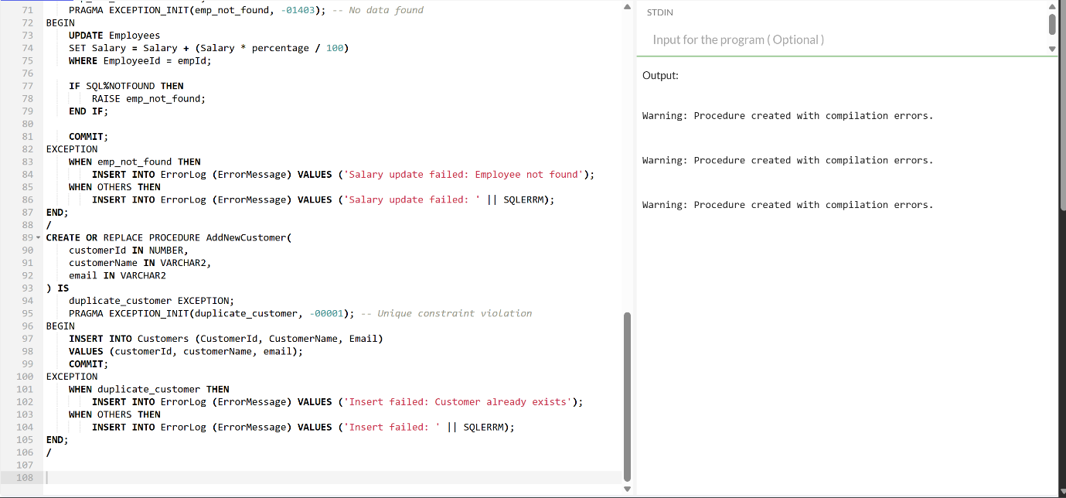

**Exercise 3: Stored Procedures**

Output:

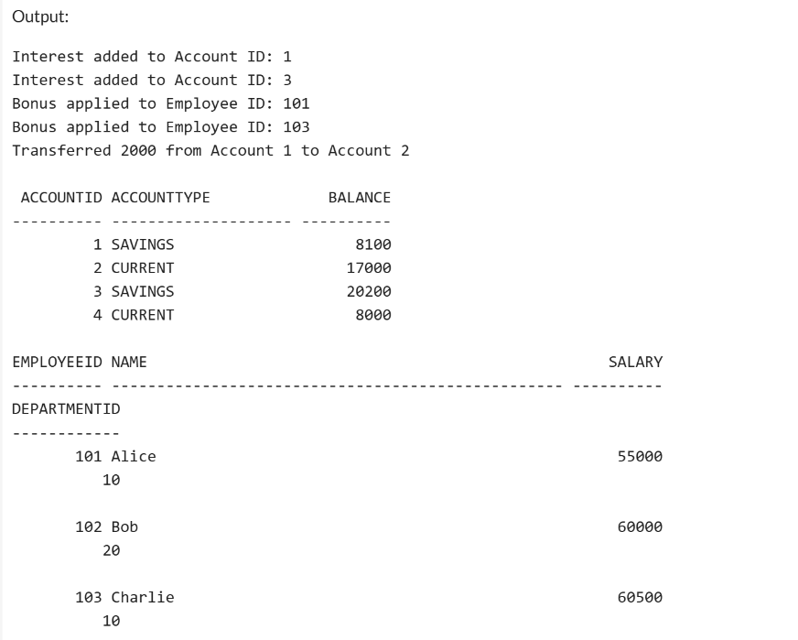

**Exercise 4: Functions**

Output:

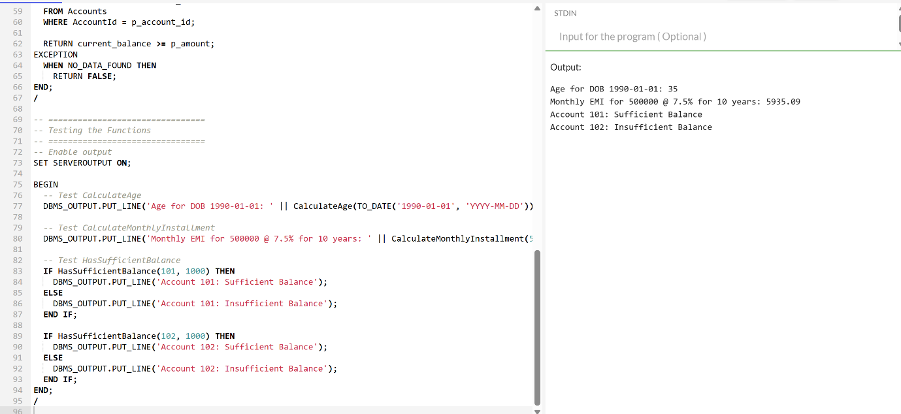

**Exercise 5: Triggers**

Output:

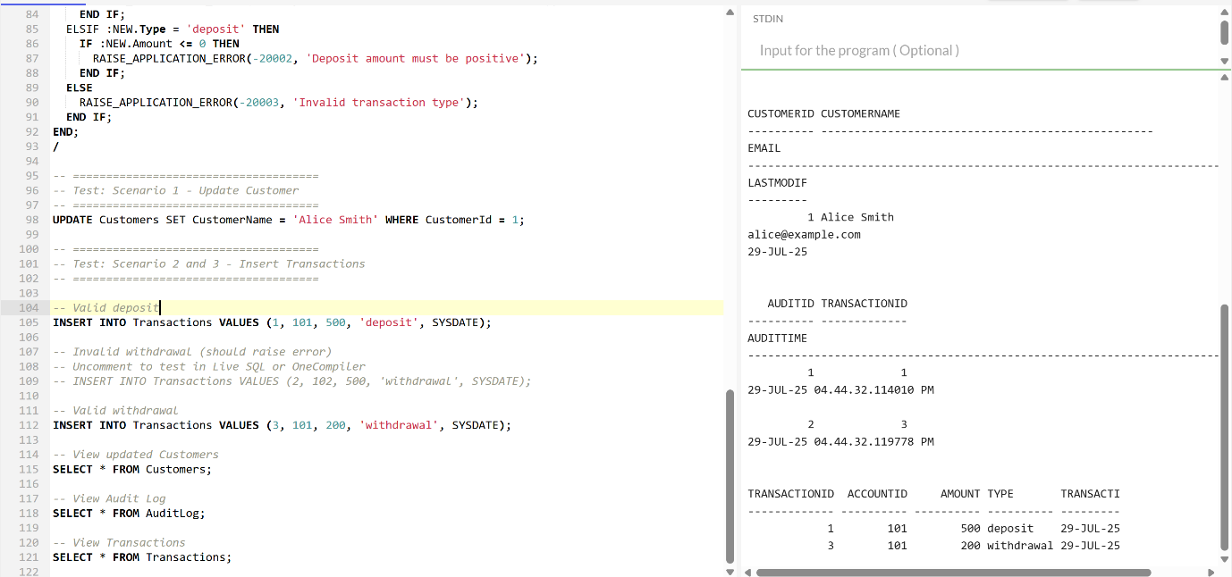

**Exercise 6: Cursors**

Output:

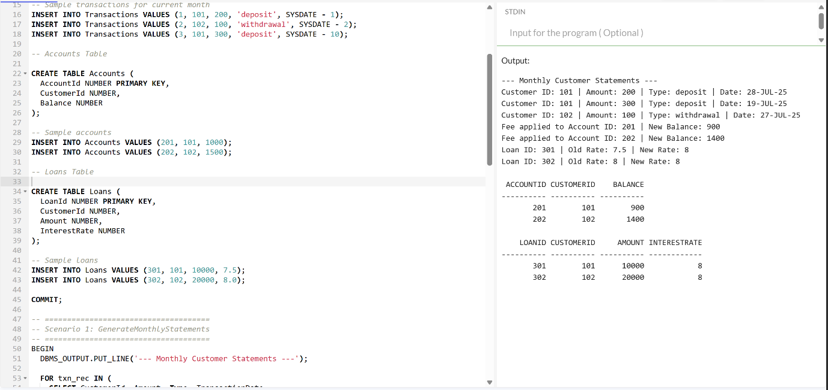

**Exercise 7: Packages**

Output:

