**Exercise 1: Configuring a Basic Spring Application**

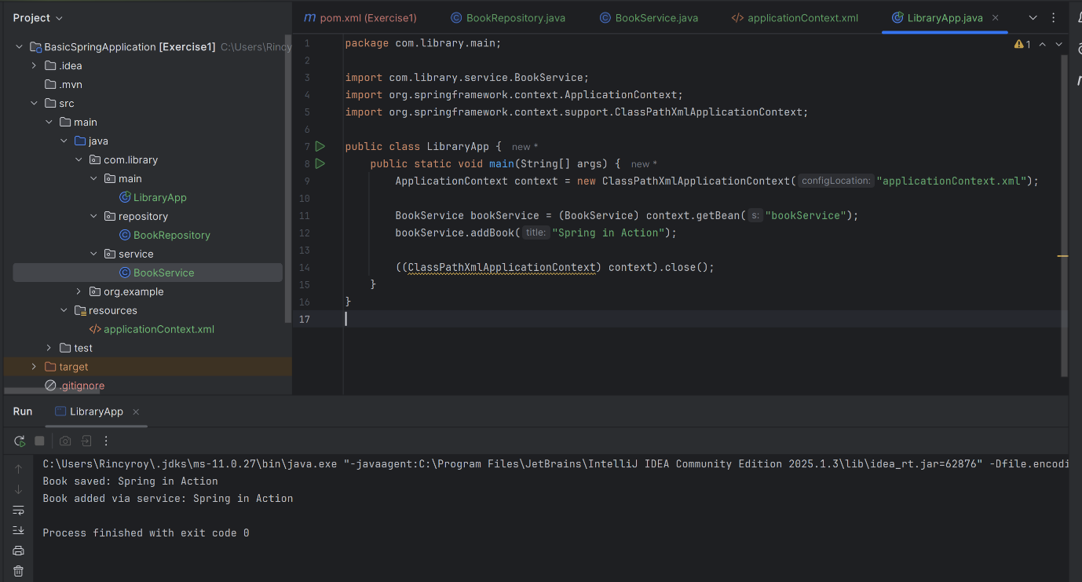

**Exercise 2: Implementing Dependency Injection**

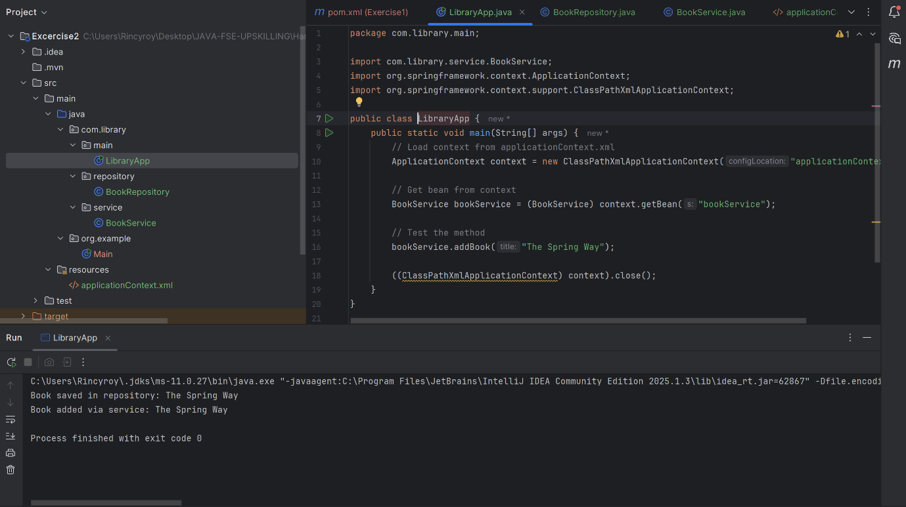

**Exercise 5: Configuring the Spring IoC Container**

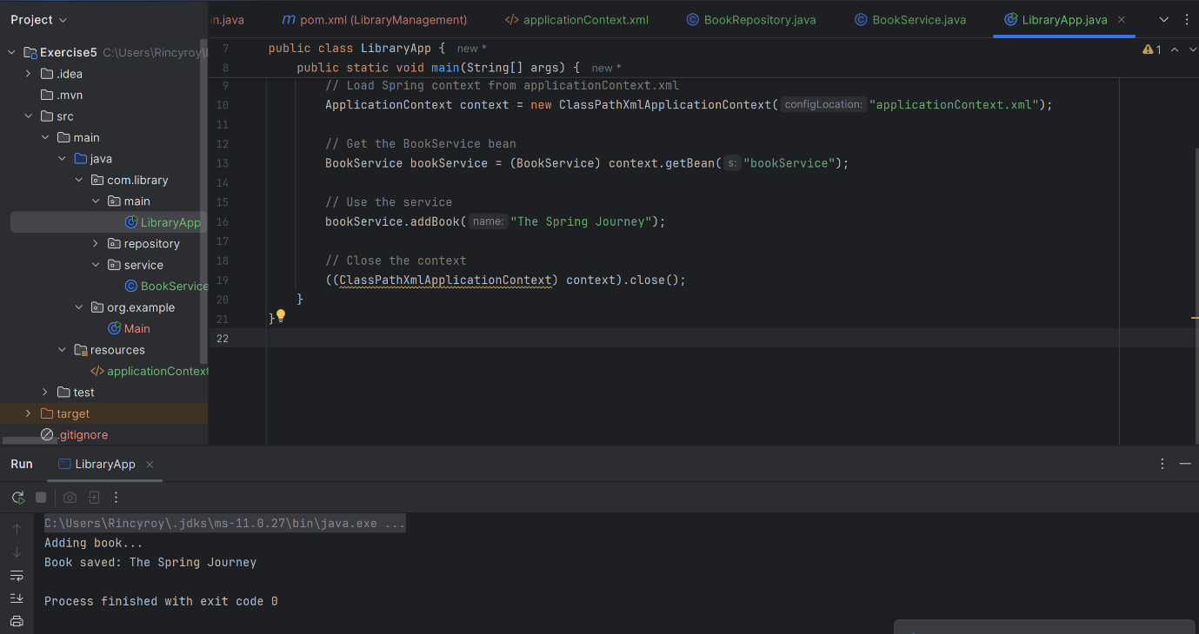

**Exercise 7: Implementing Constructor and Setter Injection**

