**Hands on 1**

**Create a Spring Web Project using Maven**

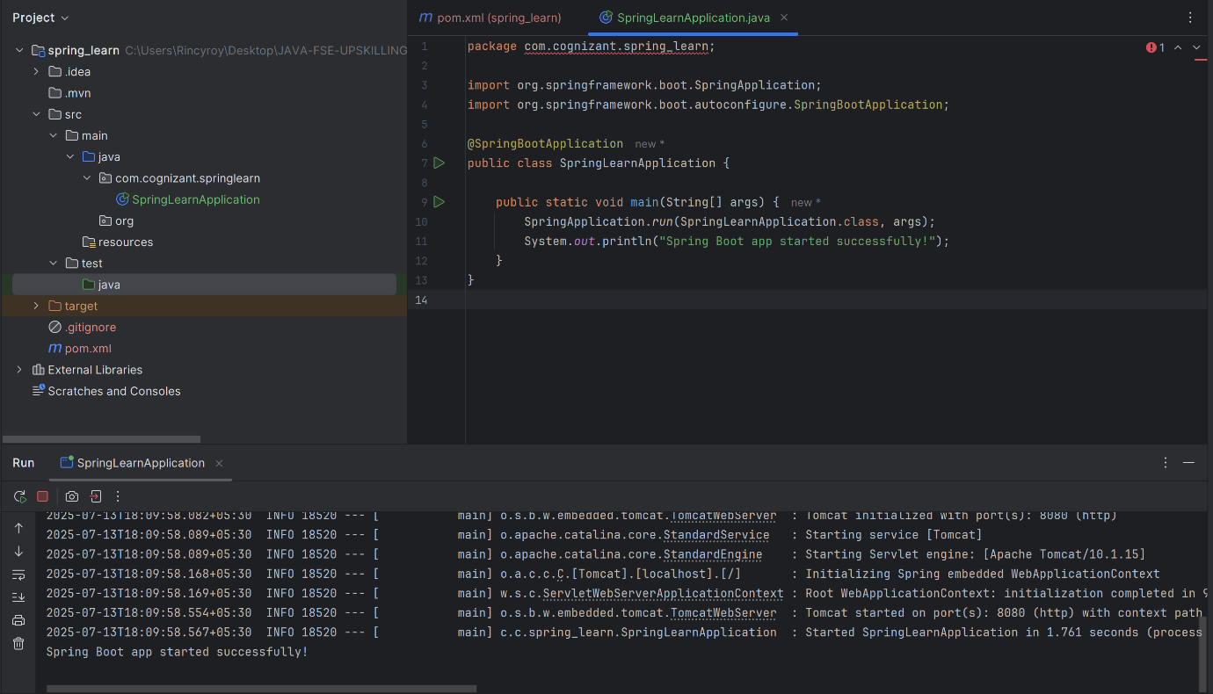

**Hands on 4**

**Spring Core – Load Country from Spring Configuration XML**   
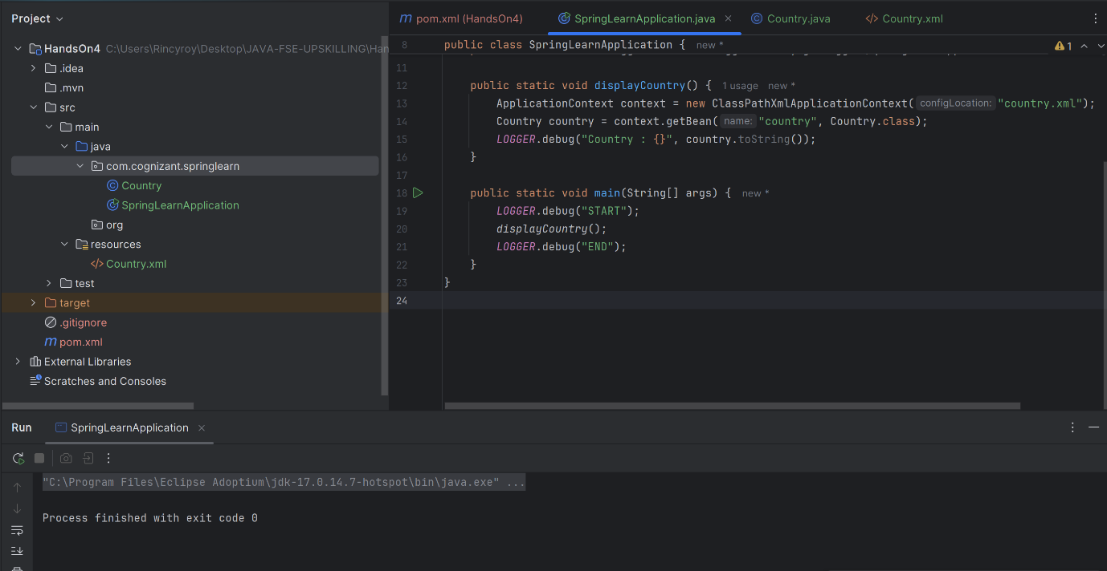

**Hello World RESTful Web Service**

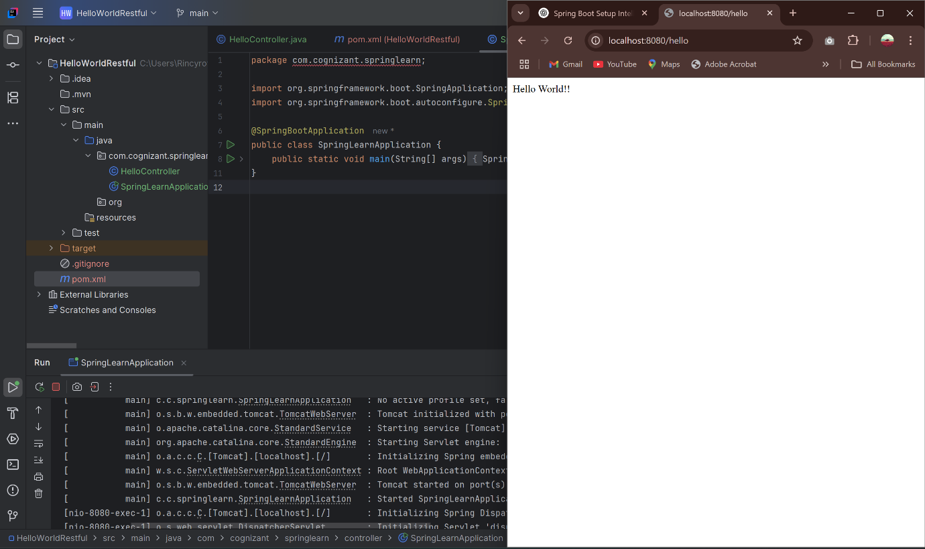

**REST - Get country based on country code**   
