**Exercise1: myfirstreact**

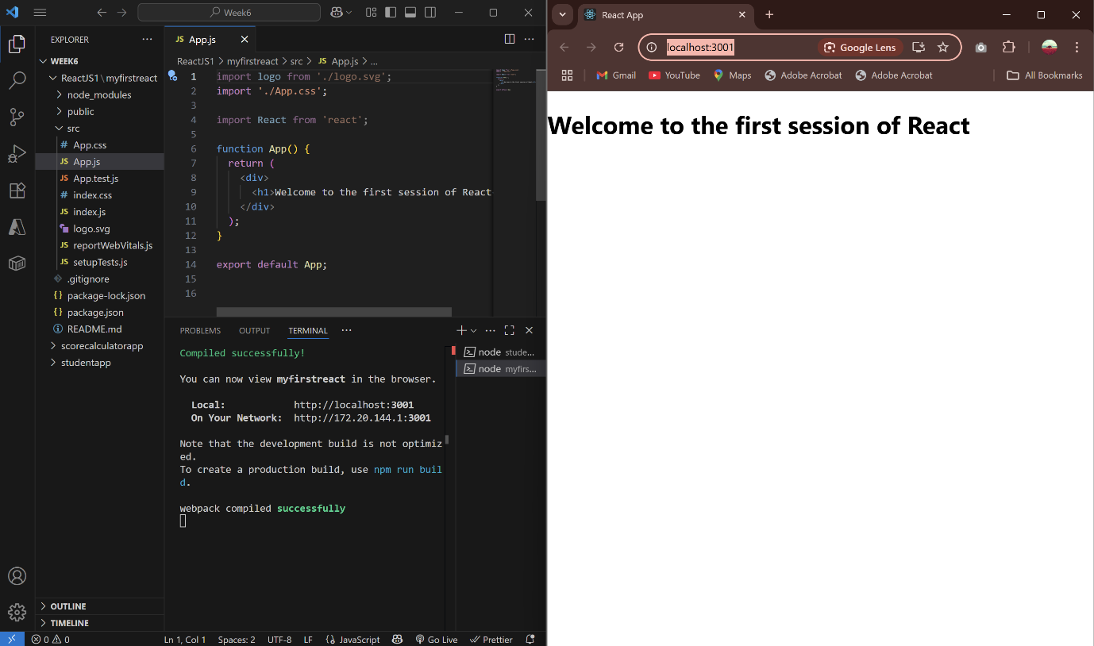

**Exercise2: StudentApp**

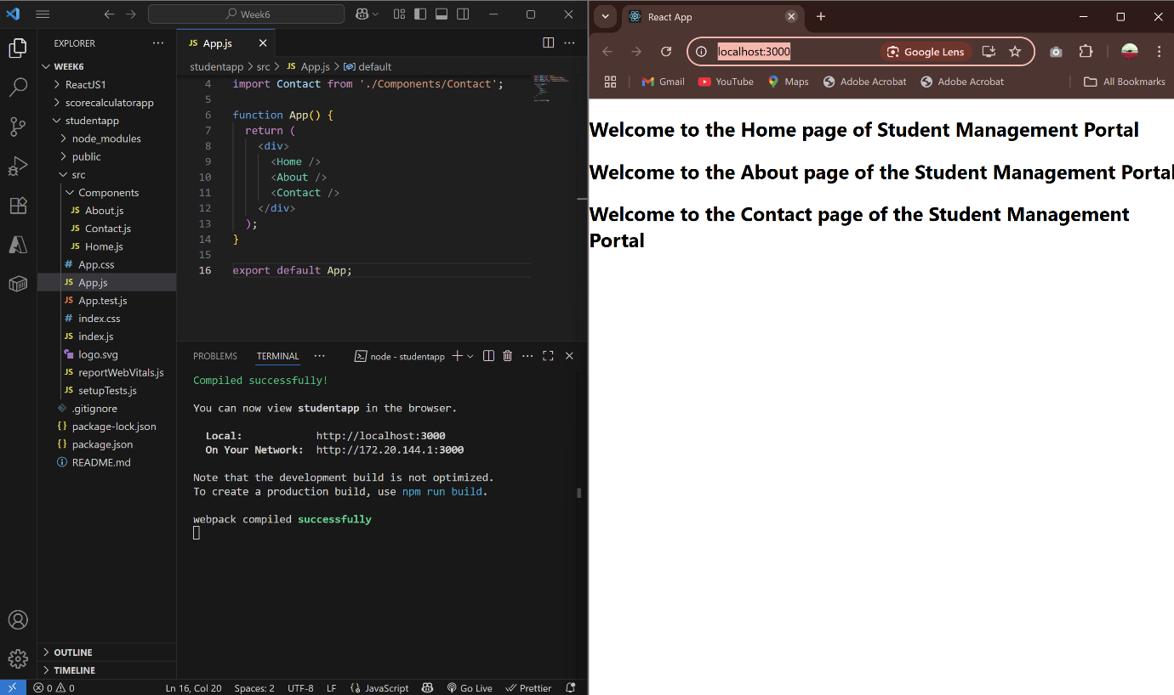

**Exercise3: scorecalculatorapp**

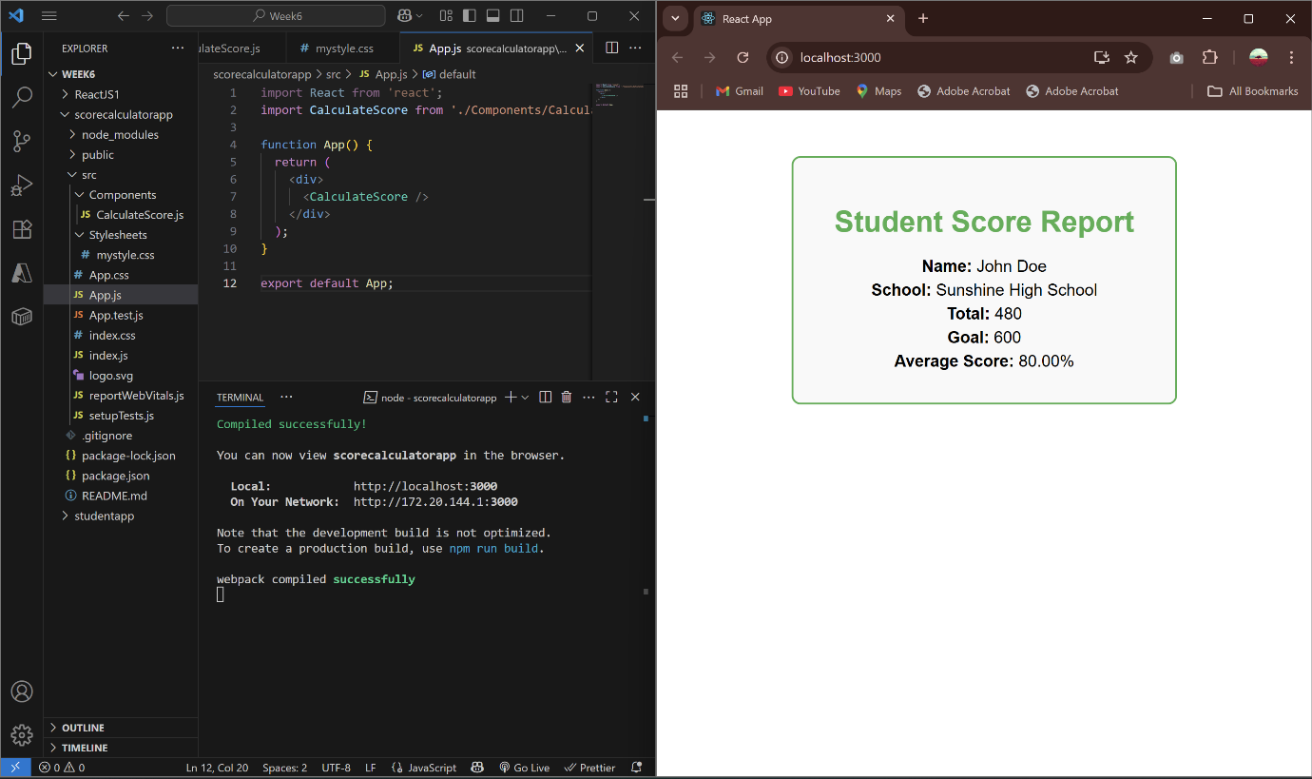

**Exercise4: blogapp**

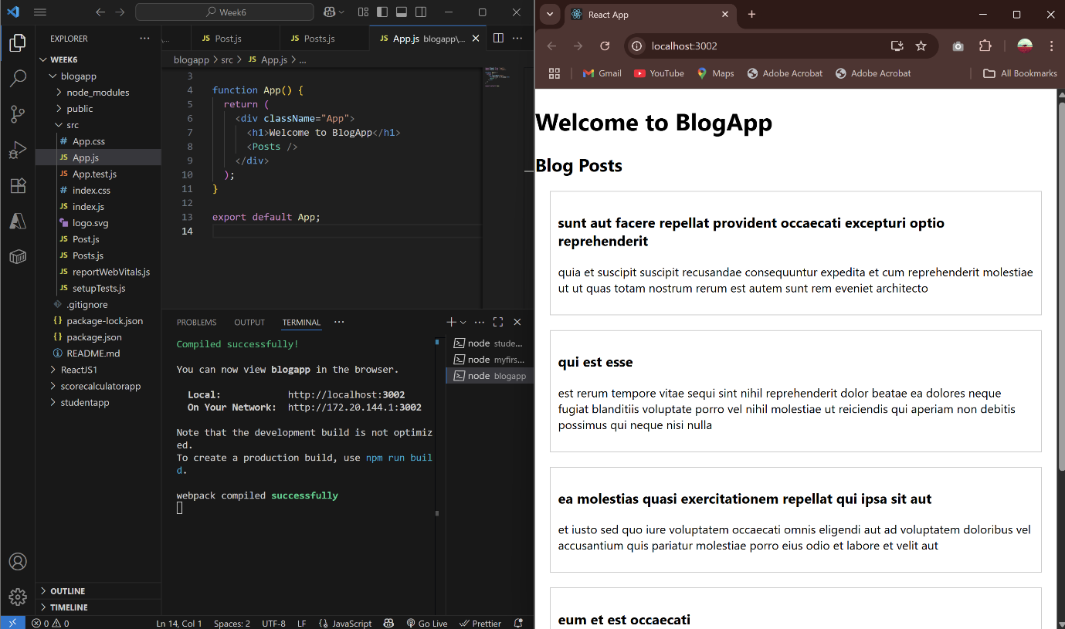

**Exercise5: cohorttracker**

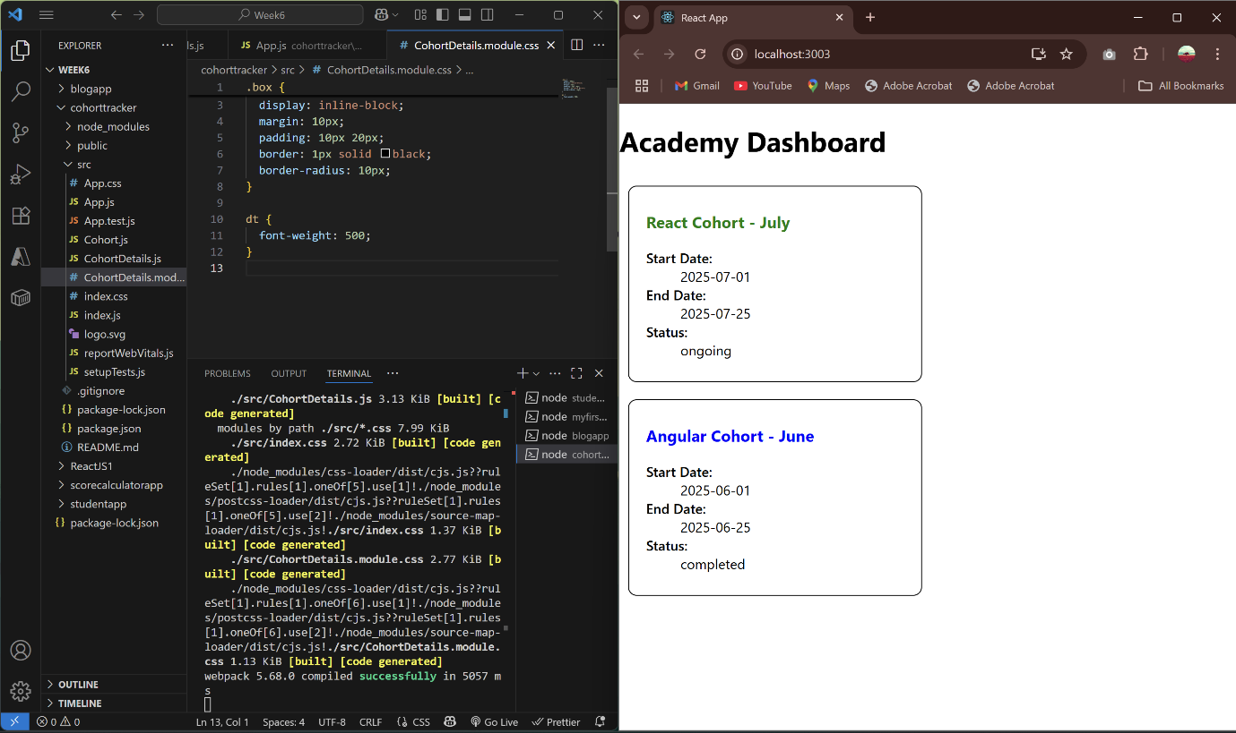

**Exercise6: TrainersApp**

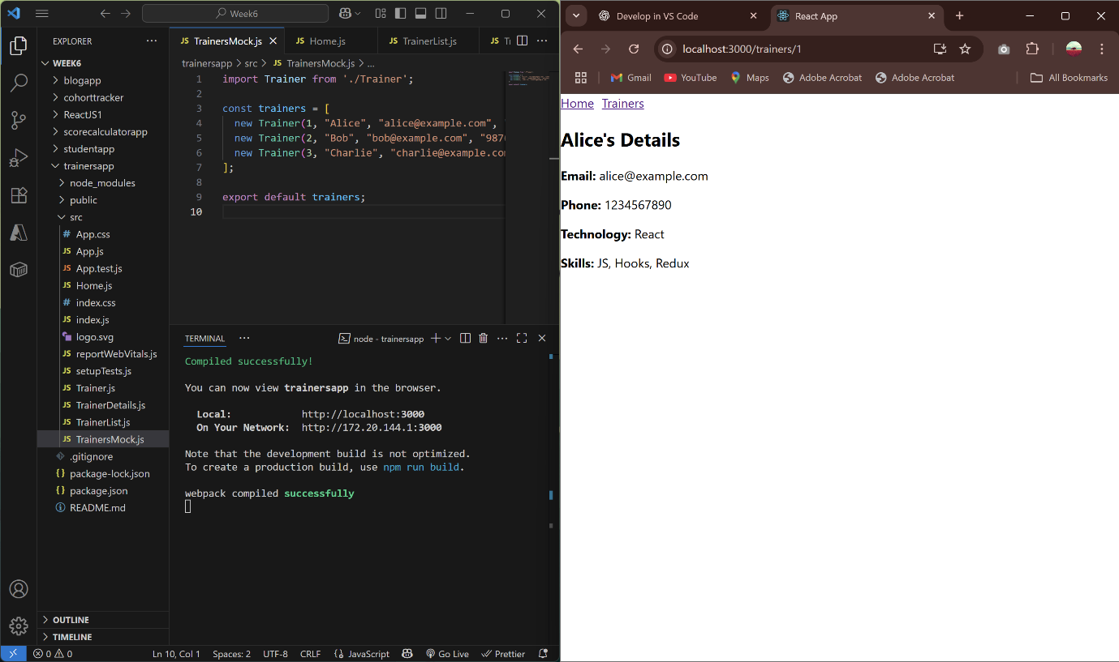

**Exercise7: shoppingapp**

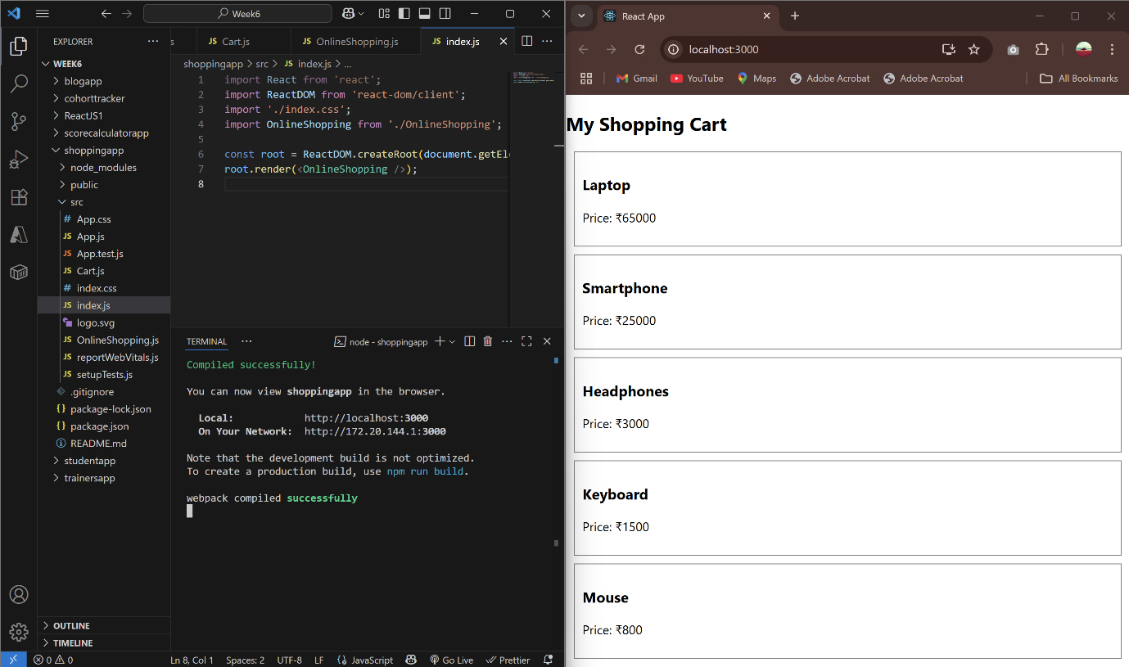

**Exercise8: counterapp**

