9. ReactJS-HOL: cricketapp

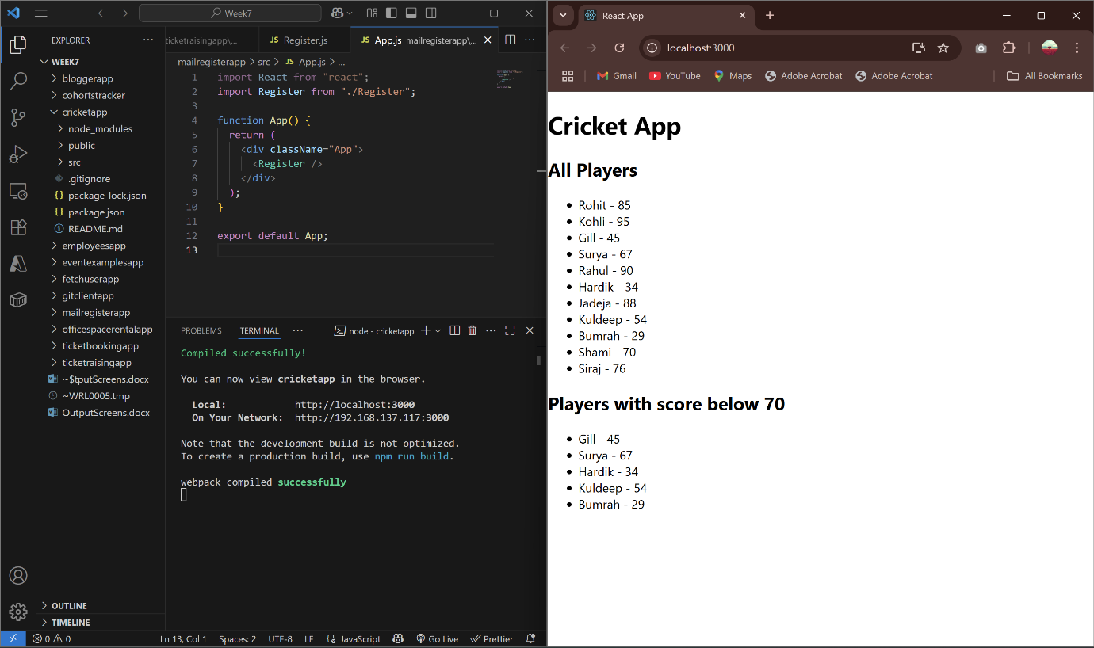

10. ReactJS-HOL: officespacerentalapp

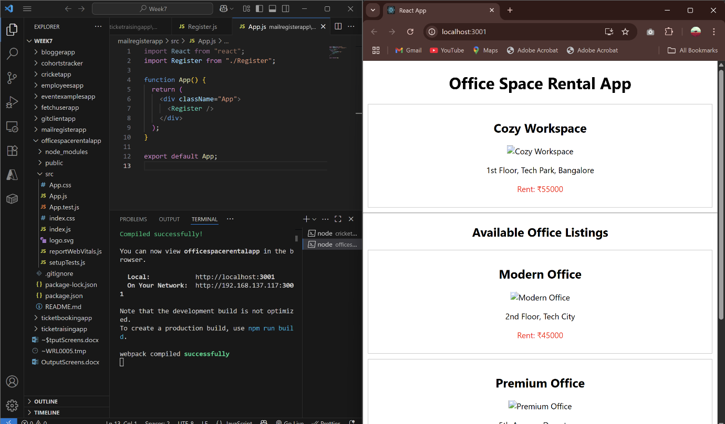

11. ReactJS-HOL: eventexamplesapp

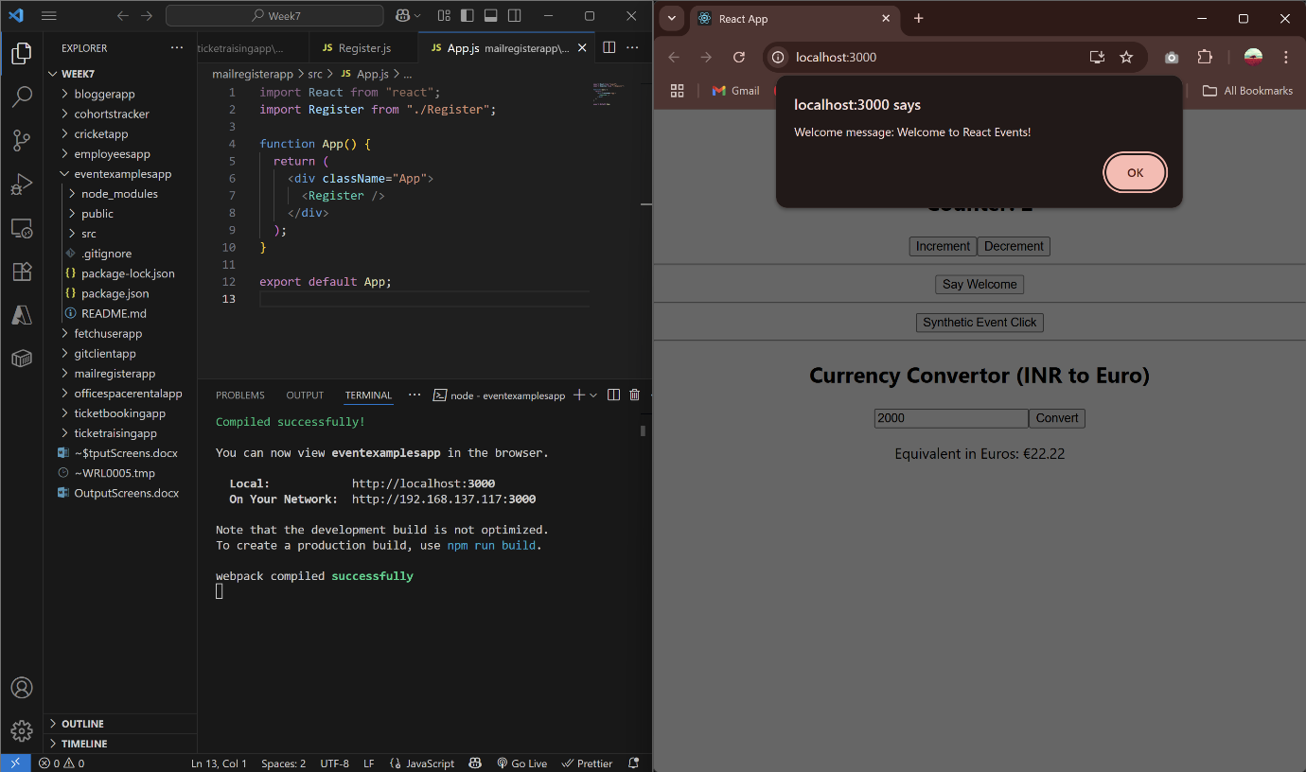

12. ReactJS-HOL: ticketbookingapp

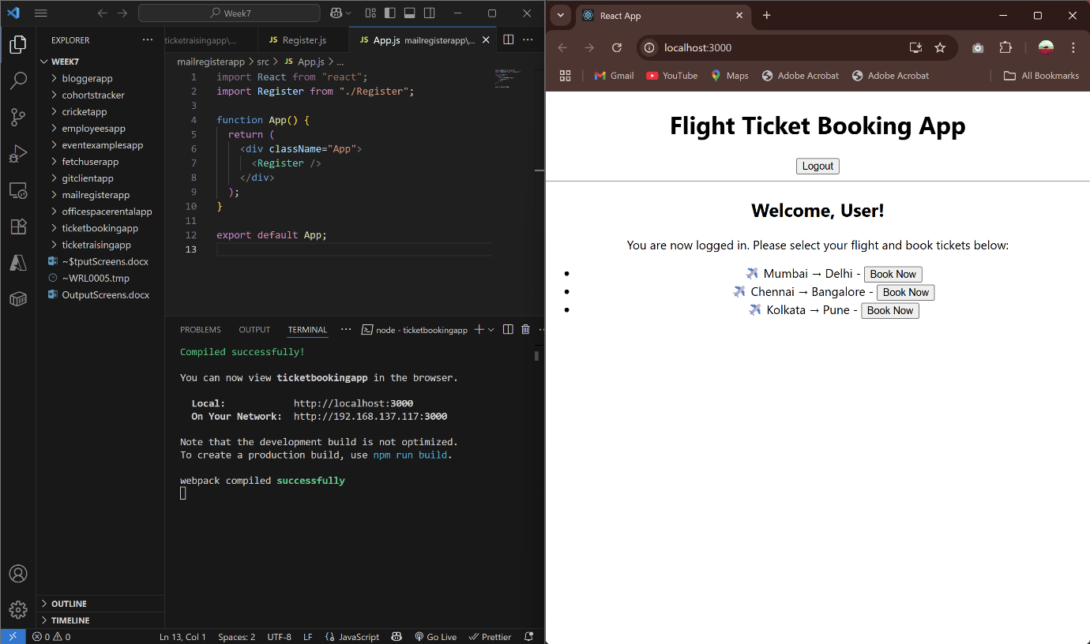

13. ReactJS-HOL: bloggerapp

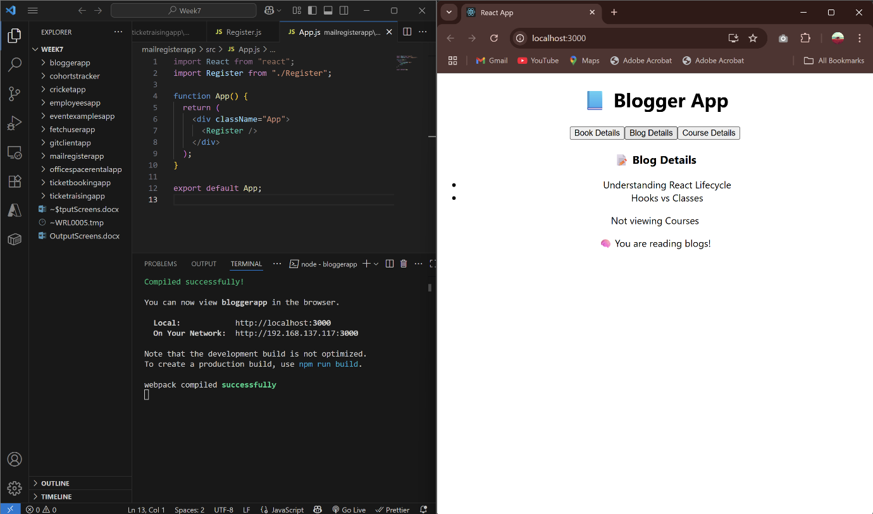

14. ReactJS-HOL: employeesapp

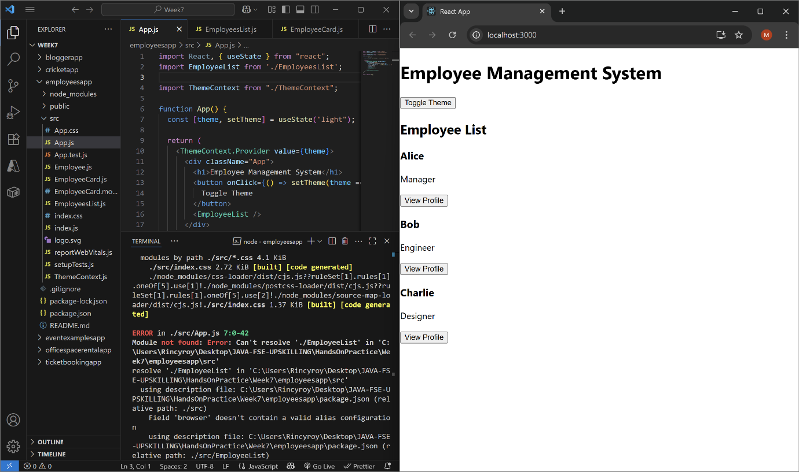

15. ReactJS-HOL: ticketraisingapp

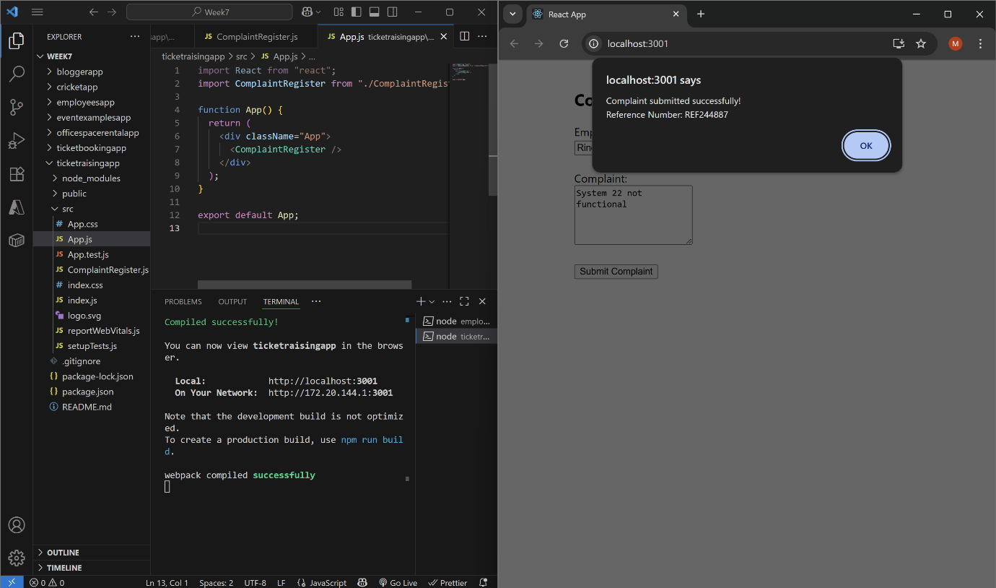

16. ReactJS-HOL: mailregisterapp

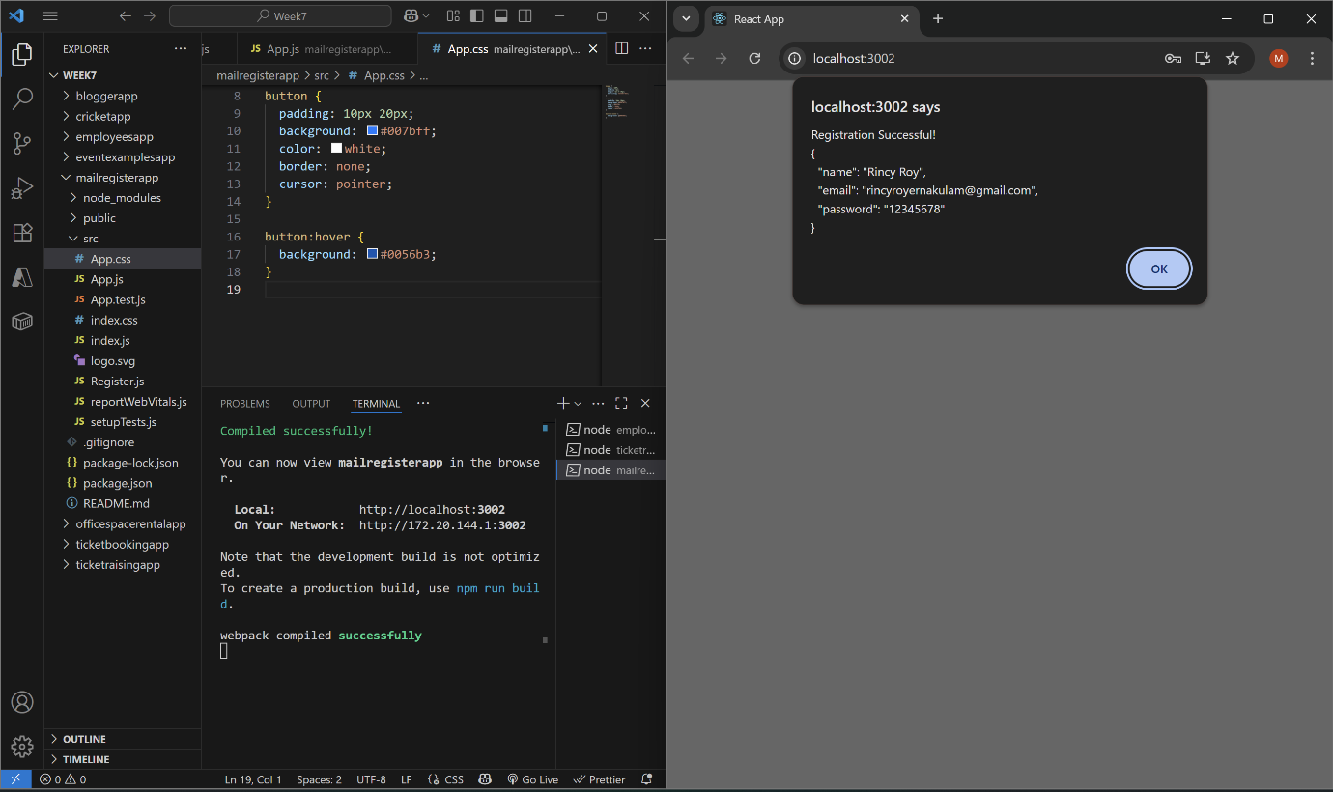

17. ReactJS-HOL: fetchuserapp

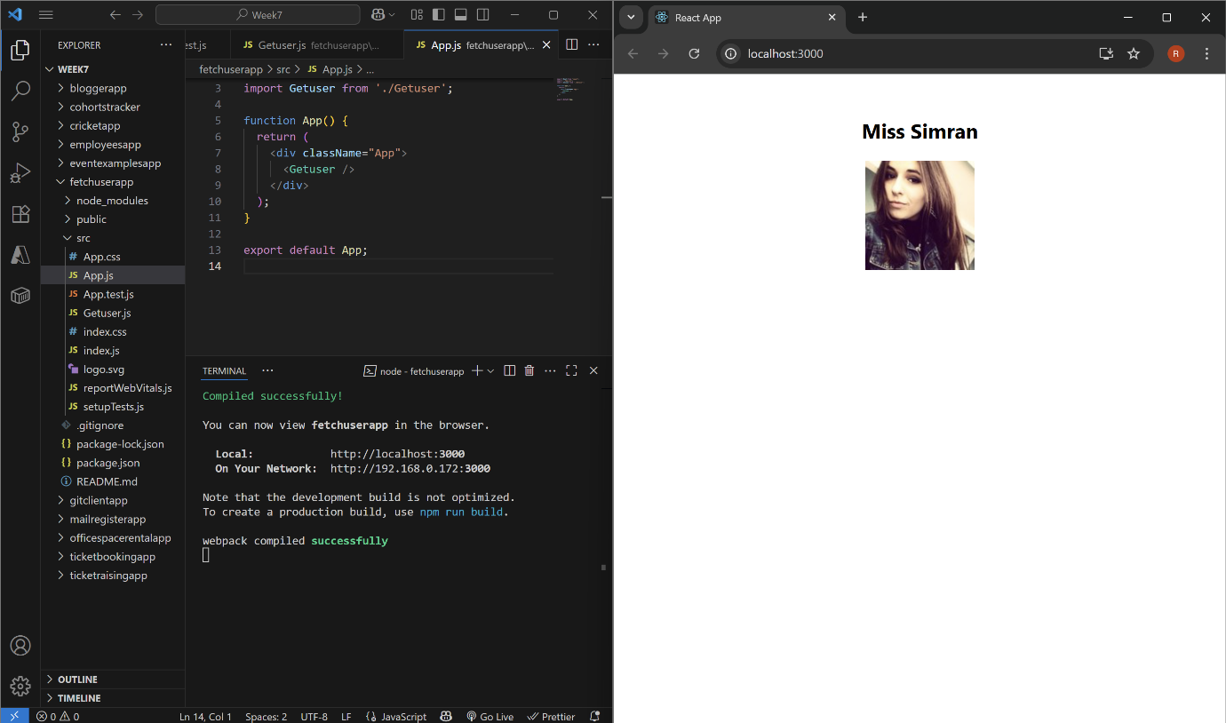

18. ReactJS-HOL: cohortstracker

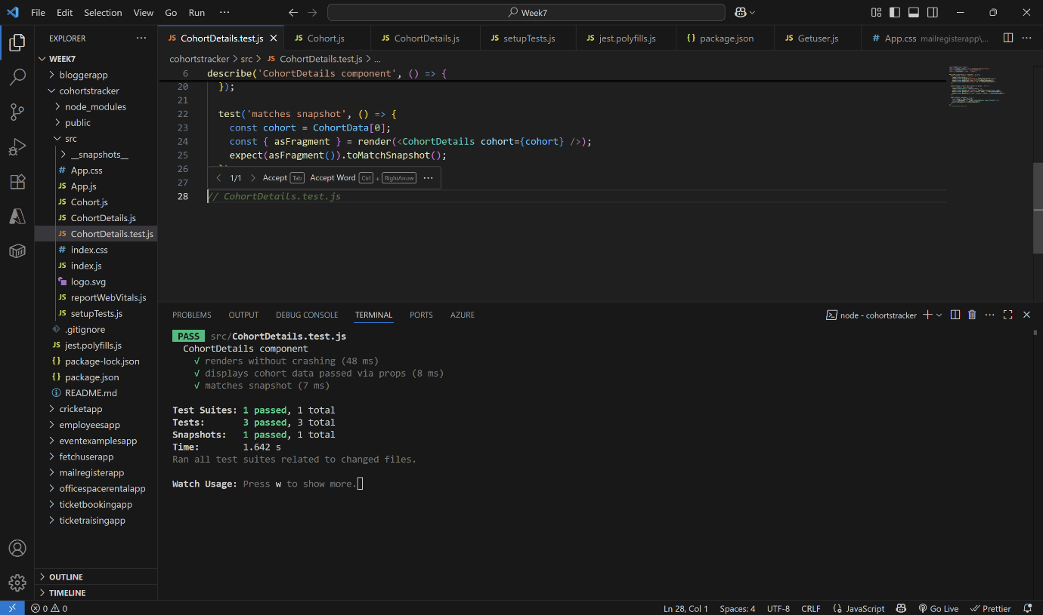

19. ReactJS-HOL: gitclientapp

