**What is Cypress?**

· Cypress is a next generation front end Automation testing tool built for the modern web applications

**How Cypress is Unique from other Automation tools?**

Cypress [automatically waits](https://docs.cypress.io/guides/core-concepts/introduction-to-cypress.html#Cypress-is-Not-Like-jQuery) for commands and assertions before moving on. No more async hell.

Cypress takes snapshots as your tests run. We can hover over each commands in the [Command Log](https://docs.cypress.io/guides/core-concepts/test-runner.html#Command-Log) to see exactly what happened at each step.

Because of its Architectural design, Cypress delivers fast, consistent and

Cypress built on Node.js and comes packaged as an npm module,

As it is built on Node.js, It uses JavaScript for writing tests. But 90% of coding can be done using Cypress inbuilt commands which are easy to understand.

Cypress also [bundles with jQuery](https://docs.cypress.io/guides/references/bundled-tools.html#Other-Library-Utilities) and inherits many of jQuery methods for UI components Identification

**Cypress Architecture**

**Selenium**

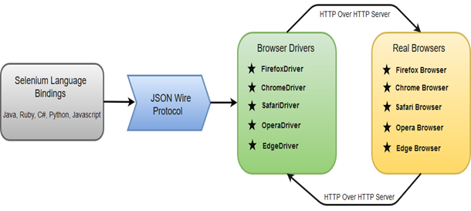

**Cypress –**

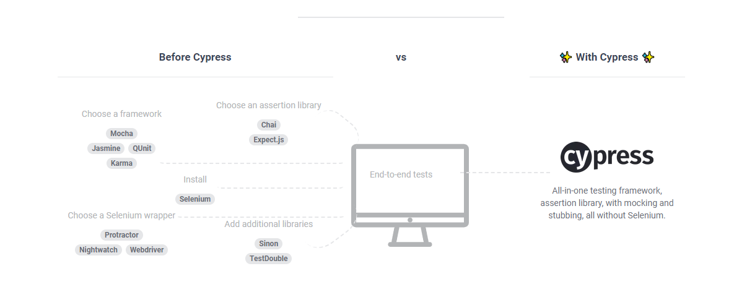

Most testing tools (like Selenium) operate by running outside of the browser and executing remote commands across the network. But Cypress engine directly operates inside the browser. In other words, It is the browser that is executing your test code

This enables Cypress to listen and modify the browser behavior at run time by manipulating DOM and altering Network requests and responses on the fly

**Cypress Browser Support:**

Chrome  
Electron  
Firefox & IE (Under Construction)

Cypress Components:

Test Runner  
Dash Board Service

"pageLoadTimeout":90000,

    "chromeWebSecurity": false,

    "video": true

1. Run cypress in headless browser – npx cypress run