CREATE DATABASE  
  
  
CREATE BOOKS TABLE  
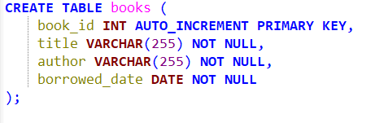  
  
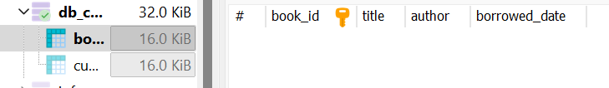  
  
DATA ENTRY:  
atleast 5 books   
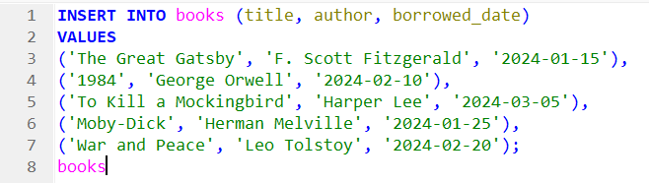  
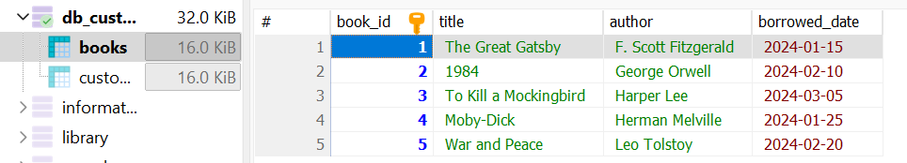  
  
  
  
  
  
  
BASIC QUERIES  
list all books

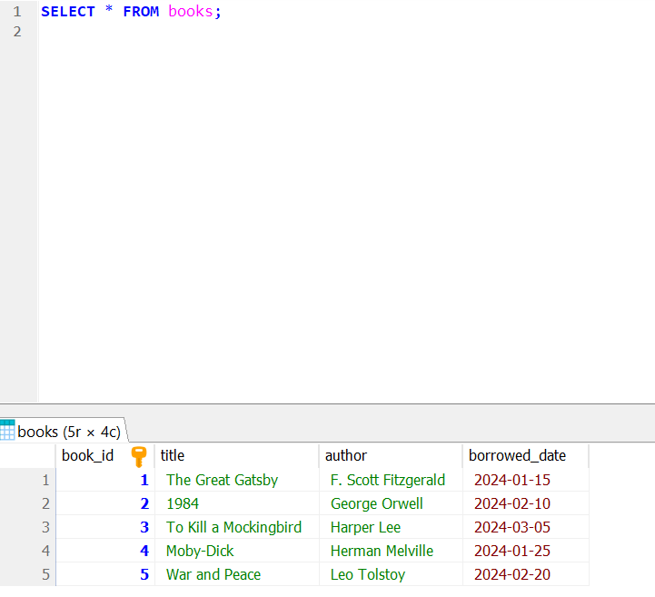  
  
  
  
  
  
  
  
  
  
  
  
  
find books by author  
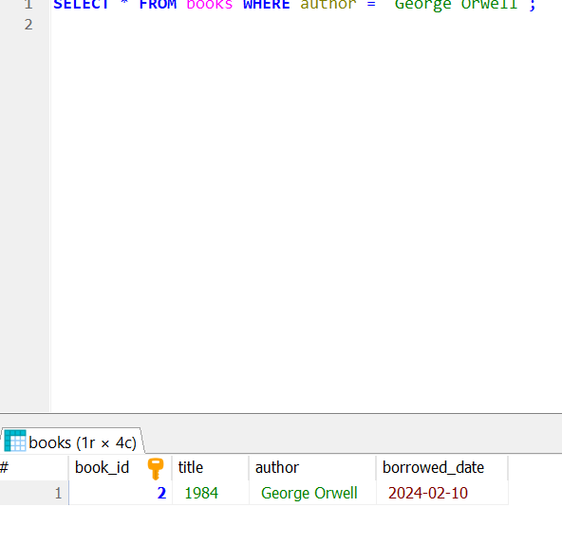  
  
  
  
  
  
  
  
  
  
  
  
  
  
  
find books borrowed on specific date  
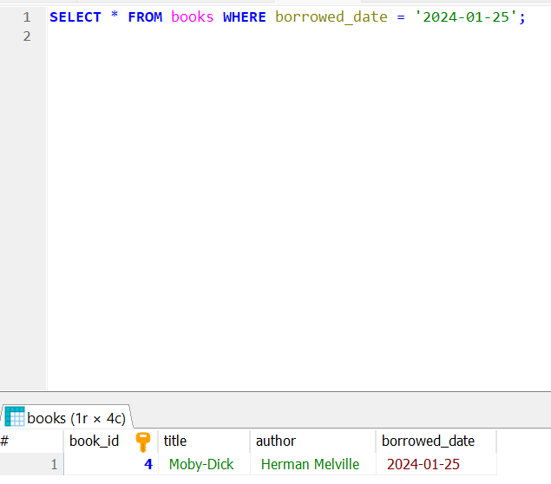  
  
  
  
  
  
  
  
  
  
  
  
  
  
  
  
find books borrowed after a certain date  
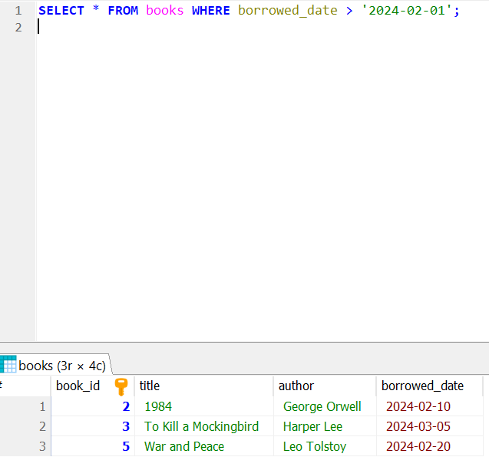  
  
  
  
  
  
  
  
  
  
  
  
  
  
  
DATA MANIPULATION  
update borrowed date  
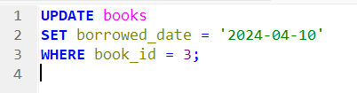  
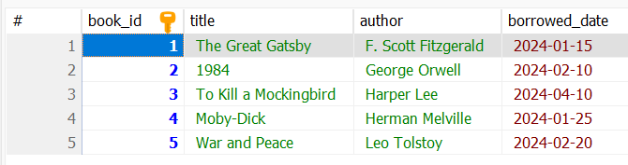  
  
delete a book  
  
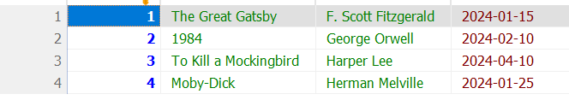  
  
re-add a deleted book  
