**Task:**

Your task is to set up an automated deployment process for a WordPress website

using Nginx as the web server, LEMP (Linux, Nginx, MySQL, PHP) stack, and GitHub

Actions as the CI/CD automation tool. The deployment process should follow security

best practices and ensure optimal performance of the website.

Below I am mentioning the step-by-step process that I followed to complete the above task.

**Step 1: Launching Server (EC2) using AWS.**

Launching an EC2 server. I have used an ubuntu 22.04 machine with t2 micro instance type having private key for authentication along with firewall settings (Allowed SSH, HTTP, HTTPS in security group) and used free volume.

After successfully launching an instance, access via ssh.

I am providing the output that I got after performing step 1.

**Output:**

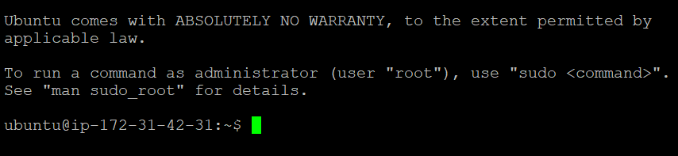

**Step 2: Update & Upgrade the packages.**

sudo apt update

**Output:**

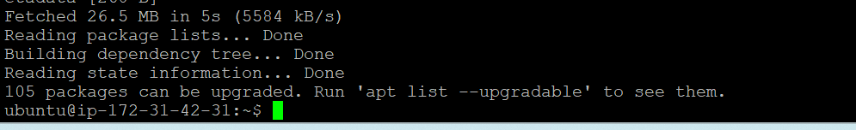

sudo apt upgrade -y

**Output:**

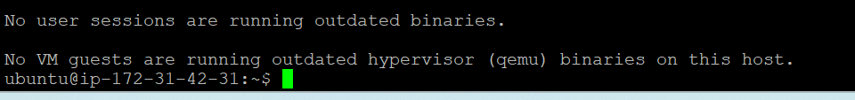

**Step 3: Install and Configure Nginx, MySQL/MariaDB, and PHP.**

Install and Configure Nginx

sudo apt install nginx

**Output:**

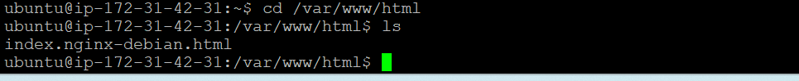

sudo systemctl start nginx

sudo systemctl enable nginx

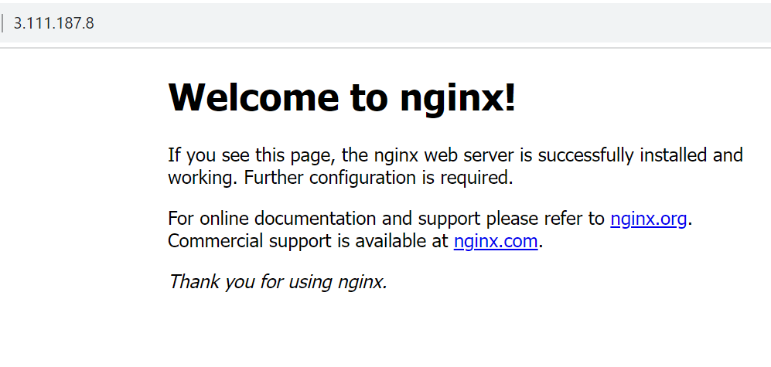

**Install and Configure PHP**

sudo apt install php-fpm php-mysql php-curl php-gd php-mbstring php-xml php-xmlrpc php-zip

**Install and Configure Mysql**

sudo apt install mysql-server

**Before going ahead, we need to configure database so that we can use it with Wordpress.**

sudo mysql -u root

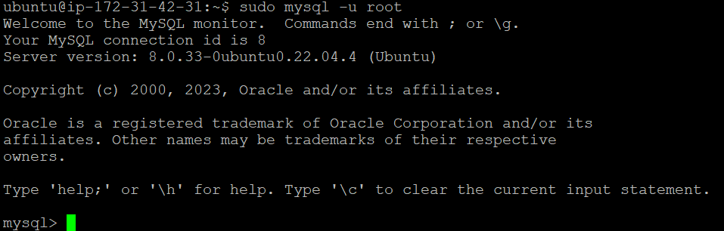

ALTER USER 'root'@localhost IDENTIFIED WITH mysql_native_password BY 'Rinku123';



CREATE USER 'rinku'@localhost IDENTIFIED BY 'Rinku123';



CREATE DATABASE Wordpress;

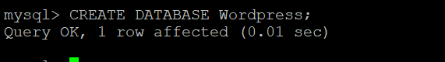

GRANT ALL PRIVILEGES ON Wordpress.* TO 'rinku'@localhost;



**Step 4: Download and Configure WordPress**

1. wget <https://wordpress.org/latest.zip>

**Output:**

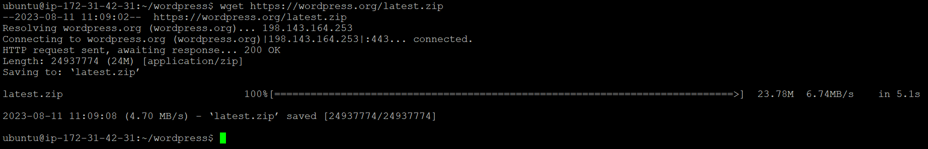

1. unzip latest.zip

**Output:**

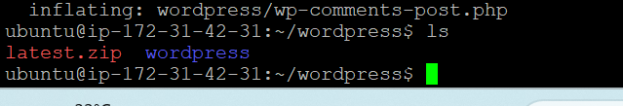

1. sudo mv wordpress/ /var/www/html
2. sudo chown -R www-data:www-data /var/www/html
3. cd /var/www/html

**Output:**

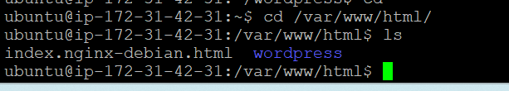

**Now we have to configure some settings in nginx server.**

So,

1) cd /var/www/html

Here we will get default folder.

2) sudo cp default wordpress.conf

Now, change some configuration settings

3) sudo vim wordpress.conf

After changing few things. We can restart the nginx server.

4) sudo systemctl restart nginx

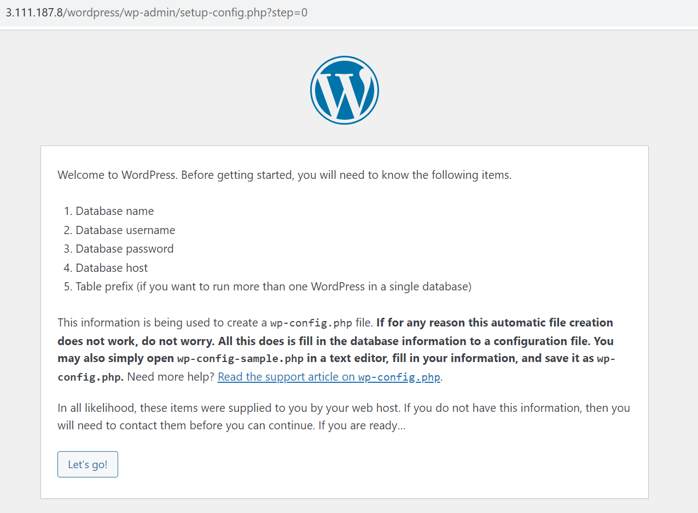

Logged using credentials and got wordpress dashboard.

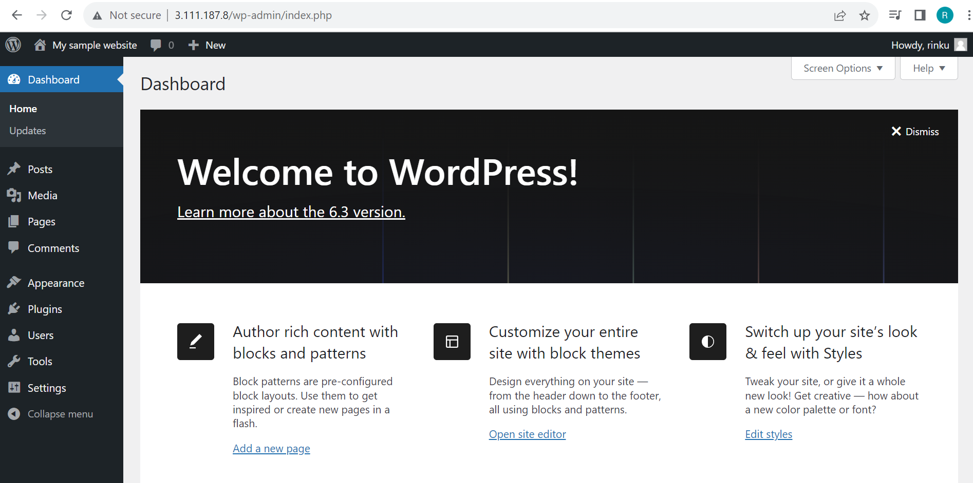

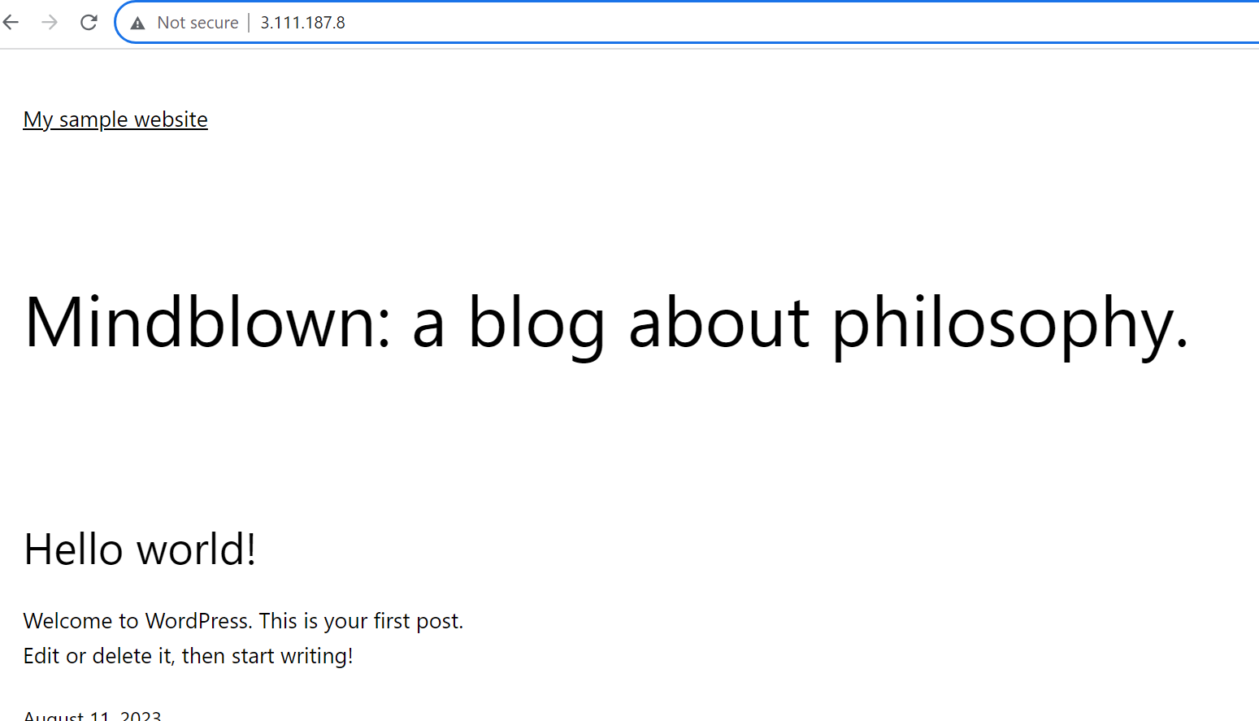

**Step 5: Now we have to secure the site so using Certbot.**

1. sudo apt install certbot python3-certbot-nginx
2. sudo certbot –nginx



We need to mention the domain name and enter. Now we can test our domain name on the browser.

Note: We need to make sure that we have registered our domain name and created hosted zone or dns name records. Route 53 can be used in order to create hosted zone.

|  |
| --- |
|  |
|  |
|  |