Project FORESIGHT
AI-Powered Demand & Inventory Intelligence Platform
Project Report
Submitted by | Rinkle
Mentor | Chandan Mishra
Programme | Data Analytics Internship
Submission date | October 2026
GitHub | github.com/rinkle-YADAV

1. Project Overview
Project FORESIGHT is a demand forecasting and inventory intelligence platform that helps a retail business plan stock more accurately. It combines forecasting and inventory analytics with business intelligence to view demand at SKU level, flag stockout and overstock risks, and turn both into ranked, actionable recommendations delivered through an interactive 12-page Power BI dashboard. The entire solution was built in Power BI using Power Query and DAX.
Objectives
- Forecast demand and revenue so purchasing can be planned ahead of the season.
- Detect SKUs at risk of stocking out before lead time runs out, so sales are not lost.
- Identify excess and slow-moving stock that ties up cash and adds holding cost.
- Understand what drives revenue: products, categories, seasons, promotions and customer segments.
- Give executives a short, prioritised list of actions with expected impact.

2. Problem Statement
Inventory decisions are usually made on averages and intuition. Too little stock causes lost sales and unhappy customers; too much stock blocks working capital and increases storage cost. Both problems exist together in the same business, in different SKUs and at different times of the year. FORESIGHT answers three questions: what will sell, what will run out, and what is sitting unsold.

3. Data Description
The analysis covers daily transactions from 1 January 2024 to 31 December 2025. Key facts from the dataset as used in the dashboard:
Item | Detail
Total revenue | 3.10 bn (2024: 1.55 bn, 2025: 1.54 bn)
Gross profit / margin | 1.22 bn / about 39.4%
Units sold | 511,810
Products and categories | 50 products across 5 categories: Home Decor, Furniture, Storage, Kitchen, Lighting
Customers | About 2,000, grouped into High Value, Regular and Occasional segments
Inventory fields | Current stock, reorder point, lead time, inventory value, days until stockout
Calendar fields | Season, quarter, month, weekday / weekend, holiday and promotion flags

4. Technology Stack
Layer | Tools | Purpose
Data preparation | Power Query, Excel | Cleaning, joins, feature creation
Forecasting and risk logic | Power BI, DAX | Revenue forecast with 95% bounds; CRITICAL / WARNING / SAFE risk classification
Analytics and BI | Power BI Desktop, DAX, Power Query | Data model, KPIs, 12-page interactive dashboard
Version control | Git, GitHub | Source code and documentation
Deployment | Netlify (hosted from GitHub) | Public access to the live project

5. System Architecture
Data flows from raw business tables through cleaning and modelling into a Power BI data model, which feeds the dashboard pages and the final recommendations.
Raw Data | Cleaning & Feature Creation | Measures & Forecast | Power BI Data Model | 12-Page Dashboard
Sales, Products, Inventory, Customers | Power Query, Excel | DAX: forecast, stock-risk logic | Relationships, DAX | Insights & recommendations
Output: forecast, stockout / overstock flags and ranked executive actions

6. Methodology
6.1 Data preparation. Sales, product master, inventory and customer tables were cleaned in Power Query (data types, duplicates, missing values) and joined on SKU / product name. Calendar features such as season, weekend, holiday and promotion flags were added to explain demand patterns.
6.2 Demand forecasting. Daily revenue was aggregated in Power BI and forecast for the period ahead. The dashboard shows the actual line, the forecast line and 95% upper and lower bounds, plus a 30-day outlook and forecast by category. Forecast and actual revenue are compared on the same daily scale so that variance can be read directly from the report.
6.3 Stockout risk. Each SKU is compared on current stock versus reorder point, and on days until stockout versus supplier lead time, using DAX measures. SKUs are labelled CRITICAL, WARNING or SAFE. CRITICAL means stock will run out before a new order can arrive.
6.4 Overstock and slow-moving stock. Excess stock value, months to clear and annual holding cost are calculated per SKU. A 20% discount scenario estimates the revenue that could be recovered by clearance sales.
6.5 Recommendations. Risk counts, growth and profitability are combined in an executive page with a risk heat map, an impact-versus-difficulty opportunity view and a ranked action list.

7. Dashboard Walkthrough and Insights
The Power BI report has 12 pages. Each page below shows a screenshot followed by the main findings.

7.1 Executive Dashboard
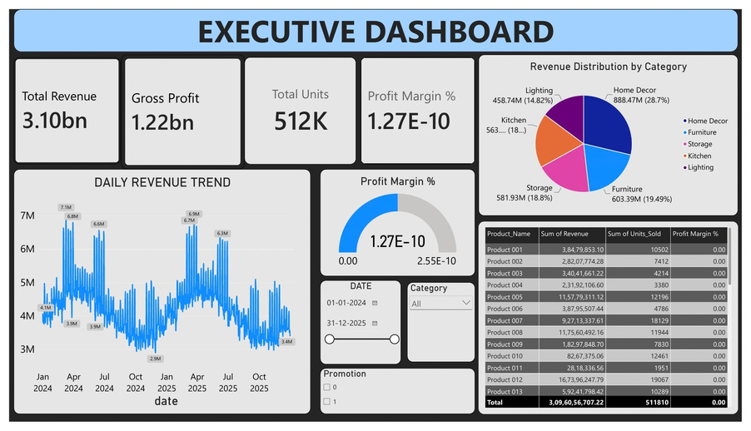
Figure: Executive Dashboard
- Total revenue is 3.10 bn from 511,810 units, with 1.22 bn gross profit.
- Daily revenue peaks at 6 to 7 M in spring (March to June) of both years and falls to about 3 M in October to December.
- Home Decor is the largest category at 28.7% of revenue; Lighting is the smallest at 14.8%.

7.2 Sales Analytics Dashboard
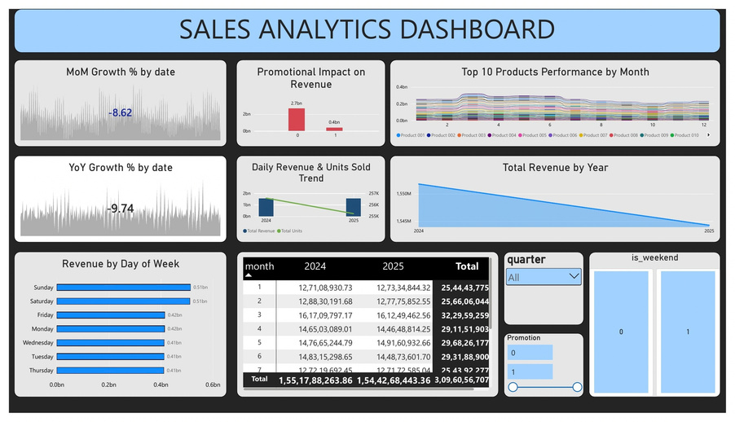
Figure: Sales Analytics Dashboard
- Revenue is almost flat year on year: 1.55 bn in 2024 versus 1.54 bn in 2025 (about -0.5%).
- Saturday and Sunday earn about 0.51 bn each versus 0.41 to 0.42 bn on other days, so weekends bring roughly a third of revenue.
- Non-promotional sales are about 2.7 bn against 0.4 bn for promotional sales. March is the strongest month.

7.3 Product Performance Dashboard
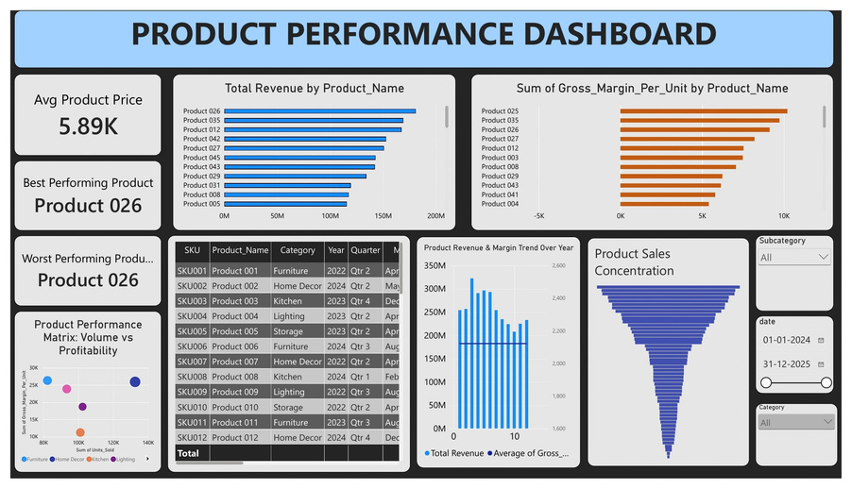
Figure: Product Performance Dashboard
- Product 026, Product 035 and Product 012 lead on total revenue, with Product 026 at around 180 M.
- Gross margin per unit is highest for Products 025, 035 and 026, so some top sellers are also the most profitable.
- The sales concentration chart shows a long tail: a few products drive most revenue while many contribute little.

7.4 Category Performance Dashboard
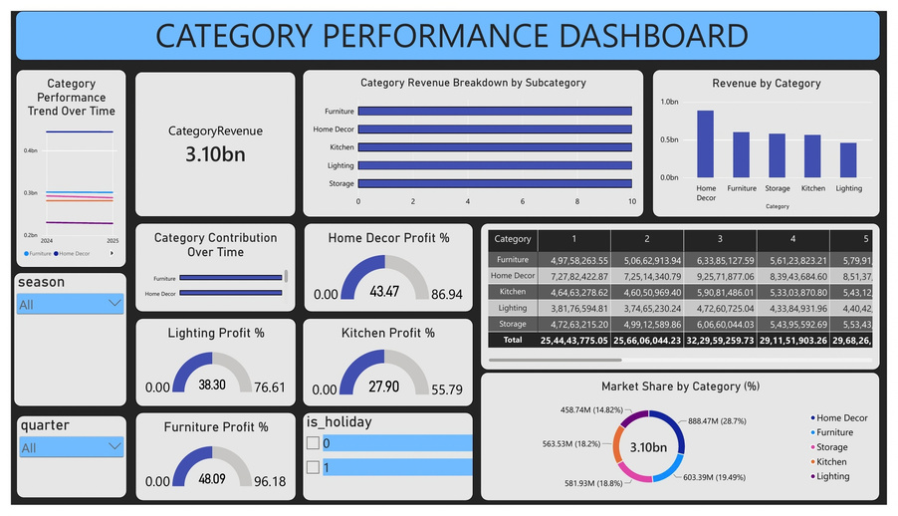
Figure: Category Performance Dashboard
- Revenue split: Home Decor 888 M, Furniture 603 M, Storage 582 M, Kitchen 564 M, Lighting 459 M.
- Furniture shows the highest profit percentage (48.09), followed by Home Decor (43.47) and Lighting (38.30); Kitchen is lowest (27.90).
- Category revenue follows the same monthly shape, peaking in March.

7.5 Inventory Dashboard
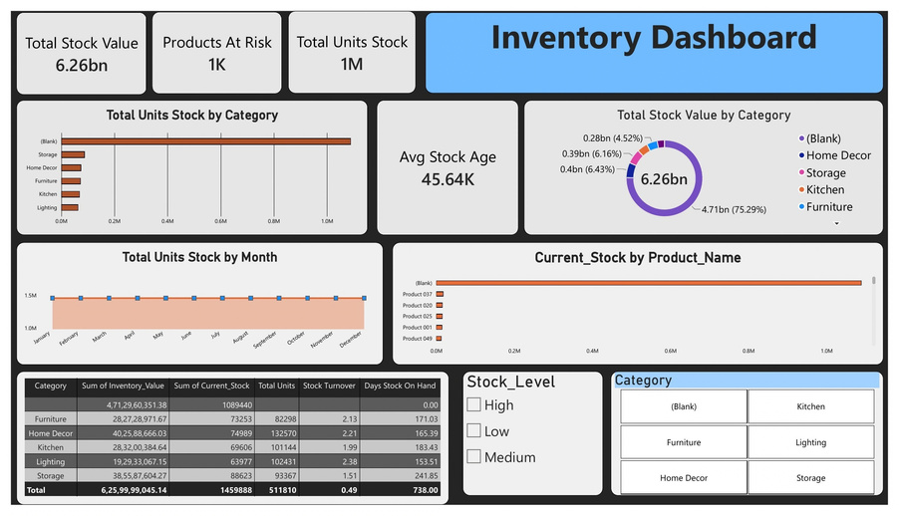
Figure: Inventory Dashboard
- Total stock value is about 6.26 bn, with roughly 1.46 M units on hand.
- Storage holds stock the longest (241.85 days on hand, turnover 1.51); Lighting turns fastest (turnover 2.38, 153.51 days).
- Stock level is nearly constant across months, so inventory is not adjusting to the seasonal demand curve.

7.6 Stockout Risk Dashboard
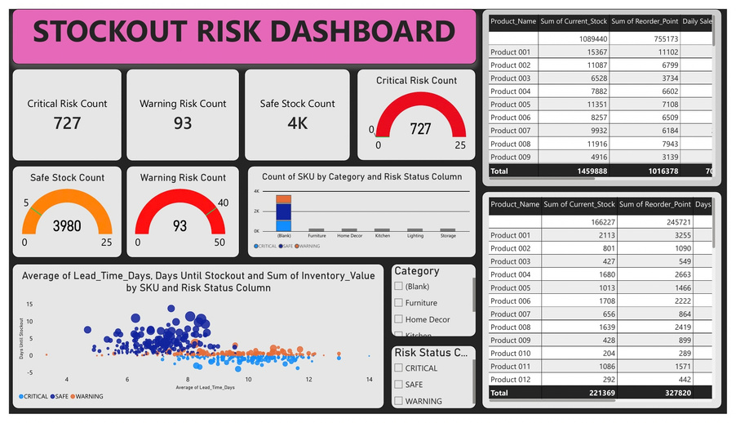
Figure: Stockout Risk Dashboard
- Risk flags: 727 CRITICAL, 93 WARNING and 3,980 SAFE.
- CRITICAL items cluster at or below zero days until stockout while lead times are 8 to 12 days, so they will run out before replenishment arrives.
- The SKU tables compare current stock with reorder point to show where to reorder first.

7.7 Overstock Dashboard
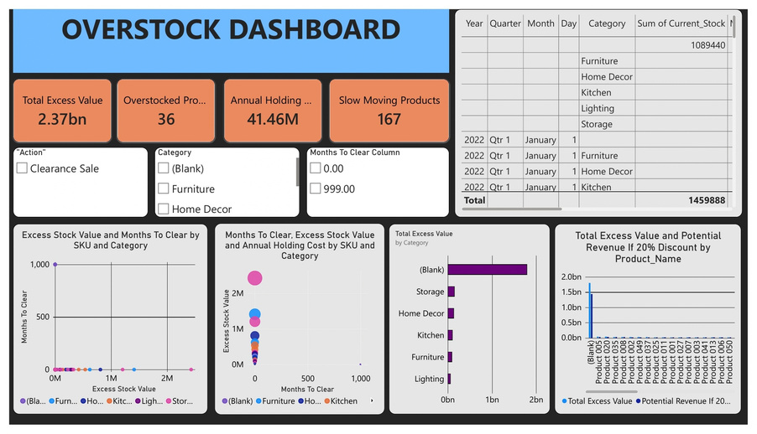
Figure: Overstock Dashboard
- Total excess value is 2.37 bn across 36 overstocked products, with 167 slow-moving products.
- Annual holding cost of the excess is 41.46 M.
- The 20% discount scenario compares excess value with potential revenue to support clearance-sale decisions.

7.8 Promotion Dashboard
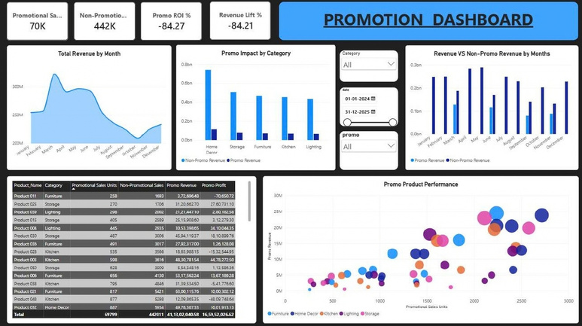
Figure: Promotion Dashboard
- Promotional sales are 69,799 units against 442,011 non-promotional units.
- Promo revenue is about 411 M; Home Decor has the highest promotional revenue among categories.
- In the product view, promo revenue rises with promotional units, with some Storage and Home Decor products performing best.

7.9 Seasonality Dashboard
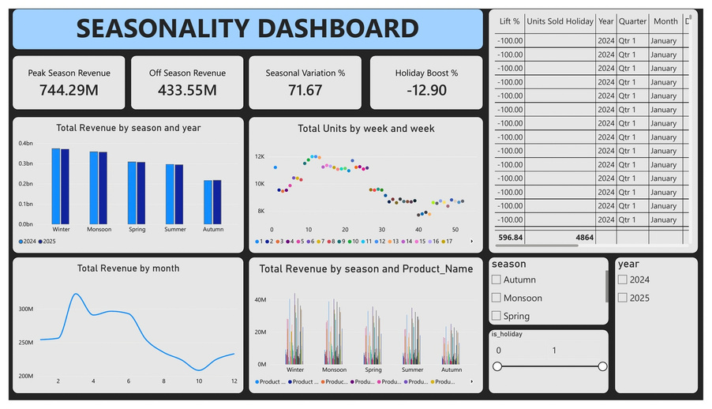
Figure: Seasonality Dashboard
- Peak-season revenue is 744.29 M versus 433.55 M off-season, a 71.67% seasonal variation.
- October is the lowest revenue month of the year.
- Weekly units are highest in weeks 10 to 14 and lowest late in the year.

7.10 Forecast Dashboard
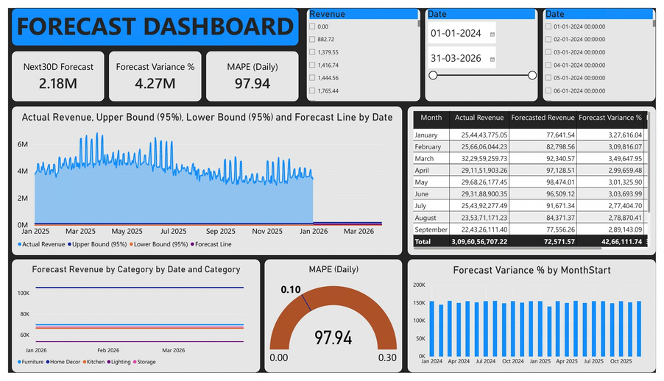
Figure: Forecast Dashboard
- Shows actual revenue with the forecast line and 95% upper and lower bounds.
- Includes a 30-day forecast, monthly forecast versus actual comparison, forecast revenue by category and forecast variance indicators.
- Forecasts feed directly into purchasing and reorder planning.

7.11 Customer and Business Insights
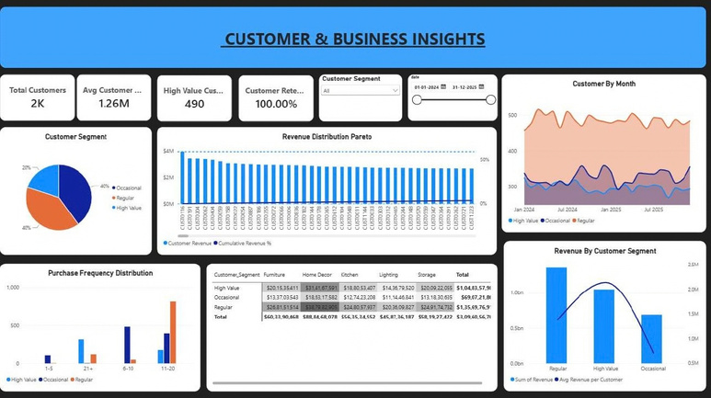
Figure: Customer and Business Insights
- About 2,000 customers: 20% High Value (490 customers), 40% Regular and 40% Occasional.
- Regular customers bring the most revenue (about 1.36 bn), High Value about 1.05 bn and Occasional about 0.69 bn. High Value customers give the highest revenue per customer.
- Regular customers buy mostly 11 to 20 times, High Value customers 21 or more times; revenue is spread across all five categories.

7.12 Executive Recommendation Dashboard
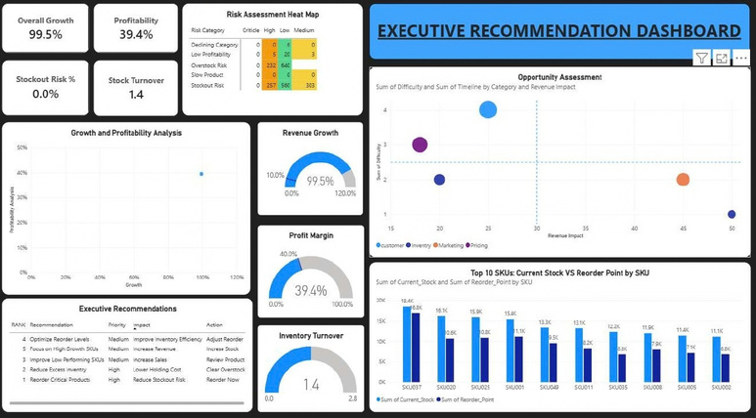
Figure: Executive Recommendation Dashboard
- Brings profitability (39.4%), stock turnover (1.4) and stockout risk into one view, with a risk heat map by category.
- The opportunity matrix plots revenue impact against difficulty for customer, inventory, marketing and pricing initiatives.
- Ranked actions: 1) reorder critical products, 2) reduce excess inventory, 3) improve low-performing SKUs, 4) optimise reorder levels, 5) focus on high-growth SKUs.

8. Key Insights and Business Recommendations
Priority | Recommendation | Why | Impact
1 (High) | Reorder critical products now | 727 SKUs are flagged CRITICAL | Prevents lost sales
2 (High) | Clear excess stock through targeted discounts | 2.37 bn excess value, 41.46 M annual holding cost | Frees cash, lowers holding cost
3 (Medium) | Review low-performing SKUs | Long tail of low-revenue products | Improves sales mix
4 (Medium) | Align reorder levels and stock with seasonality | Stock is flat while demand peaks in spring (March to June) | Better inventory efficiency
5 (Medium) | Increase stock of high-growth SKUs | Top products lead revenue and margin | Increases revenue
Additional observations: weekends and the March to June period carry the highest demand; Storage is the slowest-moving category; and a small High Value segment contributes a disproportionate share of revenue.

9. Challenges Faced
- Joining inventory records to the product master so every SKU carries the right category.
- Bringing forecast values to the same scale and level (daily total) as actual revenue for a fair comparison.
- Writing correct ratio measures in DAX (margin, growth, retention) that behave properly under filters and totals.
- Designing 12 pages that stay readable while keeping one consistent story for executives.

10. Conclusion and Future Scope
FORESIGHT shows how forecasting and inventory analytics can be combined in one decision tool. It identifies where stock is about to run out, where cash is trapped in excess stock, and which actions should be taken first. Future improvements include SKU-level forecasting models, automatic reorder-quantity suggestions, scheduled data refresh, alerts for critical SKUs, and price and promotion optimisation.

11. Project Links
Deliverable | Link
Source code (GitHub) | https://github.com/rinkle-YADAV/Project-FORESIGHT-AI-Powered-Demand-Inventory-Intelligence-Platform
Live deployment | https://foresight-demand-intelligence.netlify.app
Demo video | [add demo video link]
Feedback video | [add feedback video link]

