

A
Project Report on
“IMAGE RESIZER & COMPRESSOR”

Submitted by
Miss. Snehal Ajinath Salunke &
Miss. Rinku Ashok Salunke
T.Y.B.Sc (Computer Science)

Under the guidance of

Prof. Burte G.V.

In a partial fulfillment of the requirements of the degree of
B.Sc.(Computer Science)
Under
Savitribai Phule Pune University, Pune.

Dada Patil Mahavidyalaya Karjat, Ahmednagar.

Academic Year 2023-2024

Dada Patil Mahavidyalaya, Karjat
Department of Computer Science

CERTIFICATE

This is to certify that project entitled “IMAGE RESIZER & COMPRESSOR ” Submitted by “Miss. Snehal Ajinath Salunke & Miss .Rinku Ashok Salunke” students of T.Y.B.Sc (Computer Science) examination of Savitribai Phule Pune University, Pune during the academic year 2023-24.It is original work carried out under the supervision and guidance by Prof.Burte G.V. and under goes for the project.
Date: / /2024

Project Guide  (Prof:Anarase L.P.) | Head of Department  (Prof: Burte G.V.)

Internal Examiner | External Examiner

ACKNOWLEDGEMENT

I wish to thank the opportunity to express our prefunds thanks & gratitude to all those who have directly helped us in the completion of this project.
The project titled “IMAGE RESIZER & COMPRESSOR” would not have completed without the valuable guidance and encouragement of Professors.
I am also extremely thankful to “Prof. Burte G.V.”, (Head of Department), and “Prof.Anarase L.P.” for their guidance and moral support.
I am also thankful to my colleagues for continuously inspiring us to complete this project.
Last but not least I express my deep sense of gratitude to my parents who have give me a plenteous of moral support and without whose invigoration and understanding it would not have been virtually possible for me to achieve this
success…….

Yours Sincerely,
Miss.Snehal Ajinath Salunke
Miss.Rinku Ashok Salunke

Chapter Number | Contents | Page No.
Chapter Number | Contents | From | To
 | INTODUCTION | 5 | 8
 | 1.1 Introduction to system | 5 | 8
 | 1.2 Scope of the system | 5 | 8
 | 1.3 Existing System | 5 | 8
 | 1.4 Proposed System | 5 | 8
 | ANALYSIS | 9 | 14
 | 2.1 Feasibility Study | 9 | 14
 | 2.2 Fact Finding Technique | 9 | 14
 | 2.3 Hardware & Software Requirements | 9 | 14
 | System Design | 15 | 16
 | 3.1 E-R Diagram | 15 | 16
 | 3.2 Data Flow Diagram | 15 | 16
 | 3.3 UML Diagrams | 15 | 16
 | 3.4 Data Dictionary
 | 3.5 Form Design
 | Testing And Implementation
 | Limitations
 | Feature Enhancement
 | Bibliography

1.INTRODUCTION

- The project introduced that to provide a solution to common challenges faced by users dealing with images i.e., resizing & compressing.

- Reduce file size without significant loss in image quality.

- Preview feature to visualize changes before applying.

- Saving storage space by compressing an image size.

- Faster loading image.

- Compression reduces an image's file size by optimizing its data, which can affect quality without changing its dimensions.

- Resizing, on the other hand, changes an image's physical dimensions, reducing its resolution and detail, which also leads to a smaller file size.

1.2 SCOPE OF THE SYSTEM

- Enables users to convert images to different sizes during the compression process.

- Image processing task for photographers, designers, marketers and content creators.

- Enables users to directly save optimized images to their cloud accounts.

- Implementing mechanisms to ensure the quality of compressed and resized images meets the desired standards is important.

- Offering users options to customize compression and resizing settings according to their requirements is beneficial. Parameters such as compression level, image format, resize dimensions, etc., should be adjustable.

1.3 Existing System

- Users can upload an image from their device to the system.

- Users can specify resizing parameters such as dimensions, width, height, unit, percentage scaling to adjust the size of the images according to their requirements.

- Users may have the ability to adjust the quality settings to balance between image quality and file size.

- The system provides a preview of the compressed image and resized images.

1.4 PROPOSED SYSTEM

- A user-friendly interface where users can upload images, specify desired compression options such as dimensions, width, unit, height.

- Provide downloaded images to users during clicking on resize and compress option.

- Provides a solution for image compress and reduce problem.

- It provides a preview of resized and compressed image.

2.Analysis:

2.1Feasibility Study:

- Technical Feasibility:
- Assessment of image processing algorithms for resizing and compression.

- Evaluation of programming languages.

- Evaluate the technical requirements and challenges involved in compressing and resizing images efficiently while maintaining quality.

- Operational Feasibility:
- Determine how easily the system can be integrated into existing software applications or workflows.

- It envolves evaluating whether the proposed system can be effectively integrated into existing processes.

- Operation of collecting preview of resized and compressed image.

- Economic Feasibility:

- Evaluate the potential time savings for users by automating the process of compressing and resizing images, reducing manual effort.

- By conducting an economic feasibility analysis, you can determine whether investing in an image compress and resize system is financially aligns with the organization’s strategic goals and priorities.

3.2Fact Finding Techniques:

- Interviews:
Conduct interviews with developers, designers, content creators & system users.
Ask open ended questions to gather insights on their needs, preferences & challenges related to image resize and compression.
E.g., What features would you like to see in an image resize and compression tool?
- Document Analysis:
Review existing documents such as project proposals, system requirements, design specifications, etc.
- Observation:
Observe users and system interactions to understand how images are currently managed, uploaded and display.
- Focus Groups:
Bring together a diverse group of users to discuss image resize and compression requirements.

System Requirements:

HARDWARE & SOFTWARE REQUIREMENT

HARDWARE REQUIREMENT: -

Microprocessor: Intel Core/ I5
RAM: 15KB
Hard Disk: 4 GB or higher.

SOFTWARE REQUIREMENT: -
Operating System : Windows 11
Front End Language : JAVASCRIPT

3. System Design

3.1 ER Diagram
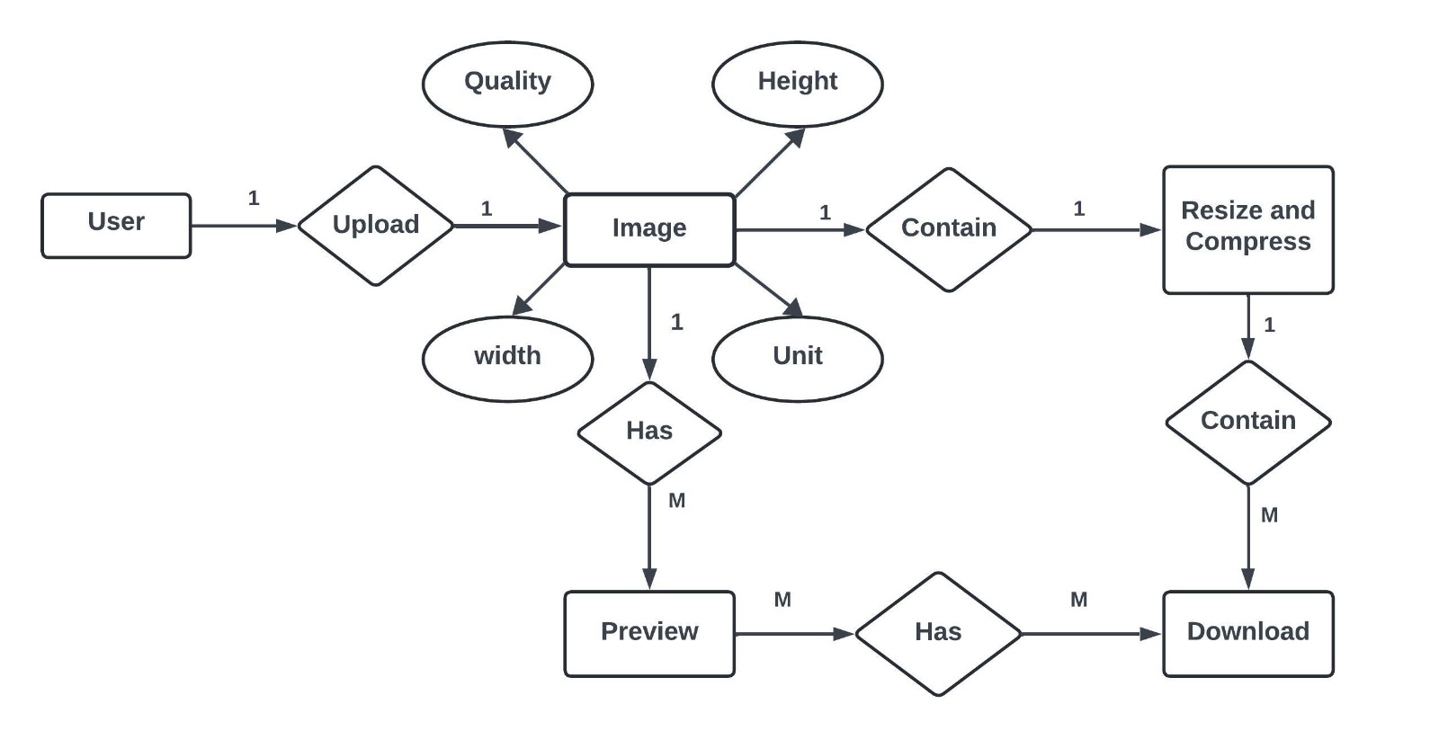

3.2 Data Flow Diagram

3.2.1 DFD for uploading image(Level 0)

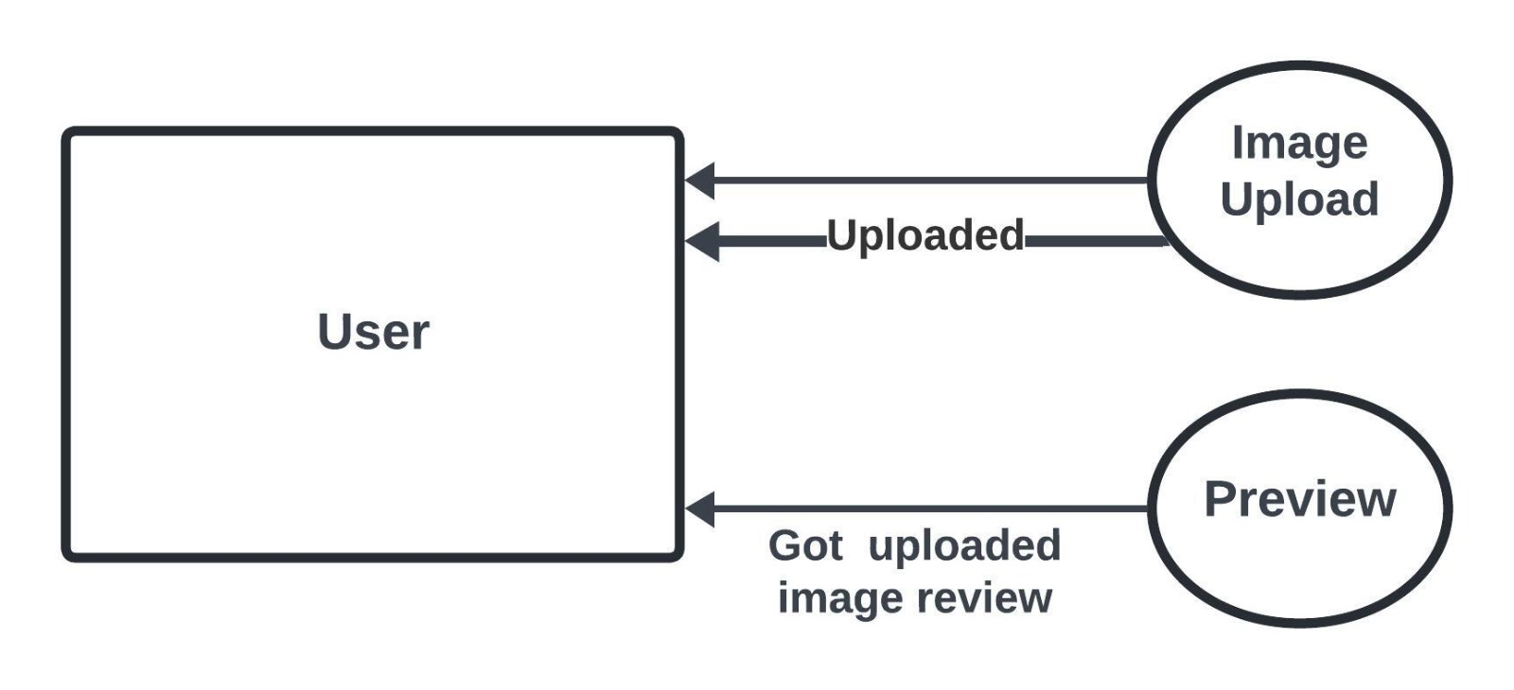

3.2.2 DFD for Downloading Compressed & Resized image(Level 2)

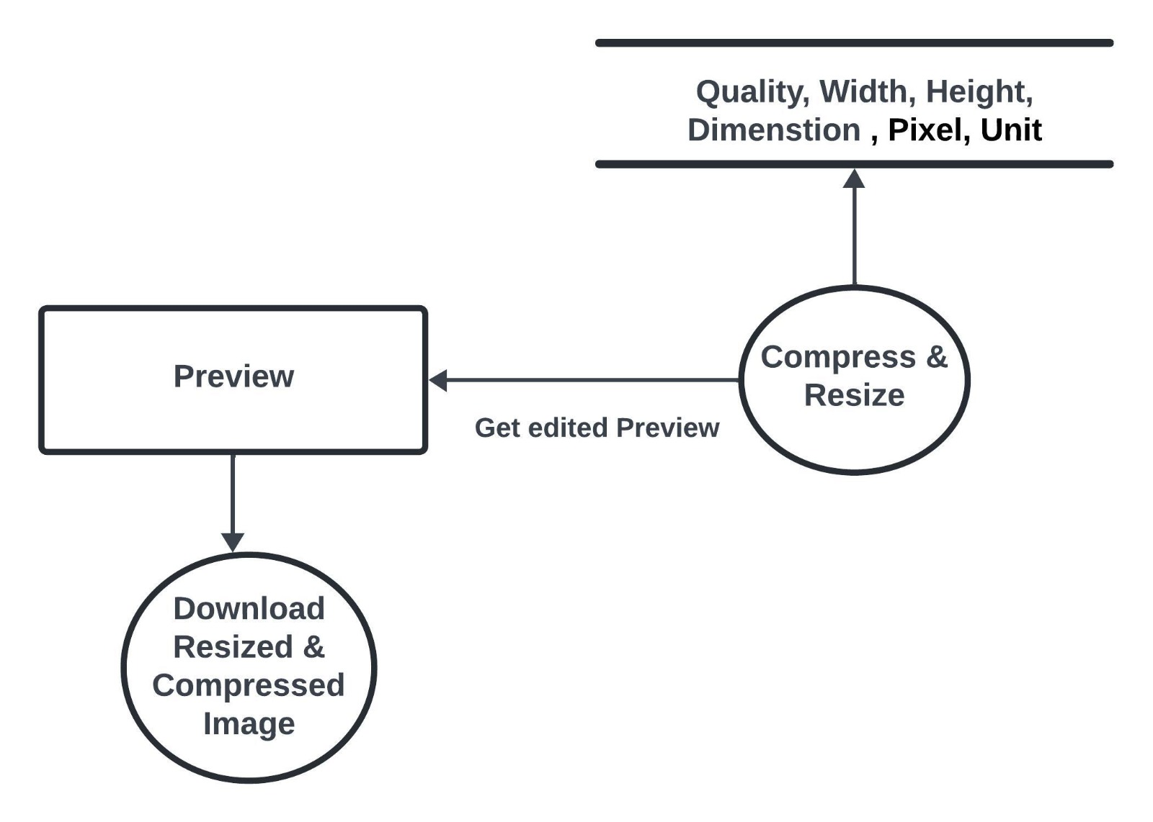

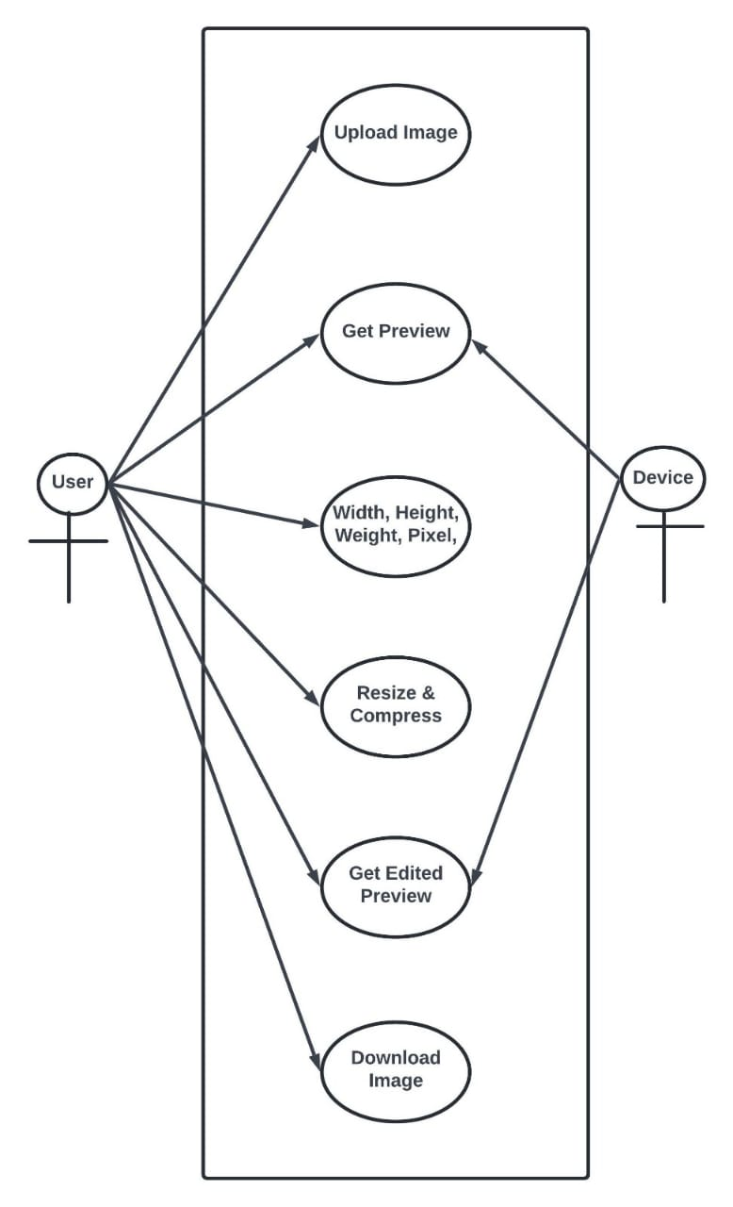

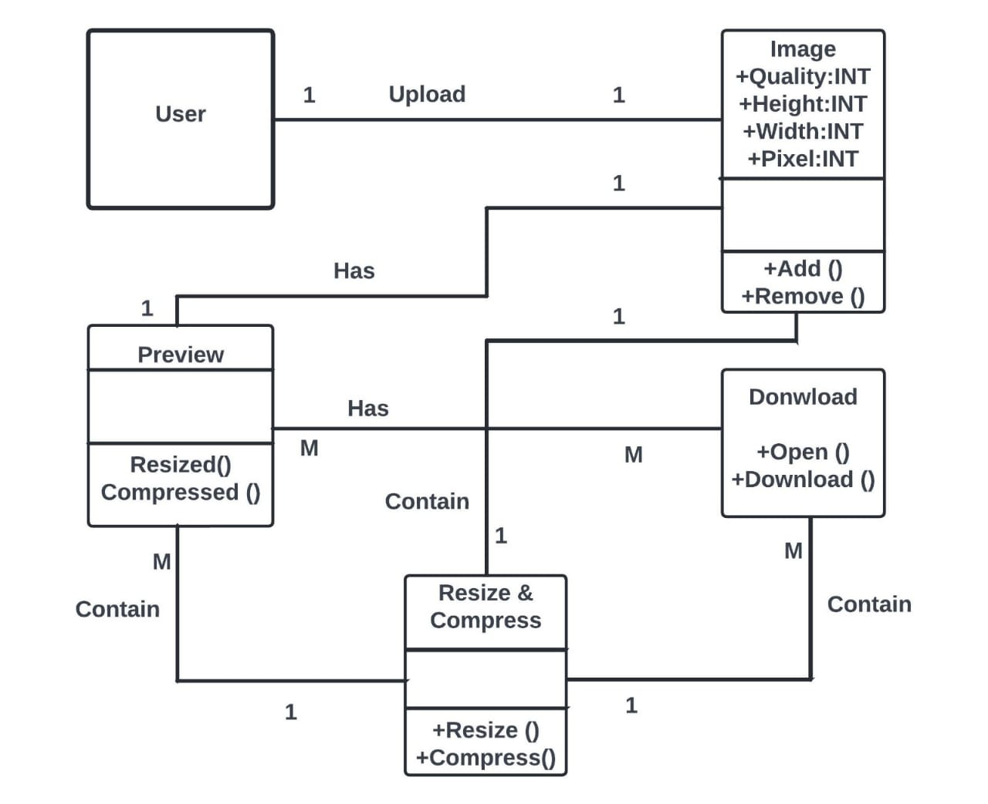

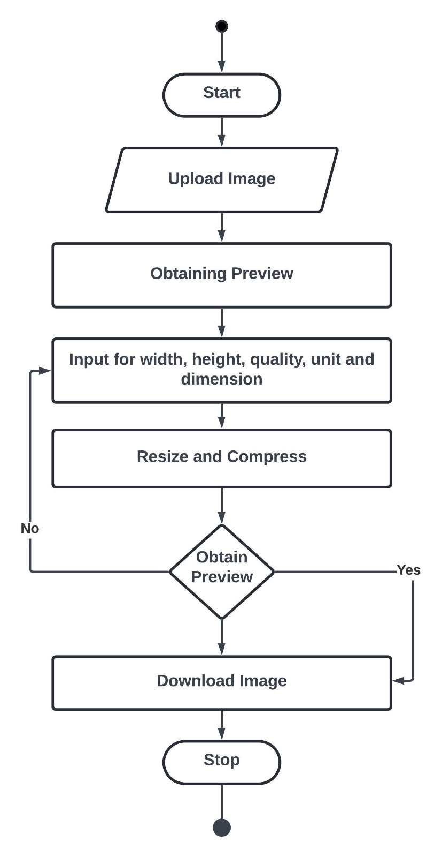

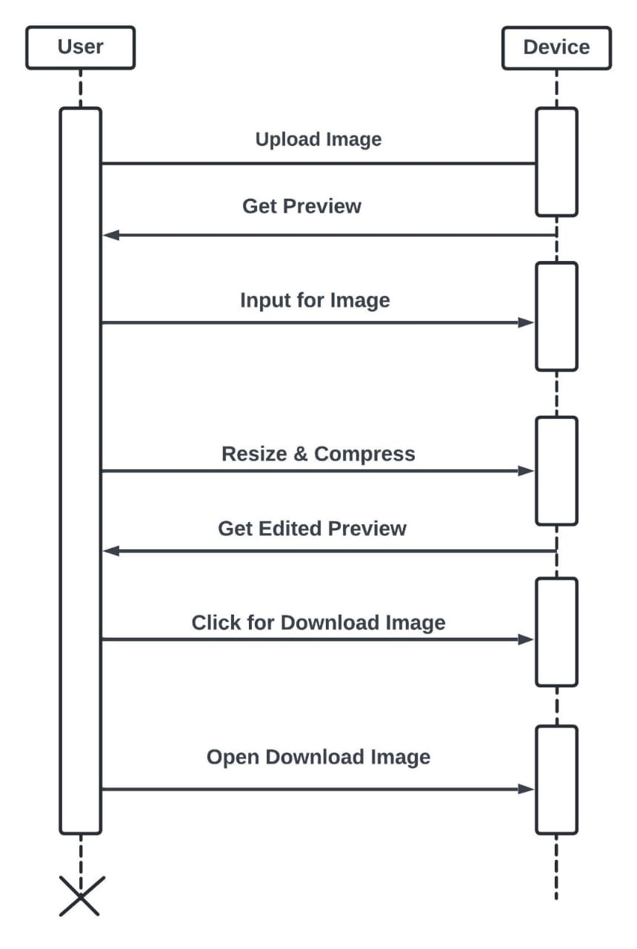

4.Testing and Implementation :-

1.Unit Testing:-
Test individual functions/methods responsible for resizing and compressing images.
Check if they maintain the aspect ratio of the images during resizing.
Test edge cases (very large images, very small images, etc.).

2.Integration Testing:-
Test the integration of resizing and compression functions.
Ensure they work together seamlessly without conflicts or unexpected results.

3.Performance Testing:-
Measure how long it takes to resize and compress various sizes of images.
Check how the system handles bulk resizing/ compression operations.

4.Quality Testing:-
Compare the quality of the resized/ compressed images with the original.
Ensure the compression does not significantly reduce image quality.
Verify that the resized images maintain clarity and sharpness.

5.Limitations:-

Resizing and compression images are common techniques used to optimize them for various purposes like web pages, emails, or storage. However, they come with some limitations and considerations:

- Loss of Original Dimentions:-
Once an image is resized and saved, it loses its original dimensions. If the original size needed later, it won’t be recoverable.

- Loss of Quality:-
When resizing an image, especially enlarging it, there is often a loss of image quality.

6.Feature Enhancement:-

Smart Resize Algorithms:-
Advanced algorithms can now intelligently resize images, preserving important details and textures while reducing file size.

Vector-Based Scaling:-
In some cases, images can be resized without loss of quality using vector-based scaling, commonly seen in programs.

7.BIBLIOGRAPHY:

- https://www.w3school.com/
- https://www.wikipedia.org

Index

