Industrial Internship Report on
"Iris Flower Species Classification using Machine Learning"
Prepared by
Durbadala Naik
Online Summer Internship in Data Science and Machine Learning
UpSkill Campus (USC) | UniConverge Technologies Pvt. Ltd. (UCT)

TABLE OF CONTENTS

1. Preface
This report summarizes the work completed during the 6-week Online Summer Internship in Data Science and Machine Learning, offered by UpSkill Campus (USC) in association with UniConverge Technologies Pvt. Ltd. (UCT).
An internship of this kind plays an important role in career development, as it bridges the gap between academic learning and real-world application. It gives a student the opportunity to move beyond theoretical concepts and understand how data science and machine learning techniques are applied to solve practical problems.
As part of this internship, I worked on a Machine Learning classification project — building and comparing multiple classification models to predict the species of iris flowers based on their physical measurements. The project covered the complete data science pipeline: data loading, exploratory data analysis (EDA), data preprocessing, model training, evaluation, and comparison of results.
This opportunity was provided through the structured learning path designed by USC and UCT, which included weekly modules, hands-on assignments, and a final project submission requirement.
The program was planned across 4 weeks of structured learning (covering Python for Data Science, statistics, data preprocessing, and machine learning algorithms), followed by a final project week.

Through this internship, I learned how to work with real datasets, apply machine learning algorithms such as Logistic Regression, K-Nearest Neighbors, Decision Trees, and Random Forests, and evaluate model performance using standard metrics. I also learned the importance of exploratory data analysis before jumping into modeling, and how to interpret confusion matrices and classification reports.
I would like to thank the mentors and instructors at UpSkill Campus and The IoT Academy for structuring this program in a way that made self-paced learning possible and effective.
To my juniors and peers who take up this internship in the future: start early, be consistent with the weekly modules, and don't leave the final project for the last moment — the concepts build on each other, and hands-on practice throughout is what makes the final project easy to complete.

2. Introduction

2.1 About UniConverge Technologies Pvt Ltd
UniConverge Technologies Pvt. Ltd. (UCT) is a company established in 2013, working in the Digital Transformation domain and providing industrial solutions with a strong focus on sustainability and Return on Investment (RoI).
UCT leverages a range of cutting-edge technologies to build its products and solutions, including the Internet of Things (IoT), Cyber Security, Cloud Computing (AWS, Azure), Machine Learning, Communication Technologies (4G/5G/LoRaWAN), Java Full Stack, and Python.

2.2 About UpSkill Campus (USC)
UpSkill Campus, along with The IoT Academy and in association with UniConverge Technologies, facilitated the smooth execution of this internship program. USC is a career development platform that delivers personalized, affordable, and scalable skill-building programs for students and working professionals.

2.3 Objective
The objectives of this internship program were to:
- Get practical, hands-on experience of working with real datasets and machine learning tools.
- Learn to apply the end-to-end data science workflow to solve a real classification problem.
- Improve job readiness and understanding of the Data Science and Machine Learning field.
- Develop personal skills such as self-paced learning, problem-solving, and technical documentation.

2.4 Reference
[1] Scikit-learn documentation — https://scikit-learn.org/stable/documentation.html
[2] Fisher, R.A. (1936). The Iris flower dataset — UCI Machine Learning Repository.
[3] UpSkill Campus course material — Online Summer Internship in Data Science and Machine Learning.

2.5 Glossary
Term | Meaning
EDA | Exploratory Data Analysis — analyzing data visually/statistically before modeling
Feature | An input variable used by the model (e.g. petal length)
Accuracy | Percentage of correct predictions out of all predictions
Confusion Matrix | Table showing correct vs incorrect predictions per class
Train/Test Split | Dividing data into a set to train the model and a separate set to evaluate it

3. Problem Statement
The assigned problem was to build a machine learning model capable of correctly classifying a flower's species based on four physical measurements: sepal length, sepal width, petal length, and petal width.
This is a multi-class classification problem with three target classes: Setosa, Versicolor, and Virginica. The challenge lies in the fact that two of the three species (Versicolor and Virginica) have overlapping measurement ranges, making perfect separation non-trivial for simpler models.

4. Existing and Proposed Solution
Existing approaches to this well-known classification problem typically use a single algorithm (most commonly K-Nearest Neighbors or a Decision Tree) and report a single accuracy figure. This makes it difficult to know whether the chosen algorithm is actually the best fit, or whether a simpler/more robust model would generalize better.
Proposed Solution: Rather than relying on one algorithm, this project trains and compares four different classification models — Logistic Regression, K-Nearest Neighbors (KNN), Decision Tree, and Random Forest — on the same train/test split, and selects the best-performing model based on test accuracy and per-class precision/recall.
Value addition: This comparative approach gives a more reliable, data-driven basis for model selection, and the exploratory data analysis (correlation heatmap and pairplot) adds interpretability by showing which features are most useful for separating the classes (petal length and petal width, in this case).

4.1 Code submission (Github link)
https://github.com/rinku0050/iris-classification-internship

4.2 Report submission (Github link)
https://github.com/rinku0050/iris-classification-internship

5. Proposed Design / Model
The solution follows the standard machine learning pipeline shown below.

5.1 High Level Diagram
Data Loading → Exploratory Data Analysis (EDA) → Data Preprocessing (Train/Test Split + Feature Scaling) → Model Training (4 algorithms) → Model Evaluation → Best Model Selection.

5.2 Low Level Diagram
1) Load the Iris dataset (150 samples, 4 numeric features, 3 classes).
2) Perform EDA — pairplot and correlation heatmap to understand feature relationships.
3) Split data into 80% training and 20% testing sets (stratified, so class balance is preserved).
4) Standardize features using StandardScaler.
5) Train four classifiers: Logistic Regression, KNN (k=5), Decision Tree, Random Forest (100 trees).
6) Evaluate each model using accuracy, precision, recall, and F1-score.
7) Generate a confusion matrix for the best-performing model.

5.3 Interfaces
Not applicable — this is a self-contained analytical/ML pipeline (no external hardware or communication interfaces).

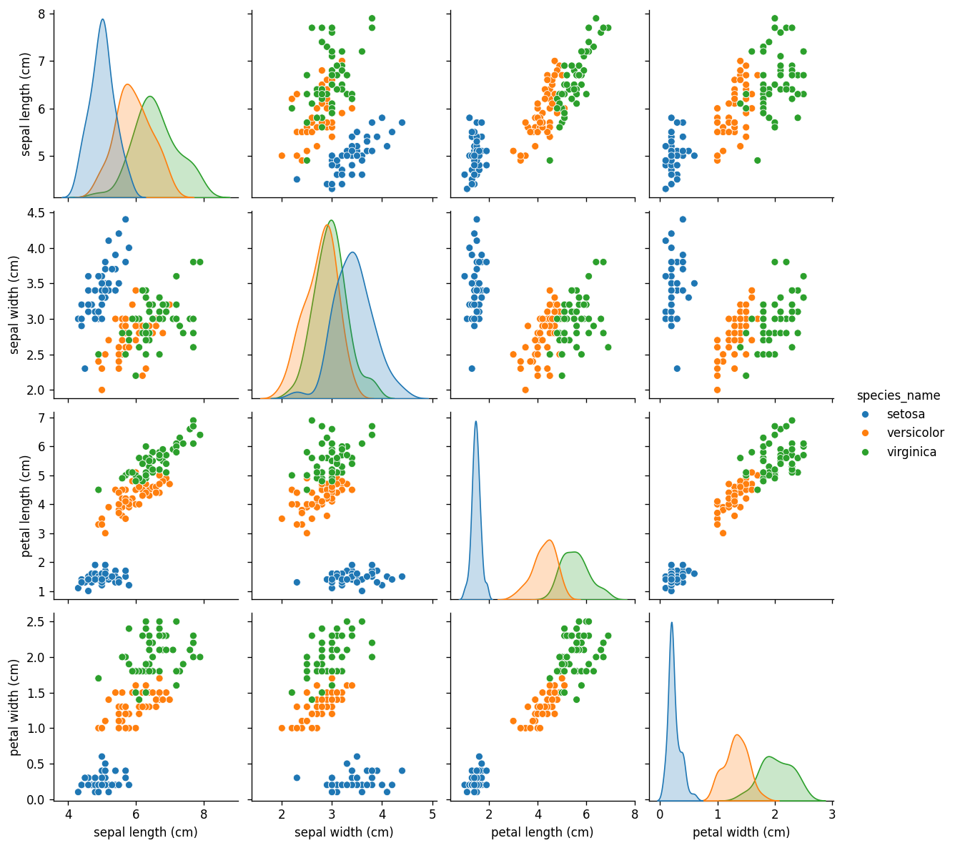
Figure 1: Pairplot of Iris features by species
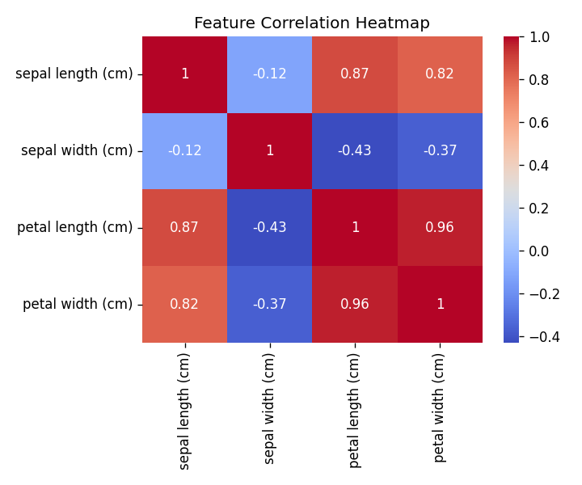
Figure 2: Correlation Heatmap of Iris Features

6. Performance Test
The key constraint for this project was classification accuracy on unseen (test) data — i.e., how well the model generalizes rather than just memorizing the training data. A stratified 80/20 train-test split was used so all three classes were fairly represented in both sets.

6.1 Test Plan / Test Cases
30 test samples (10 per class) were held out and never seen by the models during training. Each of the 4 trained models was evaluated on this identical test set to ensure a fair, apples-to-apples comparison.

6.2 Test Procedure
For each model: fit on the scaled training data → predict on the scaled test data → compute accuracy, precision, recall, F1-score, and confusion matrix using scikit-learn's metrics module.

6.3 Performance Outcome
Model | Accuracy | Precision (avg) | Recall (avg) | F1-score (avg)
Logistic Regression | 93.33% | 0.93 | 0.93 | 0.93
K-Nearest Neighbors (k=5) | 93.33% | 0.94 | 0.93 | 0.93
Decision Tree | 93.33% | 0.93 | 0.93 | 0.93
Random Forest (100 trees) | 90.00% | 0.90 | 0.90 | 0.90

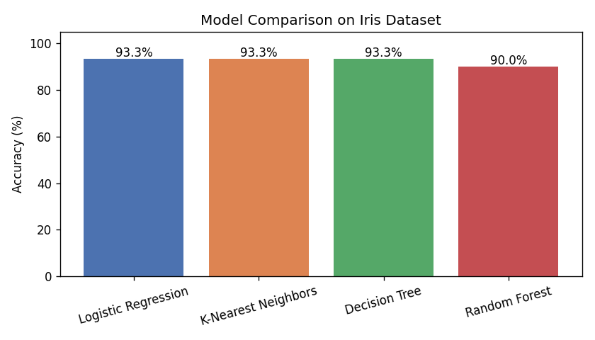
Figure 3: Model Accuracy Comparison
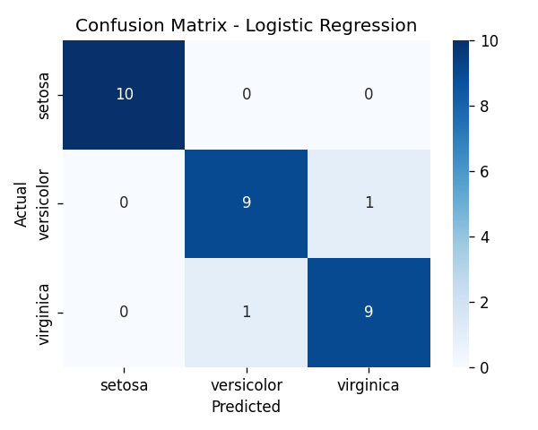
Figure 4: Confusion Matrix — Logistic Regression (Best Model)
Logistic Regression, KNN, and Decision Tree all achieved 93.33% test accuracy, while Random Forest achieved 90.00%. All models classified the Setosa class perfectly (100%), since it is linearly separable from the other two species. Most misclassifications occurred between Versicolor and Virginica, which is expected given their overlapping petal measurements — this was also visible in the EDA pairplot before any model was trained.

7. My Learnings
This internship gave me hands-on exposure to the complete machine learning workflow, from raw data to a compared, evaluated set of models. Key takeaways:
- Exploratory Data Analysis is not optional — visualizing feature relationships before modeling directly explained why certain classes were harder to separate.
- No single algorithm is universally best; comparing multiple models on the same test set is a more reliable way to choose one.
- Feature scaling matters for distance-based and gradient-based algorithms like KNN and Logistic Regression.
- Accuracy alone can be misleading — precision, recall, and the confusion matrix give a much clearer picture of where a model is actually failing.
- Documentation and reporting are as important as the modeling itself, for communicating results to a non-technical audience.
Overall, this internship strengthened both my technical foundation in Python-based machine learning and my ability to structure and present a data science project end-to-end.

8. Future Work Scope
- Apply hyperparameter tuning (GridSearchCV) to further improve model accuracy.
- Test additional algorithms such as Support Vector Machines (SVM) and Gradient Boosting.
- Deploy the best model as a simple web app (e.g., using Streamlit or Flask) for interactive predictions.
- Extend the same pipeline to a larger, real-world tabular dataset relevant to industry use cases.

