INTRODUCTION

In this Employee Attendance Monitoring project, attempts were made to register the presence of employees. The main purpose of this java application is to maintain information about the presence that all employees can use in their departments. This web application retrieves the details of the departments assigned to the relevant administrative employees and employees enrolled in the courses from the server with the internet connection and stores them in the database. At the end of the month, when the administrator is needed to attend, attendance reports can directly generate an administrator report view.

LITERATURE SURVEY

Literature survey is the most important step in software development process. Before developing the tool it is necessary to determine the time factor, economy and company strength. Once these things are satisfied, then next steps are to determine which operating system and language can be used for developing the tool. Once the programmers start building the tool the programmers need lot of external support. This support can be obtained from senior programmers, from book or from websites. Before building the system the above consideration are taken into account for developing the proposed system.

2.1 SCOPE OF THE PROJECT
The scope of the project is the system on which the software is installed, i.e., the project is developed as a desktop application, and it will work for a particular management. But later on the project can be modified to operate it online.

2.2 FUNCTIONAL REQUIREMENTS

Attendance Management System involves the following functions –

- Easily track attendance information of Employees.
- Quickly produce attendance bulletin.

2.3 NON--FUNCTIONAL REQUIREMENTS

Performance
Easy tracking of records and updating can be done. All the requirements relating to performance characteristics of the system are specified in the section below. There are two types of requirements.

Static Requirements

These requirements do not impose any constraints on the execution characteristics of the system. They are:

Number of Terminals

The software makes use of an underlying database that will reside at the server. While the front end will be available online to the administrative and departmental computers as well as employees.

Number of Users

The number of users may vary as this software finds applications in almost all department of the organization.

Dynamic requirements

These specify constraints on the execution characteristics of the system. They typically include response time and throughout of the system.

Availability
The software will be available only to authorized employees of the company like admin to admin staff attendance, admin to add an update employee records.

Security
The security requirements deal with the primary security. The software should be handled only by the administrator and authorized employees. Only the administrator has right to assign permission like creating new accounts and generating password. Only authorized
Employee can access the system with username and password.

Maintainability

Backups for database are available.

Portability

The Software is a windows-based application and is built in Java and SQL.
So it is platform independent and is independent of operating system.

SYSTEM ANALYSIS

3.1 Existing System:

In the Existing System, we maintain information manually to maintain the information in manually is also time taken. Calculate the loss of pay is also time taken.

3.2 Proposed System:

In Proposed System, we are maintaining all the employees’ information in Their attendance and their salary‘s. In this project Employee’s also can view the Attendance and LOP’S. The Application automatically calculates their LOP’s based on their Salary’s.

Advantages of Proposed System

- It is trouble-free to use.
- It is a relatively fast approach to enter attendance is highly reliable, approximate result from employee best user interface and efficient reports

3.3 MINIMUM SYSTEM CONFIGURATION:

Hardware Configuration:

Processor - Pentium –III
- System - Pentium Dual Core.
- Hard Disk - 120 GB.
- Monitor - 15’’ LED
- Input Devices - Keyboard, Mouse
- Ram - 1 GB

Software Configuration:

- Operating system - Windows 7.
- Coding Language - JAVA/J2EE
- Tool - Eclipse
- Database - Oracle 11g
- Database Connectivity - JDBC
- Client Side Technologies - HTML, CSS, JavaScript
- Webserver - Tomcat 9.0

3.4 PRELIMINARY INVESTIGATION

The first and foremost strategy for development of a project starts from the thought of designing a mail enabled platform for a small firm in which it is easy and convenient of sending and receiving messages, there is a search engine ,address book and also including some entertaining games. When it is approved by the organization and our project guide the first activity, i.e. Preliminary investigation begins. The activity has three parts:
- Request Clarification
- Feasibility Study
- Request Approval

3.4.1 REQUEST CLARIFICATION
After the approval of the request to the organization and project guide, with an investigation being considered, the project request must be examined to determine precisely what the system requires.
Here our project is basically meant for users within the company whose systems can be interconnected by the Local Area Network (LAN). In today’s busy schedule man need everything should be provided in a readymade manner. So taking into consideration of the vastly use of the net in day to day life, the corresponding development of the portal came into existence.
3.4.2 FEASIBILITY STUDY

The feasibility of the project is analyzed in this phase and business proposal is put forth with a very general plan for the project and some cost estimates. During system analysis the feasibility study of the proposed system is to be carried out. Feasibility analysis, some understanding of the major requirements for the system is essential. This is to ensure that the proposed system is not a burden to the company.

Three key considerations involved in the feasibility analysis are

ECONOMICAL FEASIBILITY
TECHNICAL FEASIBILITY
SOCIAL FEASIBILITY

ECONOMICAL FEASIBILITY

This study is carried out to check the economic impact that the system will have on the organization. The amount of fund that the company can pour into the research and development of the system is limited. The expenditures must be justified. Thus the developed system as well within the budget and this was achieved because most of the technologies used are freely available.

TECHNICAL FEASIBILITY

This study is carried out to check the technical feasibility, that is, the technical requirements of the system. Any system developed must not have a high demand on the available technical resources. This will lead to high demands on the available technical resources. This will lead to high demands being placed on the client. The developed system must have a modest requirement, as only minimal or null changes are required for implementing this system.
Employee Attendance Monitoring System.

SOCIAL FEASIBILITY

The aspect of study is to check the level of acceptance of the system by the user. This includes the process of training the user to use the system efficiently. The user must not feel threatened by the system, instead must accept it as a necessity. The level of acceptance by the users solely depends on the methods that are employed to educate the user about the system and to make him familiar with it. His level of confidence must be raised so that he is also able to make some constructive criticism, which is welcomed, as he is the final user of the system.

3.4.3 REQUEST APPROVAL

Not all request projects are desirable or feasible. Some organization receives so many project requests from client users that only few of them are pursued. However, those projects that are both feasible and desirable should be put into schedule. Truly speaking, the approval of those above factors, development works can be launched.

3.5 SYSTEM DESIGN AND DEVELOPMENT

3.5.1 INPUT DESIGN

Input Design plays a vital role in the life cycle of software development, it requires very careful attention of developers. The input design is to feed data to the application as accurate as possible. So inputs are supposed to be designed effectively so that the errors occurring while feeding are minimized. According to Software Engineering Concepts, the input forms or screens are designed to provide to have a validation control over the input limit, range and other related validations.

This system has input screens in almost all the modules. Error messages are developed to alert the user whenever he commits some mistakes and guides him in the right way so that invalid entries are not made. Let us see deeply about this under module design.
Input design is the process of converting the user created input into a computer-based format. The goal of the input design is to make the data entry logical and free from errors. The error is in the input are controlled by the input design. The application has been developed in user-friendly manner. The forms have been designed in such a way during the processing the cursor is placed in the position where must be entered. The user is also provided within an option to select an appropriate input from various alternatives related to the field in certain cases. Validations are required for each data entered. Whenever a user enters an erroneous data, error message is displayed and the user can move on to the subsequent pages after completing all the entries in the current page.

3.5.2 OUTPUT DESIGN

The Output from the computer is required to mainly create an efficient method of communication within the company primarily among the project leader and his team members, in other words, the administrator and the clients. The output of VPN is the system which allows the project leader to manage his clients in terms of creating new clients and assigning new projects to them, maintaining a record of the project validity and providing folder level access to each client on the user side depending on the projects allotted to him. After completion of a project, a new project may be assigned to the client. User authentication procedures are maintained at the initial stages itself. A new user may be created by the administrator himself or a employee can himself register as a new user but the task of assigning projects and validating a new employee rests with the administrator only.

The application starts running when it is executed for the first time. The server has to be started and then the internet explorer in used as the browser. The project will run on the local area network so the server machine will serve as the administrator while the other connected systems can act as the clients. The developed system is highly user friendly and can be easily understood by anyone using it even for the first time.

MODULES

- Admin
- Admin Staff
- Employee

MOUDLUE DESCRIPTION

4.1 Admin

In this module, admin has to login with valid username and password. After login successful he can do some operations such as view all employee, their details,
- Login
- View Employee Details
- Add Employee Details
- Delete Employee Details

4.2 Admin Staff

In this module, there are n numbers of employees are present. After registration successful he can login by using valid user name and password. Login successful he will do some operations like View Attendance, View Salary.
- Update the Employee Attendance.
- Calculate LOPS

4.3 Employee

In this module, Employee has to login with valid username and password. After login successful he can do some operations such as view all employee details, View Lops, Apply Leaves their details,
- Login
- View Employee Attendance
- View Lop
- Apply for The Leave

SYSTEM DESIGN

System Design Introduction

The System Design Document describes the system requirements, operating environment, system and subsystem architecture, files and database design, input formats, output layouts, human-machine interfaces, detailed design, processing logic, and external interfaces.

5.1 SYSTEM ARCHITECTURE
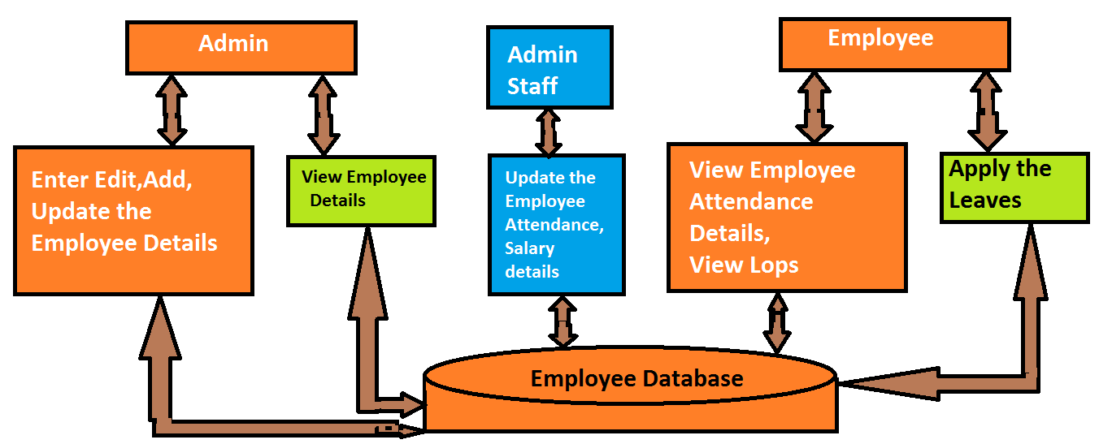

figure 1: SYSTEM ARCHITECTURE

5.2 DATA FLOW DIAGRAM:

- The DFD is also called as bubble chart. It is a simple graphical formalism that can be used to represent a system in terms of input data to the system, various processing carried out on this data, and the output data is generated by this system.
- The data flow diagram (DFD) is one of the most important modeling tools. It is used to model the system components. These components are the system process, the data used by the process, an external entity that interacts with the system and the information flows in the system.
- DFD shows how the information moves through the system and how it is modified by a series of transformations. It is a graphical technique that depicts information flow and the transformations that are applied as data moves from input to output.
- DFD is also known as bubble chart. A DFD may be used to represent a system at any level of abstraction. DFD may be partitioned into levels that represent increasing information flow and functional detail.

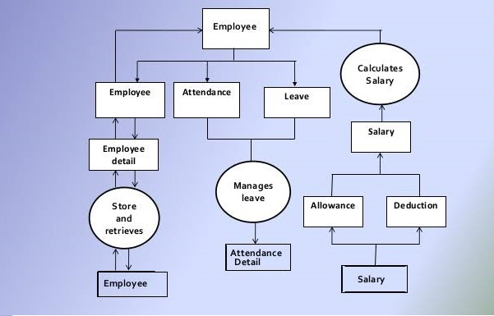
Figure 2: Dataflow diagram

5.3 LOGICAL DESIGN
The logical design of a system pertains to an abstract representation of the data flows, inputs and outputs of the system. This is often conducted via modeling, using an over-abstract (and sometimes graphical) model of the actual system. In the context of systems design are included. Logical design includes ER Diagrams i.e. Entity Relationship Diagrams

5.4 PHYSICAL DESIGN
The physical design relates to the actual input and output processes of the system. This is laid down in terms of how data is input into a system, how it is verified/ authenticated, how it is processed, and how it is displayed as output. In Physical design, following requirements about the system are decided.
- Input requirement,
- Output requirements,
- Storage requirements,
- Processing Requirements,
- System control and backup or recovery.
Put another way, the physical portion of systems design can generally be broken down into three sub-tasks:
- User Interface Design
- Data Design
- Process Design
User Interface Design is concerned with how users add information to the system and with how the system presents information back to them. Data Design is concerned with how the data is represented and stored within the system. Finally, Process Design is concerned with how data moves through the system, and with how and where it is validated, secured and/or transformed as it flows into, through and out of the system. At the end of the systems design phase, documentation describing the three sub-tasks is produced and made available for use in the next phase.
Physical design, in this context, does not refer to the tangible physical design of an information system. To use an analogy, a personal computer's physical design involves input via a keyboard, processing within the CPU, and output via a monitor, printer, etc. It would not concern the actual layout of the tangible hardware, which for a PC would be a monitor, CPU, motherboard, hard drive, modems, video/graphics cards, USB slots, etc. It involves a detailed design of a user and a product database structure processor and a control processor. The H/S personal specification is developed for the proposed system.
5.5 INPUT DESIGN

The input design is the link between the information system and the user. It comprises the developing specification and procedures for data preparation and those steps are necessary to put transaction data in to a usable form for processing can be achieved by inspecting the computer to read data from a written or printed document or it can occur by having people keying the data directly into the system. The design of input focuses on controlling the amount of input required, controlling the errors, avoiding delay, avoiding extra steps and keeping the process simple. The input is designed in such a way so that it provides security and ease of use with retaining the privacy. Input Design considered the following things:
- What data should be given as input?
- How the data should be arranged or coded?
- The dialog to guide the operating personnel in providing input.
- Methods for preparing input validations and steps to follow when error occur.

Objectives:
1. Input Design is the process of converting a user-oriented description of the input into a computer-based system. This design is important to avoid errors in the data input process and show the correct direction to the management for getting correct information from the computerized system.
2. It is achieved by creating user-friendly screens for the data entry to handle large volume of data. The goal of designing input is to make data entry easier and to be free from errors.
3. When the data is entered it will check for its validity. Data can be entered with the help of screens. Appropriate messages are provided as when needed so that the user will not be in maize of instant. Thus the objective of input design is to create an input layout that is easy to follow.

5.6 OUTPUT DESIGN
A quality output is one, which meets the requirements of the end user and presents the information clearly. In any system results of processing are communicated to the users and to other system through outputs. In output design it is determined how the information is to be displaced for immediate need and also the hard copy output. It is the most important and direct source information to the user. Efficient and intelligent output design improves the system’s relationship to help user decision-making.
1. Designing computer output should proceed in an organized, well thought out manner; the right output must be developed while ensuring that each output element is designed so that people will find the system can use easily and effectively. When analysis design computer output, they should Identify the specific output that is needed to meet the requirements.
2. Select methods for presenting information.
3. Create document, report, or other formats that contain information produced by the system.
The output form of an information system should accomplish one or more of the following objectives.
- Convey information about past activities, current status or projections of the Future.
- Signal important events, opportunities, problems, or warnings.
Trigger an action and confirm an action.

5.7 UML DIAGRAMS

UML stands for Unified Modeling Language. UML is a standardized general-purpose modeling language in the field of object-oriented software engineering. The standard is managed, and was created by, the Object Management Group.
The goal is for UML to become a common language for creating models of object oriented computer software. In its current form UML is comprised of two major components: a Meta-model and a notation. In the future, some form of method or process may also be added to; or associated with, UML.The Unified Modeling Language is a standard language for specifying, Visualization, Constructing and documenting the artifacts of software system, as well as for business modeling and other non-software systems.
The UML represents a collection of best engineering practices that have proven successful in the modeling of large and complex systems. The UML is a very important part of developing objects oriented software and the software development process. The UML uses mostly graphical notations to express the design of software projects.

Goals:
The Primary goals in the design of the UML are as follows:
- Provide users a ready-to-use, expressive visual modeling Language so that they can develop and exchange meaningful models.
- Provide extendibility and specialization mechanisms to extend the core concepts.
- Be independent of particular programming languages and development process.
- Provide a formal basis for understanding the modeling language.
- Encourage the growth of OO tools market.
- Support higher level development concepts such as collaborations, frameworks, patterns and components.
- Integrate best practices.

5.7.1 USE CASE DIAGRAM:

A use case diagram in the Unified Modeling Language (UML) is a type of behavioral diagram defined by and created from a Use-case analysis. Its purpose is to present a graphical overview of the functionality provided by a system in terms of actors, their goals (represented as use cases), and any dependencies between those use cases. The main purpose of a use case diagram is to show what system functions are performed for which actor. Roles of the actors in the system can be depicted.

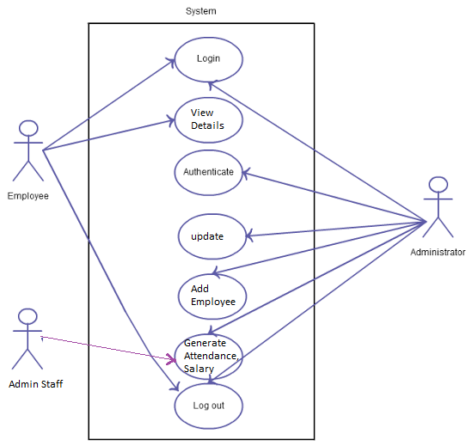

Figure 3: Users Use Case Diagram

5.7.2 SEQUENCE DIAGRAM:

It is a construct of a message sequence chart. A sequence diagram shows object interactions arranged in time sequence. It depicts the objects and classes involved in the scenario and the sequence of messages exchanged between the objects needed to carry out the functionality of the scenario
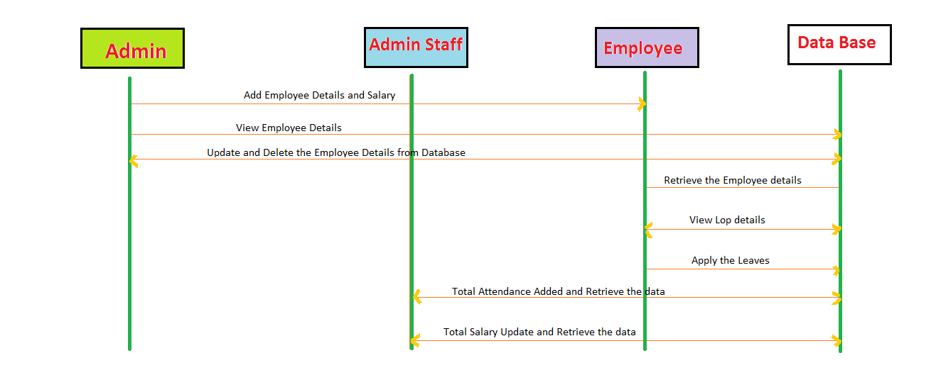
Figure 4: Sequence Diagram

5.7.3 FLOW CHART DIAGRAM:

A flowchart is a visual representation of the sequence of steps and decisions needed to perform a process. Each step in the sequence is noted within a diagram shape. Steps are linked by connecting lines and directional arrows. This allows anyone to view the flowchart and logically follow the process from beginning to end.

A flowchart is a powerful business tool. With proper design and construction, it communicates the steps in a process very effectively and efficiently.

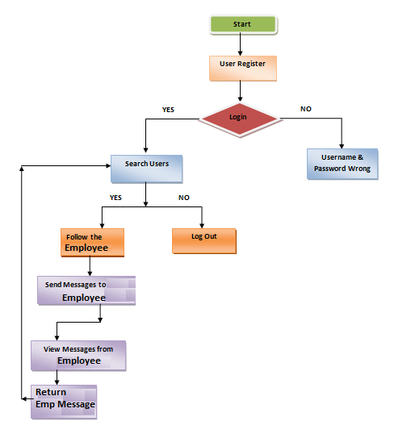

Figure 5: Flow Chart Diagram

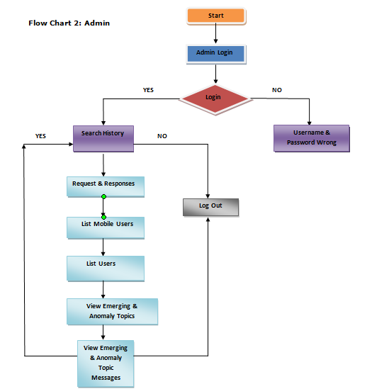

Figure 6: Flow Chart Diagram

IMPLEMENTATION

Software Environment

Client Server:

With the varied topic in existence in the fields of computers, Client Server is one, which has generated more heat than light, and also more hype than reality. This technology has acquired a certain critical mass attention with its dedication conferences and magazines. Major computer vendors such as IBM and DEC, have declared that Client Servers is their main future market. A survey of DBMS magazine reveled that 76% of its readers were actively looking at the client server solution. The growth in the client server development tools from $200 million in 1992 to more than $1.2 billion in 1996. Client server implementations are complex but the underlying concept is simple and powerful. A client is an application running with local resources but able to request the database and relate the services from separate remote server. The software mediating this client server interaction is often referred to as MIDDLEWARE. The typical client either a PC or a Work Station connected through a network to a more powerful PC, Workstation, Midrange or Main Frames server usually capable of handling request from more than one client. However, with some configuration server may also act as client.
A server may need to access other server in order to process the original client request. The key client server idea is that client as user is essentially insulated from the physical location and formats of the data needs for their application. With the proper middleware, a client input from or report can transparently access and manipulate both local database on the client machine and remote databases on one or more servers. An added bonus is the client server opens the door to multi-vendor database access indulging heterogeneous table joins.

What is a Client Server

Two prominent systems in existence are client server and file server systems. It is essential to distinguish between client servers and file server systems. Both provide shared network access to data but the comparison dens there! The file server simply provides a remote disk drive that can be accessed by LAN applications on a file by file basis. The client server offers full relational database services such as SQL-Access, Record modifying, Insert, Delete with full relational integrity backup/ restore performance for high volume of transactions, etc. the client server middleware provides a flexible interface between client and server, who does what, when and to whom.
In my project, I have chosen Java language for developing the code.

About Java
Initially the language was called as “oak” but it was renamed as “Java” in 1995. The primary motivation of this language was the need for a platform-independent (i.e., architecture neutral) language that could be used to create software to be embedded in various consumer electronic devices.
- Java is a programmer’s language.
- Java is cohesive and consistent.
- Except for those constraints imposed by the Internet environment, Java gives the programmer, full control.
Finally, Java is to Internet programming where C was to system programming.

Importance of Java to the Internet
Java has had a profound effect on the Internet. This is because; Java expands the Universe of objects that can move about freely in Cyberspace. In a network, two categories of objects are transmitted between the Server and the Personal computer. They are: Passive information and Dynamic active programs. The Dynamic, Self-executing programs cause serious problems in the areas of Security and probability. But, Java addresses those concerns and by doing so, has opened the door to an exciting new form of program called the Applet.

Java can be used to create two types of programs
Applications and Applets: An application is a program that runs on our Computer under the operating system of that computer. It is more or less like one creating using C or C++. Java’s ability to create Applets makes it important. An Applet is an application designed to be transmitted over the Internet and executed by a Java –compatible web browser. An applet is actually a tiny Java program, dynamically downloaded across the network, just like an image. But the difference is, it is an intelligent program, not just a media file. It can react to the user input and dynamically change.

Features of Java

Security
Every time you that you download a “normal” program, you are risking a viral infection. Prior to Java, most users did not download executable programs frequently, and those who did scanned them for viruses prior to execution. Most users still worried about the possibility of infecting their systems with a virus. In addition, another type of malicious program exists that must be guarded against. This type of program can gather private information, such as credit card numbers, bank account balances, and passwords. Java answers both these concerns by providing a “firewall” between a network application and your computer.
When you use a Java-compatible Web browser, you can safely download Java applets without fear of virus infection or malicious intent.

Portability
For programs to be dynamically downloaded to all the various types of platforms connected to the Internet, some means of generating portable executable code is needed .As you will see, the same mechanism that helps ensure security also helps create portability. Indeed, Java’s solution to these two problems is both elegant and efficient.

The Byte code
The key that allows the Java to solve the security and portability problems is that the output of Java compiler is Byte code. Byte code is a highly optimized set of instructions designed to be executed by the Java run-time system, which is called the Java Virtual Machine (JVM). That is, in its standard form, the JVM is an interpreter for byte code.
Translating a Java program into byte code helps makes it much easier to run a program in a wide variety of environments. The reason is, once the run-time package exists for a given system, any Java program can run on it. Although Java was designed for interpretation; there is technically nothing about Java that prevents on-the-fly compilation of byte code into native code. Sun has just completed its Just In Time (JIT) compiler for byte code. When the JIT compiler is a part of JVM, it compiles byte code into executable code in real time, on a piece-by-piece, demand basis. It is not possible to compile an entire Java program into executable code all at once, because Java performs various run-time checks that can be done only at run time. The JIT compiles code, as it is needed, during execution.

Java, Virtual Machine (JVM)
Beyond the language, there is the Java virtual machine. The Java virtual machine is an important element of the Java technology. The virtual machine can be embedded within a web browser or an operating system. Once a piece of Java code is loaded onto a machine, it is verified. As part of the loading process, a class loader is invoked and does byte code verification makes sure that the code that’s has been generated by the compiler will not corrupt the machine that it’s loaded on. Byte code verification takes place at the end of the compilation process to make sure that is all accurate and correct. So byte code verification is integral to the compiling and executing of Java code.

Java Source
Java byte code
JavaVM
Java
.Class

Picture showing the development process of JAVA Program
Java programming uses to produce byte codes and executes them. The first box indicates that the Java source code is located in a. Java file that is processed with a Java compiler called javac. The Java compiler produces a file called a. class file, which contains the byte code. The. Class file is then loaded across the network or loaded locally on your machine into the execution environment is the Java virtual machine, which interprets and executes the byte code.

Java Architecture
Java architecture provides a portable, robust, high performing environment for development. Java provides portability by compiling the byte codes for the Java Virtual Machine, which is then interpreted on each platform by the run-time environment. Java is a dynamic system, able to load code when needed from a machine in the same room or across the planet.

Compilation of code
When you compile the code, the Java compiler creates machine code (called byte code) for a hypothetical machine called Java Virtual Machine (JVM). The JVM is supposed to execute the byte code. The JVM is created for overcoming the issue of portability. The code is written and compiled for one machine and interpreted on all machines. This machine is called Java Virtual Machine.
During run-time the Java interpreter tricks the byte code file into thinking that it is running on a Java Virtual Machine. In reality this could be a Intel Pentium Windows 95 or Sun SARC station running Solaris or Apple Macintosh running system and all could receive code from any computer through Internet and run the Applets.

Simple
Java was designed to be easy for the Professional programmer to learn and to use effectively. If you are an experienced C++ programmer, learning Java will be even easier. Because Java inherits the C/C++ syntax and many of the object oriented features of C++. Most of the confusing concepts from C++ are either left out of Java or implemented in a cleaner, more approachable manner. In Java there are a small number of clearly defined ways to accomplish a given task.

Object-Oriented
Java was not designed to be source-code compatible with any other language. This allowed the Java team the freedom to design with a blank slate. One outcome of this was a clean usable, pragmatic approach to objects. The object model in Java is simple and easy to extend, while simple types, such as integers, are kept as high-performance non-objects.

Robust
The multi-platform environment of the Web places extraordinary demands on a program, because the program must execute reliably in a variety of systems. The ability to create robust programs was given a high priority in the design of Java. Java is strictly typed language; it checks your code at compile time and run time.
Java virtually eliminates the problems of memory management and deallocation, which is completely automatic. In a well-written Java program, all run time errors can –and should –be managed by your program.

Hyper Text Markup Language
Hypertext Markup Language (HTML), the languages of the World Wide Web (WWW), allows users to produces Web pages that include text, graphics and pointer to other Web pages (Hyperlinks).
HTML is not a programming language but it is an application of ISO Standard 8879, SGML (Standard Generalized Markup Language), but specialized to hypertext and adapted to the Web. The idea behind Hypertext is that instead of reading text in rigid linear structure, we can easily jump from one point to another point. We can navigate through the information based on our interest and preference. A markup language is simply a series of elements, each delimited with special characters that define how text or other items enclosed within the elements should be displayed. Hyperlinks are underlined or emphasized works that load to other documents or some portions of the same document.
HTML can be used to display any type of document on the host computer, which can be geographically at a different location. It is a versatile language and can be used on any platform or desktop.
HTML provides tags (special codes) to make the document look attractive. HTML tags are not case-sensitive. Using graphics, fonts, different sizes, color, etc., can enhance the presentation of the document. Anything that is not a tag is part of the document itself.

Basic HTML Tags :
<!-- --> Specifies comments
<A>……….</A> Creates hypertext links
<B>……….</B> Formats text as bold
<BIG>……….</BIG> Formats text in large font.
<BODY>…</BODY> Contains all tags and text in the HTML document
<CENTER>...</CENTER> Creates text
<DD>…</DD> Definition of a term
<DL>...</DL> Creates definition list
<FONT>…</FONT> Formats text with a particular font
<FORM>...</FORM> Encloses a fill-out form
<FRAME>...</FRAME> Defines a particular frame in a set of frames
<H#>…</H#> Creates headings of different levels
<HEAD>...</HEAD> Contains tags that specify information about a document
<HR>...</HR> Creates a horizontal rule
<HTML>…</HTML> Contains all other HTML tags
<META>...</META> Provides meta-information about a document
<SCRIPT>…</SCRIPT> Contains client-side or server-side script
<TABLE>…</TABLE> Creates a table
<TD>…</TD> Indicates table data in a table
<TR>…</TR> Designates a table row
<TH>…</TH> Creates a heading in a table
ADVANTAGES
- A HTML document is small and hence easy to send over the net. It is small because it does not include formatted information.
- HTML is platform independent.
- HTML tags are not case-sensitive.
Java Database Connectivity
What Is JDBC?
JDBC is a Java API for executing SQL statements. (As a point of interest, JDBC is a trademarked name and is not an acronym; nevertheless, JDBC is often thought of as standing for Java Database Connectivity. It consists of a set of classes and interfaces written in the Java programming language. JDBC provides a standard API for tool/database developers and makes it possible to write database applications using a pure Java API.
Using JDBC, it is easy to send SQL statements to virtually any relational database. One can write a single program using the JDBC API, and the program will be able to send SQL statements to the appropriate database. The combinations of Java and JDBC lets a programmer write it once and run it anywhere.
What Does JDBC Do?

Simply put, JDBC makes it possible to do three things:
- Establish a connection with a database
- Send SQL statements
- Process the results.

JDBC versus ODBC and other APIs
At this point, Microsoft's ODBC (Open Database Connectivity) API is that probably the most widely used programming interface for accessing relational databases. It offers the ability to connect to almost all databases on almost all platforms.
So why not just use ODBC from Java? The answer is that you can use ODBC from Java, but this is best done with the help of JDBC in the form of the JDBC-ODBC Bridge, which we will cover shortly. The question now becomes "Why do you need JDBC?" There are several answers to this question:
- ODBC is not appropriate for direct use from Java because it uses a C interface. Calls from Java to native C code have a number of drawbacks in the security, implementation, robustness, and automatic portability of applications.
- A literal translation of the ODBC C API into a Java API would not be desirable. For example, Java has no pointers, and ODBC makes copious use of them, including the notoriously error-prone generic pointer "void *". You can think of JDBC as ODBC translated into an object-oriented interface that is natural for Java programmers.
- ODBC is hard to learn. It mixes simple and advanced features together, and it has complex options even for simple queries. JDBC, on the other hand, was designed to keep simple things simple while allowing more advanced capabilities where required.
- A Java API like JDBC is needed in order to enable a "pure Java" solution. When ODBC is used, the ODBC driver manager and drivers must be manually installed on every client machine. When the JDBC driver is written completely in Java, however, JDBC code is automatically installable, portable, and secure on all Java platforms from network computers to mainframes.

Two-tier and Three-tier Models
The JDBC API supports both two-tier and three-tier models for database access.
In the two-tier model, a Java applet or application talks directly to the database. This requires a JDBC driver that can communicate with the particular database management system being accessed. A user's SQL statements are delivered to the database, and the results of those statements are sent back to the user. The database may be located on another machine to which the user is connected via a network. This is referred to as a client/server configuration, with the user's machine as the client, and the machine housing the database as the server. The network can be an Intranet, which, for example, connects employees within a corporation, or it can be the Internet.
In the three-tier model, commands are sent to a "middle tier" of services, which then send SQL statements to the database. The database processes the SQL statements and sends the results back to the middle tier, which then sends them to the user. MIS directors find the three-tier model very attractive because the middle tier makes it possible to maintain control over access and the kinds of updates that can be made to corporate data. Another advantage is that when there is a middle tier, the user can employ an easy-to-use higher-level API which is translated by the middle tier into the appropriate low-level calls. Finally, in many cases the three-tier architecture can provide performance advantages.
Until now the middle tier has typically been written in languages such as C or C++, which offer fast performance. However, with the introduction of optimizing compilers that translate Java byte code into efficient machine-specific code, it is becoming practical to implement the middle tier in Java. This is a big plus, making it possible to take advantage of Java's robustness, multithreading, and security features. JDBC is important to allow database access from a Java middle tier.

JDBC Driver Types
The JDBC drivers that we are aware of at this time fit into one of four categories:
- JDBC-ODBC bridge plus ODBC driver
- Native-API partly-Java driver
- JDBC-Net pure Java driver
- Native-protocol pure Java driver

JDBC-ODBC Bridge
If possible, use a Pure Java JDBC driver instead of the Bridge and an ODBC driver. This completely eliminates the client configuration required by ODBC. It also eliminates the potential that the Java VM could be corrupted by an error in the native code brought in by the Bridge (that is, the Bridge native library, the ODBC driver manager library, the ODBC driver library, and the database client library).

What Is the JDBC- ODBC Bridge?
The JDBC-ODBC Bridge is a JDBC driver, which implements JDBC operations by translating them into ODBC operations. To ODBC it appears as a normal application program. The Bridge implements JDBC for any database for which an ODBC driver is available. The Bridge is implemented as the
sun.jdbc.odbc Java package and contains a native library used to access ODBC. The Bridge is a joint development of Intersolv and JavaSoft.

Java Server Pages (JSP)
Java server Pages is a simple, yet powerful technology for creating and maintaining dynamic-content web pages. Based on the Java programming language, Java Server Pages offers proven portability, open standards, and a mature re-usable component model .The Java Server Pages architecture enables the separation of content generation from content presentation. This separation not eases maintenance headaches, it also allows web team members to focus on their areas of expertise. Now, web page designer can concentrate on layout, and web application designers on programming, with minimal concern about impacting each other’s work.

Features of JSP

Portability:
Java Server Pages files can be run on any web server or web-enabled application server that provides support for them. Dubbed the JSP engine, this support involves recognition, translation, and management of the Java Server Page lifecycle and its interaction components.

Components

It was mentioned earlier that the Java Server Pages architecture can include reusable Java components. The architecture also allows for the embedding of a scripting language directly into the Java Server Pages file. The components current supported include Java Beans, and Servlets.

Processing
A Java Server Pages file is essentially an HTML document with JSP scripting or tags. The Java Server Pages file has a JSP extension to the server as a Java Server Pages file. Before the page is served, the Java Server Pages syntax is parsed and processed into a Servlet on the server side. The Servlet that is generated outputs real content in straight HTML for responding to the client.

Access Models:
A Java Server Pages file may be accessed in at least two different ways. A client’s request comes directly into a Java Server Page. In this scenario, suppose the page accesses reusable Java Bean components that perform particular well-defined computations like accessing a database. The result of the Beans computations, called result sets is stored within the Bean as properties. The page uses such Beans to generate dynamic content and present it back to the client.
In both of the above cases, the page could also contain any valid Java code. Java Server Pages architecture encourages separation of content from presentation.

Steps in the execution of a JSP Application:
- The client sends a request to the web server for a JSP file by giving the name of the JSP file within the form tag of a HTML page.
- This request is transferred to the JavaWebServer. At the server side JavaWebServer receives the request and if it is a request for a jsp file server gives this request to the JSP engine.
- JSP engine is program which can understand the tags of the jsp and then it converts those tags into a Servlet program and it is stored at the server side. This Servlet is loaded in the memory and then it is executed and the result is given back to the JavaWebServer and then it is transferred back to the result is given back to the JavaWebServer and then it is transferred back to the client.

JDBC connectivity
The JDBC provides database-independent connectivity between the J2EE platform and a wide range of tabular data sources. JDBC technology allows an Application Component Provider to:
- Perform connection and authentication to a database server
- Manager transactions
- Move SQL statements to a database engine for preprocessing and execution
- Execute stored procedures
- Inspect and modify the results from Select statements.

Tomcat 9.0 web server

Tomcat is an open source web server developed by Apache Group. Apache Tomcat is the servlet container that is used in the official Reference Implementation for the Java Servlet and Java Server Pages technologies. The Java Servlet and Java Server Pages specifications are developed by Sun under the Java Community Process. Web Servers like Apache Tomcat support only web components while an application server supports web components as well as business components (BEAs Web logic, is one of the popular application server).To develop a web application with jsp/servlet install any web server like JRun, Tomcat etc to run your application.

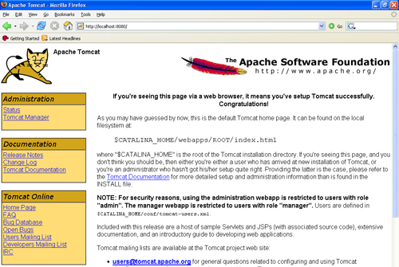

7.2 SOURCE CODE

Index.html
<!DOCTYPE html>
<html>
<head>
<link rel="stylesheet" href="home.css">
<script src="loginvalidation.js"> </script>

<title>Employee Attendance Monitoring System</title>

</head>
<body>

<div class="h1-tag">Employee Attendance Monitoring System</div>

<div class="h4">
<div class="h2">
<center><br>
<a href="admin.html"><img src="images/logo.png" width="250px" height="250px" style="border-radius:50px 50px 50px 50px;box-shadow: 15px 15px 5px #8888;"></a><br><br>
<font size="5" face="Verdana" color="red">Admin Login</font><br><br>
</center>
</div>

<div class="h3">
<center><br>
<a href="adminstaff.html"><img src="images/logo2.png" width="250px" height="250px" style="border-radius:50px 50px 50px 50px;box-shadow: 15px 15px 5px #8888;"></a><br><br>
<font size="5" face="Verdana" color="red">Admin Staff</font><br><br>
</center>
</div>

<div class="h5">
<center><br>
<a href="employee.html"><img src="images/logo1.png" width="250px" height="250px" style="border-radius:50px 50px 50px 50px;box-shadow: 15px 15px 5px #8888;"></a><br><br>
<font size="5" face="Verdana" color="red">Employee Login</font><br><br>
</center>
</div>
</div>
</body>
</html>

AdminLogin.java

package com.employee.servlets;

import java.io.IOException;

import java.io.PrintWriter;

import javax.servlet.ServletException;
import javax.servlet.annotation.WebServlet;
import javax.servlet.http.HttpServlet;
import javax.servlet.http.HttpServletRequest;
import javax.servlet.http.HttpServletResponse;
import javax.servlet.http.HttpSession;

@WebServlet("/AdminLogin")
public class AdminLogin extends HttpServlet {
protected void doPost(HttpServletRequest request, HttpServletResponse response) throws ServletException, IOException
{
response.setContentType("text/html");
PrintWriter out=response.getWriter();

out.print("<!DOCTYPE html>");
out.print("<html>");
out.println("<head>");
out.println("<title>Admin Section</title>");
out.println("</head>");
out.println("<body>");

String email=request.getParameter("email");
String password=request.getParameter("password");

if(email.equals("admin@gmail.com")&&password.equals("admin12"))
{
HttpSession session=request.getSession();
session.setAttribute("admin","true");

request.getRequestDispatcher("adminlogin.html").include(request, response);

}else{

request.getRequestDispatcher("admin.html").include(request, response);
out.println("<br><br><br><center></h3>Username or password error</h3></center></body></html>");

}

out.close();
}

}

SYSTEM TESTING

The purpose of testing is to discover errors. Testing is the process of trying to discover every conceivable fault or weakness in a work product. It provides a way to check the functionality of components, sub assemblies, assemblies and/or a finished product It is the process of exercising software with the intent of ensuring that the
Software system meets its requirements and user expectations and does not fail in an unacceptable manner. There are various types of test. Each test type addresses a specific testing requirement.

Unit Testing

Unit testing involves the design of test cases that validate that the internal program logic is functioning properly, and that program inputs produce valid outputs. All decision branches and internal code flow should be validated. It is the testing of individual software units of the application .it is done after the completion of an individual unit before integration. This is a structural testing, that relies on knowledge of its construction and is invasive. Unit tests perform basic tests at component level and test a specific business process, application, and/or system configuration. Unit tests ensure that each unique path of a business process performs accurately to the documented specifications and contains clearly defined inputs and expected results.

Integration Testing

Integration tests are designed to test integrated software components to determine if they actually run as one program. Testing is event driven and is more concerned with the basic outcome of screens or fields. Integration tests demonstrate that although the components were individually satisfaction, as shown by successfully unit testing, the combination of components is correct and consistent. Integration testing is specifically aimed at exposing the problems that arise from the combination of components.

Functional Testing

Functional tests provide systematic demonstrations that functions tested are available as specified by the business and technical requirements, system documentation, and user manuals.
Functional testing is centered on the following items:
Valid Input : identified classes of valid input must be accepted.
Invalid Input : identified classes of invalid input must be rejected.
Functions : identified functions must be exercised.
Output : identified classes of application outputs must be exercised.
Systems/Procedures : interfacing systems or procedures must be invoked.

Organization and preparation of functional tests is focused on requirements, key functions, or special test cases. In addition, systematic coverage pertaining to identify Business process flows; data fields, predefined processes, and successive processes must be considered for testing. Before functional testing is complete, additional tests are identified and the effective value of current tests is determined.

System Test

System testing ensures that the entire integrated software system meets requirements. It tests a configuration to ensure known and predictable results. An example of system testing is the configuration oriented system integration test. System testing is based on process descriptions and flows, emphasizing pre-driven process links and integration points.

White Box Testing

White Box Testing is a testing in which in which the software tester has knowledge of the inner workings, structure and language of the software, or at least its purpose. It is purpose. It is used to test areas that cannot be reached from a black box level.

Black Box Testing

Black Box Testing is testing the software without any knowledge of the inner workings, structure or language of the module being tested. Black box tests, as most other kinds of tests, must be written from a definitive source document, such as specification or requirements document, such as specification or requirements document. It is a testing in which the software under test is treated, as a black box .you cannot “see” into it. The test provides inputs and responds to outputs without considering how the software works.

8.1.1 Unit Testing:

Unit testing is usually conducted as part of a combined code and unit test phase of the software lifecycle, although it is not uncommon for coding and unit testing to be conducted as two distinct phases.

Test strategy and approach

Field testing will be performed manually and functional tests will be written in detail.

Test objectives
- All field entries must work properly.
- Pages must be activated from the identified link.
- The entry screen, messages and responses must not be delayed.

Features to be tested
- Verify that the entries are of the correct format
- No duplicate entries should be allowed
- All links should take the user to the correct page.

8.1.2 Integration Testing

Software integration testing is the incremental integration testing of two or more integrated software components on a single platform to produce failures caused by interface defects. The task of the integration test is to check that components or software applications, e.g. components in a software system or – one step up – software applications at the company level – interact without error.
Test Results:
All the test cases mentioned above passed successfully. No defects encountered.

8.1.3 Acceptance Testing

User Acceptance Testing is a critical phase of any project and requires significant participation by the end user. It also ensures that the system meets the functional requirements.
Test Results:
All the test cases mentioned above passed successfully. No defects encountered.

8.2 Test Cases

Validation Checking
Validation checks are performed on the following fields.

Text Field
The text field can contain only the number of characters lesser than or equal to its size. The text fields are alphanumeric in some tables and alphabetic in other tables. Incorrect entry always flashes and error message.

Numeric Field
The numeric field can contain only numbers from 0 to 9. An entry of any character flashes an error messages. The individual modules are checked for accuracy and what it has to perform. Each module is subjected to test run along with sample data. The individually tested modules are integrated into a single system. Testing involves executing the real data information is used in the program the existence of any program defect is inferred from the output. The testing should be planned so that all the requirements are individually tested.
A successful test is one that gives out the defects for the inappropriate data and produces and output revealing the errors in the system.

Preparation of Test Data
Taking various kinds of test data does the above testing. Preparation of test data plays a vital role in the system testing. After preparing the test data the system under study is tested using that test data. While testing the system by using test data errors are again uncovered and corrected by using above testing steps and corrections are also noted for future use.

SCREEN SHOTS

9.1 Home Page:
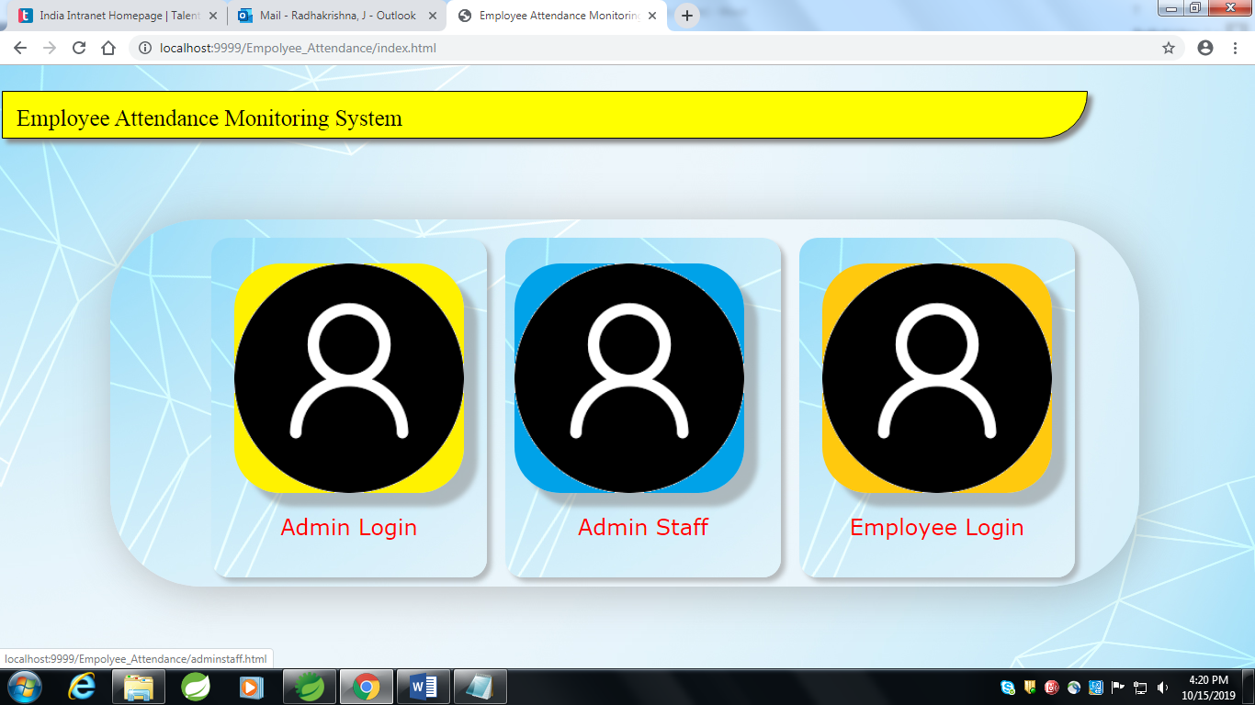

Admin Login

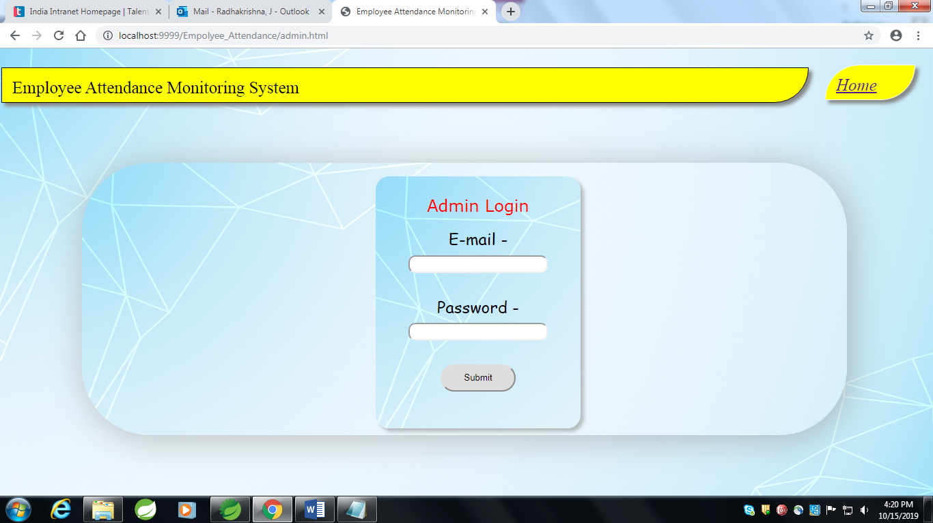

9.2 Admin Login page

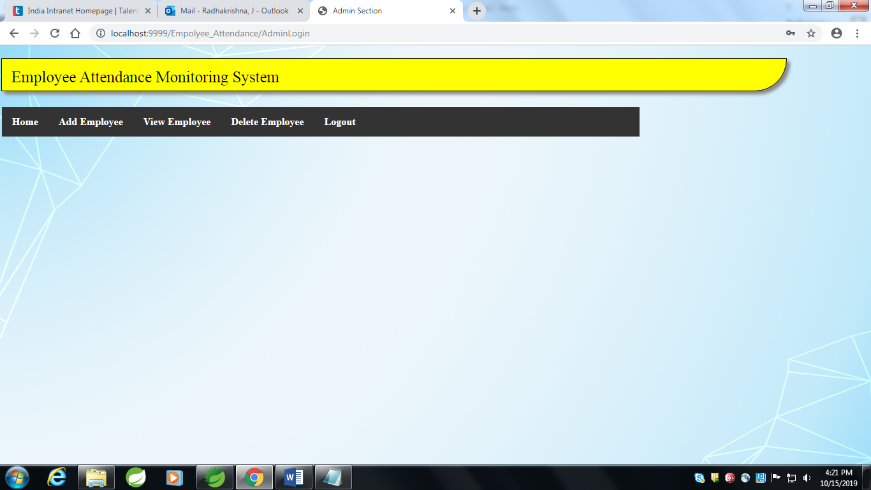

9.3 Employee Registration Page:

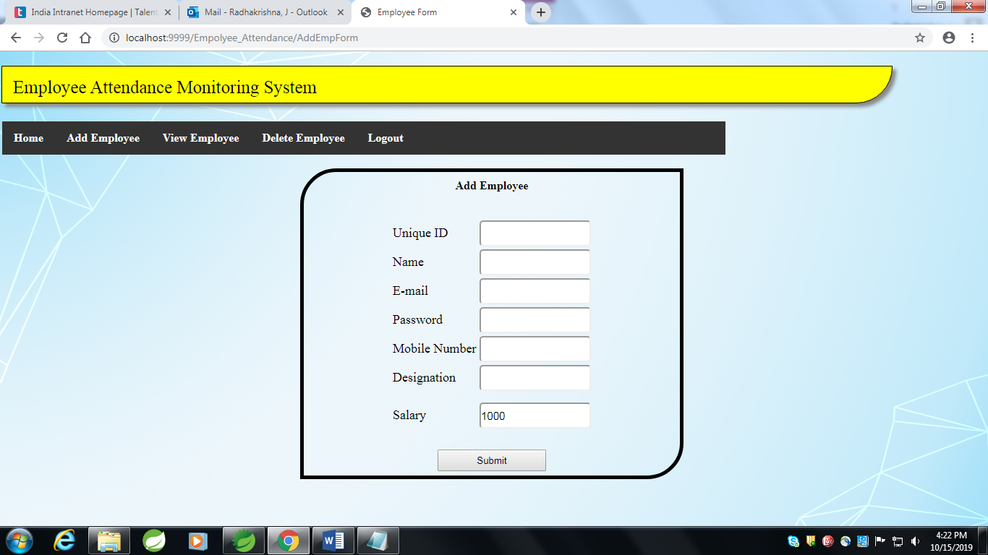

9.4 Admin Staff Login

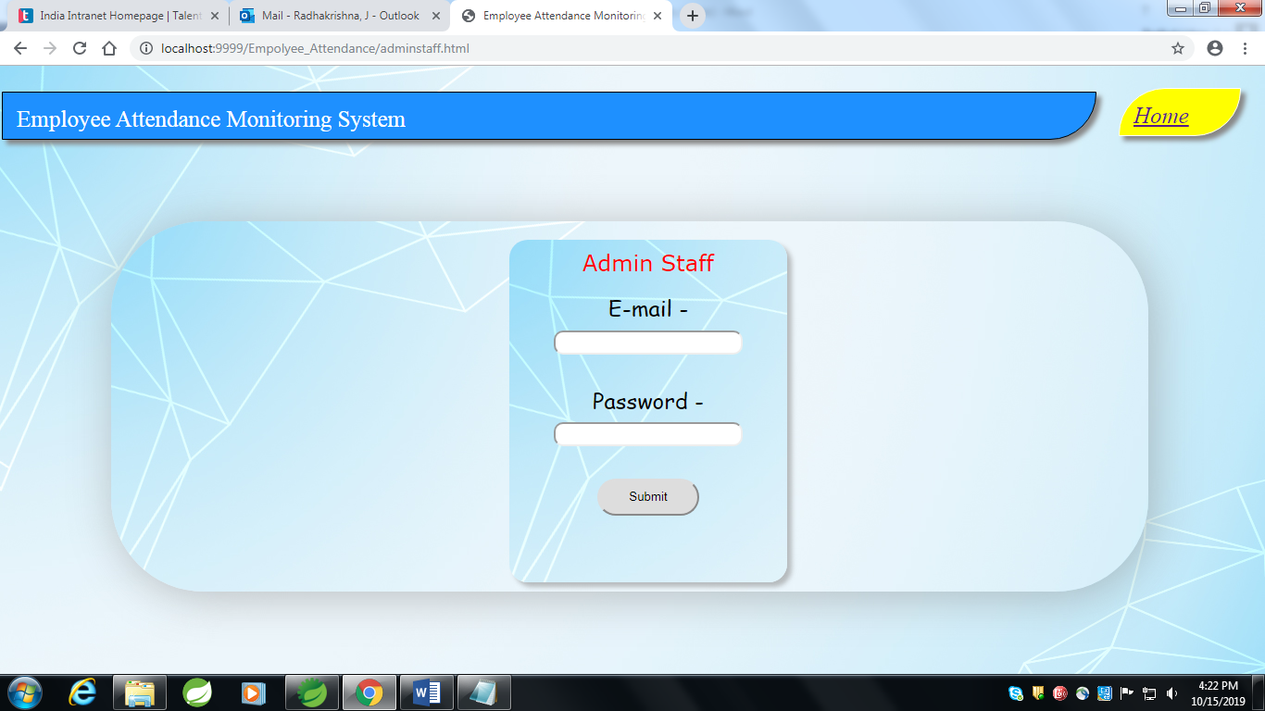

9.5 Employee Login Page

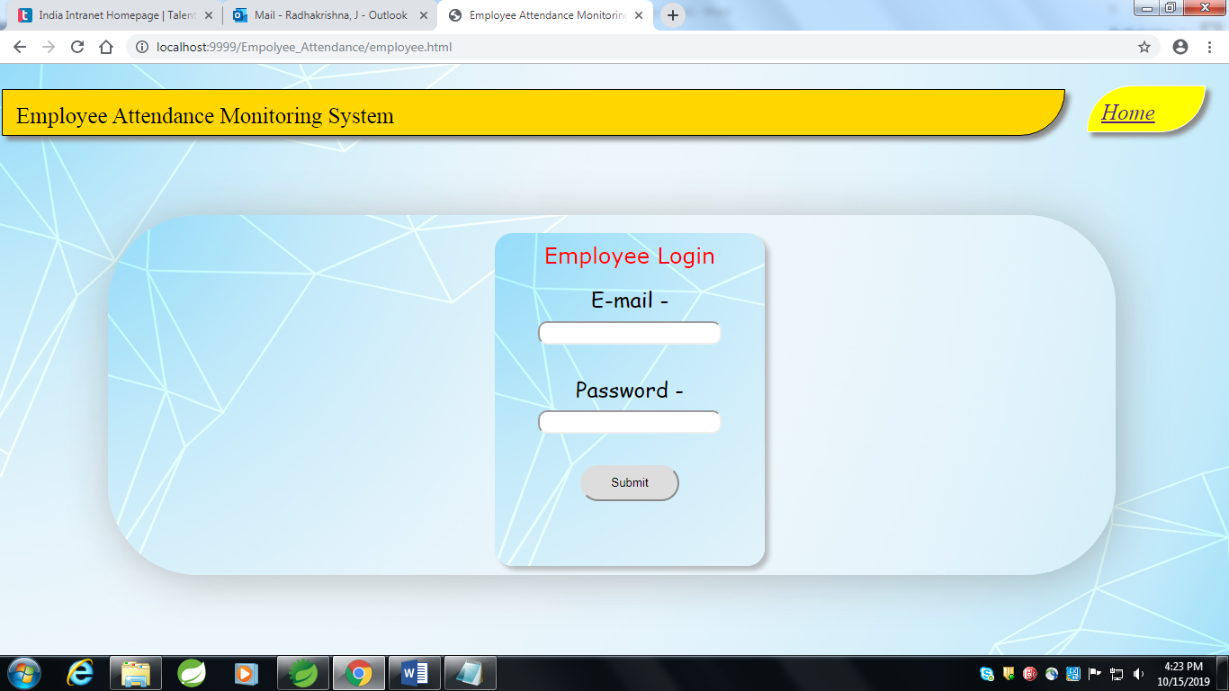

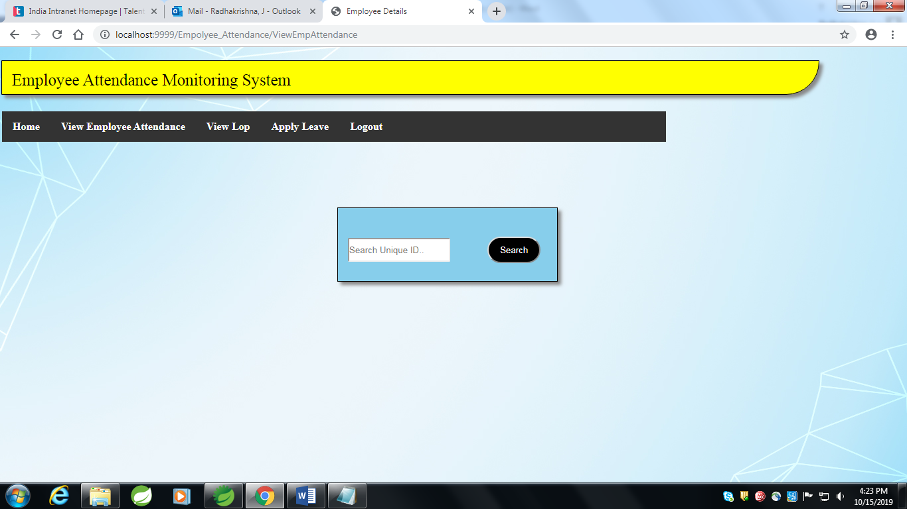

9.6 View Lop’s

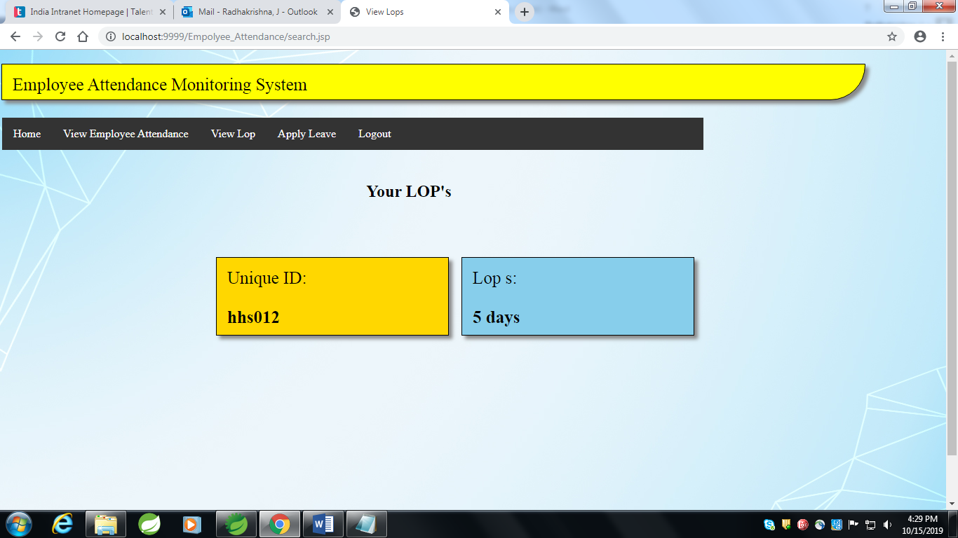

CONCLUSION

The Employee Attendance Management System is developed using Java fully meets the objectives of the system which it has been developed. The system has reached a steady state where all bugs have been eliminated. The system is operated at a high level of efficiency and all the employees and admin staff associated with the system understands its advantage. The system solves the problem. It was intended to solve as requirement specification.

