To check the images:

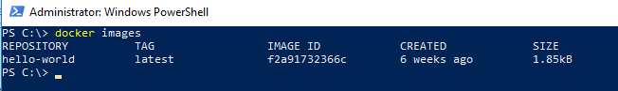

Installing JENKINS on windows container using Docker file:

1. Go to <https://jenkins.io/download/>
2. Download window .zip file

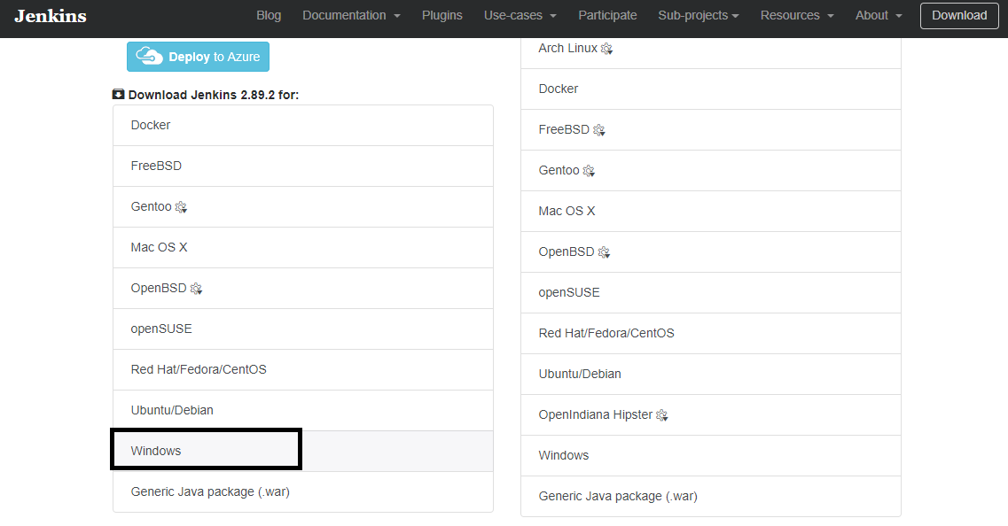

1. Put the jenkins.msi file in a setup folder and create dockerfile.

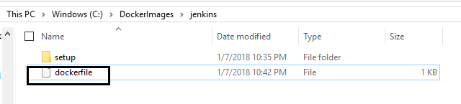

**Docker File:**

#THIS DOCKER FILE IS DEVELOPED BY ASSISTANZ NETWORKS

#SPECIFY THE CONTAINER IMAGE

FROM microsoft/windowsservercore

#COPY THE JENKINS INSTALLATION FILES INTO THE CONTAINER

ADD ./setup c:/jenkins

#INSTALLING IIS

RUN Powershell.exe -Command Install-WindowsFeature Web-Server

#INSTALLING JENKINS

RUN ["msiexec.exe", "/i", "C:\\jenkins\\jenkins.msi", "/qn"]

#REMOVING SETUP FILES FROM CONTAINER

RUN Powershell.exe -Command remove-item c:/jenkins -Recurse

1. Go to powershell and create container.

docker build -t jenkins C:\DockerImages\jenkins

Note : Make sure Docker must “Switch to Window Container”

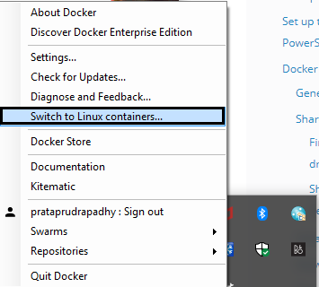

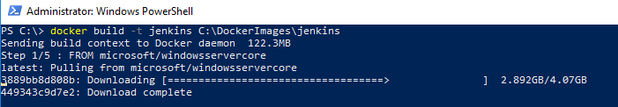

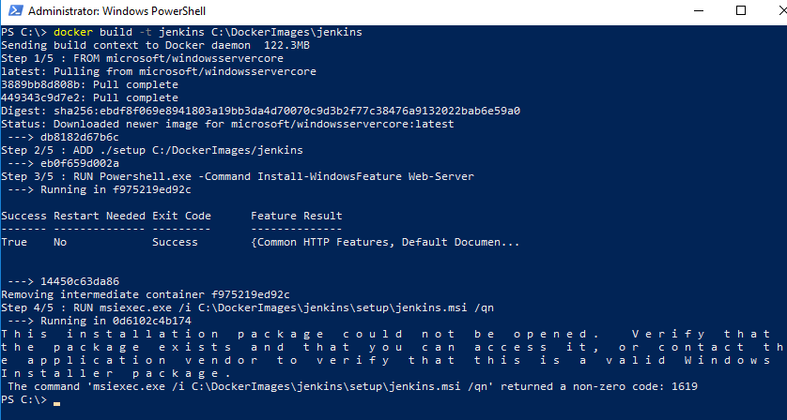

This error due to wrong folder mention in the dockerfile.

1. Docker builds generation.

It will take several minutes to complete the build.

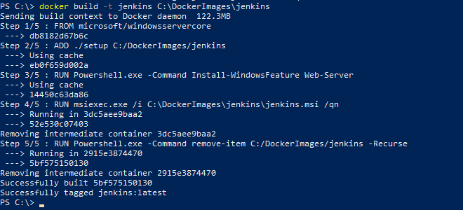

**CONFIGURE JENKINS**

* Launch a new container using the Jenkins image which we built earlier.

**docker run -it jenkins powershell**

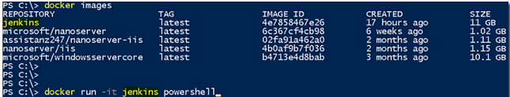

* Once the container is created, type **ipconfig** to find the IP address.

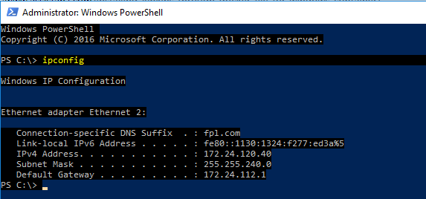

* Browse the IP along with port 8080 from your container host. It prompts for the initial administrator password to configure Jenkins.

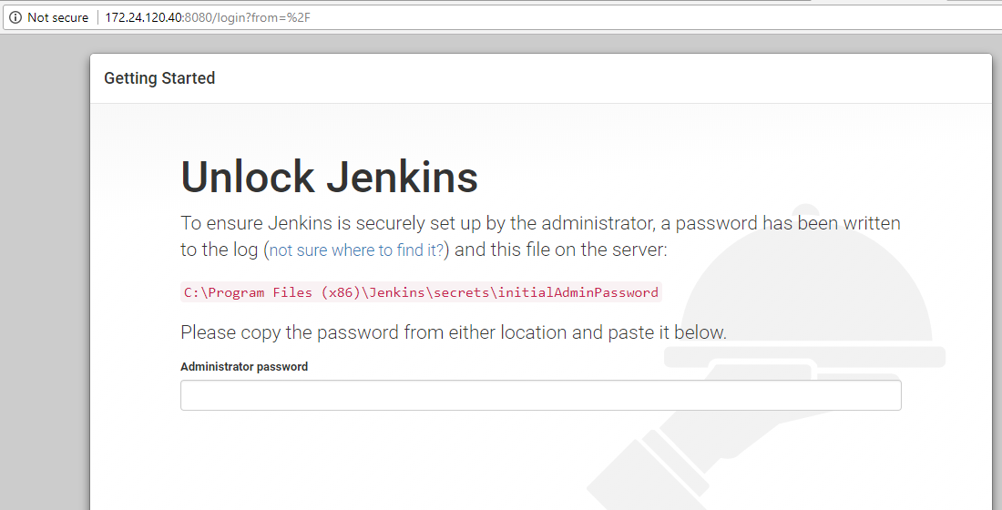

Go to kitemetic to check the image output :

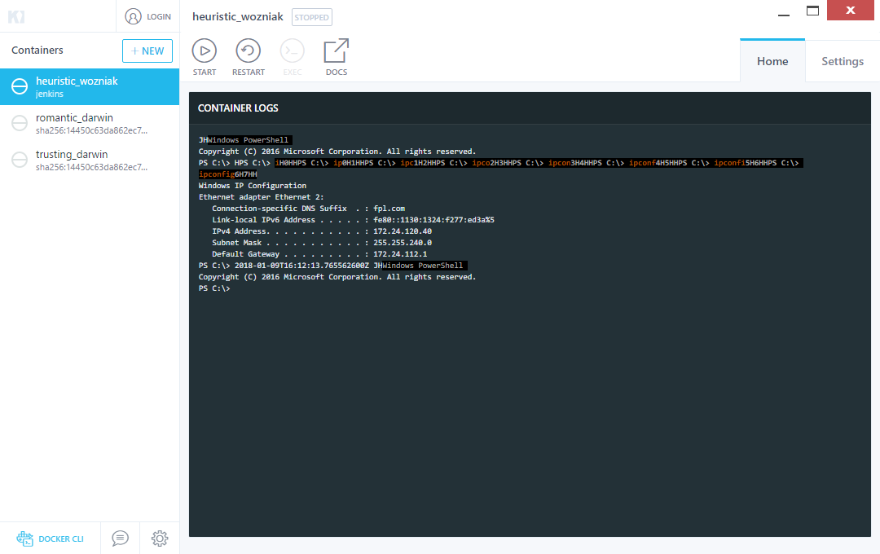

Docker images setup:

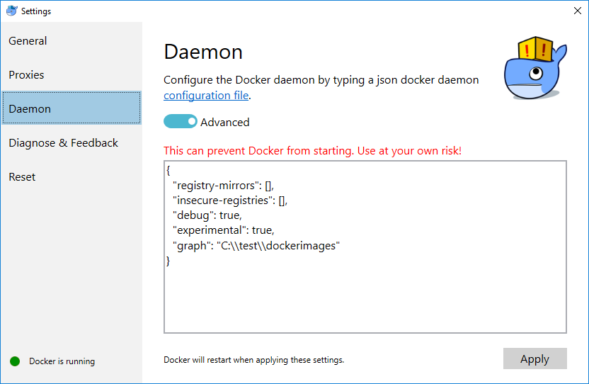

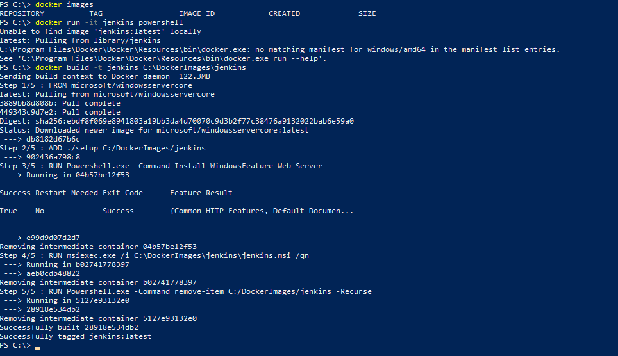

https://docs.microsoft.com/en-us/virtualization/hyper-v-on-windows/quick-start/create-virtual-machine