**SPEED CONTROL OF SEPARATELY EXCITED DC MOTOR**

**Software Used:**

MATLAB R2022a with addons:

1. Simulink
2. Simscape
3. Simscape electrical

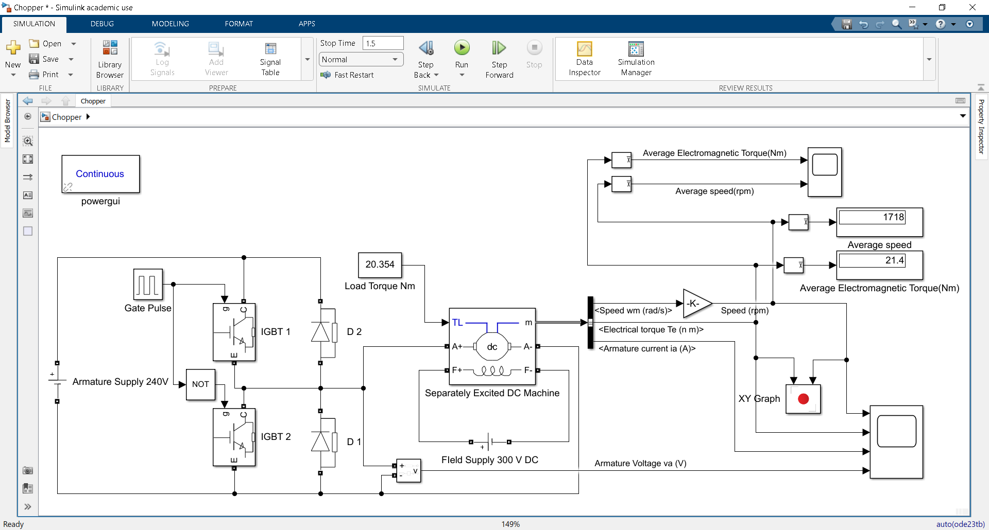

Fig-1: Simulink model for bi-directional chopper fed separately excited dc motor drive with field excitation kept constant

**Block Parameters:**

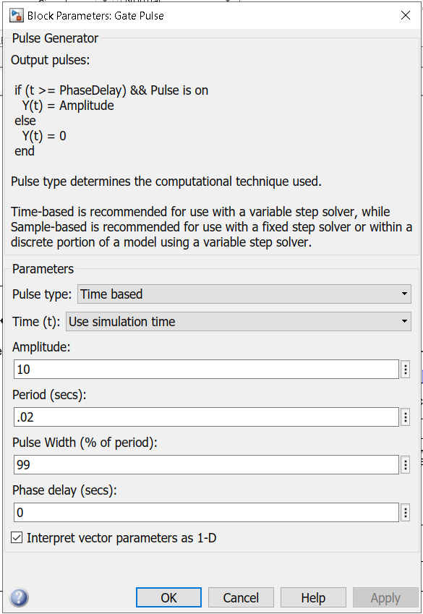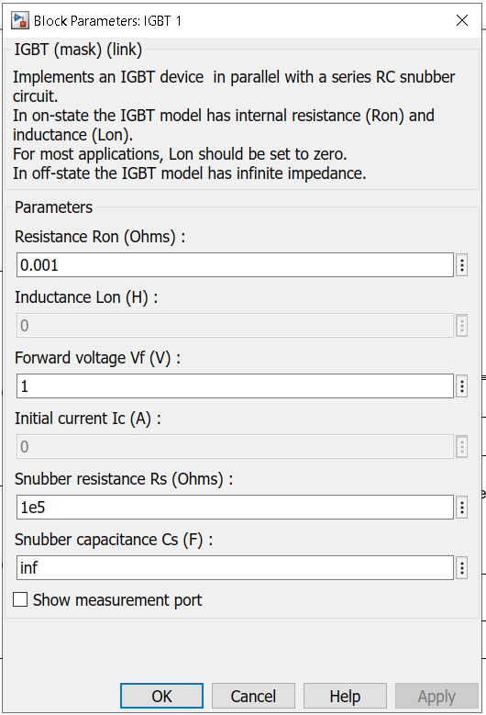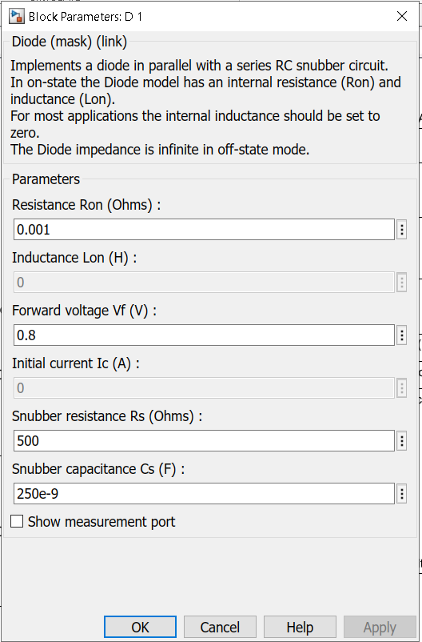

Fig-2: Block parameters for pulse generator, IGBTs, and diodes

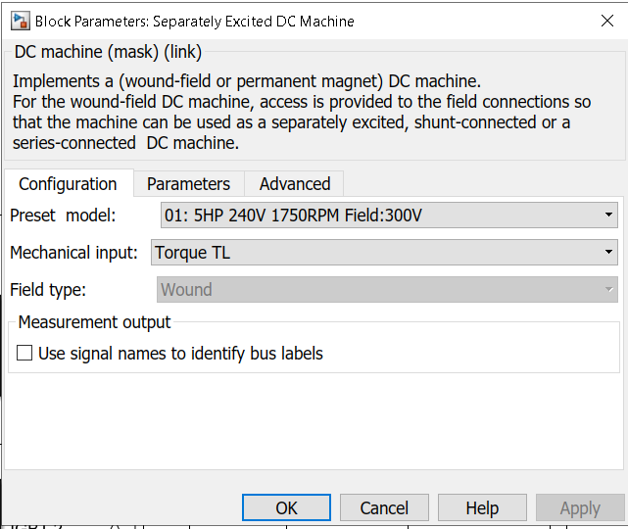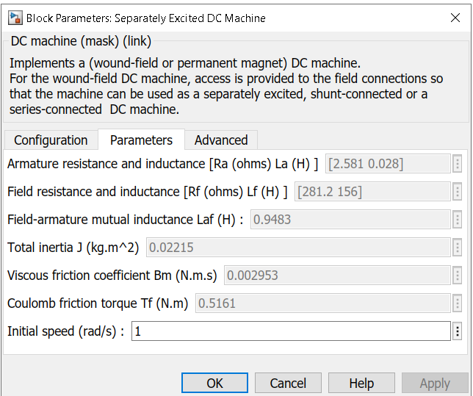

Fig-3: Block Configuration and parameter for DC Machine

**Testing:**

For DC Machine the rated values are:

Rated power = 5 HP = 3728.5W

Rated armature voltage = 240V

Rated Field voltage = 300V

Rated Speed = 1750 RPM = 183.26 rad/s

Expected motor torque in rated condition is

Te = POUT /m = 3728.5/183.26 = 20.34 Nm

When the simulation was run with 99% pulse width for pulse width generator (i.e. armature voltage equal to 240 V) and load of 20.34 Nm it was observed that the steady state value of speed was 1718Nm and average electromagnetic torque produced by the dc machine was 21.4Nm. The steady state speed was thus close to rated speed of dc machine and ensuring that model is working properly at rated condition.

**Waveforms:**

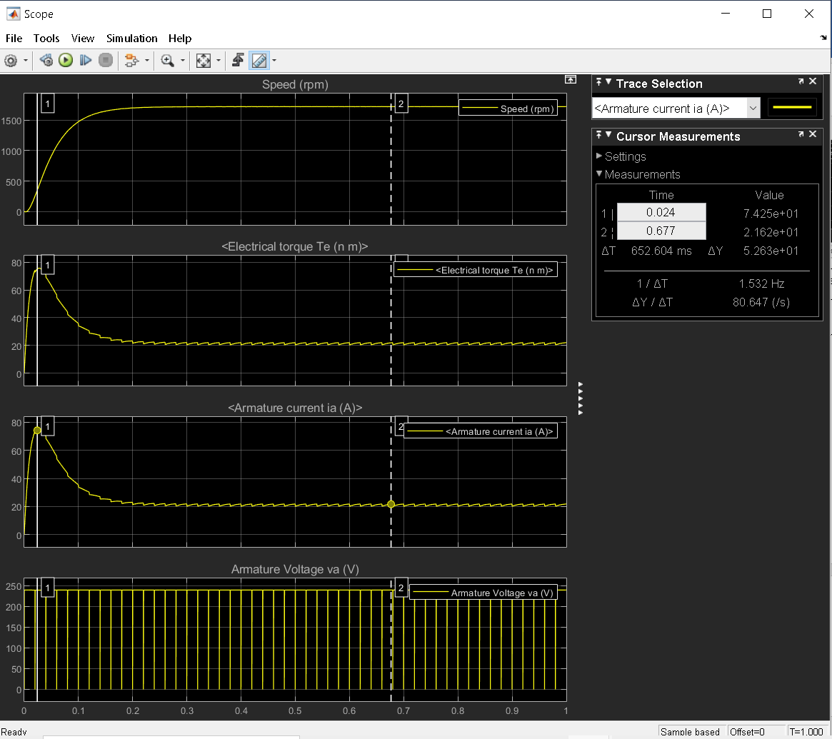

Fig-5: Speed(rpm), torque (Nm), armature current(A), and armature voltage(V) waveforms vs time

It was observed that the dc machine draws a large amount of current during starting. It is caused dues to small armature resistance and no induced emf at starting condition. This results in large amount of starting current and starting torque.

Maximum armature current drawn = 74.89A

Steady state average value of armature current drawn = 21.15A

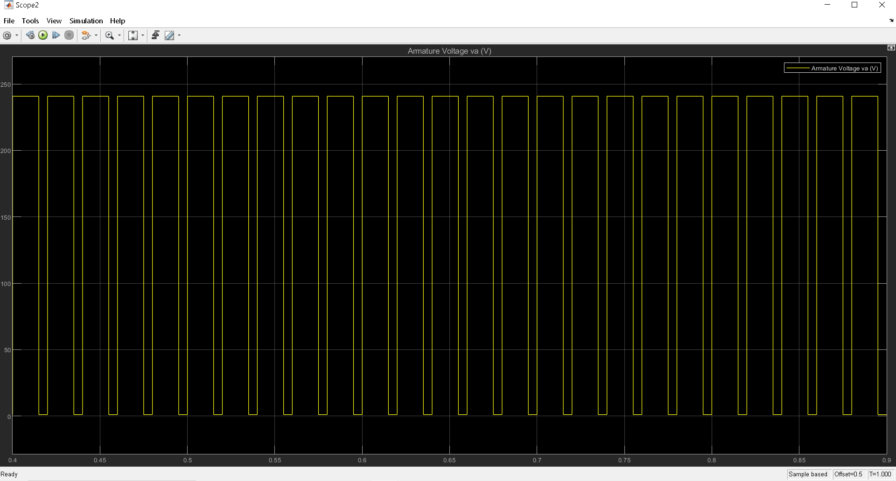

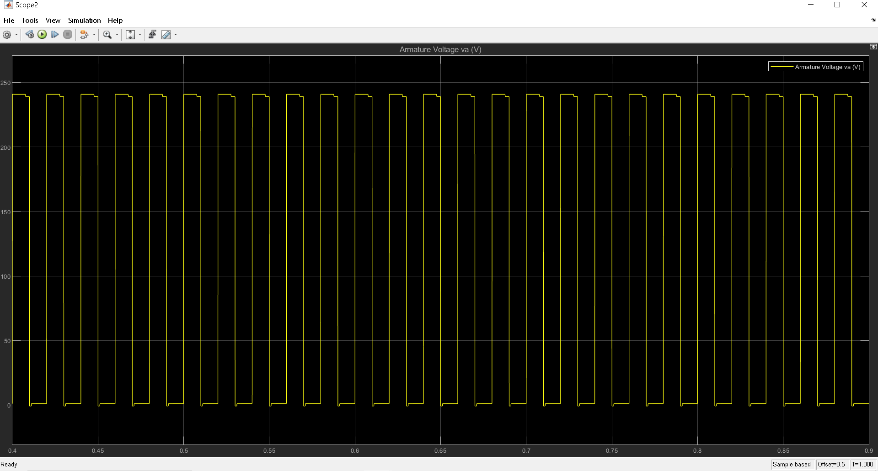

Fig-6: Voltage waveforms for different values of duty cycles i)D = 75% and ii)D=50%

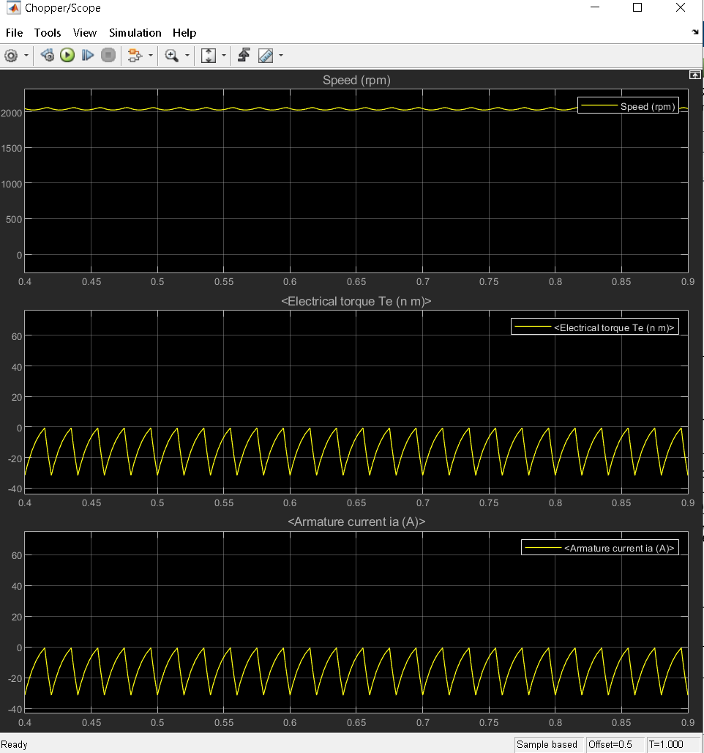

Fig-7: Speed, torque and current waveform for duty cycle of 75% and load torque of -15Nm

In this case current is always in negative direction.

When magnitude of current is falling diode D2 is conducting.

When magnitude of current is rising IGBT 2 is conducting.

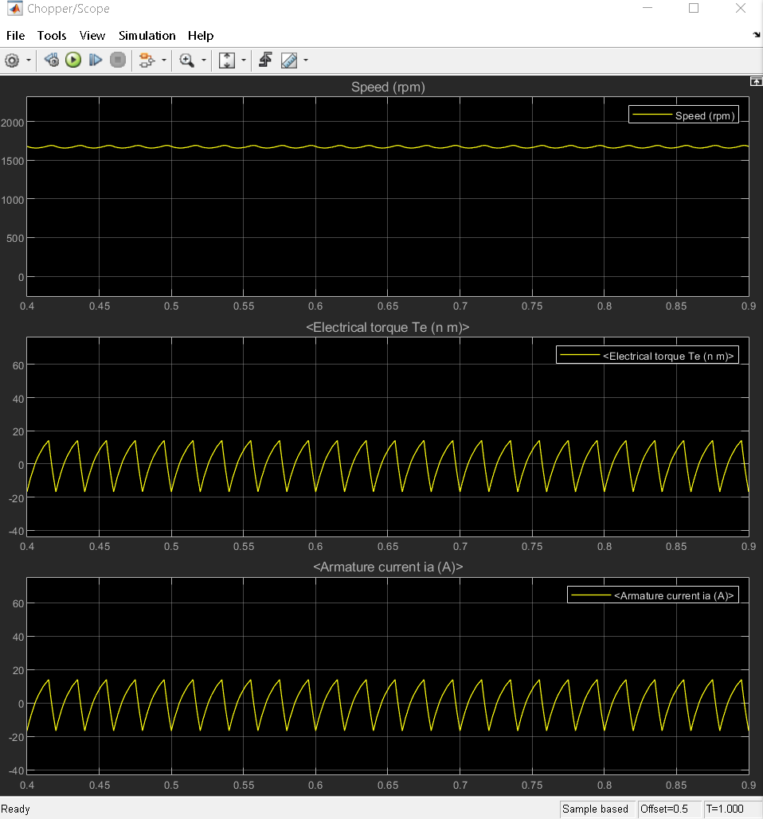

Fig-8: Speed, torque and current waveform for duty cycle of 75% and load torque of 0Nm

When current is rising and is in negative direction diode D2 is conducting.

When current is rising and is in positive direction IGBT 1 is conducting.

When current is falling and is in positive direction diode D1 is conducting.

When current is falling and is in negative direction IGBT 2 is conducting.

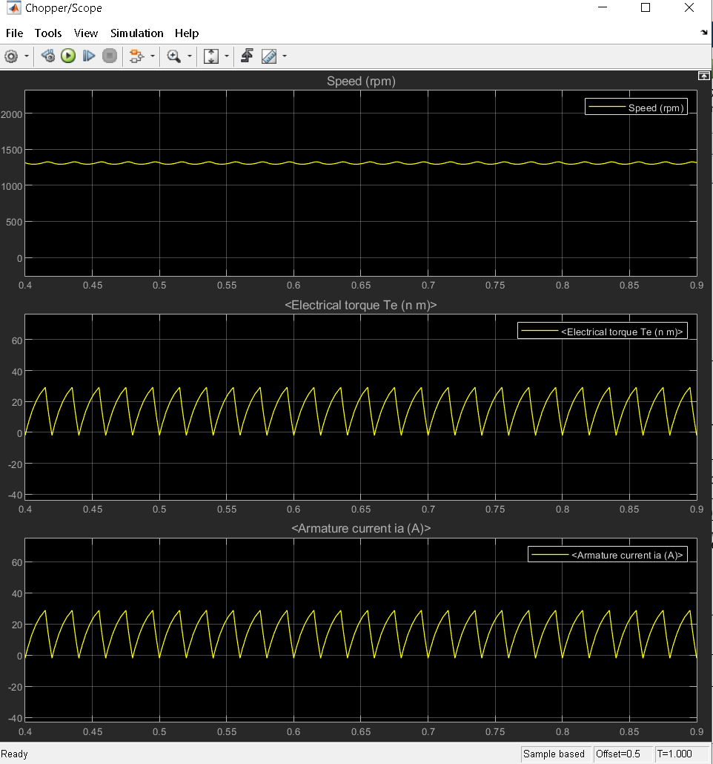

Fig-9: Speed, torque and current waveform for duty cycle of 75% and load torque of 15Nm

In this case, current is always in positive direction.

When magnitude of current is falling IGBT 1 is conducting.

When magnitude of current is rising diode D1 is conducting.

**Speed Torque Characteristics:**

The load torque was varied and the steady state motor torque and speed were noted for different duty cycles D = 75% and D = 50% from display block.

|  |  |  |  |  |
| --- | --- | --- | --- | --- |
| Load Torque  (Nm) | For Duty Cycle D = 75% | | For Duty Cycle D = 50% | |
| Electromagnetic  Torque (Nm) | Speed  (RPM) | Electromagnetic  Torque (Nm) | Speed  (RPM) |
| -15 | -13.85 | 2041 | -14.03 | 1476 |
| -10 | -8.891 | 1971 | -9.065 | 1355 |
| -5 | -3.929 | 1795 | -4.103 | 1233 |
| 0 | 1.033 | 1672 | .8599 | 1112 |
| 5 | 5.996 | 1551 | 5.822 | 990.2 |
| 10 | 10.96 | 1429 | 10.78 | 868.6 |
| 15 | 15.92 | 1307 | 15.75 | 747 |

Fig-10: Speed vs torque characteristics