**Braintree Note**

**IP Address :-**

* IP Stand for Internet Protocol.
* An IP address is a Unique number provided to each and every devices.
* An IP address is a **unique numerical identifier assigned to each device connected to a computer network**. It is also called Logical Address.
* Uses the IP for communication Purpose.

Addressing

* It is different each and every Devices(Individual).

**IP addresses serve two main functions:**

* Network interface identification
* Location addressing

MAC(Physical)

IP(Logical)

**Types Of IP Address :-**

1. Static IP (Configure Manually)
2. Dynamic IP (It is Obtained Automatically)

**Version of IP Address :-**

1. **IPv4 (32-bit address)**

* IP stands for Internet Protocol and v4 stands for Version Four (IPv4).

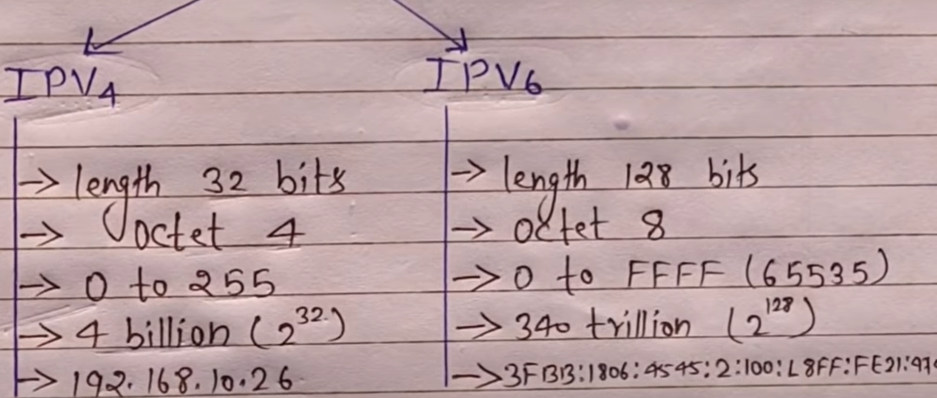

* It is must be unique in your network.
* An IPv4 address is a 32-bit number.
* It is Divided into 4 groups called Octet.
* Each Group Consist of 8 bits.
* Each group Separated by dotted ( **.** ), Like 192.168.1.1 .
* It has 5 classes ranges from 0 to 255

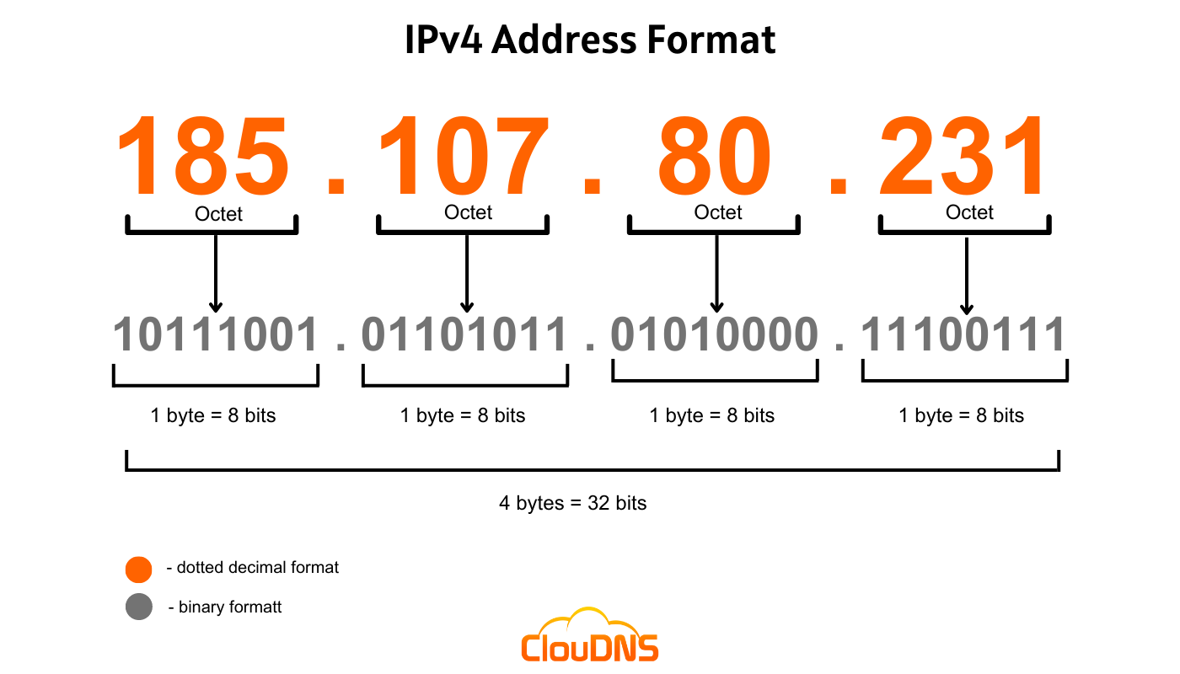

**Class of IPv4 :-**

Class A, B ,C are used for LAN & WAN.

D is Reserved for Multi cast address

E is Reserved for Defense & Research.

* Class A: 0–126
* Class B: 128–191
* Class C: 192-223
* Class D: 224–239
* Class E: 240–255

127 is Loop Back address – 127.0.0.0

**Loop Back address :-**

* It is used to test weather TCP or IP Protocol is currently Working or not .
* Example- 127.0.0.0 (used for testing purpose)
* It is Loop back address of IPV4.
* It is Dedicated to Loop back IP Address in a network in IPv4.

**LAN :- Local Area Network**

* Spreads within an Organization
* **LAN is a group of computers and devices connected together in a limited area, like a home, office, or school.** They're typically connected via cables or Wi-Fi, and allow devices to share resources like printers, files, and the internet.
* LANs connect computers together and provide shared access to printers, file servers, and other services.

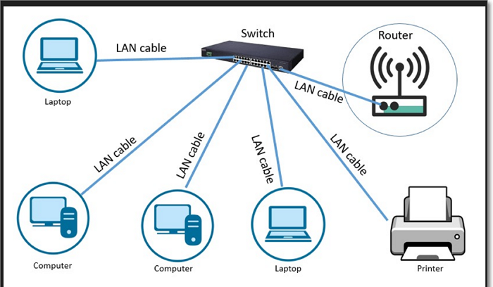

**WAN -: Wide Area Network :-**

* It is Spreads over a Geographical area.
* Internet is an example of WAN.
* It's a network that connects multiple locations across a large geographic area. WANs can connect offices, data centers, cloud applications, and cloud storage.

**Number System :-**

Binary – 0,1 (0,1)

Decimal- 0, 1,2,3,4,5,6,7,8,9 (0-9)

Octal- 0,1,2,3,4,5,6,7 (0-7)

Hexadecimal- 0,1,2,3,4,5,6,7,8,9,A,B,C,D,E,F (A=10,B=11,C=12,D=13,E=14,F=15)

**How to Check IP Address :-**

Window+R🡪cmd🡪ipconfig

**How to Assign IP Address :-**

Control Panel🡪Network and Internet🡪View Network status & tasks🡪Change Adapter Settings🡪 Right click on Ethernet 🡪Properties 🡪Select –Internet Protocol Version (TCP/IPv4)🡪Properties 🡪Use the Following IP address.

**Or**

Window+R 🡪ncpa.cpl🡪It will Open Adapter Settings

**DHCP :-**

* DHCP Stands for Dynamic Host Configuration Protocol (DHCP)
* It is Automatically assigns IP addresses to devices.
* (Port no-67 & 68) 67 is reserved for the DHCP server & 68 is reserved for the DHCP client.

**DORA Process:-**

* DORA Stands for Discover, Offer, Request, and Acknowledge.
* It's the four-step-process communication between DHCP server and DHCP Client is called DORA Process.

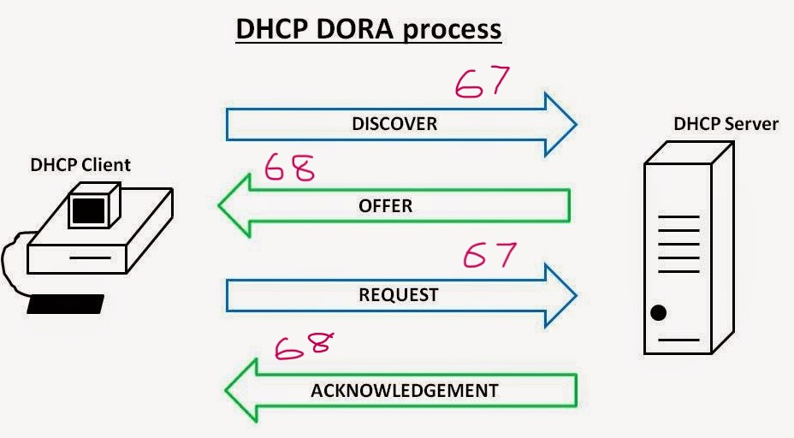

Systems

* **Discover:** The client send Discover message to find a DHCP server on the network.
* **Offer:** DHCP Server offer an IP Address, To client.
* **Request:** The Client request to Server keep the IP address.
* **Acknowledgement:** DHCP Server send a acknowledgement to keep the IP Address.

When system communication with the server it used port no- **67** and When Server Communication with Client is used port no- **68**.

**DNS :-**

* DNS stands for Domain Name System.
* The work with DNS Resolves Domain name to IP address and IP address to Domain name. ( and vice versa)
* DNS uses **port number** **53** for both TCP and UDP communication.
* Example:- [www.google.com](http://www.google.com) It is Domain name.
* DNS is an automatic process that converts the domain name into your web browser to its corresponding IP address (number), so that your browser can understand which web page you want to access on the internet

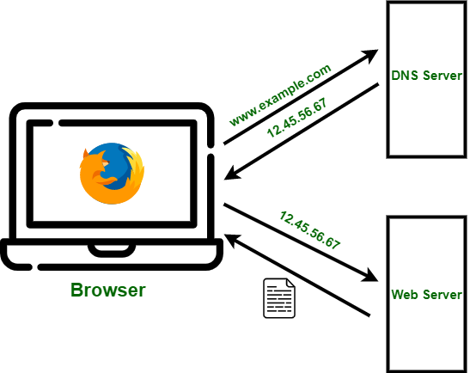

**Different 2 types of Lookup zone**

**Forward Lookup Zone:**

* Resolve Domain names to IP addresses is called Forward Lookup Zone.
* A forward lookup zone stores the relationship between a host name and an IP address.

**Reverse lookup zone :-**

* Resolve IP addresses to Domain names is called Reverse lookup zone.
* A reverse lookup zone stores the relationship between an IP address and a host name.

**Types of DNS zones :- 4 types**

**Primary Zone**

* Here DNS Data are store in Text format.
* It’s Editable which is Read-write copy of the DNS database

**Secondary Zone**

* It is Backup of Primary Zone.
* It is not Editable, it is only Read & Copy it.

**Active Directory Integrated Zone**

* In this Zone DNS is Integrated with active directory.

**Stub Zone**

* In this zone frequently used data & important data are stored.

**SYSTEM PERFORMANCE ISSUE / SYSTEM SLOW :-**

* First we go to “task manager”🡪Performance 🡪To see the CUP and memory Utilization .
* If it is high, then go to “Process tab of task”🡪”See which application is utilizing more Resources and inform the respective application department.
* Delete the unwanted files from the temporary folder.
* Do Disk cleaner.
* If it is System Related issue we try to Resolved it by Microsoft Recommendation or Searching on internet.

Shortcut key :- 1. Ctrl + alt + delete

2. Ctrl + Shift+ esc

Temporary file Show (delete)- Windows +r+ %temp%

**BSOD - BLUE SCREEN OF DEATH / BLUE SCREEN ERROR / STOP ERROR /BLUE DUMP ISSUE :-**

* BSOD Stands for Blue Screen of Death.
* It occurs when windows face an error .
* It error occurs, when the software, hardware and drive not Support by OS.
* By looking at the error code, we have to search in the Google it, and Resolve it as per the Microsoft Recommendations.

**Solution of BSOD in Windows-7 :-**

* First restart the System 🡪 Continuously press F8🡪go to “Advance boot Options”
* Then we go to safe mood to Remove faulty drivers, If it not Solve.
* Lastly we go to last known good configuration to boot the system from the last well rebooted files.

**Solution of BSOD in Windows-10 :-**

* First restart the system by pressing Shift key
* Select Trouble shoot
* Select Advance Option.
* Select Startup Setting.
* Press 4 (Safe mood) or press 5 (safe mood with networking)

**VPN :-**

* It Stand for “Virtual Private Network”
* VPN is a service that creates/Enable secure and encrypted connection between Client and Server.
* VPNs protect internet traffic by encrypting data and hiding IP addresses.

**How To Check VPN network :-**

**VPNs can also help users:**

* Circumvent geographic-based blocking and censorship
* Use public Wi-Fi hotspots safely
* Sidestep website blocks and firewalls

**Some VPN apps include:**

* Secure VPN: Works with Wi-Fi, 5G, LTE/4G, 3G, and all mobile data carriers
* Turbo VPN: Can unblock and access streaming videos, movies, live sports matches, and more

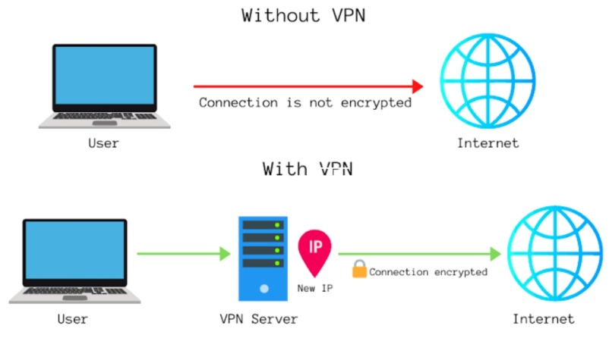(VPN Hide your Device IP Address, Firewall given own IP address to Internet )

**BIT LOCKER :-**

It is Protect Data and Privacy by Encrypted to the Drive/Volume.

**Setup Process –**

* First Select the Drive 🡪 Right Click 🡪 Manage Bit Locker 🡪 Set Password 🡪
* Then it will have Recovery key, which is 48 bit Character.