IMCE
IMCE is an image/file uploader and browser that supports personal directories and quota. IMCE, initially, was implemented for easy uploading images and adding them to FCKeditor. IMCE support for inline image/file insertion into plain textareas. The IMCE module provides more sophisticated capabilities for inserting image nodes.

IMCE Features
- Improved UI:
    - Tabbed interface for file operations.
    - Resizable workspaces.
    - Ftp-like directory navigation.
    - Log messages.
    - Additional keyboard shortcuts: home, end, ctrl+A, R(esize), T(humbnails), U(pload)
    - Multiple file selection(using ctrl or shift).
- Ajax file operations.
- Operate on multiple files at a time.
- Directory caching.
- Themable layout using tpl files.
- Improved configuration profiles.
- Multiple personal or shared directory assignments for users.
- Permissions per directory.
- Option to use total user quota together with the directory quota.
- Replace method options for existing files.
- Multiple thumbnail definitions.

Configuration
- There are several settings that can be configured in the following places:
Administer > Site building > Modules (admin/build/modules)
Enable or disable the module. (default: disabled)
Check the 'Enabled' box next to the module and then click the 'Save Configuration' button at the bottom.

Administer > User management > Permissions (admin/user/permissions)
Under fckeditor module:
access fckeditor: Enable access to the fckeditor page. (default: disabled)
administer fckeditor: Enable access to the module settings page. (default: disabled)
allow fckeditor file uploads: Enable access to the fckeditor page. (default: disabled)

Administer > Site configuration > FCKeditor settings (admin/settings/fckeditor)
When user create / edit profile they can view the file browser settings.
Browser type settings can be configured for the below configuration option:
- File browser settings
A file browser will allow you to explore the files contained on the server and embed them as links, images or flash movies. Besides the built-in FCKeditor file browser, you can also use a contributed module like IMCE. The quick upload setting controls whether images, flash movies and files can be uploaded using the upload tab of the respective dialogs.
Administer > Site configuration > IMCE
(admin/settings/fckeditor)
This is where all the module-specific configuration options can be set.
Setting up IMCE profiles
IMCE allows you to assign profiles to roles.

By default, IMCE Configuration profiles come with two profiles: User-1 and Sample profile.

Add new IMCE profile to assign to the role.

Define directories that users of this profile can access.
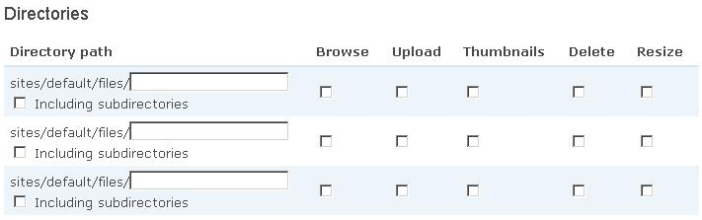
Directory creation tool for IMCE
Here you can create subdirectories for your users. Multiple directory creation is possible at a time with the * character. For example, specifying user*/foo will create foo named directories under each directory starting with user. */foo*/bar will create bar named directories under directories starting with foo in each directory of file system path.
If IMCE is configured properly:
FCKeditor users will be able to open IMCE by clicking the Browse Server button in image() or link() dialog.

Sample screen of the IMCE
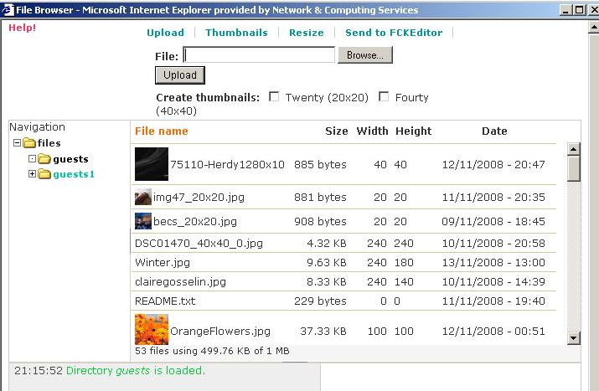

Uninstalling a module
Not all modules have specific uninstall functions programmed in. A module will only show up on the uninstall tab if it has this feature. If it doesn't, skip this step and simply delete its files.
- Click on the “uninstall” tab at the top of the Administer > Site building > Modules page.
- Click on the checkbox next to the desired module and click the uninstall button.
- Next, you'll have a screen verifying your intention to uninstall this module.
- Click on the uninstall button again, and you'll get a screen with green text verifying that the module is uninstalled.

