NLP INTERNSHIP | WEEK 6 FINAL REPORT
End-to-End Integration and Reporting of NLP-based Data Analytics
Case study: a Student Career Guidance Assistant for engineering students
Item | Detail
Prepared by | Sangeeta Kalburge, BKIT Bhalki
Report date | 24 October 2026
Scope | Integrates Week 1 (proposal), Week 2 (preprocessing), Week 3 (classification), Week 4 (NER pipeline) and Week 5 (topic modeling and summarisation)
Code | career_pipeline.py (single reproducible script, random_state = 42), results.json, four figures

How to read the numbers in this report
Every figure, table and score in this report was produced by running career_pipeline.py on the prototype data described in Section 5. The prototype corpus is small (160 queries) and partly template-generated, so the scores demonstrate how the pipeline is evaluated and where it breaks; they are not benchmark results and should not be compared with published numbers. Section 12 states exactly how optimistic they are likely to be.

1. Executive Summary
Students at small engineering colleges often have to choose between campus placements, higher studies (GATE, GRE, CAT) and skill-building without access to a mentor who knows the options. The Student Career Guidance Assistant proposed in Week 1 addresses this by reading a student's free-text question, working out what the student wants (intent), picking out the exams, companies, skills, roles and cities mentioned (entities), and giving counsellors a view of what students are asking about (topics) together with short summaries of long counselling notes.
This report joins the work of Weeks 1 to 5 into one pipeline and measures every stage on the same prototype data. The main findings are:
- Intent classification reached macro-F1 0.969 (5-fold cross-validation, 160 queries). Logistic regression and a linear SVM tied, and naive Bayes was about one point behind, so the choice of model mattered far less than the data.
- Preprocessing did not help the classifier: macro-F1 was 0.975 on raw text and 0.969 after cleaning and stemming. The cleaning step cut the vocabulary by 30% (172 to 120 words) but removed no useful signal and introduced stemmer artefacts such as "infosys" becoming "infosy".
- Rule-based NER scored entity-level F1 0.892 on 12 hand-annotated sentences and 0.909 after adding an alias list. Adding capitalisation rules lowered F1 to 0.882, so they were rejected.
- LDA topic modeling with k = 5 produced weak topics (dominant-topic purity 45.6% against the intent labels) because question words and generic verbs dominated short texts.
- TextRank summarisation beat a Lead-3 baseline on average (ROUGE-1 0.453 against 0.383) but missed the application deadlines in one document, which shows why ROUGE alone is not enough.

Component | Method | Evaluation | Result
Intent classifier | TF-IDF (1,2) + LogReg / LinearSVM | 5-fold CV, n = 160 | Macro-F1 0.969
Named entity recognition | Gazetteer + alias list | 12 sentences, 35 gold entities | P 0.968, R 0.857, F1 0.909
Topic model | LDA, k = 5 | Purity vs intent labels | 45.6%
Summariser | TextRank (extractive) | 3 passages vs reference | ROUGE-1 0.453, ROUGE-2 0.247
Table 1. Results at a glance.

2. Review of Weeks 1 to 5
The table summarises what each earlier task contributed and what was carried into the integrated system. The recurring request in the evaluation feedback was for concrete numbers, worked examples and original analysis, so this report is organised around measured results and a traced example rather than descriptions.
Week | Task | Contribution to final system | Carried forward
1 | Project proposal | Defined the Student Career Guidance Assistant, objectives and risks | Problem statement, five intent categories, human-in-the-loop principle
2 | Data collection, preprocessing, feature engineering | Cleaning, tokenisation, stop-words, stemming, TF-IDF vs embeddings | preprocess() function and the decision to keep question words
3 | Text classification | Logistic regression, SVM, evaluation with precision, recall, F1 | Intent classifier and cross-validated evaluation
4 | NER pipeline design | Entity types, gazetteer plus model approach, post-processing | Five entity types (SKILL, ORG, LOC, EXAM, ROLE) and an entity-level metric
5 | Topic modeling and summarisation | LDA, TextRank, abstractive vs extractive trade-offs, coherence and ROUGE | Analytics layer for counsellors and summariser for long notes
Table 2. How each week feeds the final system.

3. Problem Statement and Objectives
Problem. Career information for engineering students is spread across placement notices, exam websites and informal advice. Students from smaller towns have fewer mentors, and generic search engines or chatbots do not tell them how a choice such as GATE versus a job offer applies to their own marks and skills. Counsellors in turn have no structured view of what students are worried about.
Why NLP. The questions are free text, vary widely in phrasing ("Should I write GATE?" and "Is M.Tech better than joining TCS?" share an intent but almost no words) and contain entities that determine the right answer. These properties suit classification, entity extraction and topic analysis rather than fixed menus.
Objectives for this report.
- Integrate the five earlier components into a single workflow with defined inputs and outputs.
- Measure each component with an appropriate metric on the same prototype data.
- Trace one real query through every stage to show how the parts interact.
- Identify limitations honestly and set measurable targets for the next iteration.

4. Integrated Workflow
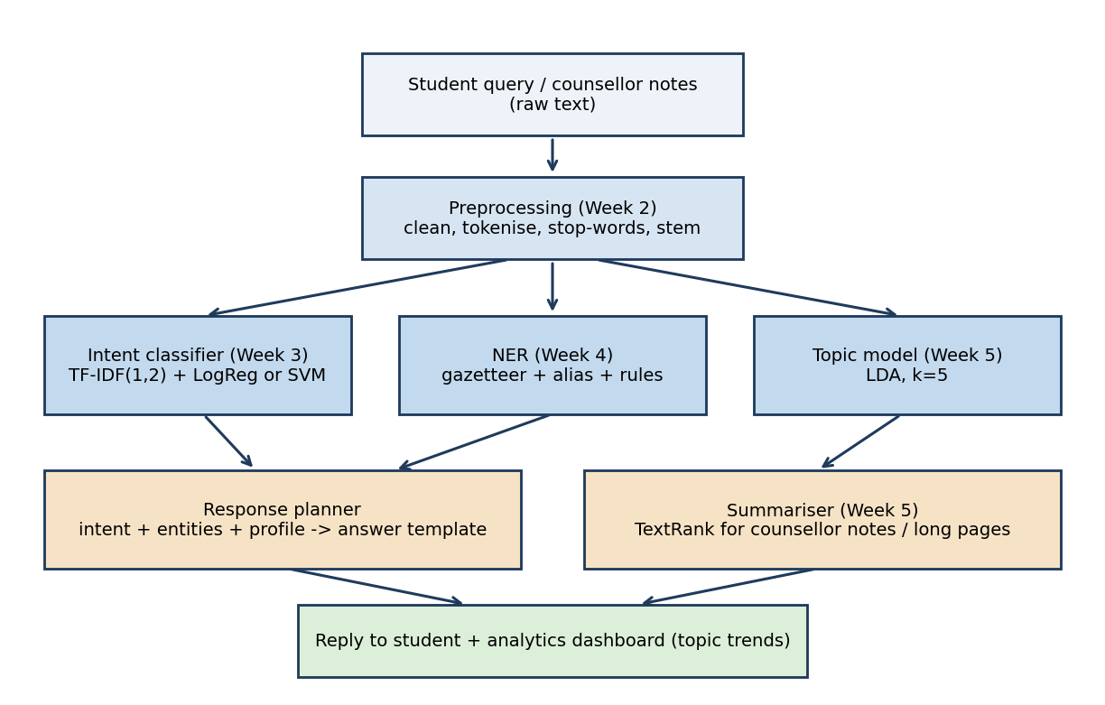
Figure 1. End-to-end architecture. Blue boxes are the analysis stages from Weeks 2 to 5; orange boxes combine their outputs.
Stage | Input | Output | Why it is placed here
Preprocessing | Raw query text | Cleaned, stemmed tokens | All three analysers need a common, noise-reduced representation
Intent classifier | Cleaned tokens | Intent label + probability | Decides which answer template applies; probability drives clarification
NER | Original text (case kept) | List of (span, type) | Runs on raw text because capital letters help (GATE, Wipro)
Topic model | Cleaned tokens | Topic distribution | Aggregated across queries for counsellor analytics, not used per reply
Response planner | Intent, entities, student profile | Answer or clarifying question | Combines evidence from the three analysers
Summariser | Long notes or web pages | Short extract | Keeps long counselling notes readable
Table 3. Component interfaces.
One design decision is worth stating. NER receives the original text, not the preprocessed text, because lower-casing and stemming destroy the signals NER relies on (capitalisation and exact spelling). This is why the diagram shows three parallel branches rather than a single chain.

5. Data

5.1 Prototype corpus used in this report
No public dataset matches this exact domain, so a prototype corpus was constructed. Thirty question templates (six for each of five intents) were filled with slot values (10 skills, 6 companies, 5 cities, 4 exams, 5 roles) with five random draws per template, giving 150 queries, plus 10 hand-written queries that deliberately mix two intents (for example "Do I need GATE to become a software developer?"). The result is 160 queries, of which 130 are unique because random slot filling produced 30 duplicates.
Intent | Example query | Count
course | Which course should I take to learn Python? | 31
role | What is the average salary of a data analyst in Pune? | 32
skillgap | What skills am I missing to get hired as a ML engineer? | 32
intern | How can I get an internship at Bosch? | 32
higher | Should I write GATE to do my masters? | 33
Table 4. Intent classes and counts (balanced within 31 to 33).
Two further hand-made sets were used: 12 sentences with 35 gold entities for NER (deliberately including forms not in the gazetteer such as "Infy", "ML", "Germany", "Power BI" and "BKIT Bhalki"), and 3 counselling-style passages of 103 to 126 words with one reference summary each for summarisation.

5.2 Public datasets for the scaled-up version
Task | Public dataset | Why it fits | Swap-in effort
Intent classification | CLINC150 (150 intents), Banking77 | Short task-oriented queries similar in length to student questions | Replace the loader; model code is unchanged
NER | CoNLL-2003 | Standard PER/ORG/LOC/MISC benchmark for pre-training before adding EXAM and SKILL | Needs BIO conversion and fine-tuning
Topic modeling | 20 Newsgroups | Labelled topics allow purity and coherence checks | Replace the loader
Summarisation | CNN/DailyMail | Standard ROUGE benchmark for comparing TextRank and abstractive models | Replace the loader
Table 5. Public datasets recommended for the next iteration (not used for the scores in this report).

6. Data Preprocessing
The preprocessing function lower-cases the text, removes punctuation except characters that matter in technical terms (. + #), splits into tokens, removes stop-words and applies a light suffix stemmer. Question and negation words (what, which, how, when, not, no, before, after) were removed from the stop-word list because they signal intent.
Step | Output for: "Which skills do recruiters at Infosys expect from a data analyst?"
Raw | Which skills do recruiters at Infosys expect from a data analyst?
Lower-case + punctuation removal | which skills do recruiters at infosys expect from a data analyst
Stop-word removal (do, at, from, a) | which skills recruiters infosys expect data analyst
Light stemming | which skill recruiter infosy expect data analyst
Table 6. Worked preprocessing example.
Vocabulary fell from 172 distinct words to 120 (a 30.2% reduction). The example shows a pitfall of rule-based stemming: "Infosys" became "infosy" and elsewhere "business" became "busines". These truncated forms are harmless to a classifier but make topic words unreadable (see Section 9) and break any later lookup against an entity list, which is a second reason NER uses the original text.

Pitfalls found and how they were handled
Pitfall | Observed effect | Handling
Stop-word list removes intent words | "what" and "what skill" are among the strongest features for the role and skillgap classes | Custom KEEP set subtracted from the stop-word list
Stemmer damages proper nouns | infosys to infosy, business to busines | Do not stem for NER; use a lemmatiser (spaCy) in the next iteration
Duplicate queries across CV folds | 30 of 160 queries are duplicates, so some test items were seen in training | Reported as a limitation; de-duplicate before the next evaluation
Case folding removes capital letters | "CAT" (exam) becomes "cat" (word) | NER runs on original text; ambiguity discussed in Section 8
Table 7. Data-handling pitfalls observed in this project.

7. Intent Classification

7.1 Models and results
Four combinations of vectoriser and classifier were compared with stratified 5-fold cross-validation on all 160 queries. Naive Bayes on raw counts is the baseline. TF-IDF weights words by how specific they are to a query (Salton and Buckley, 1988), and the (1,2) setting adds two-word phrases such as "summer internship".
Model | Accuracy | Precision (macro) | Recall (macro) | F1 (macro)
Naive Bayes + bag of words | 0.956 | 0.957 | 0.957 | 0.956
Logistic regression + TF-IDF (1,1) | 0.969 | 0.970 | 0.969 | 0.969
Logistic regression + TF-IDF (1,2) | 0.969 | 0.970 | 0.969 | 0.969
Linear SVM + TF-IDF (1,2) | 0.969 | 0.970 | 0.969 | 0.969
Table 8. Cross-validated results (all differences between the last three rows are zero at this precision).
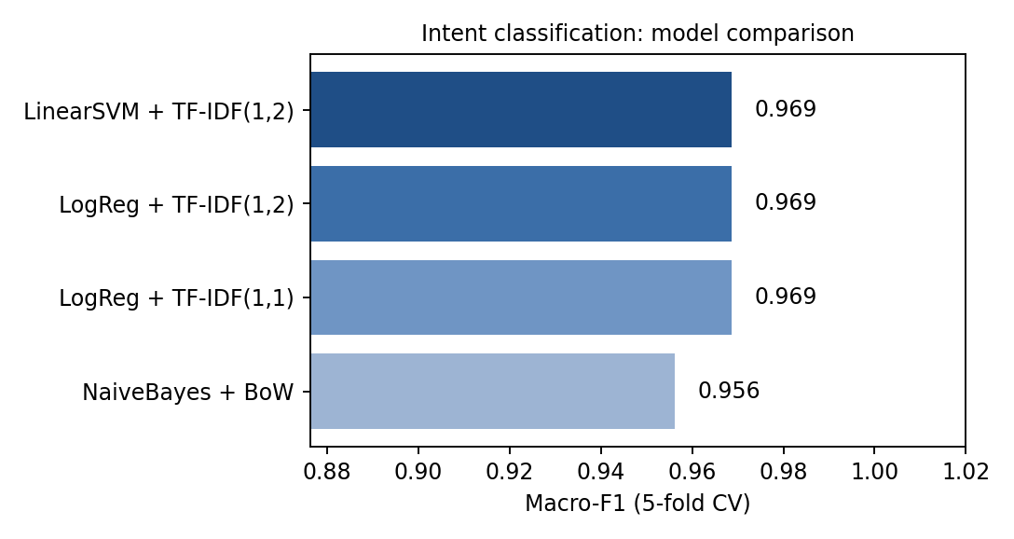
Figure 2. Macro-F1 by model.
The 95% Wilson confidence interval for the accuracy of 0.969 (155 of 160 correct) is roughly 0.929 to 0.987. A gap of one percentage point between naive Bayes and the other models is therefore well inside the noise: with 160 examples, the evidence does not support ranking these models.

7.2 Per-class results and confusion matrix
Intent | Precision | Recall | F1 | Support
course | 0.909 | 0.968 | 0.938 | 31
higher | 1.000 | 0.970 | 0.985 | 33
intern | 0.970 | 1.000 | 0.985 | 32
role | 0.969 | 0.969 | 0.969 | 32
skillgap | 1.000 | 0.938 | 0.968 | 32
Table 9. Per-class scores for logistic regression + TF-IDF (1,1).
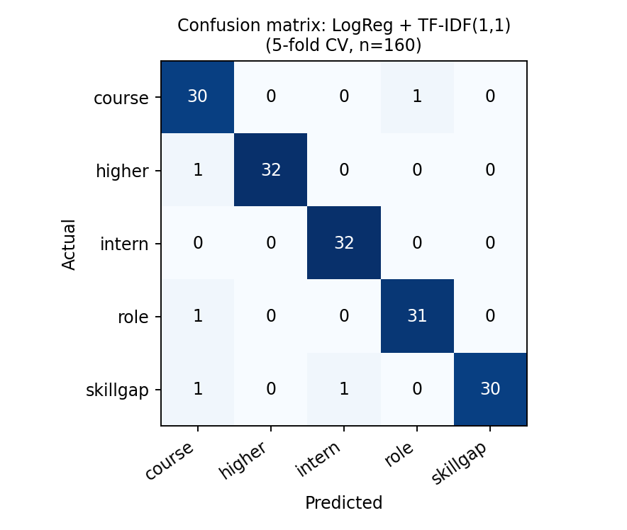
Figure 3. Confusion matrix. Five of 160 queries are misclassified; three of the five are predicted as "course".

7.3 Error analysis
Query | True | Predicted | Likely reason
Suggest courses to become a business analyst | course | role | "become a business analyst" matches role templates ("qualifications to become...")
Will learning SQL help me get a job at Infosys? | skillgap | course | "learning SQL" is a course-style phrase; the job-related words are too few
Is data analysis a good career and which course should I do? | role | course | Two intents in one sentence; the label is a judgement call
Course for GRE or for cloud computing, confused | higher | course | The word "course" dominates; GRE appears once
What skills does Bosch want for embedded systems internships? | skillgap | intern | "internships" is a strong intern feature and outweighs "what skills"
Table 10. All five misclassified queries.
All five errors come from the 10 hand-written ambiguous queries, none from the template queries. This pattern matters: the templates are separable by construction, so the headline 0.969 mostly reflects how easy the template data is. On the ambiguous queries alone the classifier scored 5 errors out of 10, equivalent to 50% accuracy, which is a better indication of difficulty on real student text.

7.4 Ablation: does preprocessing help?
The same logistic regression with TF-IDF (1,2) was run on the raw, unprocessed queries. Macro-F1 was 0.975 on raw text against 0.969 on preprocessed text. For this short, clean, templated text, preprocessing gave no benefit, and the small drop (one query) is within noise. TF-IDF already down-weights common words, and stemming merged few useful forms. The practical conclusion is that preprocessing should be treated as a hypothesis to test, not a default; its value is likely to appear on noisy real queries with spelling variation and code-mixed text.

7.5 What the model learned
Intent | Top five features (logistic regression coefficients)
course | learn, course, suggest, course learn, roadmap
higher | better, gate, kcet, master, cat
intern | internship, how internship, summer internship, summer, resume internship
role | career, engineer, what, market, job market
skillgap | skill, job, what skill, resume list, list
Table 11. Highest-weighted features per intent.
The features are sensible and interpretable, which supports using a linear model in a counselling setting where explanations matter. The feature "cat" for the higher-studies class is the exam name, but it also shows the case-folding problem noted in Table 7.

8. Named Entity Recognition
The NER component extracts five entity types: SKILL, ORG, LOC, EXAM and ROLE. The prototype uses a gazetteer (dictionary) with whole-word, case-insensitive matching and longest-match-wins overlap resolution. It was evaluated at entity level: a prediction counts as correct only if both text span and type match a gold entity.
Worked example. For "Should I prepare for GATE or apply for a data analyst job at Wipro?" the tagger returns GATE (EXAM), data analyst (ROLE) and Wipro (ORG), which matches the gold annotation exactly.
Version | Change | TP | FP | FN | Precision | Recall | F1
v1 | Gazetteer only | 29 | 1 | 6 | 0.967 | 0.829 | 0.892
v2 | + alias list (ML, AI) | 30 | 1 | 5 | 0.968 | 0.857 | 0.909
v3 | + capitalisation rules | 30 | 3 | 5 | 0.909 | 0.857 | 0.882
Table 12. NER ablation on 12 sentences with 35 gold entities. v2 is the selected version.

Error analysis for v1
Error | Item | Cause | Fix
Missed | Infy (ORG) | Informal abbreviation | Add alias; long term, use a model with character features
Missed | ML (SKILL) | Abbreviation of machine learning | Alias list (applied in v2)
Missed | Power BI (SKILL) | Skill not in dictionary | Grow gazetteer from job descriptions
Missed | Germany, USA (LOC) | Country names not in the city list | Add countries (or a geographic gazetteer)
Missed | BKIT Bhalki (ORG) | Institution not in list | Needs a trained model; unseen names cannot be listed
Spurious | cat (EXAM) | "cat" lower-case is not the CAT exam in this sentence | Case-sensitive matching for short acronyms
Table 13. Seven errors made by the gazetteer-only tagger (6 missed entities, 1 spurious).
The capitalisation rules in v3 were meant to catch unseen places and companies after "in", "at" or "to". They did not recover any missing entity and added two boundary errors ("the Chennai" and "the USA" were captured with the article), which cut precision from 0.968 to 0.909. A rule that does not raise recall and lowers precision should not be kept. The remaining misses are unseen names, which only a trained sequence model (for example spaCy or a BERT token classifier fine-tuned on CoNLL-2003 plus career data) can address.
Polysemy. The spurious "cat" case is the simplest example of the ambiguity challenge from Week 4: the same string can be an exam, an animal or part of a word. The next iteration should match short acronyms case-sensitively and use sentence context (for example, the presence of "exam", "score" or "prepare") to disambiguate.

9. Topic Modeling for Counsellor Analytics
Latent Dirichlet Allocation (Blei et al., 2003) was fitted on bag-of-words counts of the preprocessed queries (words appearing in at least 2 documents and in no more than 60% of documents). Models with 3 to 8 topics were compared using perplexity (lower is better) and UMass coherence (Mimno et al., 2011; higher, i.e. closer to zero, is better).
Topics (k) | Perplexity | UMass coherence
3 | 105.6 | -2.061
4 | 108.1 | -1.789
5 | 109.3 | -1.897
6 | 114.5 | -1.885
7 | 108.7 | -1.777
8 | 110.3 | -1.680
Table 14. LDA model selection. The selected k = 5 is highlighted.
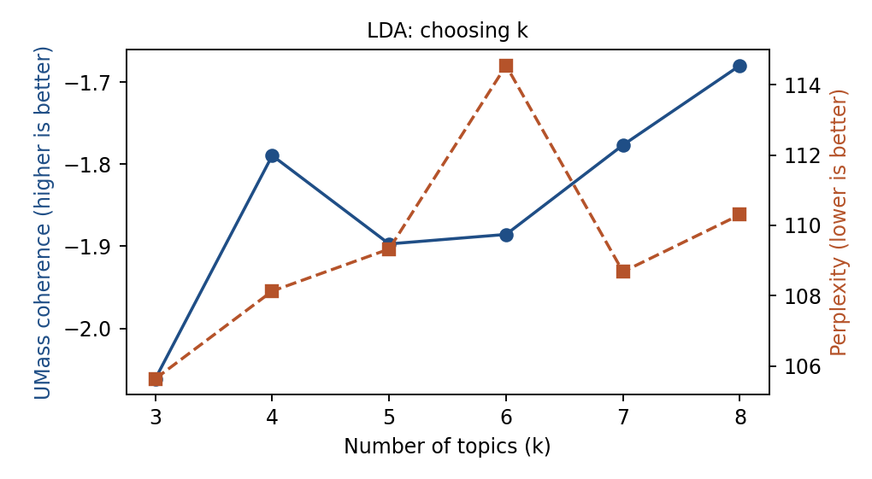
Figure 4. Perplexity and coherence by number of topics.
Coherence improves slowly towards k = 8 while perplexity is almost flat, so the statistics do not give a clear answer. k = 5 was chosen to match the five known intents, which makes the output easier to explain to counsellors, and because the coherence difference between k = 5 and k = 8 is small relative to the noise on 160 short documents.
Topic | Top words (stemmed) | Reading
0 | analyst, data, skill, busines, what, which, does | Data/business analyst roles and skills; the only fairly clear topic
1 | learn, want, career, machine, student, begin, start | Learning beginnings
2 | internship, how, security, cyber, year, job, study | Internships and cyber security
3 | internship, course, which, good, engineer, learn, resume | Courses and resume advice (mixed)
4 | what, engineer, need, ml, network, better, when | Mostly question words (weak)
Table 15. Topic words for k = 5.
Critical analysis. The dominant topic of each query matches its intent label for only 45.6% of queries (purity), against 20% for random assignment. Topics 3 and 4 are dominated by function words ("which", "what", "when"), which is a direct consequence of keeping question words for the classifier in Section 6. This is a concrete example of one preprocessing choice helping one component and harming another. The fix is to use a separate, stricter preprocessing path for LDA: a longer stop-word list that includes question words, lemmatisation instead of the truncating stemmer, and noun-phrase filtering. Short texts are also a known difficulty for LDA, so BERTopic or NMF on TF-IDF would be tried on the larger real dataset.
Decision value. Even imperfect topics are useful in aggregate. If, for example, the share of queries in an "internship" topic doubles in August, the placement cell knows to schedule an internship workshop. This is the intended use: monitoring trends, not labelling individual queries.

10. Summarisation
Extractive summarisation selects existing sentences. TextRank (Mihalcea and Tarau, 2004) builds a graph in which sentences are nodes, edges are weighted by TF-IDF cosine similarity, and a PageRank-style iteration (damping 0.85) scores sentences. The top three sentences are returned in original order. The baseline is Lead-3 (first three sentences). Quality was measured with ROUGE-1 and ROUGE-2 F1 (Lin, 2004), implemented in the script as unigram and bigram overlap with the reference.
Passage | Words | Sentences picked (TextRank) | TextRank R-1 / R-2 | Lead-3 R-1 / R-2
1. Counselling meeting | 126 | 1, 2, 6 | 0.457 / 0.233 | 0.423 / 0.157
2. Internship notice | 104 | 1, 3, 7 | 0.381 / 0.171 | 0.415 / 0.175
3. Advisory article | 103 | 1, 6, 7 | 0.521 / 0.338 | 0.312 / 0.160
Average |  |  | 0.453 / 0.247 | 0.383 / 0.164
Table 16. Summarisation results (3 passages; one hand-written reference each).
Worked example (passage 3). TextRank returned: "Many engineering graduates struggle to decide between higher studies and jobs. A conversational assistant that understands the student's question and profile can reduce this gap. Such an assistant should always direct students to a human counsellor for final decisions." It selected the opening problem sentence and the two sentences about the assistant, which together cover the reference's main points, and scored ROUGE-1 0.521 against 0.312 for Lead-3.
Where it failed (passage 2). Lead-3 scored higher here because the useful content (application dates 15 to 30 November, 60% minimum marks, the internship areas) sat in sentences 2 to 4, while TextRank preferred sentence 7 ("Students are encouraged to update their resumes..."), which shares many words with other sentences but contains no deadline. A summary that omits the deadline is poor for a student even though its ROUGE score is only about three points lower. Two further observations: the TextRank outputs were 40 to 66 words against 33 to 41 words in the references (too long for a short brief), and ROUGE rewards word overlap rather than whether key facts such as dates are present.
Recommendation. Use extractive summaries by default because they cannot invent facts, and add a rule that always includes sentences containing dates, numbers or eligibility terms. Test an abstractive model (BART or T5; Lewis et al., 2020) on CNN/DailyMail first, and add a faithfulness check before using it, since abstractive models can state things the source does not say.

11. Integrated Case Study: One Query Through the Pipeline
The query "Should I prepare for GATE or apply for a data analyst job at Wipro?" was passed through the final models (trained on all 160 queries) to show how the components interact.
Stage | Result | Interpretation
Preprocessing | prepare gate apply data analyst job wipro | Stop-words dropped, "should", "for", "at" removed
Intent (logistic regression) | higher 0.365, skillgap 0.215, role 0.187, intern 0.143, course 0.090 | Predicted intent is higher studies, but with only 36.5% probability the model is unsure
NER | GATE (EXAM), data analyst (ROLE), Wipro (ORG) | All three entities correct; they show the student is comparing exam prep with one specific employer
Topic distribution (k = 5) | Topic 2: 0.71, Topic 0: 0.21, others 0.03 | Internship/job-oriented topic dominates, consistent with a placements-versus-GATE worry
Response planner | Confidence below 0.5, so ask a clarifying question | "Are you deciding between GATE preparation and a job at Wipro? Tell me your branch and current CGPA and I can compare the options."
Table 17. Stage-by-stage trace of one query.
This trace produced the most useful design insight of the project: the classifier's top label is correct, but its probability is low because the question genuinely spans two intents (higher studies and job search). A probability threshold turns a probable error into a clarifying question. The entities then make the clarifying question specific instead of generic. Neither the classifier alone nor NER alone would give this behaviour, which is the argument for integrating them. The threshold of 0.5 is an assumption and should be tuned on real data by plotting accuracy against coverage.

12. Insights and Limitations

Insights
- Data difficulty mattered more than model choice. Three different classifiers produced the same macro-F1; every error came from the ambiguous queries.
- Preprocessing is component-specific. Keeping question words helped intent classification and damaged topic quality; removing capitalisation would damage NER. A single shared preprocessing step is therefore a poor design; each component should declare its own.
- Simple rules need an ablation. The alias list added a correct entity at no cost; the capitalisation rules added only errors. Without the entity-level comparison in Table 12, both would have looked reasonable.
- Metrics must be paired with a usefulness check. On the passage where TextRank omitted the application deadline, ROUGE rated it only about three points below Lead-3; a student reading the two summaries would rate the gap as large.

Limitations
Limitation | Effect on the results | Mitigation planned
Template-generated corpus, 160 queries, 30 duplicates | Cross-validation scores are optimistic; duplicates appear in both train and test folds | Collect real queries; group folds by template and de-duplicate
Ambiguous queries are only 10 of 160 | Accuracy on real, messy queries is probably nearer the 50% observed on this subset than 97% | Report scores separately on an ambiguous test set
NER test set has 12 sentences and 35 entities | One entity changes F1 by about 2 points; differences between v1 and v2 are not statistically reliable | Annotate at least 300 sentences with two annotators
Summarisation tested on 3 passages | Averages are illustrative only | Evaluate on 100+ passages and add human ratings
English only | Real students mix English, Kannada, Hindi and Hinglish | Add code-mixed data and multilingual models (e.g. XLM-R)
No student profile or answer database | Pipeline understands the question but does not yet give personalised answers | Add a profile form and a curated knowledge base
Table 18. Limitations, their effects and mitigations.

13. Risks and Responsible Use
Risk | Why it matters | Mitigation
Wrong or outdated advice (exam dates, eligibility) | Students may miss deadlines | Show source and last-updated date; summaries always keep dates
Bias in advice | Training data from one college may under-serve other branches or backgrounds | Evaluate per branch and gender-neutral wording; review samples regularly
Over-reliance on the assistant | Career choices have long-term consequences | Always offer a human counsellor for final decisions (Week 1 principle)
Privacy of student data | Queries may include marks and personal circumstances | Collect with consent, remove names, store minimally
Model drift | Exams, companies and skills change | Re-train each semester; update the gazetteer from new placement notices
Table 19. Risk register.

14. Recommendations and Future Work
Phase | Work | Measurable target
1 (weeks 1 to 3) | Collect at least 1,000 real, consented student queries; annotate intents and entities; de-duplicate | Inter-annotator agreement (Cohen's kappa) of at least 0.7
2 (weeks 4 to 6) | Fine-tune DistilBERT / MuRIL for intent and a token classifier for NER; keep TF-IDF + LogReg as a baseline | Macro-F1 of at least 0.85 on a held-out set that includes ambiguous queries; NER F1 of at least 0.85
3 (weeks 7 to 8) | Rebuild the LDA path (separate preprocessing); compare with BERTopic and NMF; add dates-aware extractive rules and test BART | Coherence (C_v) of at least 0.45; ROUGE-1 above Lead-3 on 100 passages; no missed deadlines in a manual check of 30 summaries
4 (weeks 9 to 10) | Build the response planner with confidence thresholds, a student profile form and a counsellor dashboard; pilot with one class | At least 70% of pilot users rate answers as helpful; fewer than 5% flagged as wrong
Table 20. Proposed next phases. The targets are proposals to be tested, not results.
Potential applications beyond career guidance: the same pipeline (intent, entities, topics, summaries) transfers to a college helpdesk for admissions and scholarships, to a placement cell's notice analysis, and to summarising feedback forms.

15. Conclusion
The report joined five separately studied techniques into one workflow and measured each stage. The integrated system works best where the techniques complement each other: entity extraction makes the classifier's clarifying question specific, and probability thresholds protect against the classifier's confident-looking mistakes. Evaluation also showed where the prototype is weak: high classification scores that reflect easy template data, a rule-based NER that cannot recognise unseen names, and topics degraded by preprocessing choices made for another component. Those findings define the next iteration: real data, trained sequence models, component-specific preprocessing and a human counsellor kept in the loop.

References
Blei, D. M., Ng, A. Y. and Jordan, M. I. (2003). Latent Dirichlet Allocation. Journal of Machine Learning Research, 3, 993-1022.
Casanueva, I. et al. (2020). Efficient Intent Detection with Dual Sentence Encoders (Banking77). NLP for Conversational AI Workshop, ACL.
Larson, S. et al. (2019). An Evaluation Dataset for Intent Classification and Out-of-Scope Prediction (CLINC150). EMNLP-IJCNLP.
Lewis, M. et al. (2020). BART: Denoising Sequence-to-Sequence Pre-training for Natural Language Generation, Translation, and Comprehension. ACL.
Lin, C.-Y. (2004). ROUGE: A Package for Automatic Evaluation of Summaries. Text Summarization Branches Out, ACL.
Mihalcea, R. and Tarau, P. (2004). TextRank: Bringing Order into Texts. EMNLP.
Mimno, D. et al. (2011). Optimizing Semantic Coherence in Topic Models. EMNLP.
Salton, G. and Buckley, C. (1988). Term-weighting approaches in automatic text retrieval. Information Processing & Management, 24(5), 513-523.
Tjong Kim Sang, E. F. and De Meulder, F. (2003). Introduction to the CoNLL-2003 Shared Task: Language-Independent Named Entity Recognition. CoNLL.
Pedregosa, F. et al. (2011). Scikit-learn: Machine Learning in Python. Journal of Machine Learning Research, 12, 2825-2830.

Appendix A. Reproducing the Results
Repository layout (to be uploaded to GitHub together with this report):
career-guidance-nlp/
career_pipeline.py # corpus, preprocessing, classification, NER, LDA, summarisation, figures
requirements.txt # scikit-learn, numpy, matplotlib
results.json # all numbers quoted in this report
fig_pipeline.png, fig_models.png, fig_confusion.png, fig_lda.png
README.md

Run: pip install -r requirements.txt, then python career_pipeline.py. The script is deterministic (random_state = 42), so the same numbers are produced on each run with the same library versions. Small differences in LDA output are possible across scikit-learn versions.

Appendix B. Metric Definitions
Metric | Definition | Used for
Precision | TP / (TP + FP) | Classification, NER
Recall | TP / (TP + FN) | Classification, NER
F1 | 2PR / (P + R); macro-F1 averages F1 over classes equally | Classification, NER
Entity-level match | Correct only if both span and type equal the gold entity | NER
Perplexity | Exponentiated negative per-word log-likelihood of held-in data; lower is better | LDA
UMass coherence | Mean of log((co-occurrence + 1) / document frequency of the more frequent word) over top-word pairs | LDA
Purity | Share of documents whose dominant topic's majority intent equals their own intent | LDA vs intent labels
ROUGE-N F1 | Harmonic mean of n-gram precision and recall against the reference summary | Summarisation

