Advanced NLP Pipeline Design
for Named Entity Recognition (NER)
System Architecture • Model Strategy • Error Analysis • Deployment Readiness
Assignment | Week 4 — NER Pipeline
Prepared by | Sangeeta Kalburge
Domain | Natural Language Processing / Machine Learning
Deliverable | Advanced technical design report and implementation blueprint

Executive Summary
This report presents a robust, modular design for a Named Entity Recognition (NER) system that converts unstructured text into structured entity spans. The proposed pipeline combines data validation, offset-preserving preprocessing, consistent annotation, contextual model inference, constrained post-processing, rigorous evaluation, and production monitoring. It recommends a measurable baseline before adopting a fine-tuned transformer and emphasizes that accuracy depends on dataset quality, domain fit, label consistency, and error analysis—not only model size. The design includes ambiguity handling, multilingual considerations, privacy controls, reproducibility, model governance, a flowchart, pseudocode, testing strategy, and a GitHub delivery plan.

1. Problem Definition and Objectives
NER identifies and classifies text spans such as PERSON, ORGANIZATION, LOCATION/GPE, DATE, MONEY, PRODUCT, EVENT, or domain-specific entities. The label inventory must be selected for the intended use case and documented before annotation.
- Convert raw text into validated, machine-readable entity spans with labels and source offsets.
- Support contextual disambiguation when one surface form has multiple meanings.
- Keep preprocessing conservative so names, punctuation, capitalization, and offsets are not damaged.
- Build a reproducible baseline and compare it with a domain-adapted model using held-out data.
- Handle long documents, unknown entities, class imbalance, noisy text, and model failures.
- Make the system testable, observable, privacy-aware, and maintainable after deployment.
- Provide a documented repository containing code, configuration, evaluation, sample data, and limitations.

2. Functional and Non-Functional Requirements
Requirement class | Requirements | Acceptance evidence
Functional | Input validation, NER inference, span reconstruction, normalization, JSON output | Unit tests and sample request/response
Accuracy | Entity-level precision, recall, F1, per-class analysis | Held-out test report and error review
Reliability | Recoverable errors, timeouts, schema validation, deterministic configuration | Failure-path tests and logs
Performance | Bounded input length, batching, measurable latency and throughput | Benchmark on representative hardware
Security / privacy | Minimal sensitive logging, access controls where required, dataset licence review | Documented data-handling policy
Maintainability | Pinned dependencies, versioned model artifacts, clear labels and configuration | README, environment file, model card

3. Advanced End-to-End Architecture
The architecture is divided into independent stages. Each stage should expose clear inputs, outputs, validation rules, and error codes so that defects can be localized instead of hidden.
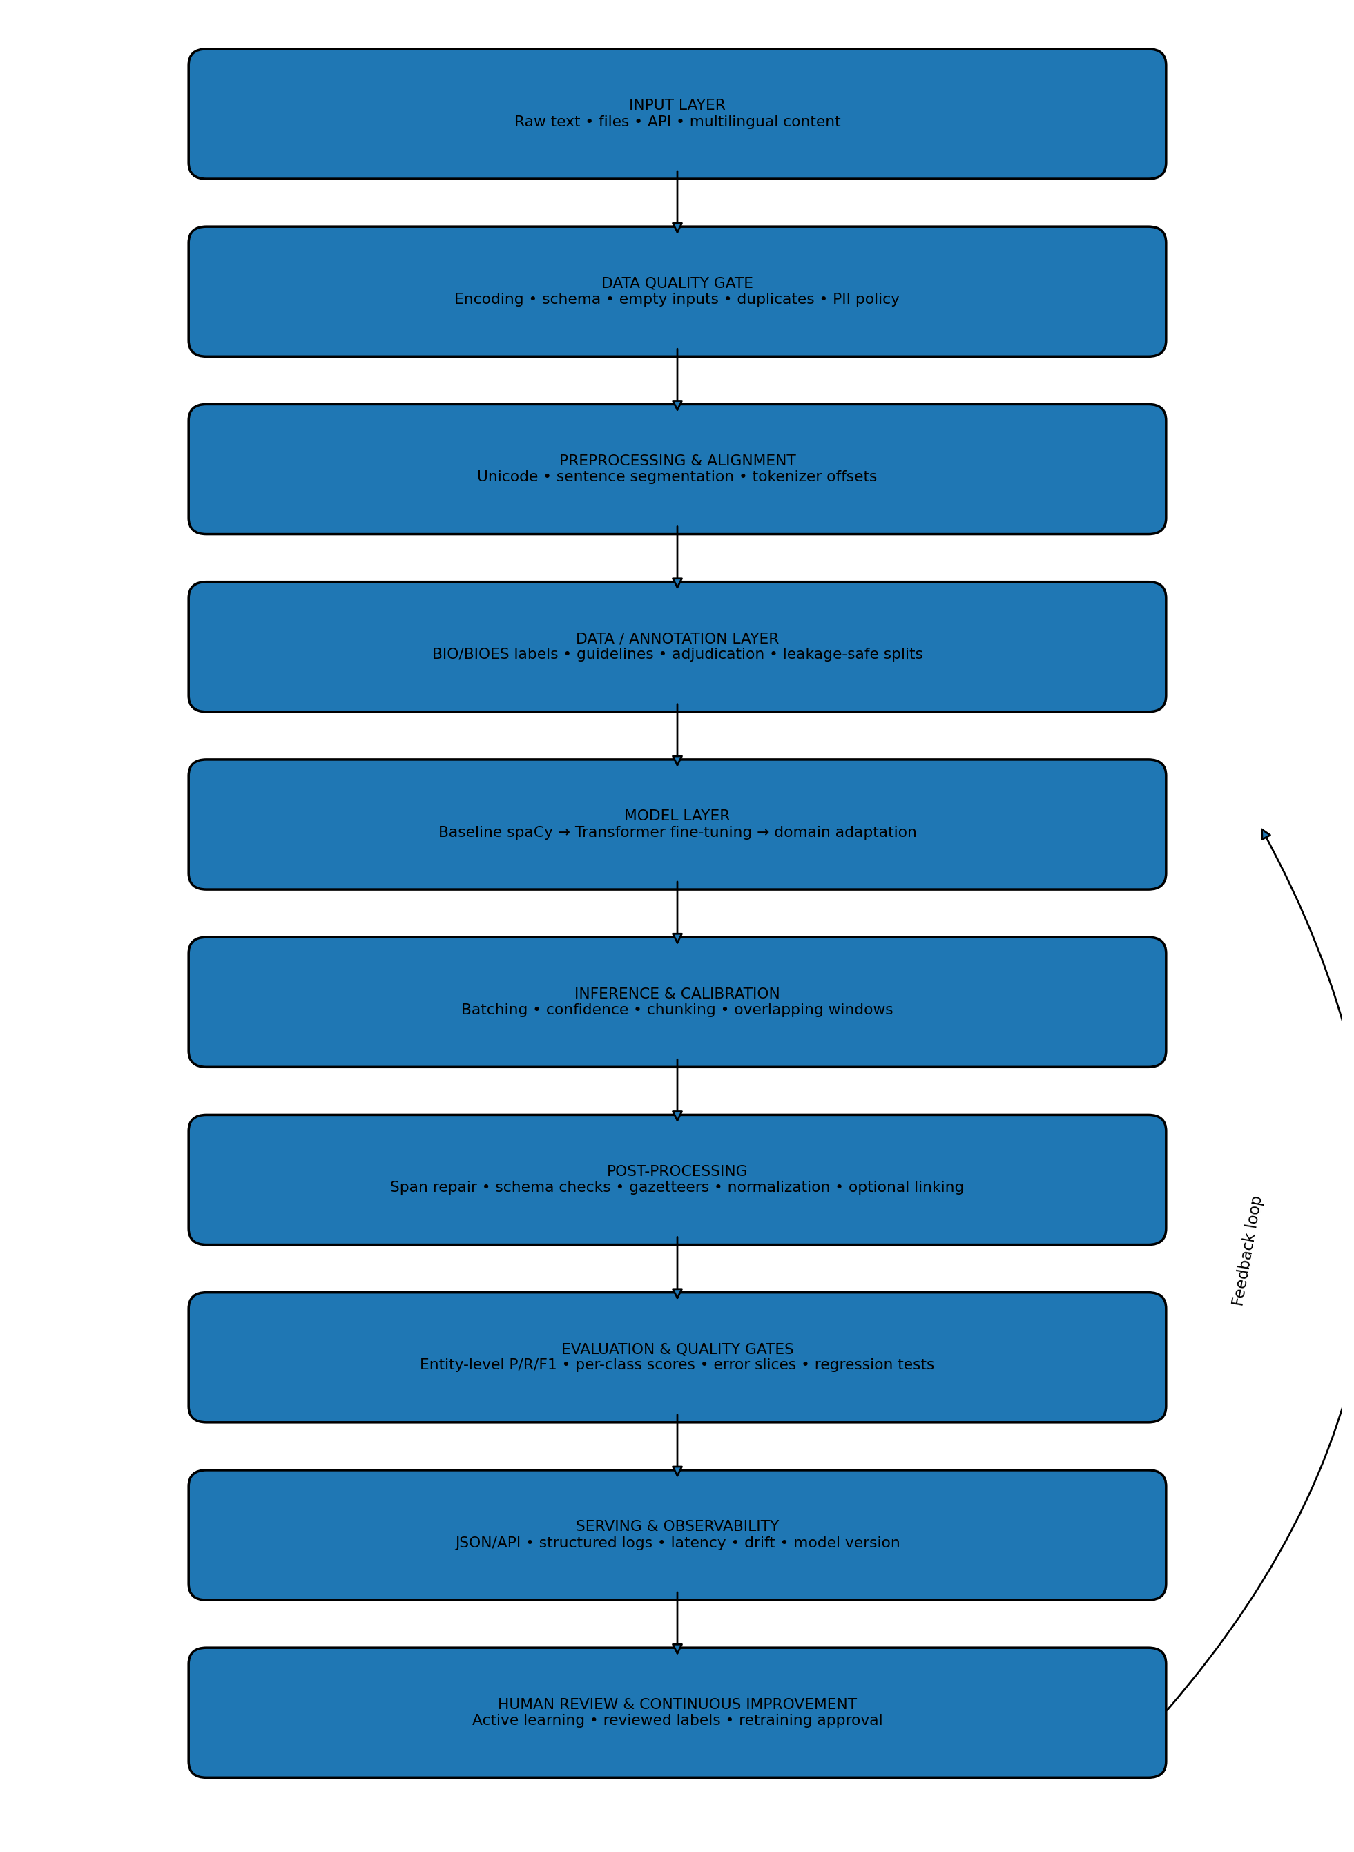
Figure 1. Modular NER architecture with quality gates and a human-feedback loop.
- Input layer: accepts text, files, or API requests and assigns a stable request/document identifier.
- Quality gate: checks encoding, schema, size limits, empty records, duplicates, and prohibited content.
- Preprocessing: normalizes Unicode conservatively and creates sentence/token boundaries while tracking offsets.
- Annotation and data layer: applies agreed entity guidelines, label mappings, adjudication, and leakage-safe splits.
- Model layer: starts with a baseline, then permits fine-tuning or domain adaptation based on measured needs.
- Inference layer: manages chunking, overlapping windows, confidence signals, and batch processing.
- Post-processing layer: validates spans and applies only narrow, tested corrections.
- Evaluation layer: measures entity-level quality and blocks releases that fail agreed regression criteria.
- Serving and observability: exposes a stable output contract and tracks latency, errors, drift, and model version.
- Human feedback: reviewed mistakes become candidate training examples only after quality checks and approval.

4. Data Ingestion, Validation, and Governance
- Accept only documented input formats and reject unsupported types with actionable messages.
- Validate UTF-8 or source encoding; detect malformed byte sequences rather than silently corrupting names.
- Check required fields, maximum document size, null values, unexpected types, and duplicate identifiers.
- Retain original text for auditing and offset verification; store normalized text as a separate representation.
- Record data lineage: source, collection date, licence, language, domain, annotation version, and preprocessing version.
- Remove or protect personal and sensitive information where appropriate; avoid retaining raw text in routine logs.
- Separate training data from inference data and ensure public data licences permit the intended use.
- Define retention and access policies before processing confidential or regulated content.

5. Preprocessing and Offset Preservation

5.1 Recommended operations
- Unicode normalization (usually NFC) to reduce equivalent-character inconsistencies.
- Line-ending and whitespace normalization where it does not alter entity meaning.
- Sentence segmentation using language-aware rules; avoid splitting at common abbreviations or inside names.
- Tokenizer alignment using the exact tokenizer associated with the model checkpoint.
- Character-offset tracking so predicted token spans map back to the original source text.
- Chunk long documents into model-sized windows with overlap to reduce boundary losses.
- Language identification when multilingual routing is required; do not assume every input is English.

5.2 Operations to avoid by default
- Do not remove stop words: they can be part of names and surrounding context.
- Do not stem or lemmatize the input used for span extraction; these transformations alter surface forms.
- Do not lowercase everything: capitalization may distinguish acronyms, names, and ordinary words.
- Do not strip punctuation indiscriminately: punctuation can define boundaries or be part of identifiers.
- Do not apply aggressive spelling correction to names without evidence; it may convert a valid rare name into a common word.
Every transformation that changes character count must have an offset mapping or a reversible strategy. A core invariant is that the returned entity text must equal the corresponding substring of the original input.

6. Annotation Design and Dataset Preparation
- Define entity labels and boundary conventions before labelling; avoid changing them midway through the project.
- Use BIO or BIOES tagging for flat sequence labelling. For example, B-PER begins a person span, I-PER continues it, and O marks non-entity tokens.
- Document edge cases: honorifics, possessives, punctuation, acronyms, abbreviations, organization suffixes, nested entities, and partial mentions.
- Use double annotation on a sample and adjudicate disagreements; report agreement where feasible.
- Inspect label frequency, document length, source, language, and domain distributions.
- Deduplicate before splitting. Group by source or document and use time-based splits when deployment predicts future data.
- Use train/validation/test partitions; tune on validation data and keep the final test set untouched.
- Map label schemas carefully when combining datasets; document labels that cannot be mapped reliably.
- Do not use test-set examples to select rules, thresholds, prompts, or model checkpoints.

7. Model Selection and Training Strategy
Model family | Advantages | Risks / selection criteria
spaCy pretrained NER | Fast baseline, convenient span objects and deployment | May struggle with specialized labels, code-mixed or domain-shifted text
CRF / classical sequence labelling | Lightweight and feature-driven; useful for controlled tasks | Manual feature engineering and weaker long-range contextualization
BERT / RoBERTa token classifier | Contextual representations and flexible fine-tuning | Requires compute, subword alignment, and careful training validation
Domain-specific transformer | Can improve specialized vocabulary and conventions | Check licence, training data, bias, language coverage, and task fit
Hybrid model + deterministic rules | Useful for highly structured identifiers and known formats | Broad rules can create false positives and override contextual meaning

7.1 Recommended experimental protocol
- Establish a simple pretrained baseline and record its exact checkpoint, configuration, and test results.
- Define a model-selection matrix covering entity-level F1, per-class recall, inference latency, memory use, and licence.
- Fine-tune only when the baseline reveals a meaningful gap or domain adaptation is required.
- Use a fixed random seed where practical, versioned splits, and reproducible training configuration.
- Monitor training and validation loss; stop or regularize if validation performance degrades.
- Evaluate confidence calibration separately if confidence scores drive human review or automated decisions.
- Compare the candidate model against the baseline on the same untouched test set.
- Do not claim improved performance without measured results and a clearly described evaluation setup.

8. Public Datasets and Pretrained Resources
- CoNLL-2003: English news NER with PER, ORG, LOC, and MISC categories; useful as a classic baseline.
- WNUT-17: noisy social-media text and emerging entities; useful for informal text and novel names.
- OntoNotes 5.0: multiple genres and richer annotation; access conditions and licence must be checked.
- WikiANN / PAN-X: multilingual NER resources; annotation quality and label mapping may vary by language.
- Hugging Face model and dataset repositories: convenient distribution and model cards, but verify licences, provenance, intended use, and benchmark comparability.
- spaCy model packages: practical baseline models with documented pipelines; confirm language and label coverage.
Public benchmark performance does not guarantee real-world performance. For Kannada, Hindi, transliteration, code-mixed messages, local organizations, or industry-specific text, build a representative target-domain evaluation set.

9. Post-Processing, Entity Linking, and Validation
- Decode token labels into contiguous entity spans using the correct BIO/BIOES transition rules.
- Repair invalid transitions only through a documented policy; count repairs and inspect whether they are frequent.
- Validate offset bounds, start < end, non-empty spans, legal label names, and exact substring correspondence.
- Use curated gazetteers as supporting evidence for known names, not as universal truth.
- Normalize dates, quantities, currencies, and identifiers only after entity type and format have sufficient evidence.
- Keep NER separate from entity linking: recognition identifies a span; linking resolves it to a canonical record.
- Maintain separate confidence values for recognition and linking when both stages are used.
- Route uncertain, conflicting, or high-impact results to human review rather than automatically forcing a label.
- Create rule tests for every post-processing correction and run them against a regression corpus.

10. Ambiguity, Polysemy, and Difficult Cases
Challenge | Illustrative case | Mitigation
Polysemy | Apple: company or fruit | Contextual model, contrastive examples, error slices
Same name, multiple types | Jordan: person, country, brand | Use surrounding syntax and domain context
Emerging entities | New startup, product, public figure | Review unknown/uncertain spans; update data under version control
Nested entities | University of California, Berkeley | Define nesting policy and choose compatible architecture
Rare labels | Few EVENT or PRODUCT examples | Collect representative examples; report per-class metrics
Code-mixing / transliteration | Kannada-English or Hindi-English text | Language-aware data, multilingual models, target-domain validation
OCR / spelling noise | Scanned or misspelled text | Conservative normalization and OCR-aware tests
Long documents | Entity crosses a chunk boundary | Overlapping windows and offset-aware span merging
Domain shift | News model applied to clinical text | Domain-labelled evaluation and fine-tuning
Annotation disagreement | Different boundaries for organization names | Guidelines, double annotation, adjudication

11. Evaluation Framework
Use strict entity-level matching: a prediction is correct only when both the entity type and span boundaries match the gold annotation. Token accuracy alone can be misleading because most tokens may be non-entities.
Metric | Definition / purpose | What it reveals
Precision | TP / (TP + FP) | How many predicted entities are correct
Recall | TP / (TP + FN) | How many gold entities were found
F1-score | Harmonic mean of precision and recall | Balanced summary of extraction quality
Per-label metrics | Precision, recall, F1 for each entity class | Weaknesses hidden by aggregate scores
Exact-span match | Correct type and exact start/end boundaries | Boundary reliability for downstream use
Latency / throughput | Time per request and records per second | Operational performance
Robustness slices | Metrics by source, language, length, or noise level | Performance gaps across input conditions
- Report evaluation data size, label definitions, split strategy, model version, and confidence threshold.
- Inspect false positives, false negatives, type confusions, boundary errors, and out-of-domain failures.
- Use bootstrap confidence intervals or repeated runs when dataset size permits and results are close.
- Compare against a baseline and use identical test examples for fair comparison.
- Create a release gate: do not deploy if key label metrics regress beyond an agreed tolerance.

12. Error Handling and Operational Resilience
- Use explicit exception categories for invalid input, tokenizer failure, model-loading failure, timeout, and post-processing failure.
- Return a stable schema even when processing fails; use warning/error codes rather than fabricated empty success results.
- Set maximum document size, batch size, and execution time; process long inputs in controlled chunks.
- Use health checks for model availability and readiness checks before accepting requests.
- Log request IDs, model version, latency, and error category; avoid logging sensitive raw text by default.
- Use retries only for transient infrastructure errors, not deterministic malformed input.
- Add dependency pinning, model checksum/version tracking, and reproducible environment instructions.
- Maintain a fallback strategy such as returning a clear unavailable status rather than silently switching to an unvalidated model.

13. Security, Privacy, Bias, and Responsible Use
- Review dataset and pretrained-model licences, attribution requirements, and restrictions before reuse.
- Minimize collection of personal data and apply access control, retention limits, and secure storage as appropriate.
- Test whether error rates vary by language, source, dialect, name type, or demographic proxies relevant to the application.
- Do not assume model confidence equals correctness; calibrate and validate confidence-driven decisions.
- Keep human review for high-impact decisions and make limitations visible to downstream users.
- Document known failure modes and avoid using NER output as the sole basis for consequential decisions.

14. Monitoring and Continuous Improvement
- Track request volume, latency percentiles, error rate, empty-output rate, confidence distribution, and per-label trends.
- Monitor input drift: new vocabulary, changing sources, language shifts, longer documents, and emerging entity categories.
- Sample reviewed outputs using a privacy-aware policy to estimate real-world quality.
- Use active learning to prioritize uncertain predictions and examples where model versions disagree.
- Only add reviewed and adjudicated examples to the training set; keep a changelog of annotation updates.
- Run regression tests and compare metrics before releasing a new model.
- Version model artifacts, tokenizer, labels, preprocessing code, thresholds, and evaluation reports together.

15. Reference Implementation Pseudocode
def extract_entities(raw_text, request_id):
if not isinstance(raw_text, str) or not raw_text.strip():
return {"request_id": request_id, "entities": [],
"status": "invalid_input", "warnings": ["empty_or_non_string"]}
original_text = raw_text
try:
normalized_text, offset_map = normalize_with_offset_map(raw_text)
chunks = split_with_overlap(normalized_text, tokenizer_limit=MAX_TOKENS)
predictions = []
for chunk in chunks:
encoded = tokenizer(
chunk.text,
return_offsets_mapping=True,
truncation=True
)
logits = model_predict(encoded)
predictions.extend(decode_labels(logits, encoded, chunk.offset))
spans = merge_overlapping_predictions(predictions)
spans = map_to_original_offsets(spans, offset_map)
spans = validate_spans(spans, original_text)
spans = apply_versioned_postprocessing(spans, original_text)
return {"request_id": request_id, "entities": spans,
"status": "success", "model_version": MODEL_VERSION}
except InputValidationError:
return {"request_id": request_id, "entities": [],
"status": "invalid_input", "warnings": ["validation_failed"]}
except ModelUnavailableError:
log_event(request_id, "model_unavailable")
return {"request_id": request_id, "entities": [],
"status": "temporarily_unavailable",
"warnings": ["retry_later"]}
except Exception as exc:
log_safe_error(request_id, type(exc).__name__)
return {"request_id": request_id, "entities": [],
"status": "processing_error", "warnings": ["inference_failed"]}

16. Illustrative Structured Output
Input: “Riya joined Infosys in Bengaluru on 12 June 2025.”
{
"request_id": "example-001",
"status": "success",
"model_version": "ner-model-v1",
"entities": [
{"text": "Riya", "label": "PERSON", "start": 0, "end": 4},
{"text": "Infosys", "label": "ORG", "start": 12, "end": 19},
{"text": "Bengaluru", "label": "GPE", "start": 23, "end": 32},
{"text": "12 June 2025", "label": "DATE", "start": 36, "end": 48}
],
"warnings": []
}
This is an illustrative schema, not a guaranteed prediction. Actual labels and offsets depend on the model, label map, and exact original input.

17. Test Plan and Quality Assurance
Test category | Test examples | Expected property
Input validation | Empty string, None, numeric input, oversized document | Clear error status; no crash
Offset correctness | Accents, emoji, Unicode, multiple spaces | Entity substring matches original text
Boundary cases | Hyphenated names, initials, punctuation, quotes | Consistent documented boundaries
Sequence decoding | Invalid BIO transitions, adjacent entities | Valid spans and logged repairs
Long documents | Entity near chunk edge | No duplicated or lost spans after merge
Domain robustness | Rare names, noisy text, code-mixing | Measured error profile and graceful handling
Service failures | Model unavailable, timeout, malformed payload | Stable response schema and safe logs
Regression | Previously reviewed difficult examples | No unexplained quality regressions
Recommended automation: unit tests for preprocessing and offsets, integration tests for the full pipeline, and regression tests for previously observed errors. Keep a small manually reviewed “gold” set for fast checks and a larger held-out set for formal evaluation.

18. Suggested Project Structure
ner-nlp-pipeline/
├── README.md
├── requirements.txt
├── configs/
│ └── ner_config.yaml
├── data/
│ ├── README.md
│ └── sample/
├── notebooks/
│ └── exploratory_analysis.ipynb
├── src/
│ ├── ingest.py
│ ├── preprocess.py
│ ├── train.py
│ ├── predict.py
│ ├── postprocess.py
│ └── evaluate.py
├── tests/
│ ├── test_preprocess.py
│ ├── test_offsets.py
│ └── test_pipeline.py
├── reports/
│ ├── evaluation.md
│ └── error_analysis.md
└── app.py # optional API or demo

19. Recommended Development Milestones
- Milestone 1 — Specification: define language, labels, target domain, input limits, and output contract.
- Milestone 2 — Data audit: inspect data quality, label distribution, licensing, and split strategy.
- Milestone 3 — Baseline: run a pretrained model and record entity-level evaluation.
- Milestone 4 — Improvement: fix annotation issues, test domain fine-tuning, and compare alternatives.
- Milestone 5 — Reliability: implement offset validation, exception handling, and regression tests.
- Milestone 6 — Documentation: write setup steps, model/data provenance, evaluation, limitations, and examples.
- Milestone 7 — Release: publish code, verify repository contents, and submit the real GitHub URL.

20. GitHub Deliverable
The assignment instructions make a GitHub URL compulsory for a technical task. Create a repository, upload the code and report, and include a README with installation, usage, model/dataset sources, licence notes, sample input/output, evaluation results, and known limitations.
Suggested repository name: ner-nlp-pipeline
Proposed repository URL: https://github.com/rinkykalburge/ner-nlp-pipeline
Important: This address is a suggested URL and has not been verified as an existing repository. Create the repository and upload the project before submitting it.

21. Conclusion
A production-minded NER pipeline requires more than selecting a large model. Reliable performance comes from precise task definition, high-quality annotation, conservative preprocessing, context-aware inference, offset-safe post-processing, representative evaluation, and disciplined monitoring. The proposed design uses measurable quality gates and a human-feedback loop to improve accuracy without hiding uncertainty. A baseline-first workflow makes the system easier to evaluate, explain, and extend to new domains or languages.

References and Technical Documentation
- Tjong Kim Sang, E. F., & De Meulder, F. (2003). Introduction to the CoNLL-2003 Shared Task: Language-Independent Named Entity Recognition.
- Liu, Y. et al. (2019). RoBERTa: A Robustly Optimized BERT Pretraining Approach.
- spaCy documentation: Named Entity Recognition and EntityRecognizer.
- Hugging Face Transformers documentation: Token classification.
- seqeval documentation: Evaluation metrics for sequence labelling.
- Dataset documentation and licences for CoNLL-2003, WNUT-17, OntoNotes, and WikiANN/PAN-X.

