**Week 1:**

Evidence-based management (EBM) process

1. **Collect evidence**: Conduct studies
2. **Aggregate evidence**: Meta-Analysis
3. **Translate**: develop guidelines, principles for action
4. **Show efficacy**: Evaluate guidelines

Theory

* Aggregate of propositions [Anhäufungen von Aussagen]
  + **Proposition**: are causal statement linking two constructs
  + **Construct**: is usually not directly observable (motivation, justice)
* Testable through hypotheses
  + **Hypotheses**: are testable statements derived from the theory linking two measurable variables
  + Big issue: **operationalization** [legt fest, wie ein [Konstrukt](https://de.wikipedia.org/wiki/Konstrukt) (z.B. [Schwerkraft](https://de.wikipedia.org/wiki/Schwerkraft), [Intelligenz](https://de.wikipedia.org/wiki/Intelligenz) oder [Gerechtigkeit](https://de.wikipedia.org/wiki/Gerechtigkeit)) beobachtbar und [messbar](https://de.wikipedia.org/wiki/Messung) gemacht werden soll]
* Based on assumptions [Basiert auf Annahmen]

Scientific method:

* Relies on **empiricism**: things need to be observed [Was man nicht mit den Sinnen erfahren kann (sehen, hören…) glaubt man nicht]
* Observable data needs to be collected **objectively**
  + impossible, replace by replicable and testable intersubjectively, needs to be fully disclosed and described
* **Control**: data needs to be collected without bias [verzerren]
  + correct selection of people and method
  + correct application of selected method
* **Intersubjektivität**: komplexer Sachverhalt von mehreren Betrachtern gleichermaßen erkennbar und nachvollziehbar ist (einig, wie man etwas wahrnimmt/einordnet)

What is theory good for?

* Gives **meaning** (understand why things are happening)
* Allows for **prediction** (Abstraction, Generalization, Causal Learning, Survival, Power, Intervention)

Meaning for research:

* Bold conjectures (go big with research, [Vermutungen])
* Replication (important)
* Conduct in research process (increase better understanding, [Verhalten])
* Philosophical questions

What makes theory good?

* **Falsifiability** [Widerlegbarkeit]
* **Accuracy** ([Genauigkeit], better at explaining)
* **Parsimony** ([Geiz], fewer assumptions)

Deduction [Ableitung] and Induction [Herbeiführung]

* **Deduction**: from general proposition/theory to specific implications
* **Induction**: abstracting a proposition [Aussage] from data
  + Cannot be proven to be correct

Value chain

1. State of current research (definition of research field/question)
2. Research design (selection method of data collection, operationalization, inspecting criteria)
3. Data collection (sampling, pretesting, data collection)
4. Data analysis (data preparation, descriptive/inferential statistics)
5. Publication (interpretation of results, writing a research paper, submitting, revision)

Layout of any academic paper

1. Summary of the paper
2. Introduction
3. Theory
4. Data & Methods
5. Findings
6. Conclusion

**Week 2:**

Interesting contribution [Beitrag]

* New (Novel)
* Interesting (“that’s interesting!”, Counter intuitive, views)
* Relevant

Interesting research questions

* questions can be at different levels
* First question will often be too broad for testing, or is not what you intend to test
* Research project needs focus: only study one thing at a time
* Key question: what **exactly** are you studying?
* What boggles you? (erschüttern, sprachlos sein)
* From literature
  + conflicting results
  + boundary conditions
  + increase specificity
  + new phenomena
  + suggestions for future research

Qualitative and Quantitative

* qualitative: discover relationships, explain the why
* quantitative: corroborate [bestätigen] relationships, measure effects

**Week 3:**

(Folie 8??)

Tools to determine quality:

* Journal, journal rankings (objective: impact factor, subjective journal lists)
* Citation (derivative measures, e.g. h-index)
* Combined measures (Handelsblatt Ranking, FT Rankings, Research excellence framework)
* Boundary conditions (field, co authorships)

Research ethics

* Causing physical harm? [Schaden zufügen]
* Deceiving people? [täuschen]
* Are you the owner of the ideas? (Plagiarism?)

Reliability and Validity

* **Reliability**: “If I measure this again, I will get the same results”
* **Validity**: “I am doing what I say I am doing”, free of bias

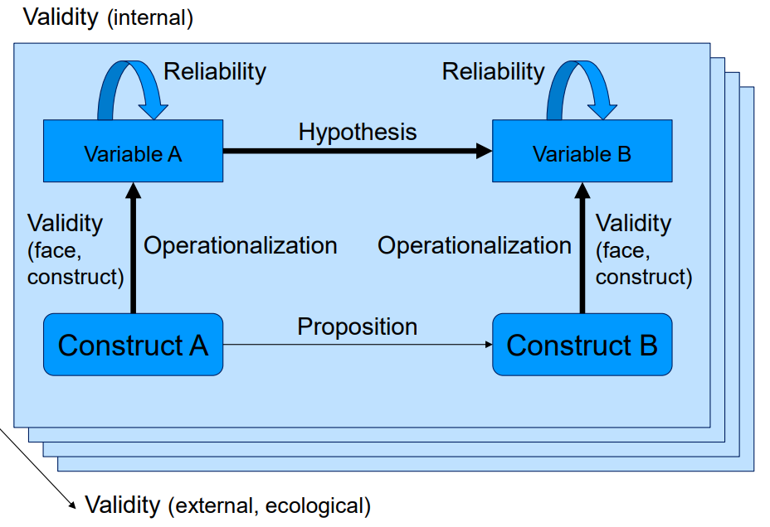

Forms of validity

* **Internal validity**: basic minimum, “did in fact the experimental treatments [Bearbeitung] make a difference in this specific instance?” [Schlussfolgerung gerechtfertigt]
* **External validity**: question of generalizability [Verallgemeinern]
* **Face validity**: does the item measure the construct? Does this make sense?
* **Construct validity**: (wird das Richtige gemessen?)
  + Convergent validity: correlates with similar scales/constructs?
  + Discriminant validity: district from other scales/constructs?
  + Content validity: really fully captured?

Causality in a single study

* Correlation/assocation (connection between A and B, free of bias [frei von Urteilen])
* Direction (connection goes from A to B, but not reverse, Problem: reverse causality)
* Non-spuriousness (truly A drives B, and not any other unobserved mechanism C)

**Week 4:**

Making choices of research methods design

McGrath: you can optimize on only one of three goals

* Generalizability: reach as many people as possible
* Precision: have full control over study
* Realism: degree to which the actual phenomenon is studied

Three Archetypes of Methodological Fit in Field Research

|  |  |  |  |
| --- | --- | --- | --- |
|  | **Nascent [Entstehung]** | **Intermediate** | **Mature [Reife]** |
| Research questions | Open-ended inquiry about a phenomenon of interest  [offene Untersuchung] | Relationships between new and established constructs | Focused questions relating existing constructs |
| Type of date collected | qualitative | Hybrid (both qual and quant) | quantitative |

Research methods

* Descriptive research: status quo [Gegenwärtiger Zustand]
* Correlation research: link between variables
* Experimental research: cause of things

Sample and population

* who you actually want to research 🡪 **sampling**
* sampling strategy must aware:
  + **Validity**: incorrect sampling 🡪 no conclusion about the phenomenon
  + **Representativeness**: the chosen people must be representative for all the people
  + **Anything** can be the population

Sampling Techniques

1. **Probability sampling:** (Each unit within the population has a known chance of being selected)
   * Random sampling: equal probability, random numbers, hard to achieve
   * Stratified sampling: subgroups/strata, randomly selected from strata [Schicht]
   * Cluster sampling: hierarchical stages, different units of each stage
2. **Non probability sampling**: (The chance of being selected of each unit is unknown or predefined)
   * Convenience sampling: selected at the convenience [Bequemlichkeit] of the researcher -> good for pilot study
   * Quota sampling: convenience sample, certain distributions of demographic variables
   * Snowball sampling: access hard to reach populations and particular subgroups in the population
   * Judgement sampling: researcher uses judgement, population is difficult to locate, members are thought to be better
   * Theoretical sampling: extreme cases -> qualitative work, maximize the likelihood [Wahrscheinlichkeit] of observability

**Week 5:**

Why qualitative research?

* Document, describe (execute more than one observations)
* Explain (see the “big picture”)
* Qualitative research in 3 ways
  + Theory testing
  + theory elaborating
  + theory generating
* methods: (each method use/produce multiple kind of data, methods can be mixed)
  + Case study research
  + Ethnography
  + Process research
  + In-depth-interviews

Case study research

* Neutral standards, standards in managements, extracting reliable and valid theory from qualitative research
* Eisenhardt (maybe genauer erklären Seite 20)

1. Getting started
2. Selecting cases
3. Crafting instruments and protocols
4. Entering the field
5. Analysing data
6. Shaping propositions
7. Enfolding literature [umfassen]
8. Researching closure

Coding is the most difficult part

* Coding for data reduction
* Begins with reading and marking
* Iterative aggregation – several “levels”

**Week 6:**

Quantitative data

* Primary data (data that is originally collected for the focal [ursprüngliche] study, e.g. surveys)
* Secondary data (data that already exists, e.g. financial records)

What measurement captures are variables

* “perceivability” [Wahrnehmbarkeit]:
  + **Manifest** 🡪 can be observed directly (first week philosophy vs science)
  + **Latent** 🡪 cannot be observed directly
* Outcome of operationalization:
  + **Dichotomous**: only two values
  + **Discrete**: only a few values, but these are “separate”
  + **Continuous**: “fluid” range of values
* Outcome determines the format of the variable
  + **Nominal**, **ordinal** and **metric** variables

Elements of survey design: [Umfrage]

1. Welcome: encourage and instruct people
2. Legitimation [Berechtigungsnachweis]: “university” – “important”
3. Motivation: price draw, results
4. Story: survey should follow a plan
5. Gain trust: ask sensitive questions later in the survey

Defining a scale

* **Scale** is a set of items (questions) that jointly measure a construct
* before a scale can be used, it needs to be validated extensively

Kirton-Adaption-Invention-Index (KAI)

* Measures how individuals react to changes [innovativ / adaptiv]
* Splits up in three dimensions:
  + How much individuals like to work with new ideas
  + How much individuals focus on being efficient
  + How much individuals conform to rules and authority

Reliability

* Test – retest
* Parallel test
* Split half
* Interrater
* Internal consistency

Increasing validity

* Use existing scales
* Pilot study
* Good questions
* Multiple measurements

Where to find existing scales?

* My conversation or related ones
* Books

Why use existing datasets?

* Conversation, costs time, easier

Things to watch out for with secondary data

* Suitability
* Validity and reliability
* Biases
* Missing data
* Non-response

**Week 8:**

Preparation for Data Analysis

* Coding (To categorize the responses for analysis)
* Editing (Fix errors, obviously incorrect responses, allow processing [erlaubt Bearbeitung])
* **Never** overwrite the original dataset

**Coding**: describes the process through which survey answers, texts, etc. are transformed into processable [verarbeitbare] numbers

Missing values

* Answers that are not processable (incl. “just not there”) need to be defined as so called missing values

Addressing missing values

* Imputation (infer [folgern] the answers that are missing from the other answers)
* Scales and indices (not necessarily that all items are represented)
* Pair-wise statistics (maximum number of combinations possible)
* Drop-observations (those observations where all variables are present)

Data reduction

* **Factor analysis**: tries to group variables
* **Cluster analysis**: tries to group people

Factor analysis

* Interdependence technique, all variables are simultaneously considered each related to all others

What is the purpose of factor analysis?

* Can test the validity of a scale
* Reveals interesting patterns
* Solving problems of multicollinearity
* Gives a smaller number of variables

Two different types of FA:

* + Exploratory FA:
* Uncover underlying structure of a large set of variables
* Any indicator may be associated with any factor
* Asses reliability [bewertet Zuverlässigkeit]
* Always needs to be done
  + Confirmatory FA:
* Number of factors from pre-established theory
* Shows construct validity of a scale
* Not necessary if scale has been used before

Three steps of exploratory FA

1. Examine which variables are correlated (KMO – criterion -> should be >= 0,8, must be >=0,5)
2. Extract factors from the variables
3. Factor axes have to be rotated

Variables:

* need to be continuous
* need to be normal distributed

Two different methods for factor extraction

* Principle component analysis
  + Maximize the explained variance
  + Small number of linear combinations (as much info as possible)
  + Assumes that all variance can be explained
* Common factor analysis
  + Maximize the underlying correlations
  + Aims more at what we would really consider latent constructs

Factor analysis – Kaiser criterion

* Only factors having eigenvalues > 1 are retained [beibehalten, speichern]
  + Eigenvalue: correlation of one factor with multiple variables
  + Communality [Kommunalität]: correlation of one variable with multiple factors
* Variance criterion: 60 % ((Percentage of variance criterion: based on achieving a high specified cumulative % of total variance extracted by successive factors (usually 60%)))
* Elbow criterion: plot of eigenvalues and cut where the curve flattens
* Want variables to load with only one factor

Factor rotation (Week 8 Folie 35)

* Orthogonal rotation [senkrecht]: axes are maintained at 90°
  + means that resulting factor scores are uncorrelated
  + Usually combined with principal component factor extraction
  + varimax, quartimax, equimax 🡪 uncorrelated
* Oblique rotation [schief]: allow for correlated factors rather than maintain independence between rotated factors
  + Means that resulting factors will usually be correlated
  + Usually combined with common factor analysis
  + Oblimin, analysis, promax 🡪 correlated
* Results:
  + > 0,4 for factor of interest
  + < 0,4 for all others
* Reliability:
  + Values >= 0,7 are good

$α=(\frac{k}{k-1})(\frac{V_{t- \sum{V_{i}}}}{V_{i}})$

**Week 9:**

Simple linear regression

* Correlation: indicator of how closely two variables are associated
* Model:
  + Y = ß0 + ß1X + ε
  + Deterministic: ß0+ ß1X (model the regression with only 2 variables)
  + Stochastic or random: ε (impact of all the other factors)
  + Y is the dependent variable (output)
  + X is the independent variable (input)
  + ß0 is the constant parameter (intercept)
  + ß1 is the coefficient parameter (slope)

OLS regression (ordinary least squares)

* Minimizes the variance of the residuals in the sample
* Dependent variable (Y):
  + Ranges from + to – infinity
  + Only real number
  + Constant units of measurement
* Independent variable (X): (Standards for “Simple Regression”)
  + SR1: Linear
  + SR2: Error terms have zero mean (non spuriousness 🡪 [keine Unwahrheit])
  + SR3: Error terms have consistent variance (homoscedasticity 🡪 [Gleichheit der Streuung der Ergebnisse])
  + SR4: Zero covariance between the error terms (no autocorrelation)
  + SR5: Variable x is not random (no linear combinations of the independent variables (no multicollinearity))
  + SR6: Error term is normally distributed
* Works well only for continuous, metric dependent variables

BLUE (best linear unbiased estimator)

* What needs to be fulfilled for the betas (ß)
  + To be unbiased [unvoreingenommen] (must)
  + To be efficient (should)

Multiple regression

* Using variation of equation of a straight line:
* Y = b0 + b1X1 + b2X2 + b3X3 + … + bnXn

Four basic components:

* F-test: May I interpret the model at all, value must below
* coefficient of determination (R2): how well do I explain the DV (dependent variable), between 0 and 1, variance explained, high
* Regression coefficients: relationships between IV and DV
* Significance level of the coefficients: can I interpret coefficients?

“Null hypothesis”

* We say the opposite of what we are attending H0: ß = 0
* Alternative hypothesis: H1: ß ≠ 0
* Reject H0 🡪 accept the hypothesis

Test statistic and p-value

* Calculate test statistics
  + t-distribution in small samples, n-2 degrees of freedom
  + Normal distribution in large samples (z statistic)
  + Identical to **coefficient divided by standard error**
* Software will calculate the p-value (significance level)
  + The probability of observing a test statistic bigger than “t” or more negative than

“–t” if H0 is true

* Magical “t”/”z”
  + p-value is the probability that what we are observing is a “false positive” (no link in reality, but we still think there is)
  + significance level: define the level of this type of error that we are willing to accept
  + checking happens via the probability density function of the respective test statistic
* Understanding type I and type II error
  + Type I Error: You’re pregnant (but you aren’t)
  + Type II Error: You’re not pregnant (but you are)

Reject the hypothesis?

* Significance level implies the level of type of type I error you are willing to accept
* p-value <= α „not reject“ your hypothesis
* reject H0 (means “accept your hypothesis) if absolute value of t falls in the critical regions
* FROM STATISTIC 🡪 3 types of H1:
  + **H1 > x** 🡪 reject if: **test stats > t1-α**
  + **H1 < x** 🡪 reject if: **test stats < -t1-α**
  + **H1 ≠ x** 🡪 reject if: **|test stats| > t1- α/2**
* **AUFPASSEN: in statistic hom mors ondersch ummer gmocht als dooo**

**Week 11:**

F-Test:

* Can assess multiple coefficients simultaneously
* **F statistic** when deciding to support or reject the null hypothesis
* In your **F-test** results, you’ll have both
  + **F value** and an
  + **F critical value**
* Check **p-value** to indicate the **probability** that your results could have happened by chance
  + If the p-value is < your alpha level, you can reject the null hypothesis.
* If **calculated F value** in a test is **larger** than your **F statistic**, you can reject the null hypothesis
  + **F values** will range from 0 to an arbitrarily [willkürlich] large number

F-test: Calculation ????

Moderation

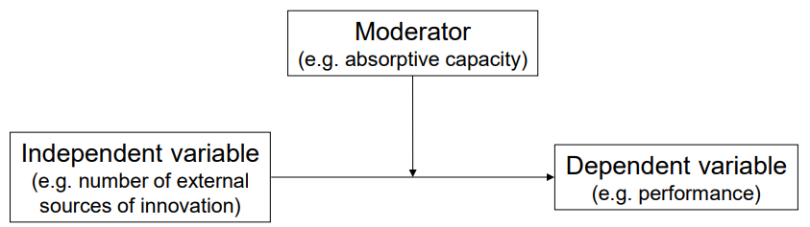

* Allows us to express conditional effects
  + Condition Z (moderator) will determine what type of effect X has on Y

Why moderation or interaction effects?

* Simple regression vs. conditional
  + Simple regression only contains linear terms
  + Conditional regression contains moderation effects captured by interaction terms
* Interaction effects:
  + [zusätzliche Abweichungen, die nicht von den Haupteffekten erklärt werden können]
* Sometimes we have more values of Z to substitute into the equation
  + If Z were categorical, e.g. gender 🡪 compute two regression functions, one for men and one for woman

U-shaped???

Mediation [Vermittlung]

* Allows us to model causal chains (X 🡪 Z 🡪 Y)
* Z mediates the effect of X on Y
* Full mediation:
  + X has no effect on Y in the presence of Z
* Partial mediation:
  + the magnitude [Ausmaß] of the effect of X on Y is significantly reduced in the presence of Z

Mediator Model

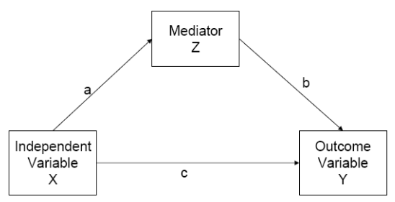

Four rules of mediation to occur

1. Independent variable significantly predicts the mediator (a)
2. Mediator has a significant effect on the dependent variable (b)
3. Independent variable significantly predicts the dependent variable in the absence of the mediator (c)
4. Effect of the independent variable on the dependent variable shrinks/disappears when the mediator is added to the model

* Conduct them as four separate regressions and observe the change

Overcoming some more limitations of OLS

* Singular causality:
  + such pathways as multi causality may be modelled through
    - SEM (structural equation modelling) and
    - PLS (Partial least squares) methods
* Nature and distribution of the dependent variable
  + Very strict assumptions about DV
  + Some distributions are nowhere near the normal distribution and they cannot be appropriately modelled with OLS

Robustness checks section

* Test and exclude alternative explanations
* Do sensitivity analysis (challenge your own core assumptions)
* Do subsample analysis (reliability, predictions for sub-populations, robustness checks)
* Provide additional evidence

**Week 12:**

Experimental research

Experiments are research designs in which the researcher

* manipulates one or more variables (IV)
* … measures any change in other variables (DV)
* … while controlling for the influence of extraneous variables (control variables)

Basic ingredients:

* Independent variables
* one or more variables are manipulated
* an IV must have two or more levels (awareness to money 🡪 1) no exposure, 2) exposure)
* Dependent variables
* response being measured in a study (e.g. feelings, behaviour)

administer a survey:

* get baseline variables
* get further variables
* manipulation checks

Five essential properties of an experiment

1. control
2. randomization
3. systematic manipulation (checked in a pilot test)
4. descriptiveness
5. reproducibility

Confounding variables [Fremdvariablen]

* an extraneous variable whose presence affects the variables being studied so that the results do not reflect the actual relationship between the variables under investigation

Threats to internal validity

* **failed random assignment**
  + groups are not equivalent in the beginning
* **different drop-art rates**
  + e.g. one of experimental/control is boring, more participants leave
* **extraneous events**
  + external impacts, outside the research that impacts the participants responses, e.g. noise from outside
* **experimenter expectancy**
  + when the researcher on his own manipulate the participants with his/her expectations
  + may be a serious threat avoiding this, researcher use double – blind procedures

Trade-off between internal and external validity

(Kompromiss zwischen interner und externer Gültigkeit)

* The more tightly controlled an experiment, the stronger its internal validity
* Higher degree of control lowers external validity

Experimental economics

* Real money payoffs
* Publish full experimental instructions
* Do not use deception
* Avoid introducing specific, concrete context

Conjoint experiments

* Discrete dimensions
* Define values for each dimension
* Derive reduces set of “cards” to capture values on each dimension
* Ask people to rank cards or compare in pairs/groups
* [Sortiere vorgelegte Elemente absteigend (ansprechend bis nicht ansprechend)]

Natural experiments

* One group is treated by a chance event or something outside their control, the other is not
  + Natural disasters, lotteries

Quasi experiment

* Similar to natural experiments, but variable does not occur naturally
  + Children born into different types of households
  + Students assigned to different classes (if not by lottery)

Understanding experimental designs

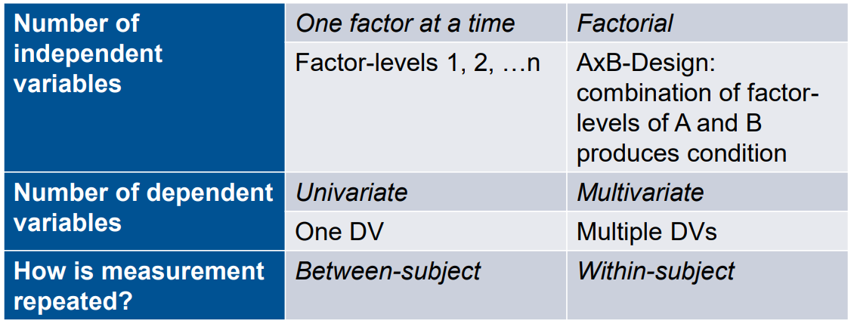

**Week 13:**

T-test

* Checks mean of one variable is equal to a certain value
* Checks difference between the means of two variables is significant
* Depends on mean, distribution and number of observations

**Seite 20**

ANOVA

* Checks whether one variable has different means across different groups of population
* Compares multiple independent variables
* Compares multiple subgroups