TEST PROJECT   
IT SOFTWARE SOLUTIONS   
FOR BUSINESS

module 1

WSC2017_TP09_M1_actual

Submitted:

WorldSkills International   
Independent Test Project Design Team

## Contents

This Test Project proposal consists of the following documentation/files:

1. WSC2017_TP09_S1_EN.pdf (Session 1 instructions)
2. Session1-MySQL.sql (SQL Script to create tables with data for MySQL)
3. Session1-MsSQL.sql (SQL Script to create tables with data for Microsoft SQL)
4. UserData.csv (User information to be imported in the database)

## Introduction

AMONIC Airlines has offices in different locations based on the countries they have active flights on. The automated software system which is the subject of this Test Project will be available to managers and system operators at those offices. The first point of entry of the system is the login form and the authentication system.

The following basic characteristics for the solution must be fulfilled in this session:

* Provide access to different sections of the system based on each user’s role
* Control and monitor clients’ access to the system

## Description of project and tasks

While developing the Test Project, please make sure the deliverables conform to the basic guidelines drawn out by different departments at AMONIC Airlines:

* There should be consistency in using the provided style guide throughout development.
* All required software modules must have applicable and useful validation and error messages as expected by the industry.
* Where applicable, use comments in code to have the code more programmer-readable.
* The use of valid and proper naming conventions is expected in all material submitted.
* Any form or report once created should be displayed in the centre of the screen.
* When a form or a dialogue is in focus, operations on other forms need to be suspended.
* The caption of Delete and Cancel buttons need to be in red to help with accidental mishaps.
* When using colours to differentiate between rows or records, there needs to be visible clarification on the screen as to what they stand for.
* The wireframe diagrams provided as part of this document are only suggestions and the solution produced does not have to be, in any way, mirror what has been pictured.
* Time management is critical to the success of any project and so it is expected of all deliverables to be complete and operational upon delivery.

## Instructions to the Competitor

### 1.1 CreatING the database

Create a database by the name of “Session1” in your desired RDBMS Platform (MySQL or Microsoft SQL Server). This will be the main and only database you will use in this session.

### 1.2 ImportING database structure

Depending on your preferred RDBMS platform, a SQL scripts is made available. The said scripts consists of the database structure and data required to complete the required tasks. The data needs to be imported to the database created for this session named “Session1”.

As instructed by the designers, the database structure provided for the purpose of this section cannot be altered. This applies to removal of tables, adding or deleting any fields on the tables or of change in their data types.

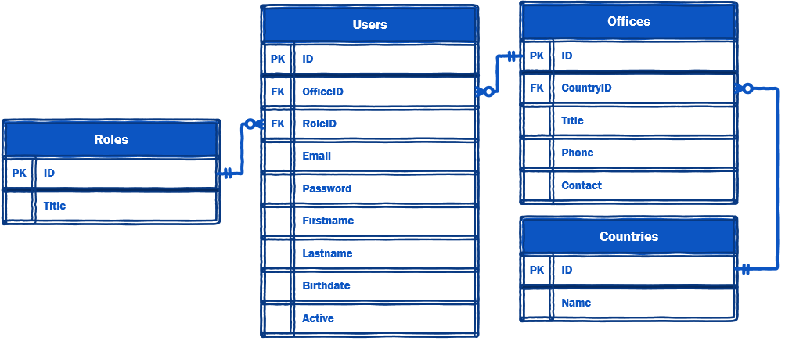

To help further perceive the thinking behind the structure of the database, the database designers provide an Entity-Relationship Diagram (ERD). The aforementioned diagram explains the conceptual and representational model of data used in the database.

### 1.3 Import User data

The management has approved a list of users that will need access to the system. The list that has been provided as “UserData.csv” needs to be imported into the “Users” table.

The list of the data fields that need to be imported and referenced against the database for each user are Role, Email, Password, First name, Last name, Title, Birthdate, and Active.

The password in the data files provided are clear text but for better security need to be converted to md5. From here on, all password should be stored in that same format. It goes without saying that since the e-mail address is being used as the username to log onto the system, it needs to be unique.

### 1.4 monItoring of User activity

Because of the security policy AMONIC Airlines has adapted, the company has asked for additional tracking implemented on the system. This requires analysis and development of additional table(s) which will need to be implemented on the database.

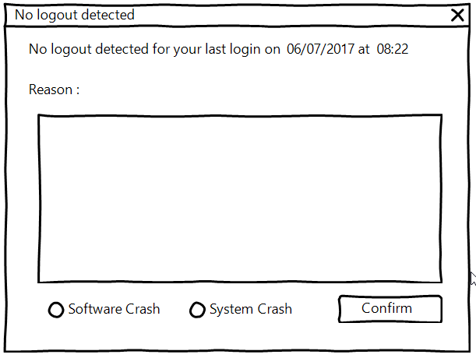

The goal of adding this option is to know how long each user is present on the system. This means that we need to keep records when someone enters the system and when they log off. The system also needs to be able to detect when something out of the ordinary happens and the user does not log off properly (e.g. the system crashes etc.). In those circumstances, the reason for the fault needs to be kept in the database so that the administrator can later review them and take actions to eliminate them. A mockup of the dialogue for this is shown above.

### 

### 1.5 Create login screen

Create a login screen as shown above with the following characteristics:

* The Username is checked against the Email address in Users table
* If the client enters the wrong username or password for more than three times, they need to wait ten seconds before they can login to the system again. While waiting for the next chance to login, a countdown timer will indicate the time remaining for the next attempt.
* In case management disables the user and they enter the correct credentials, an appropriate message will let them know the reason why they cannot log on.
* Upon a successful attempt, based on the client’s role, they will be directed to the main menu for either the administrator (item 1.6) or the user (item 1.7).

### 

### 1.6 main menu for Administrators

The system administrator will have the following functionalities on their main screen:

* Top menu which consists of “Add user”, and “Exit”
* The list of the users on the system which is constructed as follows:
  + The list needs to have the name, family name, age, role, email address and the office they belong to
  + If the user on the list is disabled (suspended), they need to be set apart with different colour for backgrounds.
  + The age (in years) of each user should be calculated from the birthdate on the database and current to date set on the database server.
  + Using a drop-down menu or alike, the administrator would be able to display users based on the office they work at
* The administrator may want to suspend a user’s access to the system temporarily. The way this part is mean to work is with a button on the bottom of the form that toggles between “Suspend Account” for enabled users and “Unsuspend Account” for disabled accounts.
* All operations on this form need to be done in real-time and without the need to close the form and reopen it.

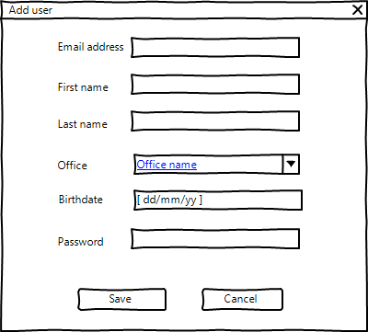

* The ability to add user accounts to the database using the button on the top menu as shown on the wireframe diagram drawn above:
  + All fields need to be filled in
  + The administrator does not have the ability to add other administrator accounts

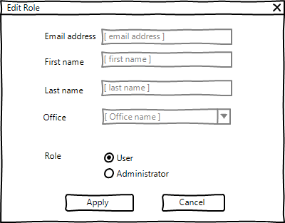

* Using the button at the bottom of the main menu marked as “Change Role” the administrator would be able to change the access level of the selected users. A mockup of the form is drawn above.

### 

### 1.7 Main menu for users

When a user successfully enters the system, they will have the following options to work with:

* Top menu which consists of “Exit”.
* The welcome message as indicated on the image above:
  + [fullname]: The username of the clients logged on to the system
  + [hh:mm:ss]: Total time that the current user has spent system in the last 30 days
  + [n]: Number of the crashes the software system has on record for the user

*Hi [fullname], Welcome to AMONIC Airlines Automation System*

*Time spent on system: [hh:mm:ss]*

*Number of crashes: [n]*

* The list of user’s activities which consists of the following:
  + The columns to be displayed are date and time of logging on and off as well as the total time one has spent on the system.
  + If there is a crash detected, the reason needs to be displayed in the appropriate column. The row that relates to the crash needs to be contrasted with a different background color.
  + The last login to the system which is the one used to get to this form is not displayed on the form.