TEST PROJECT   
IT SOFTWARE SOLUTIONS   
FOR BUSINESS

Module 2

WSC2017_TP09_M2_actual

Submitted:

WorldSkills International   
Independent Test Project Design Team

## Contents

This Test Project proposal consists of the following documentation/files:

1. WSC2017_TP09_M2_actual.pdf (Session 2 instructions)
2. Session2-MySQL.sql (SQL Script to create tables with data for MySQL)
3. Session2-MsSQL.sql (SQL Script to create tables with data for Microsoft SQL)
4. Schedules_V12.csv (Schedule changes)
5. Schedules_V12_2.csv (Schedule changes)

## Introduction

One of the vital functionalities of any software solution provided to an airline is the ability to schedule flights and manage their status. AMONIC Airlines is no different in asking for a system that fits their needs. The tasks described in this document are as follows:

* Apply schedule changes using the provided files
* Provide an interface to view and manage the schedules

## Description of project and tasks

In submitting your solution, please make sure the deliverables conform to the basic guidelines drawn out by different departments at AMONIC Airlines:

* There should be consistency in using the provided style guide throughout development.
* All required software modules must have applicable and useful validation and error messages as expected by the industry.
* Where applicable, use comments in code to have the code more programmer-readable.
* The use of valid and proper naming conventions is expected in all material submitted.
* Any form or report once created should be displayed in the centre of the screen.
* When a form or a dialogue is in focus, operations on other forms need to be suspended.
* The caption of Delete and Cancel buttons need to be in red to help with accidental mishaps.
* When using colours to differentiate between rows or records, there needs to be visible clarification on the screen as to what they stand for.
* The wireframe diagrams provided as part of this document are only suggestions and the solution produced does not have to be, in any way, mirror what has been pictured.
* Time management is critical to the success of any project and so it is expected of all deliverables to be complete and operational upon delivery.

## Instructions to the Competitor

### 2.1 CreatING the database

Create a database by the name of “Session2” in your desired RDBMS Platform (MySQL or Microsoft SQL Server). This will be the main and only database you will use in this session.

### 2.2 ImportING database structure

Depending on your preferred RDBMS platform, a SQL scripts is made available. The said scripts consists of the database structure and data required to complete the required tasks. The data needs to be imported to the database created for this session named “Session2”.

As instructed by the designers, the database structure provided for the purpose of this section cannot be altered. This applies to removal of tables, adding or deleting any fields on the tables or of change in their data types.

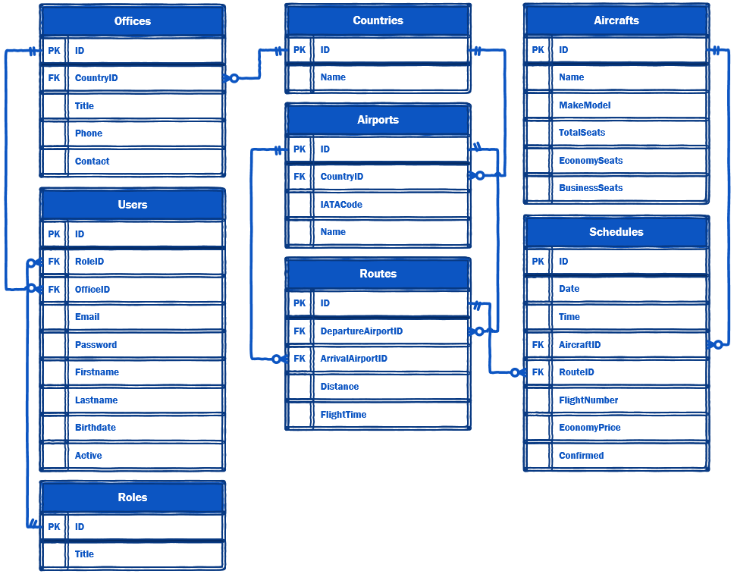

To help further perceive the thinking behind the structure of the database, the database designers provide an Entity-Relationship Diagram (ERD). The aforementioned diagram explains the conceptual and representational model of data used in the database.

### 

### 2.3 managing flight schedules

The management at the airlines has requested a form to facilitate the basic ability to view, edit and cancel flights. The following list defines the functionalities requested for the form:

* Search based on departure airport and arrival airport (they cannot be the same). Also searching for flights based on the date of departure and flight number should be included. The manager should be able to mix and match to their liking so they should be able to include or exclude any of the criteria at any time or no criteria at all (the default).
* The ability to sort the list descending by the one of the criterion of date and time, price for economy flights and whether they are confirmed or not. The default should be set on date and time.
* The list of flights scheduled on the system which is constructed as follows:
  + The list needs to include the date, time, departure airport, arrival airport, flight number, aircraft type and prices for economy, business and first class seats.
  + The price of business class seats has 35% premium over economy and first class flights are 30% more expensive than those of business class seats. In case you don’t come up with rounded numbers you can round the numbers down to their nearest whole number.
  + If a flight is marked as cancelled (not confirmed), the row corresponding to the flight should be marked with a different background color.
* Using a button on the form, the manager can toggle between “Cancel Flight” and “Confirm Flight” for the selected flight on the list. By cancelling a flight, you will set the corresponding record on the database to not confirmed.

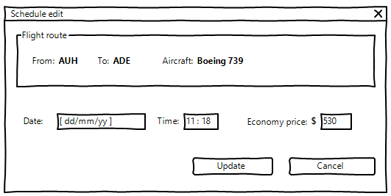

* By selecting an item from the flight schedule list and using a button on the form, one would be able to change the date, time and the price for seats in the economy class as shown above.
* All operations on this form need to be done in real-time and without the need to close the form and reopen it.

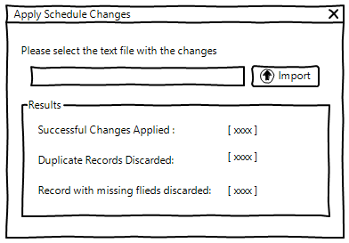

### 2.3 Applying Flight schedule CHANGES

At the end of each working day, the management of all AMONIC Airlines offices hold meetings to review the flight schedules and to make changes if required. This mean they might want to submit cancellations, changes or even add flights to the registered schedules on the system.

The way this works is at the end of every meeting, an associate will produce a text file detailing all needed changes and submit it to the IT consultants. The consultants will then apply those changes through an interface on the solution provided.

Please consider the following to complete this task:

* The data provided in order of their field list are operation, departure date, departure time, flight number, IATA code of departure airport, IATA code of arrival airport, aircraft code, base price and confirmation.
* Type of operation as set in the provided files are as follows:
  + ADD: Add a new record that represents the values on the record.
  + EDIT: If the record is found in the database it should be changed with the new values.
* Confirmation field in the data provided is either set to “OK” which are the flights that are confirmed or “CANCELLED” which refers to the ones that have to be set to not confirmed in the system.
* Flights are identified by their flight number and departure date. Should the user accidentally import the same record twice, the system must omit the duplicate flights and report them back to the user.
* All the fields in the “Schedules” table that needs to be changed are required. Which means, in case of a record with any missing fields, they should not be added to the database. The results section should reflect the number of discarded rows.