**Connecting University Students, Faculty and Administrators through an Online SMS Service**

**Reima Al-Jarf1**

*King Saud University, Riyadh, Saudi Arabia*

*\*Corresponding Author: Reima Al-Jarf*

|  |  |  |
| --- | --- | --- |
| Article Info  Article history:  Received 18 August 2021  Received in revised form 9 September 2021  Accepted 24 September 2021  *Keywords:*  Tawasul System  Online SMS  Instructor-student Communication  Administrator-Instructorstudent Communication  SMS groups |  | **Abstract**  *King Saud University (KSU) created an online Short Message Service (SMS) called “Tawasul”, developed in house, to connect administrators, faculty, and students. The KSU rector, deans, department heads and program coordinators send group season’s greetings and notifications to the mobile phones of faculty members, staff, and students. Instructors can send course notifications to their students regarding exams and other issues. There are currently 380 SMS groups for department staff, T.A.’s, workshop participants, course enrollees and others. Students and faculty surveyed indicated that the KSU online SMS Service is easy to use. It is faster and more efficient than paper memos and e-mails, especially in emergency situations. It helps conserve paper. Students and faculty can be reached anytime, anywhere and 7 days a week. Unused SMS in the user’s account can be added to his/her balance. SMSs are archived. Those interested to join a group can send a message to the group’s mobile number. Students’ mobile phone numbers are entered manually once and saved as a group. However, some faculty indicated that the allocated 200 free SMSs per month are not enough when class enrollees are more than 50. They also indicated that it is not possible to send a reply, a comment, or a query to the sender of the SMS. Sometimes the service cannot be used when it is under maintenance or when there is a technical problem. It is time-consuming to enter students’ mobile phone numbers manually particularly in large classes. Further results and recommendations are given.* |

Introduction

The emergence of mobile phones brought about new tools and new ways of communication among people. One of those is the Short Message Service (SMS) which is a text messaging service component of mobile devices. The SMS service started in 1992. It has been used by businesses, schools, higher education institutions, social groups, customers, special needs individuals and others. The SMS Service enables users to send and receive messages of up to 160 English characters to and from GSM mobiles.

Specifically, SMS communication plays a significant role in education. In numerous countries, SMS technologies have been incorporated into pedagogy such as supporting students in distance education in South Africa (Viljoen et al., 2005); use of mobile learning at the Open University of Malaysia to enhance blended learning for undergraduate distance learners (Lim et al., 2011); promoting written language skills (Geertsema et al., 2011); learning new English words (Cavus & Ibrahim, 2009); foreign language learning by beginners (Kennedy & Levy, 2008); laboratory instruction (Martinez-Torres et al., 2007); education in the Philippines and Mongolia (Librero et al., 2007); incorporating SMS into teaching practices (Broinowski, 2006); programming education (Kert, 2011); as a learning tool (Plana et al., 2012); taking classroom quizzes using students’ mobile phones to send responses (Lin & Rivera-Sanchez, 2012); utilization of an SMS crossword puzzle system to promote interaction in learning activities in a large classroom environment (Goh & Hooper, 2007); sending messages related to classroom activities and sharing ideas and resources with the students (Broinowski, 2006); engaging students in formative assessment objective questions with feedback, as well as SMS-based collaborative learning tasks (Brett, 2011); sending questions and queries during lectures and when support with the module material was required (McClean et al., 2010).

In addition, research revealed that SMS exchange significantly exceeded other modes of interaction among young people; whereas-mail was more predominantly used by "old people," and voice calls were used to communicate with parents and other family members (Averianova, 2011).

Furthermore, Brett (2011) reported positive experiences for administrative communication, learning support and suggested the use of student to tutor texts. The students had negative experiences and there was negative intrusion into personal time, lack of perceived academic benefits, the culture of immediacy in texting an SMS cost.

Crisp (2009) indicated that sending SMS to students and parents resulted in the highest assignment completion (5.16 out of 6), followed by sending text to parents (4.75 out of 6), sending text to students only (4.63 out of 6), and text to both students and parents, i.e., non-specific assignment (4.0 out of 6). There were significant differences in assignment completion rate by the type of text message intervention, and significant teacher effects, but no significant effects were found in the intervention transmission time. Overall, specific assignment information communicated by SMS from teachers to students and parents resulted in a positive effect on students’ assignment completion, and that comprehensive communication revealed a strong effect on students’ academic achievement.

At East Carolina University in the USA, the students liked to use SMS text messaging and felt that it was beneficial for enhancing communication in their online classes. SMS helped the students collaborate and communicate, created a social context that fostered a sense of community among them and improved social presence in online learning. Through the use of SMS, instructors and students became active participants in the learning process. The students shared online resources via SMS and learnt through interaction with each other in the online environment. They applied their accumulated knowledge in solving course problems. SMS also provided a medium for communication and dialogue (DuVall et al., 2007).

In comparison with other communication technologies, Austin (2012) found that SMS texting is the most frequently used synchronous text-based technology and that over 82% of students’ communication take place from their home, dormitory, or workplace. The students also reported that these synchronous text-based technologies were extremely effective in communicating with siblings, friends, and acquaintances, but much less so for communicating with parents, teachers, and employers. In another study, Lan, & Sie (2010) compared SMS, email, and RSS based on timeliness, richness, accuracy, and adaptability. The results showed that SMS surpasses email and RSS in content timeliness which makes it more appropriate for quick information delivery such as notifying and/or reminding users of some time-sensitive issues. On the other hand, email surpassed SMS and RSS on content richness and thus may be more appropriate for exhaustive information delivery. RSS surpassed SMS and Email in adaptability and content accuracy which makes it more appropriate for supporting various front-end mobile devices to access and present the content in a M-learning environment.

As for the effective use of SMS in education, Chang & Pan (2011) found that the relative advantage and ease of use are important factors that significantly affect the utilization of SMS. Service providers should design and develop successful business applications to take advantage of the benefits of SMS. Brown & Saunders-White (2008) added that the development of interactive SMS applications which ranges from simple data access applications to discovery games designed for the first-year experience, and the collaborative development of SMS applications for the whole university.

Moreover, a review of prior studies on the utilization of SMS and instant messaging in education showed lack of studies that investigated the utilizations of online SMS System at universities where bulk messages are sent through a computer via the Internet to groups of recipients who receive the messages on their mobile phones. At King Saud University, in Riyadh, Saudi Arabia, an online group SMS System, called Tawasul, has been recently developed in house by the Deanship of eTransactions to connect administrators, faculty and students. Bulk messages are sent from a computer via the Internet. Recipients of the Tawasul SMSs are course enrollees, graduate students, teaching practicum students, workshop participants, department staff, T.A.’s, members of students’ club, research chair members, quality and accreditation committee members, in addition to 380 SMS groups who use the Tawasul SMS System. The Tawasul SMS System has been upgraded to Tawasul 2

**Aims of Study**

Despite the importance of the Tawasul SMS System at KSU, no studies in Saudi Arabia have investigated the current use of the Tawasul SMS System, specifically, by instructors and their students, to uncover its benefits and shortcomings. Therefore, the present study aims to survey instructors, administrative staff and students at the College of Languages and Translation (COLT), King Saud University, Riyadh, Saudi Arabia to find the instructional and communicative uses of the Tawasul SMS System, its advantages and weakness, total number of users and messages sent, and its cost.

Findings of the current study will shed light on the amount of usage of the Tawasul SMS System in terms of the total number of users and number of messages sent monthly. It will inform the Deanship of eTransactions of the practicality, usefulness, and types of uses of this new communication system and whether it is cost-effective. It will inform the Deanship of the technical issues experienced by users.

**Methods**

The study uses a descriptive research design that depended on interviews with a sample of staff and instructors, analysis of monthly statistics on the utilization of SMS’s obtained from the Deanship of eTransactions at King Saud University, and examination of the components of the Tawasul System and some messages sent by the users.

**Participants**

Two administrators at the Deanship of eTransactions and 35 instructors at COLT, who are currently using the Tawasul SMS System to send messages to their students participated in the study.

**Data Collection**

The two administrators and instructors were interviewed by phone. They were all asked open-ended questions about the Tawasul System, its pedagogical, administrative, social and communication uses, and its benefits and shortcomings. In addition, the author obtained some statistics about the total number of Tawasul users at KSU and total number of SMSs sent over a 12-month period from the Deanship of eTransactiona at the university. The author examined the Tawasul system and account components and took a look at some messages sent by individuals and groups

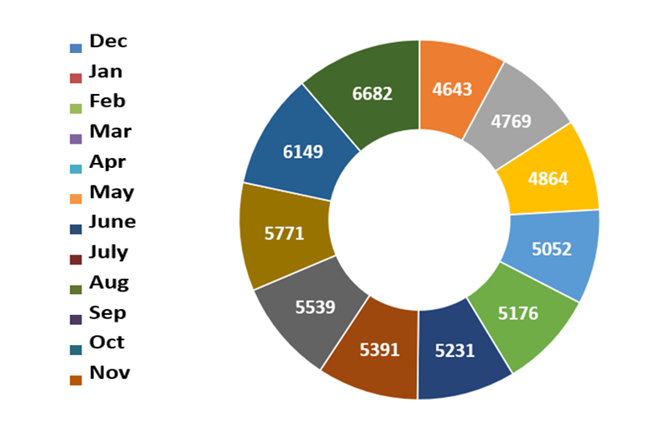

*Figure 1. Total Number of Tawasul Users per Month*

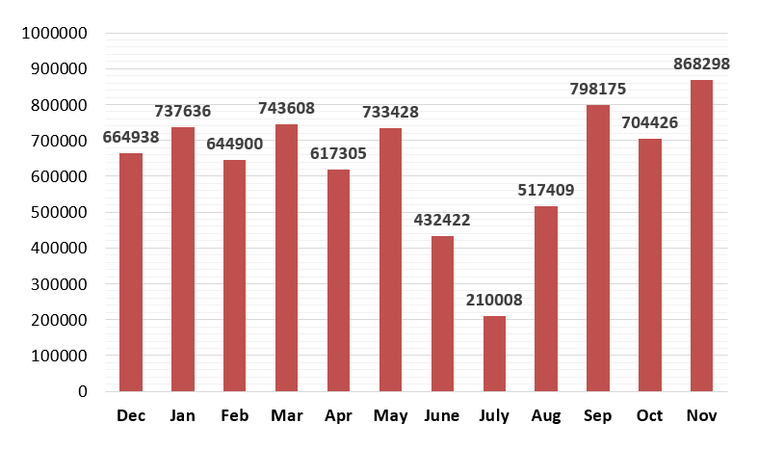

*Figure 2. Total Number of Messages Sent by All Users Per Month*

**Results and Discussion**

**Utilization of The Tawasul SMS System**

Analysis of the Tawasul messages showed that instructors send course notifications to the mobile phones of students registered in their courses regarding logistics such as exams, registration, deadlines, announcements, and other issues. The KSU rector, deans, department heads and program coordinators send season’s greetings and notifications to the mobile phones of a selected group of faculty and staff. The Tawasul group members receive notifications of university and social events, proverbs, lines of verse, sayings, language tips and inspirational quotes.

The course instructors can pre-schedule an SMS, can import students’ names and mobile phone numbers from the University Academic Portal by entering the course code. Users can also send SMSs to the mobile phone of colleagues or students through their university e-mail addresses. Each instructor is given a total of 200 SMS per month for free.

As for the total number of Tawasul number of users and SMSs sent over 12 months, the two administrators at the Deanship of eTransactions and the statistics obtained from the Deanship indicated that between December 2018 and November 2019, a total of 7,672,553 SMS were sent to a total of 63,759 recipients at KSU. The total number of users ranged between 4,492 and 6,682, and a range of 210,008 to 868,298 messages a month, with a median of 5203 users and a median of 684,682 SMSs sent (See Tables 1 & 2; Table 1). They added each message sent via the Tawasul SMS Service costs about SR0.08 per SMS, with a total of SR1,000,000 so far. All paid by the University.

Table 1. Mean, Median and Range of SMS Users Per Month and Total SMS Per Month

|  |  |  |  |
| --- | --- | --- | --- |
|  | Mean | Median | Range |
| Total Users | 5313 | 5203 | 4,492 to 6,682 |
| Total SMS | 639,379 | 684,682 | 210,008 to 868,298 |

Advantages of Tawasul as Perceived by Participants

Participants reported that the Tawasul online SMS Service is free for faculty, administrators, and students at KSU. It is easy to use. Users can send an SMS in English and Arabic and can switch languages very easily. KSU faculty, administrators, and students do not need to register in Tawasul. They can use their university username and password to log into Tawasul. The Tawasul System is faster and more efficient than paper memos, phone calls, e-mails, especially in emergency situations. It helps conserve paper. Students and faculty can be reached anytime, anywhere and 24/7. Unused SMSs can be added to the user’s balance. The SMSs sent by a user are archived. Students’ mobile phone numbers are entered manually once, and students registered in a course are saved as a group. Those interested in joining a group can send an SMS to the group administrator’s mobile number. If the SMS is irrelevant, the user does not like it or does not need it, he/she can easily delete it.

The Tawasul SMS Service is an additional effective communication channel between faculty, staff, administrators and students. It facilitates coordination of administrative tasks (meetings, announcements and reminders). It is an additional public relations/announcement tool, keeping interested users posted about important developments. It is used for quick announcements of university events. Tawasul makes is easy for Students’ Affairs and Registration Deanships and college deans to reach students anytime, especially in the case of an emergency. For example, when we had torrential rains, an SMS was sent 11 p.m. notifying all faculty and students at KSU of the suspension of classes the following day.

**Shortcomings of Tawasul as Perceived by Participants**

The participants indicated that the allocated 200 free SMSs per month are not enough when class enrollees are more than 50 students. It is not possible for the message recipient to send a reply, a comment, or a query to the sender of the SMS, i.e., SMSs are sent one way. The sender’s cell number remains anonymous. Sometimes the service cannot be used when Tawasul is under maintenance or when it has some technical problems. Some users misuse it. Some use it for personal non-academic or administrative use. Arabic SMSs are more expensive than English SMS because 1 English SMS is 160 characters long, whereas 1 Arabic SMS is 70 characters long. Some use lengthy, verbose SMSs with unnecessary headers (being unaware of the overall cost of such SMSs). When a message is long, some recipients get part of it only.

The participants indicated that Tawasul SMS System places an extra burden to secretaries, system operators and administrator as they spend additional time on the system (among other systems at KSU). The new version requires that students’ names and cell numbers be entered one by one manually. This is time-consuming. The instructor cannot copy and paste cell numbers and cannot use commas or semi-colons as separators. No way to import names and cell numbers from Edugate. The students can also enroll themselves and enter their cell numbers in an instructor’s group using a group code. Some students do not enroll themselves at all, thus do not receive any SMS.

The advantages of the Tawasul SMS System reported in the present study are consistent with findings of prior studies such as Brett (2011); Chang & Pan (2011) and Al-Jarf (2011) on the utilization and benefits of SMS and other instant messaging technologies which indicated that the relative advantage and ease of use of SMS are important factors that significantly influence mobile users' adoption of SMS. However, results of the presents study showed no pedagogical and language learning uses of the Tawasul System, which is inconsistent with prior studies such as Viljoen et al., 2005); Lim et al., 2011); Geertsema et al., 2011); Cavus & Ibrahim (2009); Kennedy & Levy (2008); Librero et al., 2007); Broinowski (2006); Kert (2011); Plana et al., 2012); Lin & Rivera-Sanchez (2012); Goh & Hooper (2007); Broinowski (2006); McClean et al (2010) and Crisp (2009). Lack of pedagogical and language learning uses of SMS in the present study may be attributed to lack of experience on the part of the instructors with regards to the instructional uses of SMS, what language learning tips, activities, questions, and group feedback they can send and how they can encourage and support students’ language learning. The limited number of free SMSs allocated to them every month may not be enough to send pedagogical tips. The instructors probably have not been introduced to the pedagogical uses of SMS and may not have received any training in that. They might not be willing to put extra time and effort in searching for and sending pedagogical SMSs. Furthermore, the shortcomings of the Tawasul System are similar to those reported by Brett (2011) and Al-Jarf (2011). Brett (2011) added further shortcomings of SMS such as intrusion into personal time, the culture of immediacy in texting, costs, and lack of perceived pedagogic benefit. Such shortcomings were not reported by participants in the present study.

**Conclusion**

Many higher education institutions in Saudi Arabia are using SMS as a communication tool to reach out more students with one SMS or email. Findings of the current study revealed inadequate uses of the Tawasul System as it is used to send SMSs about logistics but not instructional and language learning issues. Being a one-way SMS system is another weakness. There is no student engagement with the SMSs they receive. The students cannot send queries and comments on the SMSs they receive from their instructors. For SMS be a useful and effective adjunct tool to teaching and learning, the present study recommends that course instructors send language learning tips, quiz questions and resources to the students. Adding a feature to the Tawasul System by its developers that enables the students to reply, make comments and send queries to their instructors will add to the benefits of such as online SMS Service. Instructors who are not currently using Tawasul should be encouraged to use it and should be introduced to Tawasul and how it is used. Those who are proficient at using Tawasul can help their colleagues who are having problems with it. This way, utilization of Tawasul will be more effective. Finally, communication among administrators, instructors and students can be achieved through social media such as Facebook and Twitter, webconferencing software, Learning Management Systems and a Cbox or Chat Box App (Al-Jarf, 2020; Al-Jarf, 2016; Al-Jarf, 2018; Al-Jarf, 2005; Al-Jarf, 2011).

**References**

Al-Jarf, R. (2005). *Connecting students across universities in Saudi Arabia*. 4th Asia CALL Conference. ERIC Number. ED497940.

Al-Jarf, R. (2011). *Communicating and interacting with college students through a website chatbox.* 16th TCC Worldwide Online Conference, Hawaii. April 12-14.

Al-Jarf, R. (2016). College administrator-student communication via Twitter. *Journal of Basic and Applied Research International (JOBARI), 14,* 3, 176-184. Retrieved from

Al-Jarf, R. (2018). Connecting graduate students across the world with research web-conferences. *Asian Journal of Education and e-Learning (AJEEL), 6*(5), October. ERIC Number ED610938

Al-Jarf, R. (2020). *Communication among instructors and students via Twitter*. In Irena Vassileva, Mariya Chankova, Esther Breuer and Klaus P. Schneider (eds.) The Digital Scholar: Academic Communication in Multimedia Environment, pp. 265-280. Frank & Timme.

Austin, R. (2012). An investigation of the use of synchronous text-based communication technologies by undergraduate university students. Ph.D. Dissertation, Florida State University. **ERIC** ED552252.

Averianova, I. (2011). A cell phone in the classroom: A friend or a foe? *European Association for Computer-Assisted Language Learning (EUROCALL)*. ERIC ED544437.

Brett, P. (2011). Students' experiences and engagement with SMS for learning in higher education. *Innovations in Education and Teaching International, 48*(2)137-147.

Broinowski, I. (2006). Connecting with students using SMS. *New Horizons in Adult Education and Human Resource Development, 20*(4)33-36.

Brown, J., Vetter, R. & Saunders-White, D. (2008). Enhancing mobile access to information with the short message service. *Journal of Computing in Higher Education, 20*(2)24-34.

Cavus, N. & Ibrahim, D. (2009). M-learning: An experiment in using SMS to support learning new English language words. *British Journal of Educational Technology, 40*(1),78-91.

Chang, S. & Pan, Y. (2011). Exploring factors influencing mobile users' intention to adopt multimedia messaging service. *Behaviour and Information Technology, 30*(5), 659-672.

Crisp, M. (2009). Modernizing school communication systems: Using text messaging to improve student academic performance. Ph.D. Dissertation, Oregon State University. ERIC ED532093.

DuVall, J., Powell, M., Hodge, E. & Ellis, M. (2007). Text messaging to improve social presence in online learning. *EDUCAUSE Quarterly, 30*(3), 24-28.

Geertsema, S., Hyman, C. & van Deventer, C. (2011). Short message service (SMS) language and written language skills: Educators' perspectives. *South African Journal of Education*, *31*(4), 475-487.

Goh, T. T. & Hooper, V. (2007). To txt or not to txt: That's the puzzle. *Journal of Information Technology Education*, (6)441-453.

Kennedy, C. & Levy, M. (2008). L'Italiano al telefonino: Using SMS to support beginners' language learning. *ReCALL, 20*(3)315-330.

Kert, S. (2011). The use of SMS support in programming education. *Turkish Online Journal of Educational Technology - TOJET, 10*(2), 268-273.

Lan, Y. & Sie, Y. (2010). Using RSS to support mobile learning based on media richness theory. *Computers & Education, 55*(2), 723-732.

Librero, F., Ramos, A., Ranga, A., Trinona, J. & Lambert, D. (2007). Uses of the cell phone for education in the Philippines and Mongolia. *Distance Education, 28*(2), 231-244.

Lim, T., Fadzil, M. & Mansor, N. (2011). Mobile learning via SMS at open university Malaysia: Equitable, effective, and sustainable. *International Review of Research in Open and Distance Learning, 12*(2), 122-137.

Lin, J. & Rivera-Sanchez, M. (2012). Testing the information technology continuance model on a mandatory SMS-based student response system. *Communication Education, 61*(2), 89-110.

Martinez-Torres, M., Toral, S., Barrero, F. & Gallardo, S. (2007). Improving learning performance in laboratory instruction by means of SMS messaging. *Innovations in Education and Teaching International, 44*(4), 409-422.

McClean, S., Hagan, P. & Morgan, J. (2010). Text messaging for student communication and voting. *Bioscience Education*, *16*(Article 4).

Plana, M., Torrano, P. & Grova, M. (2012). SMS as a learning tool: An experimental study. *The EUROCALL Review, 20*(2), 33-47.

Viljoen, J., Du Preez, C. & Cook, A. (2005). The case for using SMS technologies to support distance education students in South Africa. *Perspectives in Education, 23*(4), 115-122.