**Analysis Of Blended Learning Development In Distance Learning In Variation Of Borg & Gall And Addie Models**

**Dedi Untoroseto1, Agung Triayudi2**

*Faculty of Communication and Information Technology, Universitas Nasional, Jakarta, Indonesia*

*Corresponding Author:* *Dedi Untoroseto  
Email:* [*setountoroo@gmail.com*](mailto:setountoroo@gmail.com)

|  |  |  |
| --- | --- | --- |
| Article Info  *Article history:*  Received 00 Month 2023  Received in revised form 00 Month 2023  Accepted 00 Month 2023  *Keywords:*  blended learning learning Model variations of Borg &; Gall and Addie |  | ***Abstract***  *With the success of blended learning and the use of online media on learning outcomes and from article search results, it shows that there have been many articles that contain blended learning and various media uses, and reviews are needed about it by reviewing existing articles or commonly called literature reviews. Borg & Gall and ADDIE models. The Borg & Gall model and ADDIE are two teaching models used in colleges and universities. ADDIE stands for Analyze, Design, Development, Implementation, and Evaluation. In the Borg & Gall model, the steps taken are research and information. Research and information is used to collect information about the need for learning evaluation instruments for learning media development courses for students. In the ADDIE model the steps taken are the same as the original which includes aspects of Analyze, Design, Development, Implementation, and Evaluation. Thus, what is needed in this development is a reference about the product procedure to be developed. The description of the development model of Borg and Gall, described as follows; Educational research and development (R&D) is the process used to develop and validate educational products. The validity of interactive blended learning is: (1) according to expert reviews the content of metrics shows a good category (92%), (2) according to expert reviews learning design is in the good category (88%), (3) according to expert reviews learning media shows a good category (86%), Thus, this interactive blended eLearning does not need to be revised and can be used for further research.* |

**Introduction**

In the development of technology and the development of Blended Learning in various models, it discusses combining two learning methods, namely online and face-to-face, to increase the effectiveness of learning and blended learning during the Covid-19 outbreak at the beginning of 2019, where there are face-to-face methods in the classroom and online lectures. . Industry 4.0 is present, characterized by physical cyber, people connecting and communicating via the internet (Hermann, Pentek, Otto, 2016; Irianto, 2017; Harto, 2018).

Blended learning is a combination of online, offline and face-to-face learning, students can access a series of learning even though they are not connected to the internet through the program application.

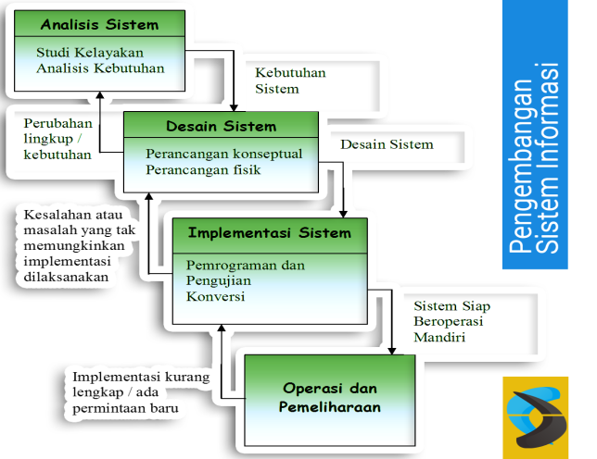

Figure 1. Information Systems Development Methodology (rahmancyber.net)

Student activities in the development of blended learning have been carried out in two large groups and each student has a schedule for distance learning and face-to-face learning. However, the application of the blended learning model that has been carried out has not yet touched on the steps in implementing the forms offered in the use of the blended learning model (Erlinda Zebua, Anugerah Tatema Harefa may 2022). This activity is required for lecturers and students to utilize Blended Learning in the learning process, in the form of access to online materials, learning videos, online discussions, online assignments, online exams and online guidance or online final trials. Apart from that, for lecturers to be able to create effective learning, they must also have planning skills in the form of preparing learning tools.

In the world of higher education, it must not be crushed, it must be able to take advantage of it, it must even be able to prepare itself to face the phenomenon of the industrial revolution 4.0. Minister of Research, Technology and Higher Education, Prof. Moh. Nasir (2018). The e-learning method can really help lecturers in delivering material that is more practical and easily accessible to students (Astuti & Hartono, 2016). Online learning is a learning model used by distance learning which has been implemented since the mid-1960s by open universities in the United States and England.

In the online learning process, various platforms can be used effectively, whether in the form of applications, websites, social networks or learning management systems. The various platforms available are used to help facilitate learning, such as a medium for delivering material, assessments, or simply for collecting assignments. They are also able to provide online content that can be accessed anytime and anywhere so it is very supportive for distance learning. According to several experts, the use of learning The management system is effective for managing learning because it has very complete features and is easy to access. (Gunawan et al (2019). Apart from being able to create more effective learning, it is hoped that lecturers must also have planning skills in the form of preparing learning tools (Febrian & Fera, 2019). (Tusa'diyah, 2020, p.12). In implementation The Blended Learning learning model has 3 components, namely:

Face to face, is direct learning that takes place at school involving teachers and students.

E-Learning is a learning process that utilizes the internet as an intermediary in implementing learning.

M-Learning is the media used to carry out online learning, for example cellphones, tablets, PCs, laptops, and many others.

Based on the division into the 3 components above, it can be said that in implementing blended learning, the learning process can run optimally. If one of these three components is missing, then it cannot be said to be a blended learning model because it is very important to be able to master learning skills that involve these three components.

Some combinations that can be applied in blended learning distance learning include:

50/50: 50% online and offline learning, and 50% face-to-face learning.

75/25: 75% online and offline learning, and 25% face-to-face learning.

25/75: 25% online and offline learning, and 75% face-to-face learning.

**Formula:**

**Validation of Learning Tools**

$$Persentase =\frac{∑\left(Jawaban x bobot tiap pilhan\right)}{n x bobot tertinggi}x 100\%$$

$$=\frac{46}{10x5}x 100\%$$

$$=\frac{46}{50} x{100\%}^{}$$

$$=92\%$$

**Validation of Learning Design**

$$Persentase=\frac{∑\left(Jawaban x bobot tiap pilhan\right)}{n x bobot tertinggi}x 100\%$$

$$=\frac{44}{10x5}x 100\%$$

$$=\frac{44}{50} x{100\%}^{}$$

$$=88\%$$

**Validation of Learning Media**

$$Persentase=\frac{∑\left(Jawaban x bobot tiap pilhan\right)}{n x bobot tertinggi}x 100\%$$

$$=\frac{56}{10x5}x 100\%$$

$$=\frac{56}{60} x{100\%}^{}$$

$$=87.69\%$$

**Test result**

$$Persentase=\frac{∑\left(Jawaban x bobot tiap pilhan\right)}{n x bobot tertinggi}x 100\%$$

$$=\frac{780}{10x5}x 100\%$$

$$=\frac{780}{60} x{100\%}^{}$$

$$=95.00\%$$

The design of blended learning for distance learning needs to pay attention to how to make learning interesting and appropriate to the characteristics of each student's learning style.

From the description that has been explained, a summary is needed regarding the influence of the learning model during online learning used by teaching lecturers on student learning outcomes. (Tita Yunia Zalni1, Fitri Arsih1, Zulyusri1, Lufri1 2022). It is hoped that the aim of the explanation above will help the process of optimizing Blended Learning for Distance Learning. One aspect of thinking is an effort to improve the quality of students and students in the Blended Learning process, distance learning. The definition of high-level thinking skills is categorized into three parts, namely as a form of learning transfer, as a form of critical thinking, and as a problem-solving process. As a result of the research above, researchers are interested in developing Blended Learning, distance learningin Borg & Gall and Addie Model Variations in the teaching and learning program development course, to help students understand concepts and practices in Blended Learning, distance learning.

Contribution Blended learning is a distance learning approach that combines elements of online and face-to-face learning to create a holistic learning experience. The Borg & Gall model and the ADDIE model (Analysis, Design, Development, Implementation, Evaluation) are two instructional development methods or models that can make a major contribution to the design and implementation of blended learning.

How both can contribute to the Borg & Gall Model and Addie Model in Blended Learning, here is the explanation:

**Contribution of the Borg & Gall Model to Blended Learning:**

Assessment of Needs (Needs Analysis):

The Borg & Gall model emphasizes needs analysis as the initial stage. In the context of blended learning, this analysis can help identify whether blended learning is the right solution and what needs must be met.

Designing the Intervention:

This model emphasizes goal- and performance-oriented design. Blended learning design can focus on developing online content and face-to-face strategies that support each other and are integrated.

Developing Materials (Material Development):

Material development in the Borg & Gall model involves the process of creating material that is relevant and effective. In the context of blended learning, this can involve the development of interactive online materials and supporting face-to-face modules.

Trying Out the Intervention:

This stage involves implementation trials. In the context of blended learning, this could include testing how students respond to a combination of online and face-to-face learning.

**Contribution of the ADDIE Model to Blended Learning:**

Analysis (Analysis):

The analysis stage in ADDIE can help identify needs, learning targets, and learning contexts that support blended learning.

Design (Design):

In the design stage, online and face-to-face learning elements can be designed in a structured and complementary manner according to learning needs.

Development (Development):

The development stage in ADDIE involves the production of learning materials. In the context of blended learning, this may include the coordinated development of online materials and face-to-face materials.

Implementation:

Implementing blended learning can involve coordination between online and face-to-face sessions, as well as the application of supporting technology.

Evaluation (Evaluation):

Evaluation in ADDIE can help in assessing the effectiveness of the combination of online and face-to-face learning. Gathering feedback can guide future improvements and enhancements.

By integrating elements from these two models, the design and implementation of blended learning can be more structured, focused on learning objectives, and responsive to student needs. The Borg & Gall model emphasizes continuous evaluation. Evaluation may include measuring the effectiveness of online and face-to-face learning and ongoing adjustments.

**Methods**

The development model methods used as reference by researchers are the Borg & Gall and ADDIE models. The Borg & Gall model and ADDIE are two teaching models used in colleges and universities. ADDIE is an abbreviation for Analyze, Design, Development, Implementation, and Evaluation. This model was developed by Reiser and Mollenda in the 1990s. The Borg & Gall model is a research and development model used to ensure designed products meet suitability standards. This research and development model is combined because it is adapted to the steps in the research and development process carried out by researchers. In the Borg & Gall model the steps taken are research and information. Research and information is used to collect information about the need for learning evaluation instruments for learning media development courses for students.

Then in the ADDIE model the steps taken are the same as in the original which includes aspects

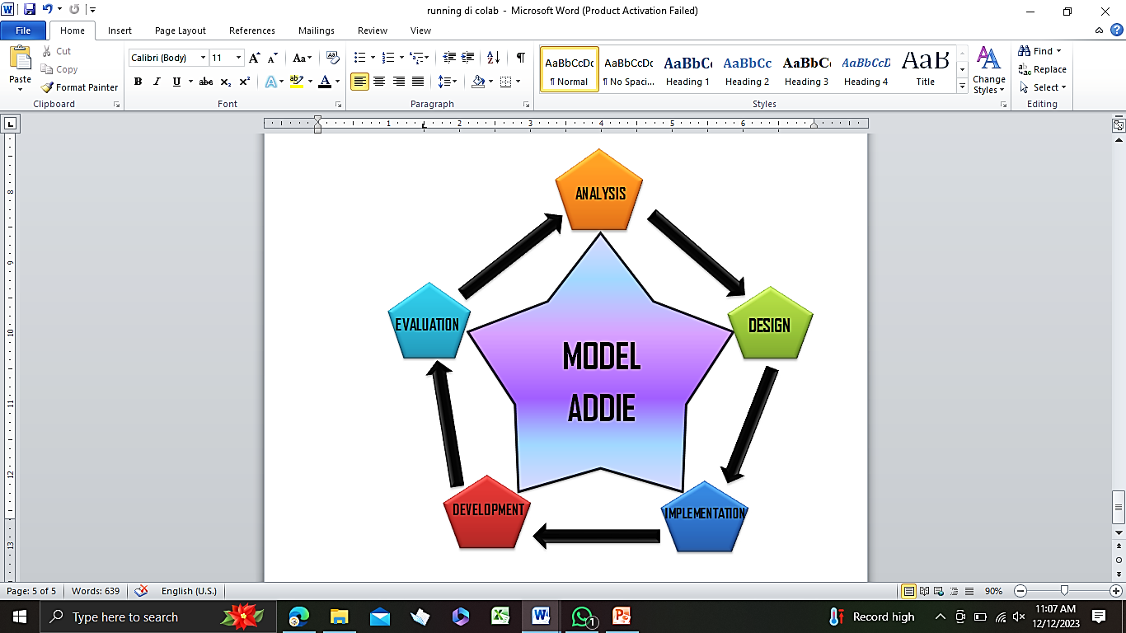

In the development model, Borg and Gall contains a systematic guide to the steps taken by researchers so that the product they design has appropriateness standards.

Thus, what is needed in this development is a reference regarding the procedures for the product to be developed. A description of the Borg and Gall development model is explained as follows; Educational research and development (R&D) is the process used to develop and validate educational products. The steps of this process are usually referred to as the R&D cycle, which consists of studying research findings related to the product to be developed, developing the product based on the findings, field testing it in the setting where it will ultimately be used, and revising it to correct deficiencies found in field testing stage. In demonstrating the product meets behaviorally determined goals. (Borg & Gall, 1983:772).

From the results of the research stage, information collection and analysis stage of learning descriptions, learning objectives require clear specifics with the involvement of learning in learning because it will grow students' skills indirectly. Next, the specific application design used in blended e-learning is presented as the input stage. The development stage can be used to guide the selection of material that will be presented in learning on digital-based applications that can be easily conveyed to students. The implementation stage requires product trials of learning applications that are used after validation by experts, teachers, then the material, activities and students are combined to use blended learning in digital-based learning applications obtained from the development results. The learning media in blended learning will then be evaluated in terms of suitability and ease of use.

**Results and Discussion**

Measuring By detailing the discussion stages, it will provide a deeper understanding of the problem context and potential solutions proposed through the development of interactive blended learning.

**Description of Design Phase Results**

In the design stage, researchers designed blended learning in specific competencies by explaining the ability to use infrastructure in distance learning, creativity in designing applications, and evaluation skills for learning application media. The design of the curriculum includes paperless learning, development of learning applications, and evaluation of digital learning application media by determining the distribution of materials and activities according to the applications used. In developing interactive learning materials, guiding students and providing tutorials to design learning applications using WhatsApp, Zoom, Google Meet and Google Classroom. The development of blended learning in interactive learning activities encourages students to integrate projects or assignments that allow students to apply their knowledge creatively. Determine assessment methods to measure understanding and application of specific competencies and design formative and summative evaluations that enable students to evaluate digital learning application media. Supporting resources such as video tutorials, user guides, or webinars will be able to help students achieve specific competencies and determine ways of interaction between students and instructors and students that support the exchange of ideas or guidance in application development. Discussion forum facilities or collaboration groups in learning platforms to support the exchange of ideas and experiences are also very necessary, through the good use of technology it is very necessary to teach students how to use technology ethically and effectively in the learning context. Monitoring and providing feedback will ensure that students can overcome obstacles and understand concepts well, creating an interesting blended learning experience that meets students' needs and achieves the specific competencies they desire.

**Description of Development Results**

In the development stage, researchers have taken several key steps to create interactive blended learning tools. The following is a description of the results of the development that has been carried out:

Learning Tool Design:

Researchers designed lecture units and semester learning plans based on interactive blended learning. It includes details about learning materials, teaching methods, activities, and assessments.

Lecture units are designed to take into account students' needs in dealing with distance learning and create an interesting learning experience.

Textbooks:

Researchers compiled textbooks that included the learning materials required for each session. This textbook can be digital or printed, according to student needs.

Textbooks are designed to be easy to understand, well structured, and support active and interactive learning.

Learning Device Validation:

Researchers carry out a validation process for the learning tools that have been developed. Validation is carried out by one or several validators who have expertise in the fields of education and learning technology.

The validation process involves assessing the suitability, clarity, and relevance of learning tools to the stated learning objectives.

Optimization Based on Validator Feedback:

After receiving feedback from validators, researchers optimized the learning tools. This may involve adjusting content, structure, or learning methods based on recommendations from validators.

The aim is to improve the quality of learning devices so that they comply with standards and meet student needs.

Readability and Accessibility Testing:

Researchers can also test the readability of textbooks and the accessibility of digital learning materials. This aims to ensure that the material can be accessed easily by students from various backgrounds.

The results of this development create a solid foundation for the implementation of interactive blended learning, with learning tools that have been designed to support student needs and achieve the desired specific competencies. In addition, validation by external parties such as validators helps ensure the quality and effectiveness of the learning tools.

**Learning Device Validation Results**

In this research, the validation process was carried out for one week with validators who were competent and understood the content of the material, learning design and learning media. Validation of course content Validator assessment becomes a guide for necessary follow-up, including material revision, format adjustments, and improving learning strategies. Further validation is also recommended to ensure that the learning tools meet the desired needs and standards. Determination of indicators with material, Determination of learning objectives, Accuracy of material and objectives and so on. The assessment results are briefly presented in Table 1 as follows:

Table 1. Learning Device Validation Results

|  |  |  |
| --- | --- | --- |
| **No** | **Criteria** | **Value Score** |
|  | Ease of indicators from KD and KI | 5 |
|  | Ease of indicators with learning materials | 5 |
|  | Accuracy of deep learning objectives | 5 |
|  | Ease of material with purpose | 5 |
|  | Ease of presenting material | 4 |
|  | Material completeness | 5 |
|  | Clarity of concepts of subject matter | 4 |
|  | Suitability of evaluation and learning objectives or indicators | 5 |
|  | Suitability of question/test tools | 4 |
|  | Clarity of subjects with the time provided | 4 |
|  |  | **46** |

The percentage of interactive blended learning achievement levels in courses, development of interactive blended learning student learning media is 92%, meaning that interactive blended learning is in the very good category, so interactive blended learning does not need to be revised. However, course content experts also provide suggestions for further development of the material and media for development of other materials.

**Validation of Learning Design**

The validator's assessment of the learning design includes several aspects, namely the attractiveness of the physical appearance of interactive blended learning in history and sociology, the balance of the color scheme, the correctness of the instructions for using interactive blended learning in history and sociology, the ease of use of the material presentation design and so on.

The assessment results are briefly presented in Table 2 as follows:

Table 2. Learning Design Validation Results

|  |  |  |
| --- | --- | --- |
| **No** | **Criteria** | **Value Score** |
|  | Suitability of interactive blended e-learning design | 5 |
|  | Balance of digital-based learning media | 4 |
|  | Easy instructions for using interactive blended e-learning in the application | 5 |
|  | Ease of use of e-learning application design | 4 |
|  | Clarity of presentation of material in the application | 4 |
|  | Suitability of material to learning indicators | 4 |
|  | Suitability of e-learning based textbooks | 4 |
|  | Suitability of time duration and target characteristics | 4 |
|  | Appropriate placement of parts in the material | 5 |
|  | Suitability of digital-based evaluation and objectives | 5 |
|  |  | 44 |

Based on the assessment of learning design experts as stated in the table above, the percentage of interactive blended learning achievement level can be calculated, namely the percentage of interactive blended learning achievement is 88.00%. This means that interactive blended learning is in the good category so that interactive blended e-learning does not need to be revised

**Validation of Learning Media**

The validation assessment of learning media includes several aspects, namely the suitability of the media for the purpose, the suitability of the media for the students, the accuracy of the interactive blended learning display, the aesthetic value of using paperless-based interactive blended e-learning.

The assessment results are briefly presented in Table 3 as follows:

Table 3. Learning Media Validation Results

|  |  |  |
| --- | --- | --- |
| **No** | **Criteria** | **Value Score** |
|  | Suitability of digital-based learning media | 5 |
|  | Suitability of blended e-learning media | 4 |
|  | Accuracy of interactive blended e-learning media display | 4 |
|  | The aesthetic value of using materials in digital learning | 5 |
|  | The quality of the display of digital applications that contain interactive blended e-learning | 4 |
|  | Conformity of material with text according to EYD | 4 |
|  | Ease of material for students in e-learning | 5 |
|  | Quality interactive blended e-learning applications | 4 |
|  | Smooth use of interactive blended e-learning applications | 4 |
|  | Fluency in using the Google site in interactive blended elearning | 5 |
|  | Color balance of interactive e-learning blended media | 4 |
|  | Unity of digital use in blended interactive e-learning | 4 |
|  |  | 56 |

Based on the assessment of learning media experts as stated in the table above, it can be calculated that the percentage of Learning Media Validation is 88.00%. The level of achievement of interactive blended e-learning is as follows:

Table 4. Testing Table

|  |  |  |
| --- | --- | --- |
| **No.** | **Name** | **Value Score** |
| 1 | Student 1 | 80 |
| 2 | Student 2 | 80 |
| 3 | Student 3 | 80 |
| 4 | Student 4 | 70 |
| 5 | Student 5 | 80 |
| 6 | Student 6 | 70 |
| 7 | Student 7 | 80 |
| 8 | Student 8 | 80 |
| 9 | Student 9 | 70 |
| 10 | Student 10 | 70 |
|  |  | 780 |

Determines the percentage achievement category value

= > 80 "Good"

= < 70 "Enough"

**Learning Device Validation Application Data**

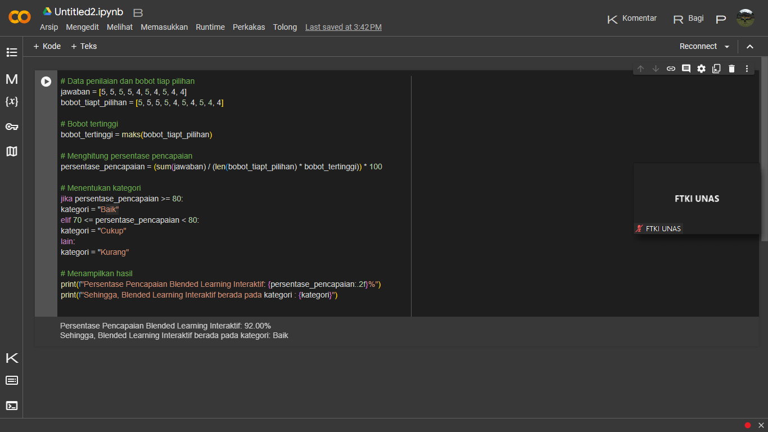Below is a picture of the application data in the results. The percentage of interactive blended learning achievement levels in courses, the development of interactive blended learning student learning media is 92%.

**Learning Design Validation Application Data**

The percentage of achievement of interactive blended e-learning is 92.00%. This means that interactive blended learning is in the good category so that interactive blended e-learning does not need to be revised.

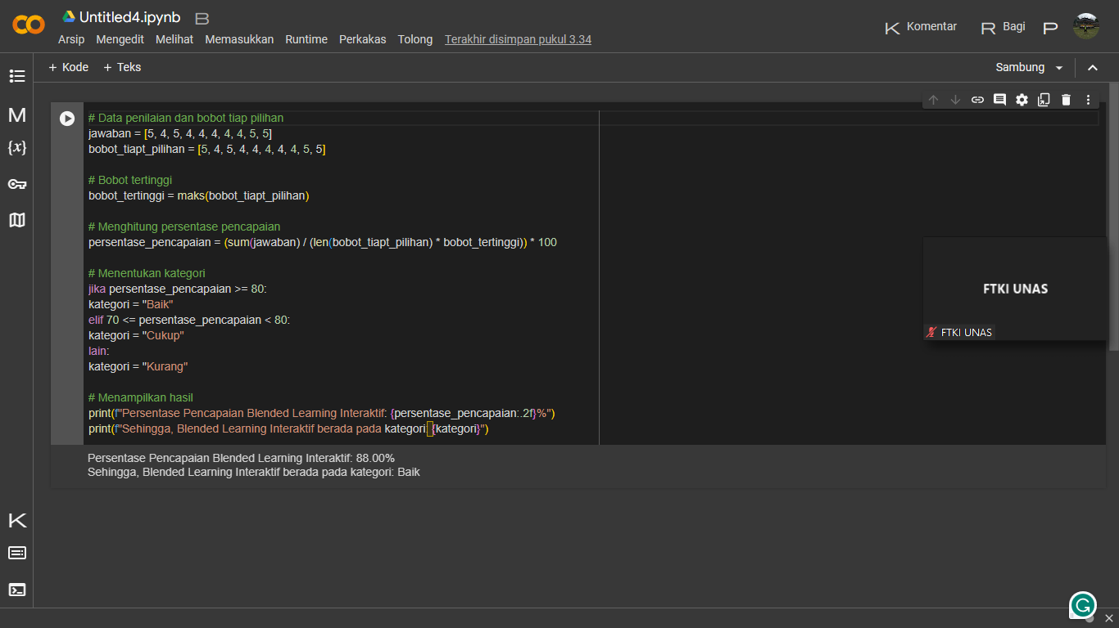

**Learning Media Validation Application Data**

Based on the assessment of learning media experts as stated in the table above, it can be calculated that the percentage of Learning Media Validation is 87.69%.

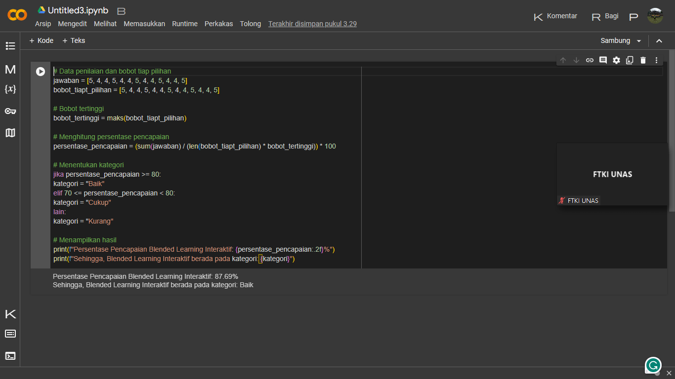

**Test Table Application Data**

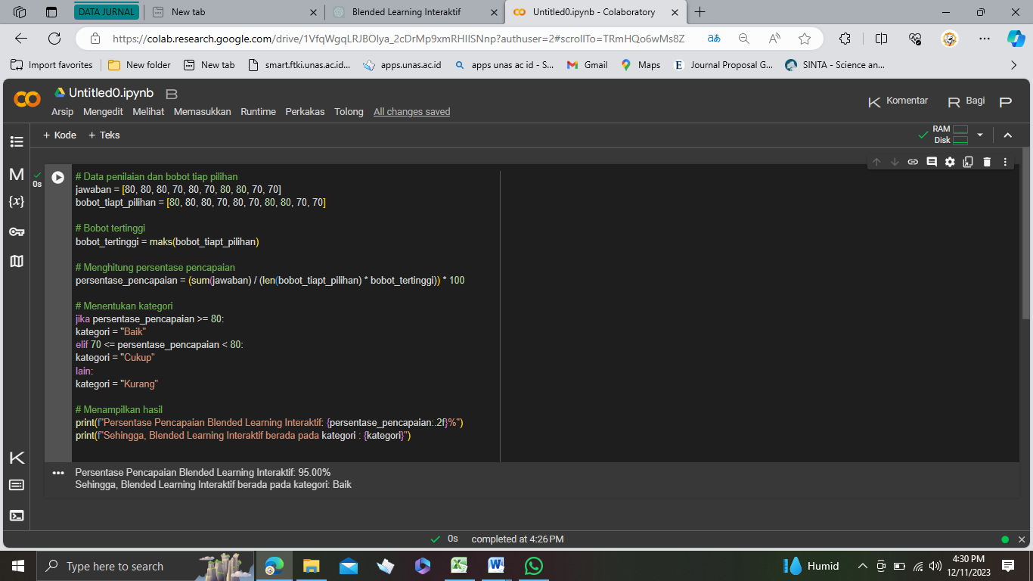Calculations on the application of data that have been carried out on test results with the presentation of Determining the category achievement. Percentage category value = > 80 "Good" and = < 70 "Fair" is 95.00%.

**Conclusions**

Based on the results of this research, interactive blended e-learning was developed based on the design (storyboard). The validity of interactive blended learning is: (1) according to expert reviews the content metrics show a good category (92%), (2) according to a review of learning design experts it is in the good category (88%), (3) according to a review of learning media experts it shows a good category (86%), (4) based on the results of individual trials, it shows the good category (95%). Thus, this interactive blended elearning does not need to be revised and can be used for further research.

**ORCID:**

[](https://orcid.org/0000-xxxx-xxxx-867X)[](https://orcid.org/0000-0001-8028-8400)**Dedi Untoroseto**  <https://orcid.org/0000-0001-8028-8400>

**Agung Triayudi** <https://orcid.org/0000-xxxx-xxxx-867X>

**References**

Abdullah, W. (2018). Model blended learning dalam meningkatkan efektifitas pembelajaran. *Fikrotuna: Jurnal Pendidikan dan Manajemen Islam*, *7*(1), 855-866. Retrieved from <https://neliti.com>.

Astuti, P., & Febrian, F. (2019). Blended learning: Studi efektivitas pengembangan konten e-learning di perguruan tinggi. *Jurnal Tatsqif*, *17*(1), 104-119. <https://doi.org/10.20414/jtq.v17i1.972>.

Borg, W.R., & Gall, D. (1983). *Penelitian Pendidikan.* Longman, New York. <https://doi.org/10.13140/RG.2.2.19276.26247>.

Febrian, F., & Fera, M. (2019). Kualitas perangkat dan keterampilan mengajar mahasiswa pendidikan matematika pada mata kuliah micro teaching menggunakan analisis model rasch. *Jurnal Gantang*, *4*(1), 87-95. DOI: <https://doi.org/10.31629/jg.v4i1.1065>.

Gunawan, G., Sahidu, H., Susilawati, S., Harjono, A., & Herayanti, L. (2019, December). Learning management system with Moodle to enhance creativity of candidate physics teacher. In *Journal of Physics: Conference Series* (Vol. 1417, No. 1, p. 012078). IOP Publishing. <https://doi.org/10.1088/1742-6596/1417/1/012078>.

Miswanto, M., Lubis, Z., Arjani, N., & Irawan, M. (2023). Desain dan Uji Kelayakan Modul Elektronik Berbasis Higher Order Thinking Skills (HOTs) di Era Hybrid Learning. DOI: <http://dx.doi.org/10.4108/eai.24-11-2022.2332609>.

Rachmadtullah, R., Yustitia, V., Setiawan, B., Fanny, A. M., Pramulia, P., Susiloningsih, W., ... & Ardhian, T. (2020). The challenge of elementary school teachers to encounter superior generation in the 4.0 industrial revolution: Study literature. *International Journal of Scientific & Technology Research*, *9*(4), 1879-1882.

Santi, A. (2022). Analisis Penerapan Blended Learning Pada Mata Kuliah Ekonomi Pembangunan Di Era New Normal. *JPEKA: Jurnal Pendidikan Ekonomi, Manajemen dan Keuangan*, *6*(2), 65-78. DOI: <https://doi.org/10.26740/jpeka.v6n2.p65-78>.

Santi, A. (2022). Analisis Penerapan Blended Learning Pada Mata Kuliah Ekonomi Pembangunan Di Era New Normal. *JPEKA: Jurnal Pendidikan Ekonomi, Manajemen dan Keuangan*, *6*(2), 65-78. <https://doi.org/0.26740/jpeka.v6n2.p65-78>.

Saputra, N., Hikmah, N., Yustitia, V., Saputra, M., Wahab, A., & Junaedi, J. (2021). Implementation of Online Learning Using Online Media, During the Covid 19 Pandemic. *Budapest International Research and Critics Institute (BIRCI-Journal): Humanities and Social Sciences*, *4*(2), 1802-1808.

Setiani, P. P., & Novariyanto, R. A. (2021). Pengembangan Blended Learning Interaktif Pada Pembelajaran Jarak Jauh Mata Kuliah Sejarah Dan Sosiologi. *MENDIDIK: Jurnal Kajian Pendidikan dan Pengajaran*, *7*(2), 252-257.

Shahzad, A., Hassan, R., Aremu, A. Y., Hussain, A., & Lodhi, R. N. (2021). Effects of COVID-19 in E-learning on higher education institution students: the group comparison between male and female. *Quality & quantity*, *55*, 805-826.

Sutisna, M.R., Mulyadi, D., Alinawati, M. (2019). PENGEMBANGAN BLENDED LEARNING DENGAN MODEL FLIPPED CLASSROOM. *PEDAGOGIA Jurnal Ilmu Pendidikan, 17*(2), 120-134. <https://doi.org/10.17509/pdgia.v17i2.17951>.

Zalni, T. Y. (2022). Meta-Analisis Pengaruh Model-Model Pembelajaran Daring Terhadap Hasil Belajar Siswa. *Symbiotic: Journal of Biological Education and Science*, *3*(1), 1-8. <https://doi.org/10.32939/symbiotic.v3i1.48>.

Zebua, E., & Harefa, A. T. (2022). Penerapan Model Pembelajaran Blended learning Dalam Meningkatkan Minat Belajar Siswa. *Educativo: Jurnal Pendidikan*, *1*(1), 251-262. <https://doi.org/:10.56248/educativo.v1i1.35>.