UNIT 4 – Homeostasis / Infectious Disease

* homeostasis is the process by which the body maintains a relatively constant internal environment; it involves a stimulus-response model in which change in external or internal environmental conditions is detected and appropriate responses occur via negative feedback
* organisms have evolved mechanisms for regulating the conditions of their internal environment in response to the external environment
* multicellular organisms have communication systems that integrate & coordinate the activities of their cells. There are two systems of internal communication: hormonal systems (found in plants & animals) & nervous systems (found in animals)
* endotherms = regulating
* endothermic animals generally maintain a higher body temperature independent of the temperature of their environment by internal heat production
* advantages of endothermy include maintain a stable body temperature (cooling and heating the body0, high levels of aerobic metabolism, sustains vigorous activity for much longer than ectotherms such as long distance running or flight
* disadvantage of endothermy is a greater food consumption is needed to meet metabolic needs
* ectotherms = conforming
* ectothermic animals are generally unable to increase their body temperature by internal heat combustion. animals control heat exchange by physiological & behavioral means
* advantages of ectotherm include less of their food is used for cellular respiration, less food is required and the organism may be able to survive for long periods of time without eating and a greater proportion of the energy obtained from food can be used for growth and repair
* disadvantages of ectothermy include being unable to be highly active in cooler temperatures, not capable of activity during winter as they can’t warm up enough, require sufficient body stores of energy to survive over winter without eating, unable to increase cell respiration (metabolism0 rates to generate internal heat
* mechanisms for thermoregulation include:
* insulation – fur, hair, feathers, fat, blubber
* evaporative cooling – sweating, panting and bathing
* shivering
* non-shivering thermogenesis and brown fat
* circulation adaptions – counter current exchange, vasodilation (cooling), vasoconstriction (heat conservation)
* behavioural responses
* physical heat exchange occurs by:
* conduction - transfer of heat between objects in direct contact with each other - results in heat gain or heat loss
* convection - heat is conducted away from an object of high temp to low temp - results in heat gain or heat loss
* radiation - transfers heat between objects not in direct contact - results in heat gain or heat loss
* 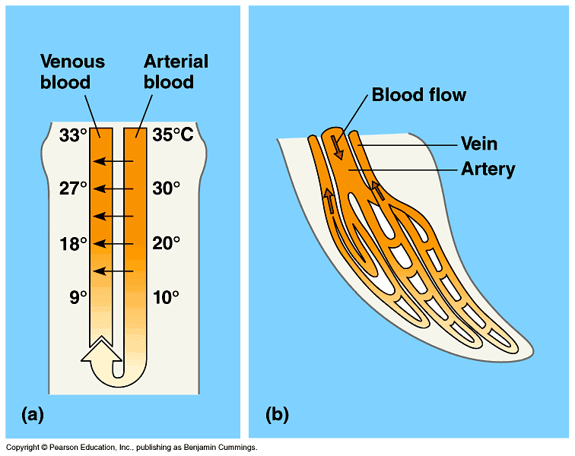evaporation - change of liquid to vapor - results in heat loss only (cooling)
* counter current heat exchange when the blood vessels lie next to one another the blood leaving the heart travelling in the arteries warms the blood at the extremities travelling back to the heart in the veins. heat is exchanged via conduction
* Counter current heat exchange helps to keep the blood at the core warm & the blood at the extremities cooler**.** common in arctic organisms & large marine mammals & sharks
* piloerection = hair/feather/fur follicles are raised via pili muscle trapping a layer of warm air at the skin surface
* sweating = sweat glands are stimulated via nerve impulses to release sweat via pore at the surface of the skin. as sweat evaporates it provides a cooling effect
* brown fat = generates heat. important in neonates, small mammals in cold environments, and animals that hibernate, located in neck and in inner scapula area
* non-shivering thermogenesis = large amounts of heat produced by oxidizing fatty acids in the mitochondria
* Circulation adaptations;
  + countercurrent heat exchange
  + lack fur/feathers to enable quick exchange of heat between blood & skin
  + vasoconstriction & vasodilation to alter blood flow to the extremities.
* Behavioral responses;
  + periods of inactivity
  + positioning in best location to absorb heat (sun, hot rock) or loose heat (shade, cool rock)
* Physiological responses;
  + cells contain antifreeze (cryoprotectant) to prevent freezing
* homeotherms = organisms that maintain a relatively constant temperature.
* poikilotherms = organisms that cannot control a constant temperature, it fluctuates with the environment.
* changes in an organism’s thermoregulatory mechanisms include structural features, behavioural responses and physiological mechanisms to control heat exchange and metabolic activity; animals can be endothermic or ectothermic
* metabolic activity, in addition to structural features and changes in physiological processes and behaviour, enable the organism to maintain its internal environment within tolerance limits (temperature, nitrogenous waste, water, salts, and gases)
* nitrogenous wastes are removed from the cell to prevent them becoming toxic. the first nitrogenous waste formed from the breakdown of protein is ammonia, which may be then converted into urea or uric acid.
* The proportions of ammonia, urea or uric acid excreted in different groups of animals are related to:
* the availability of water in the animal’s environment
* the toxicity of the nitrogenous waste
* the energy cost in producing the nitrogenous waste
* the pattern of species development (i.e. embryo develops in an egg/aquatic/terrestrial/dry habitat etc).

|  |  |  |  |  |
| --- | --- | --- | --- | --- |
| waste | advantages | disadvantages | habitat | excreted by |
| ammonia | produced with little energy | toxic in concentrated solution, must be excreted in lots of water | water | marine and fresh water invertebrates, bony fish, amphibian larvae and crocodiles |
| urea | less toxic than ammonia, less water needed to excrete it | requires moderate energy to produce it | land / sea | adult amphibians, turtles, mammals and bony fish |
| uric acid | very little water is excreted with it | requires considerable energy to produce it | land | reptiles, birds, insects and land gastro pods |

* the type of nitrogenous waste produced by different vertebrate groups can be related to the availability of water in the environment
* animals have a variety of behavioural, physiological and structural adaptations to maintain water and salt balance in terrestrial and aquatic environments
* to maintain water balance and allow for gas exchange, xerophytes and halophytes have a variety of structural and physiological adaptations
* *Kidney functions;*

1. Fluid balance
2. Salt balance
3. Removal of wastes (especially urea, ammonia)
4. pH balance

* *Water Reabsorption;*
* 60-70 % of water reabsorption occurs in the proximal convolute tubule (PCT)
* remaining 30-40 % is selectively reabsorbed in the loop of Henle, distal convolute tubule (DCT) & collecting duct
* Removal of Wastes;
* urine formation
* 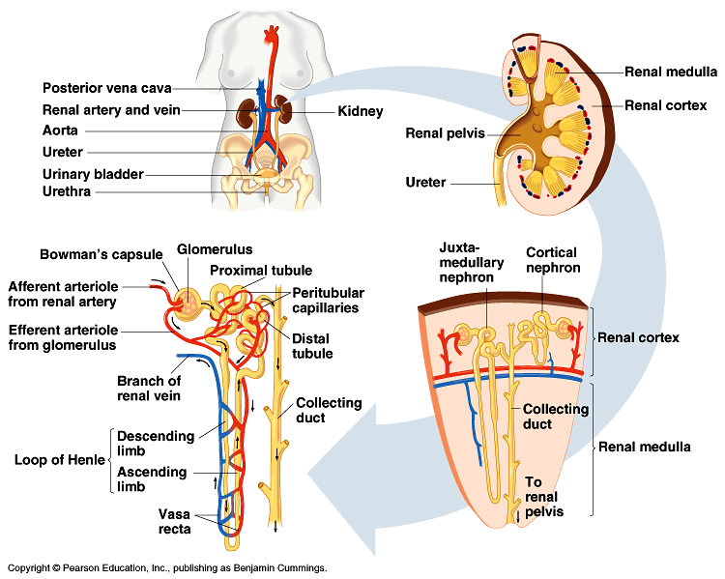nitrogenous wastes, ions, toxic substances filtered out of blood stream & into urine for excretion
* osmoregulation = the control of the concentration of body fluids.
* diffusion = movement of substance from an area of greater concentration to an area of lower concentration
* osmosis = diffusion of water through a semipermeable membrane
* water inputs = drinking, water gained from food, water as a waste product via metabolism (chemical reactions)
* water outputs = urine, faeces, sweat, respiratory surfaces
* balancing water and salt in terrestrial organisms;
* dependent on habitat environment type (desert, rainforest etc) & availability of water.
* have a range of adaptations to maintain water/salt balance.
* dependent on type of nitrogenous waste (energy & water input)
* excretory organs highly specialized to conserve water
* Balancing water and salt in aquatic organisms;
* dependent on habitat – fresh water or salt water
* respiratory & excretory organs specialized to maintain water/salt balance
* adaptions to dry environments include many animals don’t drink water, have long loops of Henle in the nephrons of the kidneys
* viruses
* small in size
* non-living
* protein coat and contains nucleic acid
* can’t function or reproduce outside a host cell
* affects include reproducing in the cell resulting in killing the tissue, disrupt the immune system, damaging particular organs depending on the type of virus
* bacteria
* larger in size
* living
* comprise of a cell wall, cell membrane, DNA and a circular plasmid
* reproduce via binary fission within or outside the host
* may produce a dormant spore that can remain within the soil for a number of years before entering a host & reproducing
* divide rapidly resulting in damaging tissues, producing toxins which disrupt cell functions, interfere or damage the host’s immune system
* infectious disease differs from other disease in that it is caused by invasion by a pathogen and can be transmitted from one host to another
* zoonoses, such as influenza, can be transmitted between vertebrate species
* the major groups of organisms that cause disease are bacteria, fungi, protists and viruses; each group can be distinguished by its structural characteristics
* diseases caused by these major pathogen groups include
* tuberculosis, tetanus, crown gall of plants
* chytridiomycosis (amphibian chytrid fungus disease)
* malaria, Phytophthora dieback (jarrah dieback)*
* influenza, Ross River virus, viral diseases of honeybees, Australian bat lyssavirus
* types of direct transmission

1. person to person
2. droplet spread

* types of in direct transmission

1. airborne transmission
2. contaminated objects
3. food and drinking water
4. animal to person contact
5. animal reservoirs
6. insect bites (vector borne)
7. environmental reservoirs

|  |  |  |  |  |
| --- | --- | --- | --- | --- |
| disease | type of organism causing the disease | mode of transmission | type of organisms affected by the disease | symptoms |
| grown gall | bacteria | direct contact via a wound on the roots | stone fruit plants & ornamentals | galls form on the crown of plants & on the roots, stunted growth & dry leaves |
| chytridiomycosis | fungi | direct contact between frogs, spores infecting water | frogs | scales/peeling skin, rigidity – lack of movement, lethargic – splayed back legs |
| honey bee VD | virus | direct via sacs bursting & spreading through larvae | honey bees | lose hair & body turns black, deformed wings – unable to fly |

* the life cycle of a pathogen and its associated diseases, including the method of invading the host, the impact on the host, and the mode of transmission (direct or indirect), determines its success for survival
* the spread of a specific disease involves a range of interrelated factors, including
* growth of the pathogen population
* density of the host population
* mode of transmission
* transmission and spread of disease is facilitated by regional and global movement of organisms
* the distribution of mosquito-borne diseases may be affected by global climatic changes
* many pathogens evolve rapidly in a changing environment
* herd immunity = the resistance to the spread of a contagious disease within a population that results if a sufficiently high proportion of individuals are immune to the disease, especially through vaccination
* management strategies are used to control the spread of infectious diseases, including
* quarantine
* immunisation – herd immunity
* disruption of pathogen life cycle
* medications – antibiotics and antivirals
* physical preventative measures
* *The Phylum Oomycota containing Phytophthora dieback has been removed from the Fungi Kingdom and placed in the Protista Kingdom

UNIT 4 – key point syllabus notes

* susceptibility of urban areas to epidemics and pandemics of infectious disease can be due to population density, variation in living conditions and healthcare provisions
* contemporary models can project the spread of disease and simulate the effects of possible interventions. Supercomputing has enabled models to predict the relationships between epidemic frequency and location, and factors such as population size, environmental change, persistence and antibiotic resistance
* international cooperation and communication are needed to evaluate the risk of the spread of disease, including the emergence of new viral diseases
* quarantine measures protect Australia’s agriculture industry and environment against the influx of disease-carrying materials and organisms in the face of increasing global trade and travel