**BIOLOGY – ATAR – UNIT 3 & 4**

**REVISION QUESTIONS**

**Name:**

**SET 1 – MULTIPLE CHOICE**

**Multiple-choice**

1. Enzymes are specialised proteins that increase the rate of biological reactions by

(a) breaking down complex substrates.

(b) acting on specific molecules.

(c) having a functional active site.

(d) lowering the activation energy.

2. Which of the following statements best describes a pathogen?

(a) A micro-organism that is able to be transmitted from one organism to the next.

(b) An organism that lives within a host, causing disease.

(c) A prokaryotic organism that infects eukaryotic organisms by evading their immune system.

(d) An agent that causes disease through infection between host organisms.

3. Which of the following homeostatic activities represent negative-feedback mechanisms?

(a) Labour, fever and gas-exchange.

(b) Water balance, gas-exchange and thermoregulation.

(c) Blood-glucose levels, thermoregulation and fever.

(d) Fever, lactation and water balance.

4. Malaria is a highly infectious disease caused by a pathogen from the *Plasmodium* genus. Malaria is transmitted through the bite of a female *Anopheles* mosquito. An effective immunisation program to prevent infection with Malaria has not been developed because

(a) it has a complex life-cycle that involves both host and vector.

(b) it produces a toxin that is unable to be eliminated by vaccine or other pharmaceuticals.

(c) the treatments available for infected persons are extremely effective and inexpensive.

(d) scientists have been unable to collect the *Plasmodium* pathogen from the host’s blood as it is rapidly destroyed by liver cells following infection.

**Questions 5 to 7 relate to the diagram below.**

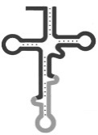

**S**

**Q**

G U U

Leu

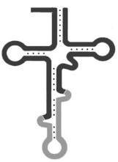

GluN

Leu

Gly

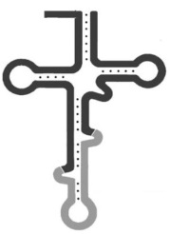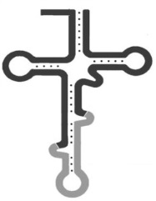

**T**

**R**

A A U

C C A

G A U

C A A

U G U

U U A

G G U

C U A

|  |  |  |  |  |  |  |  |  |  |  |  |  |  |  |  |
| --- | --- | --- | --- | --- | --- | --- | --- | --- | --- | --- | --- | --- | --- | --- | --- |
| 5’ |  |  |  |  |  |  |  |  |  |  |  |  |  |  | 3’ |

5. Which cellular process is represented in this diagram?

(a) Phosphorylation

(b) Transcription

(c) Replication

(d) Translation

6. What are the structures labelled Q, R, S and T, respectively?

(a) tRNA, ribosome, codon, anticodon

(b) mRNA, DNA polymerase, codon, DNA

(c) Amino acid, anticodon, tRNA, codon

(d) Nucleotide, codon, mRNA, DNA

7. In which organelle does this process occur?

(a) Nucleus

(b) Ribosome

(c) Endoplasmic Reticulum

(d) Mitochondria

8. The genetic code provides evidence that all organisms on the planet have a common ancestor. This is because all organisms

(a) carry the same mitochondrial DNA.

(b) past and present, carry the same nitrogenous bases in their DNA that code for the same amino acids.

(c) reproduce in the same manner.

(d) possess the exact same number of chromosomes and genes as each other.

9. Intraspecific variation refers to the

(a) phenotypic variation between individuals of the same species.

(b) genotypic variation between individuals of the same species.

(c) genotypic variation between organisms of different species.

(d) phenotypic variation amongst species of the same genus.

10. It has been suggested that the use of transgenic organisms in agriculture may have negative effects on the surrounding native flora and fauna. The most likely reason is that

(a) it may increase their resistance to disease.

(b) the altered genes could be transferred by viral or bacterial vectors to native organisms.

(c) native animals may feed on the transgenic crops and become ill.

(d) they may become invasive to the surrounding natural ecosystem.

11. Which of the following terms best represents a genotype that can be determined by more than two alleles?

(a) Polygenic inheritance

(b) Polygenic alleles

(c) Quantitative alleles

(d) Multiple alleles

12. Scientists use a molecular tool to find specific alleles in a person’s DNA. This is called a

(a) genetic sequencer.

(b) gene probe.

(c) plasmid.

(d) restriction enzyme.

13. The Bottleneck effect can be detrimental to the survival of a species because

(a) recessive alleles are removed from the gene pool creating a phenotypically dominant trait structure within the population.

(b) the gene pool is permanently reduced.

(c) individuals are no longer able to reproduce successfully with each other causing species extinction.

(d) genetic diversity within the population is increased creating more competition for resources amongst individuals.

**Questions 14 and 15 relate to the information given below.**

A scientist was investigating the inheritance of colour in capsicums. She used Mendelian methodology to cross plants with red fruit and plants with purple fruit. She successfully grew capsicums through to the F2 generation. The data collected revealed that 100% of the plants in the F1 generation produced red fruit. In the F2 generation, 75% of the plants had red fruit while the remaining 25% had purple fruit.

14. What can the scientist conclude about the original parent plants from the data collected?

(a) Red fruit is the dominant trait and the genotype of both parent plants is heterozygous.

(b) Purple fruit is the recessive trait and the genotype of the parent plants is homozygous.

(c) Purple fruit is the dominant trait and the genotype of both parent plants is homozygous.

(d) Red fruit is the recessive trait and the genotype of both parent plants is heterozygous.

15. During the investigation, the scientist noticed that purple fruit had thicker flesh than red fruit. What is the best explanation for this phenomenon?

(a) Both traits are recessive and transmitted independently of each other.

(b) The occurrence of thick flesh in the purple fruit is merely coincidental and more research should be undertaken before a solid conclusion can be made.

(c) The inheritance of purple fruit and thick flesh is an example of a monohybrid cross from independent assortment of alleles.

(d) The inheritance of purple fruit and thick flesh is an example of a dihybrid cross with linked alleles.

16. A zoonotic disease is best described as a disease that

(a) has only been found within the confines of a zoo.

(b) requires a host to complete its lifecycle.

(c) only affects organisms within Kingdom Animalia.

(d) can be transmitted between animals and humans.

17. Different animals maintain their body temperatures in a variety of ways. Which of the following best describes an animal that is an **ectotherm**?

(a) An emu living in the Simpson Desert.

(b) A tuna that can dive to great depths.

(c) A polar bear hibernating over the winter months.

(d) A green tree frog living in a temperate forest.

The following diagram represents a nephron from a human kidney.

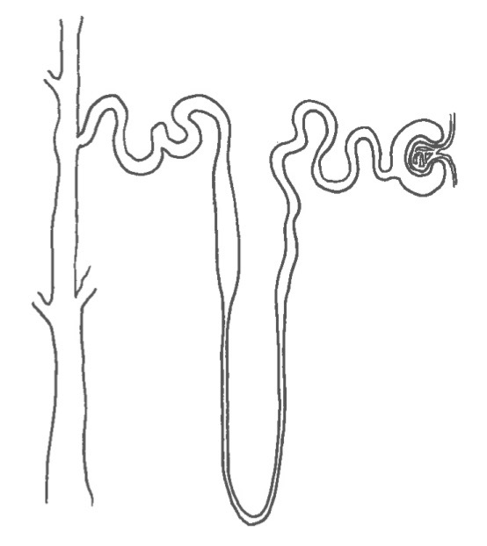

18. Which of the following statements correctly describes how the nephron of a desert marsupial is different?

(a) The loop of Henle is very long to increase the reabsorption of water.

(b) The glomerulus is smaller to decrease the amount of fluid entering the Bowman’s capsule.

(c) The loop of Henle is much shorter to stop sodium and urea from being lost in the urine.

(d) The distal convoluted tubule is reduced in order reduce amount of water reabsorbed.

Questions 19 to 21 relate to the information below.

Genetic scientists discovered a new variant to an otherwise harmless plant virus. This new variant is the result of exposure to an enzyme produced by the virus itself. Infected plants have misshapen stomata, which prevents the pores from opening properly. The scientists concluded that when mRNA is being transcribed along the affected gene, **adenine** is being read as **cytosine**.

19. What type of mutation does this virus variant cause?

(a) Frameshift mutation

(b) Missense mutation

(c) Nonsense mutation

(d) Substitution mutation

The original DNA template strand for a section of the variant gene is shown below.

AAC TGA TTC CGC CAT

20. What would the resultant mRNA molecule read for the mutated gene?

(a) UUU ACU AAG GCG GUA

(b) GGG ACG AAG GCG GGA

(c) UUG AAU AAG GAG GUA

(d) CCG ACC AAG GCG GCA

21. What would be the most direct effect of misshapen stomata to an infected plant?

(a) Photosynthesis would not occur properly, stunting plant growth.

(b) Energy would not be released to fuel metabolic activities.

(c) Transpiration would be reduced resulting in flaccid leaf cells.

(d) Xylem cells would lose their structural integrity causing the plant to wilt.

22. The mosquito borne Zika virus has rapidly spread throughout South America, causing severe illness and malformation of unborn babies. Which of the following control measures should be used to reduce the connection between the source of infection and susceptible individuals?

(a) Quarantine infected individuals and carriers of the disease.

(b) Destroy the animal reservoir of infection.

(c) Treat sewage to reduce the spread of disease through contaminated water.

(d) Destroy vectors through widespread spraying of insecticides.

**Questions 23 and 24 refer to the information and diagram below.**

The Schumann family has been in Australia for three generations. The great grandfather Amos and his father immigrated to Australia from Poland in 1947. In every generation of Schumanns born from this time, at least one member has inherited a genetic disease. As they have no family records before 1947, the origin of the disease cannot be easily identified. Amos attempted to construct a pedigree chart with all members of his family. *Individuals known to be affected are shaded grey. Deceased family members have a line through them.*

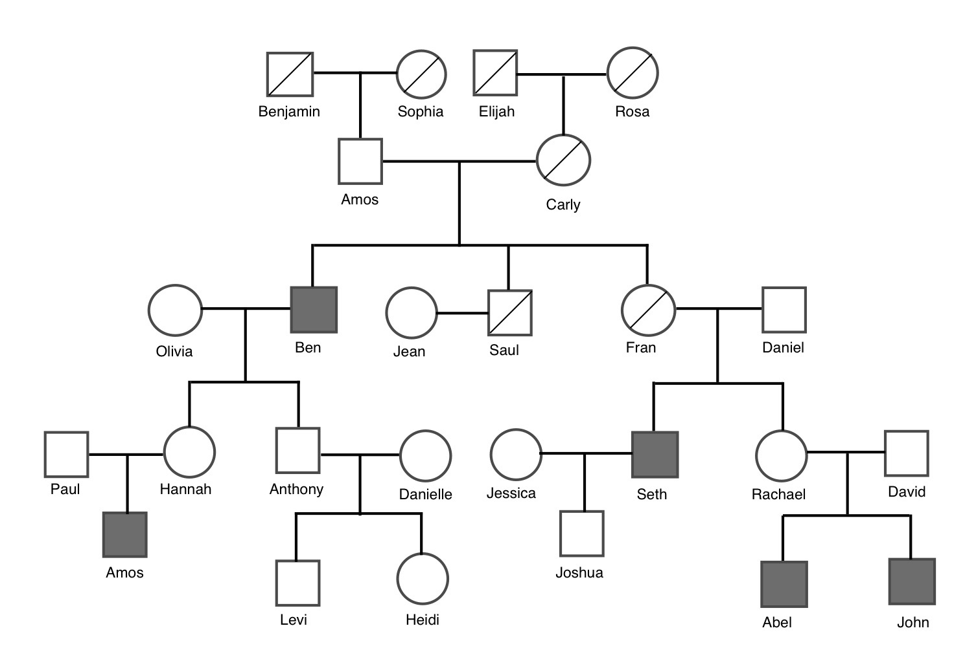

23.

What type of inheritance pattern does this pedigree reveal?

(a) Autosomal recessive

(b) X-linked dominant

(c) Autosomal dominant

(d) X-linked recessive

24. Amos was devastated when the son of his favourite grandchild, also named Amos, was born with the disease. He became convinced that he was responsible for bringing the disease into the family through his ancestors. His son Benjamin researched inherited diseases and concluded that his father was incorrect; the disease must have been passed down from his mother’s side. The main reason for his conclusion is that

(a) the disease can be inherited from unaffected parents with a heterozygous genotype.

(b) all daughters of the affected males must inherit the disease.

(c) each affected person must have at least one affected parent.

(d) affected males cannot pass on the disease to their male offspring.

Natural selection favours phenotypes that are most successful in their environment. There are three main types of natural selection that are shown in the graphs below.

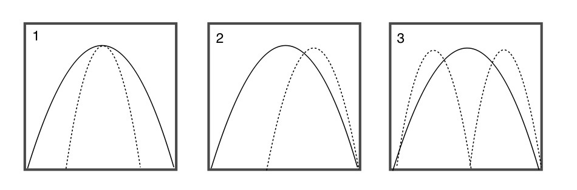

25. Which graph best represents a population that could lead to the formation of a new species?

(a) 1

(b) 2

(c) 3

(d) Both 2 and 3

26. When an enzyme becomes denatured it can no longer act as a biological catalyst. This is because

(a) the tertiary structure unravels when the bonds are broken.

(b) the peptide bonds are broken releasing amino acids into the cytosol.

(c) the protein dissolves.

(d) it can no longer react with specific molecules.

27. Australia’s quarantine measures for international trade are more effective than some other countries around the world. This is most likely attributed to Australia’s

(a) strict screening of imported produce for pests and disease.

(b) geographical isolation.

(c) restriction on international travel of diseased persons.

(d) use of isolation methods for diseased individuals entering the country.

28. In order to maintain water balance and reduce energy consumption, reptiles excrete nitrogenous waste in the form of

(a) ammonia.

(b) urine.

(c) guano.

(d) uric acid.

29. The Amphibian Chytrid Fungus Disease has caused the decline and even extinction of many frog species in Australia. The Chytrid fungus can cause death in amphibians because it

(a) infects a frog’s snout and mouth, making it difficult to breathe.

(b) infects the surface skin layers causing problems with water balance and respiration.

(c) invades a frog’s lungs, reducing the surface area for the diffusion of gases.

(d) causes the over-production of keratin in skin cells, preventing oxygen from permeating into the bloodstream.

30. Common ancestry within Phylum Chordata can be revealed during the embryonic stage with the development of numerous structures, including

(a) webbed phalanges.

(b) pharyngeal slits.

(c) vertebrae.

(d) eye spots.

**SET 1 - SHORT ANSWER**

**Question 31 (20 marks)**

Negative-feedback mechanisms respond to changes in an animal’s internal or external environment to maintain homeostasis. Plants, however, do not contain nervous or endocrine systems to help regulate their internal environment. They must possess specialised adaptations to enable them to survive environmental extremes.

(a) What is the term used to describe plants that are adapted to arid conditions? (1 mark)

(b) Identify **two** different adaptations for water-balance in this plant group and explain how these adaptations enable their survival. (4 marks)

(c) It has been suggested that increased CO2 levels will significantly improve the growth of all plant life by stimulating metabolism. Explain the accuracy of this theory based on your understanding of gas-exchange mechanisms in Australian plants. (3 marks)

(d) Suggest how this theory could be tested experimentally. (2 marks)

Approximately 1.6 million years ago, Australia was undergoing a period of drying and lush forests retreated to the periphery of the continent. Species that adapted to the changing climate may have phylogenetic links to the flora currently inhabiting Australia’s arid environments.

(e) Which biotechnological process could be used to establish the genetic relationship between a fossilised and living plant species? (1 mark)

(f) Outline the main steps in this process. (6 marks)

(g) Explain how the genetic relatedness between two different species is measured using the results from this process. (3 marks)

**Question 32 (20 marks)**

The way in which pathogens are transmitted from one host to another can significantly impact how easily it can spread.

(a) Identify **two** human behaviours that can reduce the risk of contracting or spreading a contagious disease. (2 marks)

(b) Explain why a pathogen, showing latent infection, can have a high degree of infectivity. (2 marks)

(c) Differentiate between the terms endemic, epidemic and pandemic. (3 marks)

The development of vaccines has enabled highly contagious diseases to be eradicated from the global population.

(d) Describe how immunisation programs have been successful in stopping the spread of virulent pathogens. (2 marks)

(e) Explain the concept of ‘herd immunity’. (2 marks)

(f) Explain why herd immunity has been compromised in some communities around Australia. (2 marks)

Bacteria are the most abundant and diverse group of organisms on the planet. Much of their success can be attributed to adaptations and transmission.

(g) Identify **two** adaptive characteristics of bacteria and explain how these characteristics increase a bacteria’s chance of survival. (4 marks)

(h) Outline **three** different ways in which bacteria cause disease. (3 marks)

**Question 33 (20 marks)**

A horse breeder sold a healthy young colt to a well-known trainer and jockey for a large sum of money. The colt was the offspring of a Melbourne Cup winner. The trainer received the appropriate paternity papers when the colt was delivered. The trainer was also told that the colt had three siblings fathered by the same horse.

Two months later, the trainer received information that the horse breeder was under investigation for selling horses under false pretences. The paternity of one the colt’s ‘siblings’ was under investigation. Unfortunately, the champion horse had been shipped overseas for a race and blood samples could not be taken.

(a) Identify **two** types of biological material, other than blood, that could be used to access the father’s DNA. (2 marks)

An insufficient amount of DNA was obtained from the alleged father, and a genetic profile could not be produced in order to compare his DNA with the DNA of his alleged offspring.

(b) Explain how geneticists overcome issues associated with small DNA samples. (2 marks)

(c) Geneticists use areas within the DNA called **short tandem repeats** (STR’s) or **microsatellites** to produce DNA profiles. Define the term **short tandem repeats** and discuss why STR’s are useful in this type of research. (5 marks)

Genetic samples were obtained and processed for each horse. To establish the genetic relatedness of the horses, the geneticist used gel electrophoresis to visualise the DNA.

(d) Outline the process of gel electrophoresis as a method for DNA profiling. (6 marks)

The diagram below displays the comparative DNA of each horse following the gel electrophoresis process.

|  |  |  |  |  |  |  |  |  |
| --- | --- | --- | --- | --- | --- | --- | --- | --- |
| **Father** |  | **Colt** |  | **Sibling 1** |  | **Sibling 2** |  | **Sibling 3** |
|  |  |  |  |  |  |  |  |  |
|  |  |  |  |  |  |  |  |  |
|  |  |  |  |  |  |  |  |  |
|  |  |  |  |  |  |  |  |  |
|  |  |  |  |  |  |  |  |  |
|  |  |  |  |  |  |  |  |  |
|  |  |  |  |  |  |  |  |  |
|  |  |  |  |  |  |  |  |  |
|  |  |  |  |  |  |  |  |  |
|  |  |  |  |  |  |  |  |  |
|  |  |  |  |  |  |  |  |  |
|  |  |  |  |  |  |  |  |  |
|  |  |  |  |  |  |  |  |  |

(e) Identify the order of relatedness, from most to least related, of each horse to the alleged father. (2 marks)

(f) Explain why the horse breeder is guilty of genetic fraud. (3 marks)

____________

**Question 34 (20 marks)**

Research scientists, growing new ‘skin’ for burn victims, discovered a protein that they believe accelerates cell division and growth. The gene that codes for this protein was found in a strain of smallpox previously eradicated from our population. The protein is only effective if the virus gene is integrated into the DNA of the growing skin cells.

(a) Suggest **one** reason why research scientists may have difficulty obtaining ethical permission to carry out trials on humans using these genetically modified cells. (1 mark)

(b) Suggest **one** possible, positive outcome of this research process. (1 mark)

In order to gain permission from the ethics committee, the researchers had to carry out a series of stringent experiments to prove the effectiveness of the protein on skin cell growth. Three different ‘types’ of human skin cells were used in the experiment; skin stem cells, newly differentiated skin cells and mature skin cells. Fifty cell-growth containers, each holding 200mL of nutrient medium, were inoculated with 100 genetically modified cells from each type being tested. The cells were cultured in a temperature-controlled room at 37oC for 20 days. Every two days, the number of live cells present on each agar plate was recorded.

(c) Write a hypothesis for this experiment. (1 mark)

(d) State the independent and dependent variables of this experiment. (2 marks)

(e) State **two** variables that were controlled in the experiment. (2 marks)

The scientists calculated the mean values for the data they collected over the 20-day period. This is presented in the table below.

**Table 1** – *Mean cell numbers of genetically modified skin cells over a 20-day period.*

|  |  |  |  |
| --- | --- | --- | --- |
| **Day** | ***Mean number of cells*** | | |
|  | **Stem** | **Newly differentiated** | **Mature** |
| 0 | 100 | 100 | 100 |
| 2 | 350 | 600 | 150 |
| 4 | 1000 | 1300 | 280 |
| 6 | 2500 | 6100 | 440 |
| 8 | 6000 | 10000 | 630 |
| 10 | 8500 | 15300 | 750 |
| 12 | 12400 | 21200 | 790 |
| 14 | 14100 | 23200 | 920 |
| 16 | 17500 | 23800 | 1140 |
| 18 | 19300 | 24100 | 1340 |
| 20 | 22800 | 24500 | 1480 |

(f) Construct a graph in the space provided to display the data in Table 1. (6 marks)



(g)

What can you conclude from the data presented in your graph? (3 marks)

The ethics committee was presented with a report from the skin cell experiment. To their horror, the researchers were not given permission to proceed with their human trials because the committee decided that their data was invalid. They would have to start their research over with an improved experimental design.

(h) Identify **two** errors in the experimental design and make suggestions as to how these could be resolved. (4 marks)

**Question 35 (20 marks)**

Consider the images of Australian animals shown below.

(i) (ii) (iii)

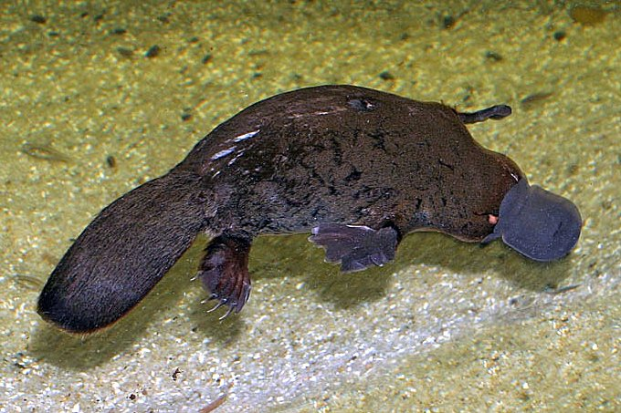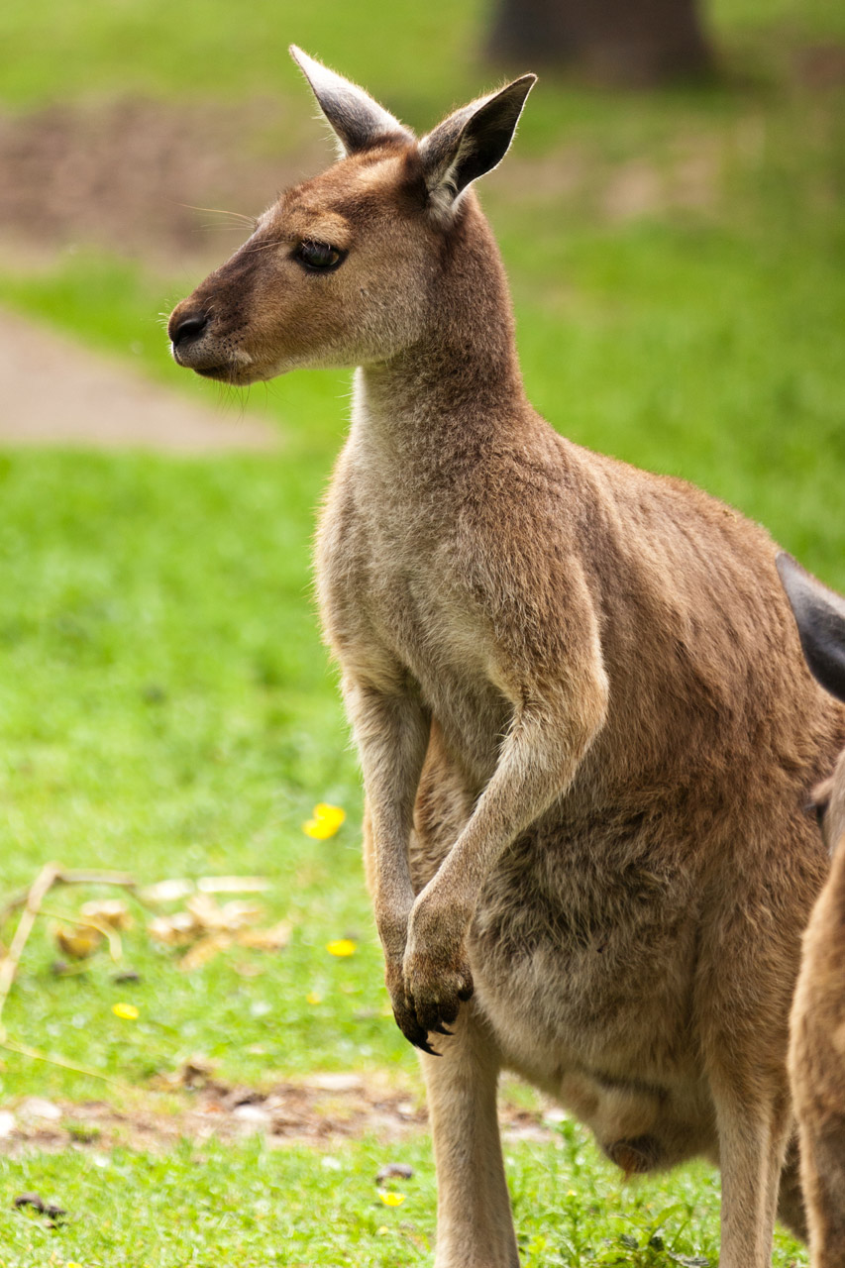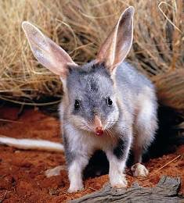

(a) Identify an adaptation for each animal that assists thermoregulation and state whether it is structural, physiological or behavioural (or a combination). (3 marks)

(i)

(ii)

(iii)

(b) Describe how these adaptations enable each animal to maintain its core body temperature. (6 marks)

Counter-current heat exchange is a structural and physiological adaptation found in animals that inhabit extremely cold environments.

(c) Draw a labelled diagram representing a counter-current heat exchange loop. (3 marks)

(d) Identify an animal in which this adaptation is found and the location in its body. (2 marks)

(e) Explain the process of counter-current heat exchange. (4 marks)

(f) Outline **two** reasons why this adaptation is so important to the survival of Antarctic or Artic animals. (2 marks)

**SET 1- EXTENDED ANSWERM QUESTIONS**

**Unit 3**

**Question 36**  **(20 marks)**

Sexual reproduction initiated the rapid evolution of millions of new species throughout geographical time.

(a) Describe how the process of meiosis and fertilisation contributes to variation within a gene pool. (10 marks)

(b) Explain how a reproductively isolated species can evolve as a result of permanent changes to gamete DNA. (10 marks)

**Question 37 (20 marks)**

Human impact on ecosystems has likely accelerated genetic drift through habitat fragmentation.

(a) “Habitat quality is more important than the habitat size itself.” Comment on the validity of this statement using a threatened Australian marsupial to illustrate your response. (10 marks)

(b) Explain the biotechnological processes biologists follow before recommending the most appropriate method of conservation for areas of fragmented land. (10 marks)

**­­­­­­­­­­­­­­­­­­­­­­­­**

**Unit 4**

**Question 38 (20 marks)**

Water is essential for life. All living organisms must continually regulate their water and solute concentrations. Most organisms have specialised adaptations in order to maintain a constant internal environment and osmotic gradients.

(a) Describe and compare the mechanisms involved in the regulation of water balance of aquatic osmoregulators and osmoconformers in both freshwater and marine ecosystems. (10 marks)

Agricultural land in Australia has been significantly affected by salinity. Most crops are salt-sensitive and cannot grow in saline soil. Some pastoralists are planting salt-tolerant plants in affected areas to provide feed for their livestock.

(b)Describe how some specialised plants are adapted to overcome excess salt in their tissues in order to maintain osmotic potential. (10 marks)

**Question 39 (20 marks)**

For thousands of years, viral infections have caused the death of billions of people worldwide. The nature of viruses has made the development of effective treatments both difficult and time consuming.

(a) Describe the structure of a virus and its method of reproduction. Including a simple, labelled diagram to show the reproductive process. (10 marks)

Australian Bat lyssavirus (ABLV) is one of twelve types of lyssavirus found worldwide. ABVL is the only type of lyssavirus found in Australia. Infection causes serious illness and death in humans.

(b) Explain how Australian Bat lyssavirus is transmitted from bat to human. Outline the signs of infection, possible treatments and preventative measures currently used in Australia. (10 marks)

**Question Number**

**Question Number**

**Question Number**

**Question Number**

**SET 2 – MULTIPLE CHOICE**

1. Which of the following statements regarding genetic mutation is correct?

(a) Somatic cell mutation will carry through to the organism’s offspring

(b) Germ-line mutations will affect every cell in the offspring’s body

(c) Germ-line mutation and somatic cell mutation occurs during the anaphase stage of mitosis

(d) Organisms with germ-line mutations cannot reproduce effectively

2. Antibiotics are ineffective at treating viral infections because

(a) viruses do not contain genetic material and invade healthy cells to avoid chemical detection from antibiotics.

(b) viruses mutate too quickly for antibiotics to be effective.

(c) antibiotics target cellular processes that occur within cellular structures not present in viruses.

(d) viruses can only be controlled by vaccination.

3. Microsatellites (or Short Tandem Repeats) have been widely used in the Human Genome Project to show variation in the DNA between individuals. Microsatellites are more effective than ‘coding’ genes in determining genetic variation because

(a) large quantities of microsatellites can be produced by PCR making analysis of variation more accurate.

(b) the nucleotide sequences in STR’s are smaller and can be separated by gel electrophoresis more readily to reveal differences.

(c) ‘coding’ genes are too similar in genetic composition between individuals of the human race.

(d) microsatellites occur in different combinations and have their own genetic profile.

Question 4 relates to the information below.

The Western Swamp Tortoise (*Pseudemydura umbrina*) is the most endangered reptile in the world and lives in a very restricted habitat located northeast of Perth, WA. There are only two populations of the tortoise remaining, comprised of less than 200 individuals.

4. If the environmental conditions were to change, and numbers suddenly and dramatically increased, these populations of the Western Swamp Tortoise would likely exhibit the effects of which evolutionary mechanism?

(a) The founder effect

(b) Speciation

(c) Random genetic drift

(d) Bottleneck effect

5. Which of the following statements referring to linked genes (found on the same chromosome) is **incorrect**? They are;

(a) found closely located on the same chromosome.

(b) independently assorted during meiosis.

(c) more likely to be present in the same gamete.

(d) inherited together more than 50% of the time.

6. DNA polymerase is responsible for

(a) copying DNA sequences using the template strand.

(b) transcribing DNA into mRNA.

(c) repairing breakages to DNA during the replication process.

(d) connecting Okazaki fragments for the lagging strand during DNA replication.

7. Consider the DNA sequences below.

**Original strand Mutated strand**

5’ GCT AAC GUU GAA CCT UGG 3’ 5’ GCT AAA GUU GAA CCT UGG 3’

What is the term given to the mutation shown in the mutated strand?

(a) Insertion

(b) Missense

(c) Frameshift

(d) Nonsense

8. Why is an ectotherm likely to survive longer without access to food than an endotherm of equal size?

(a) The ectotherm can metabolise its stored energy more efficiently

(b) The ectotherm expends more energy than the endotherm

(c) The ectotherm has a lower metabolic rate

(d) The ectotherm uses more energy to regulate its temperature

9. *Phytophthora cinnamomi* is an introduced plant pathogen that has the potential to destroy whole plant communities. The impact of this particular disease can be difficult to detect in its early stages of infection. This is because *P. cinnamomi*

(a) infects the roots of susceptible plants causing them to ‘rot’.

(b) has no measurable symptoms until the plant is dying.

(c) has a similar effect on the plant as reduced water availability.

(d) spreads too rapidly throughout an ecosystem so all infected species respond in a similar

manner.

Question 10 relates to the information below.

A small desert marsupial is exposed to the hot morning sun while it returns to the safety of its burrow. Sensory receptors detect an increase in body temperature. This information is processed through the thermoregulatory centre in the hypothalamus and the appropriate nervous response is produced. The internal temperature of this small marsupial is maintained within an optimum range.

10. The maintenance of body temperature in the marsupial was affected by a

(a) physiological response.

(b) negative feedback mechanism.

(c) stimulus-response mechanism.

(d) positive feedback mechanism.

11. A response to cold environmental temperatures in endothermic animals is likely to include

(a) sweating, vasoconstriction of capillaries and decrease in metabolism.

(b) shivering, vasodilation of capillaries and increased metabolism.

(c) shivering, vasoconstriction of capillaries and erection of hairs.

(d) sweating, reduced metabolism and erection of hairs.

12. The PCR (Polymerase Chain Reaction) process begins by targeting the specific sequence of DNA required for amplification. This is carried out by

(a) DNA polymerase.

(b) DNA primers.

(c) restriction enzymes.

(d) DNA ligase.

13. In the leafy vegetable Kale, the allele for curly leaves (C) is dominant to the allele for flat leaves (c). The allele for purple leaf rimmed leaves (P) is dominant over all-green leaves (p). In a cross between a curly, purple-rimmed leaf plant (genotype CcPP) and a flat, all-green leaf plant, the expected phenotypic ratio would be

(a) all curly, purple-rimmed leaf plants.

(b) 1 curly purple-rimmed : 1 flat all-green.

(c) 1 curly purple-rimmed : 1 flat purple-rimmed.

(d) 1 curly purple-rimmed : 1 curly all-green : 1 flat, purple-rimmed : 1 flat, all-green.

14. Which of the following statements regarding artificial selection (selective breeding) is **incorrect**?

(a) Artificial selection cannot eliminate genetic diseases or unwanted traits from the gene pool

(b) Artificial selection reduces the rate of spontaneous mutation in the gene pool

(c) Genetic diversity may be reduced in the gene pool as a result of artificial selection

(d) Artificial selection acts directly on preferred phenotypes in a population

Question 15 relates to the pedigree below, which shows the inheritance of a rare genetic disease over three generations.

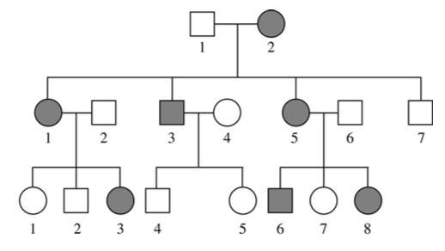

15. What is the most likely mode of inheritance for this disease?

(a) X-linked recessive

(b) Autosomal dominant

(c) Y-linked recessive

(d) Germ-line mutation

16. The internal environment of marine vertebrates, such as bony fish, is hypotonic to the surrounding water. This means that their internal solute concentration

(a) is the same as their surroundings.

(b) is greater than their surroundings.

(c) is lower than their surroundings.

(d) changes with their surroundings.

17. Which of the following statements regarding thermoregulation in mammals is **correct**?

(a) Vasodilation of skin arterioles decreases heat loss

(b) Shivering is a nervous response resulting in a decrease in core temperature

(c) Exposure to hot, moist air will impede the production of sweat

(d) Thermoregulation is controlled by the nervous and endocrine systems

18. The prevention of illness from infection by a pathogenic protist has shown to be largely ineffective. This is mainly due to the protists’

(a) method of reproduction.

(b) mode of transmission.

(c) zoonotic capacity.

(d) all of the above.

19. Halophytes are found in abundance in arid environments, salt flats and lakes and estuarine ecosystems. Halophytes possess many specialised adaptations to help them survive and flourish, despite harsh conditions. Which of the following adaptations is **unlikely** to be present in a halophyte?

(a) Waxy cuticle

(b) Salt bladders

(c) Sunken stomata

(d) Abundant stomata

20. Most pathogenic bacteria cause symptoms of illness as a result of

(a) the production of toxins.

(b) immune system disruption.

(c) rapid reproduction.

(d) cell damage.

21. Communicable diseases are transmitted via several methods. Which of the following is **not** an example of direct transmission of a communicable disease?

(a) Sexual intercourse

(b) Placental blood

(c) Kissing

(d) Consumption of contaminated food

22. Which of the following statements most accurately describes the relationship between the nucleotide sequences of the template strand and non-template strand in DNA?

(a) They are identical to each other

(b) They are complementary to each other

(c) They are held together by hydrogen bonds

(d) U is substituted for T in the non-template strand

23. Ross River Virus is a mosquito-borne disease that affects around 5000 Australians each year. Researchers predict that infection rates will increase with changes in climate. To avoid infection with this debilitating virus, health departments encourage people to

(a) remove any objects from the garden that allow ponding of water.

(b) convert chlorinated swimming pools to salt water pools.

(c) use insect repellent only at night.

(d) keep windows and doors open to allow fresh air to flow through your house.

24. Cartilaginous fish, such as sharks and rays, are osmoconformers: their body fluids are isotonic with the surrounding marine environment. This is possible because cartilaginous fish

(a) excrete large amounts of urea, thereby reducing osmolarity.

(b) drink large amounts of water and excrete concentrated urine to keep a low osmolarity.

(c) concentrate urea in their body fluids to maintain a high osmolarity.

(d) drink very little water and excrete concentrated urine to decrease osmolarity.

25. Populations change gradually over time in response to changes in their gene pool. This phenomena is known as

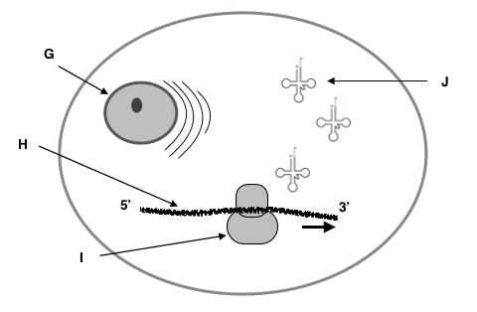 (a) adaptive evolution.

(b) genetic drift.

(c) macroevolution.

(d) microevolution.

**Questions 26 and 27 relate to the diagram below.**

26. The structure labelled J is

(a) mRNA.

(b) an amino acid.

(c) DNA.

(d) tRNA.

27. If part of the original DNA sequence reads TTG, the corresponding code on the structure labelled J would be

(a) UUG.

(b) AAC.

(c) UUC.

(d) TTG.

28. Fossils that resemble modern marine animals have been found within rocks of inland hills and mountains. How can this be explained?

(a) Marine organisms have evolved from terrestrial organisms

(b) Marine organisms possess adaptations that allow them to survive on land

(c) The rocks containing the fossils were formed under the ocean

(d) Mountains are only formed from fault lines under the ocean floor

29. Which of the following statements most accurately describes the effect of natural selection on a gene pool?

(a) Natural selection is the result of random changes in the nucleotide sequence of DNA

(b) Natural selection supports the inheritance of recessive alleles allowing homozygous genotypes to persist

(c) Natural selection works directly on the expression of phenotypes

(d) Natural selection increases the rate of mutation in a gene pool

30. On attaching itself to a host cell, a virus

(a) incorporates its nucleic acid into the cell and makes copies of itself.

(b) denatures proteins within the cell membrane.

(c) replicates its genetic material to form new viral proteins.

(d) destroys the host cell’s enzymes that govern transcription.

**Short answer**

**Question 31**

Cholera is a communicable disease that was first noticed amongst Portuguese sailors in the 16th century. The first major pandemic was recorded in 1871. The last pandemic began in 1961 and lasted 14 years. Despite modern medical treatment, Cholera still presents a significant problem in many third world countries today.

Cholera is an acute intestinal infection that causes nausea, vomiting and copious, watery diarrhoea. These symptoms can lead to severe dehydration and, if left untreated, death. Most deaths result from shock, which is caused by a severely reduced blood volume. Cholera has a short incubation period of between 1 and 5 days. Fatalities may be as high as 50% in communities without access to appropriate treatment.

The pathogen that causes Cholera is found in aquatic environments and harbouring within humans themselves. However, Cholera is rarely transmitted through person-to-person contact.

(a) Suggest the most likely modes of transmission for Cholera. (2 marks)

(b) Suggest how environmental factors could influence an outbreak of Cholera. (2 marks)

(c) State **three (3)** preventative measures that would be most effective against the spread of Cholera. (3 marks)

(d) Define the term ‘pandemic’. (2 marks)

(e) Explain why it is still possible for a Cholera pandemic to occur in the future. (3 marks)

Antibiotics are often used as a form of treatment for Cholera infections. However, resistance to some types of antibiotics is increasing in many regions susceptible to outbreak.

(f) State the type of pathogen that causes Cholera. Explain your choice. (3 marks)

(g) Explain how pathogens like this can become resistant to antibiotic treatment. (3 marks)

Vaccines are available that provide short-term protection. These are mostly used for travellers visiting affected regions.

(h) Describe why health authorities would **not** recommend the use of vaccines to prevent Cholera outbreaks. (2 marks)

**Question 32 (20 marks)**

The Pygmy Sloth (*Bradypus pygmaeus*) is one of four, three-toed sloth species from the genus *Bradypus*. It was first identified as a separate species in 2001. The Pygmy Sloth is endemic to the small island *Isla Escudo de Veraguas*, which is situated off the north coast of Panama in the archipelago of Bocas del Tora. The remaining species of *Bradypus* can be found on other islands within this archipelago and on the mainland.

The Pygmy Sloth has attracted much attention due to the rapid evolution of its small body size, which is significantly smaller than the other *Bradypus* species and 40% smaller than its other mainland relatives. The Pygmy Sloth has a total body length of approximately 53cm and weighs up to 3.5kg. Its diet is restricted to the leaves of the Red Mangrove, in which it lives. These trees grow around the perimeter of the island. Unlike other mammals, the sloth is **not strictly** homoeothermic and must therefore live in warm, tropical climes. The fur of the Pygmy Sloth is tinted green due to algal symbionts residing in each hair strand. According to the IUCN, the Pygmy Sloth is critically endangered due to habitat degradation and illegal hunting.

Research on the *Bradypus* genus has suggested that the rapid evolution of the small body size (dwarfism) can be attributed to the geology and geography of the islands within the archipelago; age of the islands (time of isolation from mainland), area of the islands and distance from the mainland.

Consider the information provided in the table below regarding geological characteristics of the islands and the average skull size of their sloth inhabitants.

**Table 1** – Average skull length (mm) of species from the *Bradypus* genus from islands of the Bocas del Tora archipelago, Panama.

|  |  |  |  |  |
| --- | --- | --- | --- | --- |
| **Island Name** | Time of isolation from mainland  (years ago) | Distance from mainland (km) | Area of island (km2) | Average skull length of sloth (mm) |
| Isla Escudo de Veraguas | 8900 | 17.6 | 4.3 | 67 |
| Isla Colon | 5200 | 1.5 | 59.0 | 71 |
| Isla Bastimentos | 4700 | 6.3 | 51.5 | 73 |
| Cayo Nancy | 4700 | 9.5 | 6.8 | 76 |
| Cayo Agua | 3400 | 6.6 | 14.5 | 72 |
| Isla Popa | 1000 | 1.8 | 53.0 | 80 |
| Isla Cristobal | 1000 | 0.3 | 36.8 | 79 |

(Adapted from Anderson & Handley, 2002)

(a) In the space provided below, construct an appropriate graph using the data regarding average skull length (mm) and time of isolation of islands from the mainland. (6 marks)

*Spare graph paper is available in the additional working space section.*



(b) Describe the relationship between the variables shown in the graph. (2 marks)

(c) Describe **two (2)** reasons why the other geographical factors **shown in the table** do not appear to have influenced the evolution of small size in the *Bradypus* sloths. (4 marks)

Island ecology is often of great interest to many scientists as many island ecosystems are characterised by species with interesting and exaggerated traits. Research has suggested that genetic drift and mutation can be ruled out as mechanisms for the rapid evolution of small body size in the Pygmy Sloth (*B. pygmaeus*).

(d) Outline the mechanisms that have driven Pygmy Sloth evolution on Isla Escudo de Veraguas. (4 marks)

(e) Describe **two (2)** ways in which the Pygmy Sloth’s adaptations have assisted its survival despite negative human impact on its environment. (4 marks)

**Question 33 (20 marks)**

Gene cloning allows the replication of whole gene sequences and the subsequent production of its associated protein. Some species of bacteria have an important role to play in gene cloning as they can reproduce quickly and easily in the laboratory and contain plasmids.

(a) Define the term ‘bacterial plasmid’. (2 marks)

(b) In the space below, construct a labelled diagram that shows the sequence of events for the technique that results in the formation of recombinant DNA in a bacterial cell. (6 marks)

The use of recombinant bacteria has been influential in the development of genetically modified crop species.

(c) Outline **three (3)** major developments in agriculture as a result of recombinant DNA technology. (6 marks)

(i)

(ii)

(iii)

(d) Describe **two (2)** possible negative effects on the environment as a result of the production of genetically modified crops. (4 marks)

(f) Explain how biotechnology has helped improve the conservation of endangered species bred in captivity. (2 marks)

**Question 34 (20 marks)**

The chemical reactions of metabolic pathways produce wastes that must be excreted. These include carbon dioxide, nitrogenous wastes and water.

(a) Explain why the removal of metabolic wastes from an organism is essential for continued metabolic activity. (3 marks)

The table below shows the nitrogenous wastes and excretory mechanisms of Australian animals.

**Table 2** – Excretion of nitrogenous wastes in different Australian animal groups.

|  |  |  |  |
| --- | --- | --- | --- |
| **Animal** | **Type of nitrogenous waste** | **Concentration in urine** | **Organs of excretion** |
| ***Reptile*** | Uric acid | High | Kidneys / Cloaca |
| ***Bird*** | Uric acid | High | Kidneys / Cloaca |
| ***Freshwater fish*** | Ammonia | Low | Kidneys / Gills |
| ***Marsupial*** | Urea | High | Kidneys / Bladder |

(b) Using the information in **Table 2**, explain the differences in nitrogenous waste production and excretion, in relation to the environment, for each animal group. (6 marks)

The structure and physiology of the kidney of mammals from arid environments is highly adapted to reduce water loss.

(c) Describe the structure of the kidney from a desert marsupial and explain how this structure enables the marsupial to produce concentrated urine. (4 marks)

A group of biology students were asked to design an experiment regarding the effect of increased levels of ammonia in aquaculture hatcheries. Their aim was to:

‘*Find out the effect of increased ammonia concentration on the hatching success rate for a commercially produced aquaculture fish species*.’

(d) Propose a possible hypothesis for this investigation. (2 marks)

(e) Identify the variables that should be considered to test this hypothesis.

(i) Independent variable (1 mark)

(ii) Dependent variable (1 mark)

Aquaculture is practiced worldwide. Collecting viable data from investigations such as this can be difficult due to large variations in water quality within and between aquaculture facilities.

(f) Identify **three** **(3)** variables that must be controlled in this investigation to ensure viable data is collected. (3 marks)

**Question 35 (20 marks)**

(a) Identify **three (3)** main reasons for constructing a phylogenetic tree in studies of evolutionary biology. (3 marks)

(b) Describe the difference between distantly related and closely related organisms in terms of their:

(i) DNA sequence. (3 marks)

(ii) Position on a phylogenetic tree. (2 marks)

(c) Describe **two (2)** other methods, using species’ anatomy, that are used by evolutionary biologists to provide evidence for evolution. (4 marks)

Since the beginning of life on Earth, some 3.5 billion years ago, species evolution has coincided with environmental change. For organisms to survive significant changes in their environment, the process of sexual reproduction must provide for genetic variation.

(d) Identify **two (2)** different ways that genetic variation can be increased as a result of sexual reproduction. (2 marks)

(e) In the space below, draw a simple, labelled diagram to *explain* how genetic variation arises during **meiosis** throughchanges to chromosomes. (6 marks)

**Unit 3 – Extended questions**

**Question 36 (20 marks)**

DNA is the universal basis of life. It holds the ‘blueprint’ for how every living creature on Earth reproduces, grows and maintains metabolic processes.

(a) Compare the processes of DNA replication and transcription in eukaryotic cells. (10 marks)

The process of DNA ‘fingerprinting’ allows scientists to visualise DNA for comparison and analysis. This technology can be applied to criminal investigations, paternity disputes, pharmaceutical productions and genetic disease identification.

(b) Describe the technique used to visualise a nucleotide sequence from a molecule of DNA. Explain how this technique could enable a researcher to determine the relatedness between family members. (10 marks)

**Question 37 (20 marks)**

Palaeontologists analyse fossils to obtain information regarding the history of life on Earth. Evolution sceptics believe that the fossil record does not provide comprehensive evidence for evolution because it is incomplete.

(a) Describe the type of data that can be obtained directly from fossils. Explain how palaeontologists infer information from fossils to ‘fill the gaps’ in the fossil record to provide evidence of evolution. (10 marks)

Modern developments in biochemistry have enabled geneticists and evolutionary biologists to compare genetic information between organisms that are living or extinct.

(b) Describe the comparative studies of DNA and mitochondrial DNA and explain how they can offer evidence for evolution. (10 marks)

**Unit 4 – Extended questions**

**Question 38 (20 marks)**

Australian arid ecosystems are characterised by organisms with specialised adaptations for thermoregulation. Floral and faunal species must cope with temperature extremes and long periods without access to fresh water.

(a) Describe the behavioural adaptations of desert marsupials and explain how these adaptations support thermoregulation. Use examples to support your answer. (10 marks)

(b) Identify and explain the adaptations of Australian xerophytes living in arid environments. (10 marks)

**Question 39 (20 marks)**

The transmission of infectious diseases is highly variable and the rate of transmission can change in response to external factors.

(a) Describe the main factors that influence the transmission of disease-causing pathogens within and between populations. (10 marks)

Managing the spread of contagious disease involves the implementation of specific measures and effective communication between health authorities.

(b) Using examples, describe the **three (3)** most common measures used to combat disease transmission in Australia. For each measure, identify a factor that may reduce its effectiveness. (10 marks)

**Question Number**

**SET 3 – MULTIPLE CHOICE**

1. DNA ligase is used extensively in recombinant DNA technologies. The function of DNA ligase in these processes is to

(a) identify the recognition sites on the foreign DNA to isolate the required gene.

(b) ‘cut’ the DNA at the correct base pairs to produce DNA fragments.

(c) identify the restriction site on the plasmid DNA.

(d) join the foreign and plasmid DNA together at the complementary base pairs.

2. The various stages of mitosis are outlined in the list below.

A – nuclear membrane breaks down

B – chromosomes condense and become visible

C – chromosomes align at the equator of the cell

D – nuclear membranes form around separated chromosomes

E – centrioles produce spindle fibres that attach to the centromere of each chromatid

F – sister chromatids are separated and move to opposite poles

Which of the following shows the correct sequence of events for mitotic division?

(a) E – A – B – D – F – C

(b) B – A – E – C – F – D

(c) C – A – B – E – F – D

(d) A – E – B – C – D – F

3. Which of the following statements regarding meiosis is incorrect?

(a) Meiosis I produces two haploid cells.

(b) Crossing over occurs in meiosis I.

(c) Meiosis I is the same as mitosis.

(d) Four haploid cells are created in meiosis II.

4. Binary fission is a type of asexual reproduction that is carried out by

(a) prokaryotes only.

(b) all prokaryotes and some eukaryotes.

(c) eukaryotes only.

(d) most prokaryotes and unicellular eukaryotes.

5. Okazaki fragments are short segments of DNA that are involved in

(a) replication.

(b) transcription.

(c) translation.

(d) gel electrophoresis.

6. The protein-coding sequence used to synthesise new polypeptides is found on

(a) mRNA.

(b) the template strand.

(c) the coding strand.

(d) tRNA.

7. Non-coding segments of DNA are termed

(a) anticodons.

(b) exons.

(c) Watson and Crick fragments.

(d) introns.

8. Which of the following are involved in gene expression?

S – triplets

T – tRNA

U – DNA polymerase

V – polypeptide

W – identical daughter cells

(a) S, U and V

(b) S, T and V

(c) U, V and W

(d) S, U and W

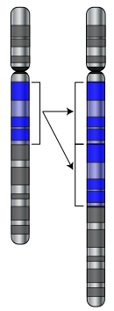

**Question 9 and 10 relate to the diagram below.**

**W**

**X**

9. The areas labelled ‘X’ on the diagram represent

(a) homologous chromosomes.

(b) loci.

(c) genes.

(d) nucleotides.

10. What type of mutation is occurring at ‘W’?

(a) Deletion

(b) Translocation

(c) Duplication

(d) Insertion

11. The four major factors that generate evolution in populations of species are

(a) population increase, genetic variation, competition and proliferation.

(b) natural selection, inheritance, genetic variation and reproductive success.

(c) genetic variation, competition, adaptation and inheritance.

(d) competition, population increase, mutation and survival.

12. Extensive bushfires in 2015 destroyed 90% of the Western Ground Parrot’s habitat. The population was reduced to 150 individuals, confined to a small area of heathland on Western Australia’s south coast. This dramatic decrease in the parrot population is referred to as

(a) gene flow.

(b) a genetic bottleneck.

(c) natural selection.

(d) disruptive selection.

13. The fossil record shows that

(a) primitive fossils are found in more recent stratum.

(b) evolution has been relatively stable.

(c) modern species are vastly different to their ancestors.

(d) rates of evolutionary change have been variable.

Question 14 relates to the diagram below.

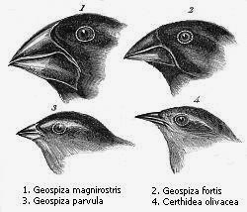

14. According to Charles Darwin, the finches of the Galapagos, shown in the diagram above, evolved from a single ancestor. This process of evolution, whereby all available niches are rapidly colonised, is called

(a) adaptive radiation.

(b) the founder effect.

(c) directional selection.

(d) migration.

15. New vaccines for influenza are produced every year due to the evolution of new virus strains. Which factor is most likely to favour the development of a new influenza virus strain?

(a) Gene flow

(b) Random mating

(c) Large population

(d) Mutation

16. The common kangaroo tick, *Amblyomma triguttatum*, is an eight-legged terrestrial invertebrate that feeds on the blood of mammals such as kangaroos, wallabies, lizards and humans. They inhabit bushland of most states in Australia and can play a role in the transmission of disease. The tick could therefore be described as a/an

(a) obligate parasite.

(b) host.

(c) parasitic vector.

(d) infectious invertebrate vector.

17. A reduction in the herd immunity of a population is likely the result of

(a) an effective immunisation program.

(b) a decrease in immunisation rates.

(c) the overuse of prescription antibiotics.

(d) an epidemic.

18. Which of the following terms refers to the capacity of a pathogen to cause disease?

(a) Pathenogenicity

(b) Infectivity

(c) Virulence

(d) Epidemiology

19. In Australia, strict quarantine procedures are carried out at state borders. The main reason for this is to

(a) reduce the transmission of communicable diseases between isolated populations.

(b) protect the agricultural food industry by preventing the import and export of contaminated produce.

(c) identify and disinfect vehicles carrying pathogen-infected soil on their tyres and undercarriage.

(d) identify individuals attempting to transport illicit substances throughout the country.

20. Which of the following best reflects the physiological response of an ectotherm to low atmospheric temperatures?

(a) Shivering

(b) Vasodilation

(c) Burrowing

(d) Reduced metabolic activity

21. Advances in biotechnology allow scientists to test the human foetal genome for inheritable diseases. This type of genetic screening would be best conducted using

(a) amino acid sequencing.

(b) molecular hybridisation.

(c) gene probes.

(d) gel electrophoresis.

22. In underdeveloped countries, the incidence of gastrointestinal infections following extreme weather events could be reduced significantly by

(a) treating infected individuals with antibiotics.

(b) practising safe sex.

(c) implementing widespread immunisation programs.

(d) treatment of drinking water.

23. Which of the following animals are likely to possess adaptations for counter-current heat exchange to prevent the adverse effects of cold temperatures?

(a) Dolphins, penguins and flamingos.

(b) Polar bears, emus and rabbits.

(c) Whales, giraffes and tuna.

(d) Kangaroos, pythons and dingoes.

24. Australian bat lyssavirus poses a threat to any mammal that comes into contact with an infected bat. This is because

(a) infected bats are more likely to show aggressive behaviour.

(b) the virus is zoonotic.

(c) transmission of the virus is through indirect methods.

(d) infected bats produce toxic saliva that can irritate the skin.

25. Which of the following features of bacteria supports antibiotic resistance?

(a) Variation in size and shape of cells.

(b) Slow reproduction rates.

(c) Transmissible plasmids.

(d) Lack of nuclear envelope.

The graph below shows the relationship between average annual rainfall of amphibian habitats and relative incidence of Amphibian Chytrid Fungus Disease.

26. Which of the following statements supports the information displayed in the graph above?

(a) Rainfall has no effect on the transmission of Amphibian Chytrid Fungus Disease.

(b) There is a negative correlation between the incidence of disease and annual rainfall.

(c) There is a positive correlation between the incidence of disease and annual rainfall.

(d) The presence of water in an amphibian’s habitat has no influence over the transmission or incidence of Amphibian Chytrid Fungus Disease.

27. Which cellular process is PCR (Polymerase chain reaction) most similar to?

(a) Transcription

(b) DNA replication

(c) Mitosis

(d) Meiosis

Questions 28 to 30 relate to the graph below.

**Mass specific metabolic rate** (mL O2 per gram per hour)

**Mass of mammal (kg)**

28. Which of the following statements best describes the relationship shown in the graph?

(a) The larger the animal, the greater its oxygen consumption per unit mass.

(b) The smaller the animal, the greater its oxygen consumption per unit mass.

(c) The metabolic rate of any animal is directly proportional to its mass.

(d) The mass of an animal is dependent upon how much oxygen it consumes.

29. Each point on the graph represents a different type of mammal. Which mammal is likely to be represented by the point marked ‘X’?

(a) Rhinoceros

(b) Kangaroo

(c) Lion

(d) Field mouse

30. If this data were part of a scientific investigation, what is the independent variable?

(a) Metabolic rate

(b) Oxygen consumption

(c) Mass of mammal

(d) Species of mammal

**Short answer**

**Question 31 (20 marks)**

(a) Label parts (J) to (M) using the diagram of the DNA molecule below. (4 marks)

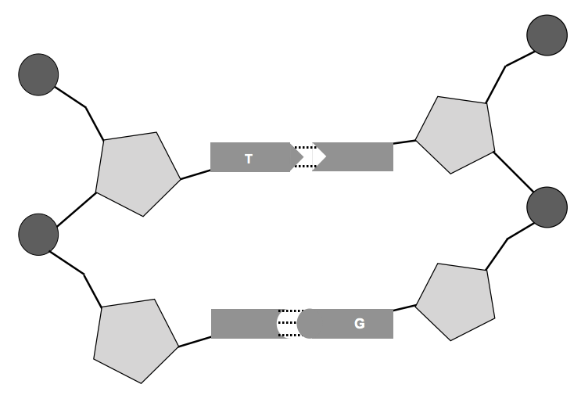

M

J

K

L

J -

K -

L -

M -

(b) Identify the feature of DNA that enables the process of gel electrophoresis to be carried out. (1 mark)

(c) Outline the main purpose of gel electrophoresis in DNA analyses. (2 marks)

_____________________________________________________

Red-tailed Black Cockatoos are endemic to Western Australia and listed as ‘Vulnerable’ under the Federal *Environmental Protection and Biodiversity Conservation Act.* In addition to enduring habitat loss and competition for resources with exotic birds, the Red-tailed Black Cockatoo is targeted by breeders and bird traffickers. Nests are raided for eggs and juvenile birds are either sold within Australia or smuggled out of the country for illegal trade on the international market.

The juvenile birds and eggs that are retrieved by authorities can undergo forensic analyses to determine their place of origin.

(d) Give a brief description of how gel electrophoresis can aid in the identification of a bird’s original habitat. (6 marks)

A PhD student was undertaking a research project on the evolution of black cockatoos in Australia. She obtained mitochondrial DNA samples from five (5) different species to establish a DNA profile. The species are as follows;

**A** – Carnaby’s Black Cockatoo (*Calyptorhynchus latirostris*)

**B** – Baudin’s Black Cockatoo (*Calyptorhynchus baudinii*)

**C** – Red-tailed Black Cockatoo (*Calyptorhynchus banksii*)

**D** – Yellow-tailed Black cockatoo (*Calyptorhynchus funereus*)

**E** – Glossy Black Cockatoo (*Calyptorhynchus lathami*)

The mitochondrial DNA profiles of each cockatoo species are visible on the ‘gel’ diagram below.

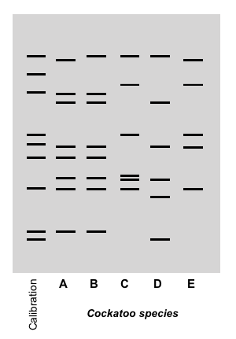

(e) Determine the relatedness of each cockatoo species using the banding pattern on the diagram above. Place the name of each species in the correct position on the following cladogram. (5 marks)

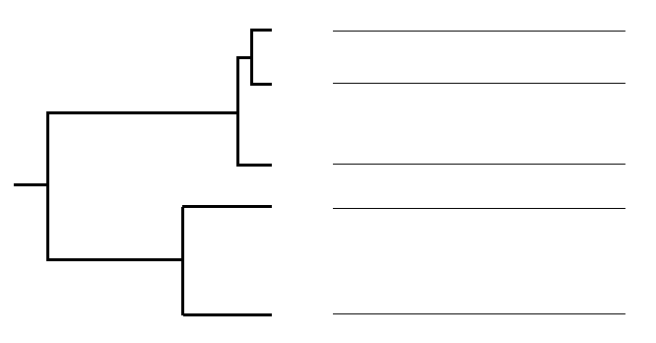

(f)

Identify **two (2)** benefits of using mitochondrial DNA in molecular genetics. (2 marks)

_______________________________________________

**Question 32 (20 marks)**

Haemophilia is a recessive, sex-linked genetic disease that is passed down through families. Around one-third of cases diagnosed appear in families with no apparent history. Haemophilia A, or classical haemophilia, is caused by a deficiency in clotting factor VIII in the blood. As a result, sufferers can experience excessive bleeding both internally and externally. In Australia, there are approximately 2,700 people who suffer from haemophilia in varying degrees.

(a) Explain what is meant by ‘sex-linked’ in relation to genetic disorders. (2 marks)

_______________________________________________

Consider the pedigree below.

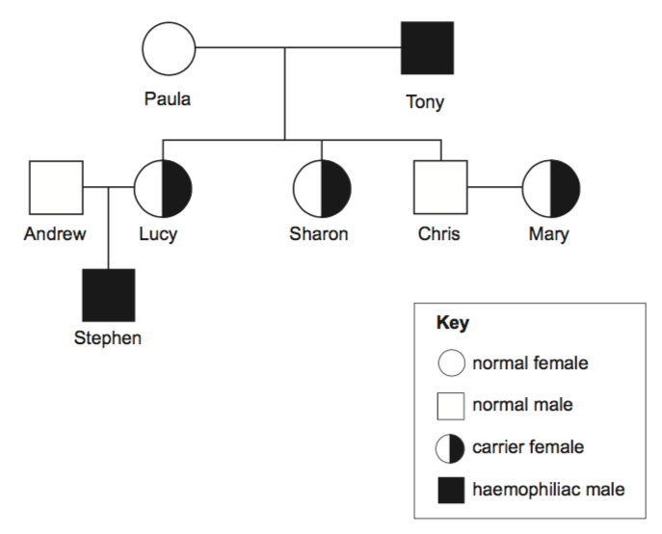

Robert

Jessica

Harrison

Nina

Max

Alyssa

Poppy

Jackson

(b) Explain why Harrison does not have haemophilia while his father Robert is a sufferer.

(3 marks)

______________________________________________________________________

(c) Jackson’s mother Nina is a carrier for the haemophilia gene. Nina discovers she is pregnant and visits a genetic counsellor to discuss her options. Using the Punnett Square below, show the possible genotypes and phenotypes of the foetus Nina is carrying. XHY designates an unaffected male, while XHXh a carrier female.

Genotypes: (4 marks)

|  |  |  |
| --- | --- | --- |
|  |  |  |
|  |  |  |
|  |  |  |

Phenotypes: (4 marks)

________________________________________________

(d) The life expectancy of a person with haemophilia has increased dramatically since the beginning of last century. As a result, the number of haemophiliacs in populations has also

increased. Explain how modern medicine has altered the gene pool for haemophilia. (3 marks)

______________________________________________________________________

Until the 1990’s, blood products used to synthesise blood-clotting treatments for haemophiliac suffers were obtained from unscreened donors. Screening donor blood was not introduced until 1992.

(e) Explain the importance of screening donor blood in modern society. (2 marks)

_______________________________________________

(f) Suggest how the use of recombinant DNA technologies in the production of haemophilia treatments can decrease the likelihood of adverse health problems.

(2 marks)

_______________________________________________

**Question 33 (20 marks)**

Marine iguanas (*Amblyrhynchus cristatus*) are endemic to the Galapagos Islands, situated in the Pacific Ocean off the coast of Ecuador. The marine Iguana is classified as a marine reptile as it is the only species of iguana to forage within the ocean. Even though the islands are located close to the equator, the waters are extremely cold due to the influence of ocean currents.

Marine iguanas are usually grey to black in colour and can grow up to 75 centimetres in length. They live in colonies located near shallow reefs that lie within an extensive intertidal zone. The volcanic rocks bordering these reefs are covered with hundreds of iguanas basking in the morning sun. During the heat of the day, some individuals forage for green algae (seaweed) in the shallow reef while others can dive to around 12 metres. The diving iguanas are able to hold their breath for up to 30 minutes before they must return to the surface.

Iguana activity slows down in the late afternoon and they retire for the day by sheltering in rock crevices or under large boulders.

1. Describe how marine iguanas regulate their body temperature through the following methods of heat transfer.

(i) Conduction (2 marks)

_____________________________________________________

(ii) Convection (2 marks)

_____________________________________________________

(iii) Evaporation (1 marks)

___________ _________________

(iv) Radiation (2 marks)

_______________________________________________

(b) Explain why small marine iguanas must feed in the shallow intertidal zones while large marine iguanas are able to dive to 12 metres for up to 30 minutes. (4 marks)

______________________________________________________________________

(c) Explain how the temperature of the water could enable the iguanas to dive for long periods of time. (4 marks)

____________________________________________________________

During their foraging, iguanas ingest large amounts of salt water. In order to maintain their internal osmotic potential, they secrete the excess salt from glands near their nose.

(d) Explain what would happen to the cells of the marine iguana if it could not excrete the excess salt it ingests. (2 marks)

(e) Describe how a marine fish, that also ingests salt water, maintains its internal osmotic potential. (3 marks)

**Question 34 (20 marks)**

(a) Explain the difference between an infectious and a non-infectious disease. (2 marks)

_______________________________________________

(b) In the last few years, there has been an increase in the number of people suffering from preventable diseases such as measles and Whooping cough. Discuss the possible causes for the increase in the incidence of these diseases. (3 marks)

____________

(c) Construct a flow diagram that outlines the method by which a virus infects a cell.

(5 marks)

HIV is a retrovirus that first became prominent in the global community in the 1980’s. HIV causes AIDS (Aquired Immune Deficiency Syndrome) by attacking the immune system, making a person’s body more susceptible to infections.

A new drug called PrEP (pre-exposure prophylaxis) has been trialled in the UK to reduce the chance of contracting HIV. Over a period of eight years, from 2010 to 2017, approximately 7000 people were involved in the PrEP trial. These people were selected for the trial based on their lifestyle choices. Along with the HIV data, information regarding other STI's and unplanned pregnancies amongst the trial population was also collected.

The data from this trial is shown in the table below.

**Table 1** - *Relative number of new infections and unplanned pregnancies for trial participants using PrEP over an eight-year period.*

|  |  |  |  |
| --- | --- | --- | --- |
| **Year** | **Relative number of affected individuals (per 100 people)** | | |
| ***HIV*** | ***Other STI's*** | ***Unplanned pregnancies*** |
| 2010 | 21 | 29 | 2 |
| 2011 | 19 | 36 | 4 |
| 2012 | 13 | 44 | 7 |
| 2013 | 12 | 39 | 9 |
| 2014 | 14 | 48 | 12 |
| 2015 | 9 | 57 | 12 |
| 2016 | 2 | 64 | 17 |
| 2017 | 3 | 68 | 21 |

(d) Construct an appropriate graph of the data presented in Table 1. (6 marks)



(e) Suggest **two (2)** major limitations in running human-based medical trials. (2 marks)

(f) Propose a possible explanation for the trend in the data presented in your graph.

(2 marks)

________________________________________________

**Question 35 (20 marks)**

(a) Define ‘homeostasis’. (2 marks)

_______________________________________________

Two teenage boys were timing how long they could hold their breath under water.

(b) Construct a flow diagram outlining the physiological mechanism that stimulates the urge to breathe after a period of breath holding. (6 marks)

(c) Identify the type of response shown in this physiological mechanism. (1 mark)

Normal metabolic reactions produce by-products that can be toxic to cells. Nitrogenous waste is one such by-product.

(d) Identify how nitrogenous wastes are produced. (1 mark)

________________________

(e) Not all animals produce the same type of nitrogenous waste. Complete the table below, regarding the waste products for **three (3)** different animals. (6 marks)

|  |  |  |
| --- | --- | --- |
| **Animal** | **Nitrogenous waste** | **Explanation for waste type** |
| **Fish** |  |  |
| **Eagle** |  |  |
| **Rock wallaby** |  |  |

(f) Identify the functional unit of the kidney. (1 mark)

(g) Explain how this functional unit differs in structure and function between a desert hopping mouse and a domestic dog. (3 marks)

___________________________________________________________

**Unit 3 - Extended answer**

**Question 36 (20 marks)**

In modern agricultural practice**,** artificial selection and biotechnology are used to produce organisms with more desirable traits.

1. Discuss the application of these two biotechnologies in 21st century farming with reference to their advantages and disadvantages. (10 marks)

Small populations of kangaroos kept in wildlife centres often produce offspring with albinism: an inherited condition seldom seen in the wild. These individuals are characterised by white fur and red eyes. Kangaroos exhibiting albinism do not produce the enzyme tyrosinase required for the production of melanin within melanocytes.

**(b)** Describe the normal cellular processes responsible for expressing genetic traits and identify how these processes are different in a kangaroo with albinism. (10 marks)

**Question 37 (20 marks)**

The Honey possum, *Tarsipes rostratus*, is endemic to southwest Western Australia. It is the sole member of its genus and the family Tarsipedidae. The Honey possum's closest relative, *Dromiciops gliroides*, is a small, marsupial-like possum found in Chile, South America. Fossils of *Dromiciops'* ancestors have been discovered in South America, Antarctica and South Australia. The Honey possum is believed to be distantly related to Australian possums; both possess a prehensile tail. They also share similar features with wallabies, kangaroos and Dasyurids (carnivorous marsupials). However, the Honey possum has been evolving independently for approximately 40 million years.

1. Discuss how scientists can establish an ancestral connection between *Tarsipes rostratus* and *Dromiciops gliroides*, utilising both traditional techniques and comparative genomics and biochemistry (that provide evidence for evolutionary relationships). (10 mark)

During the construction of a major highway, dissecting a large area of native bushland, a marsupial population is divided and becomes permanently isolated.

1. Describe the possible effects of this scenario on the marsupial populations. In your discussion, suggest effective conservation techniques that could alter future outcomes for the species. (10 marks)

**Question 38 (20 marks)**

Sickle-cell anaemia is an inherited disease caused by point mutations, resulting in cresent-shaped red blood cells and free-floating haem molecules in the blood plasma.

(a) Explain how a point mutation within a gene can result in the development of a genetic disease like sickle-cell anaemia. (10 marks)

The world's smallest reptile, a dwarf leaf chameleon (*Brookesia micra*), is endemic to a small islet on the northern tip of Madagascar. This species was only discovered in 2012, likely due to its diminutive stature - the male measures 16 millimetres and the female up to 30 millimetres. Mitochondrial DNA comparisons show that *B. micra* diverged as a single species around 20 million years ago. The tiny chameleon survives within the leaf litter of the islet's forest, feeding on small invertebrates.

(b) Discuss the mechanisms involved in the evolution of the dwarf leaf chameleon, *Brookesia micra*. (10 marks)

**Question 39 (20 marks)**

1. Discuss the function of restriction enzymes and their importance to the development of genetic engineering techniques. (10 marks)
2. Discuss why homologous structures support the concept of adaptive radiation. Use specific examples to support your response. (10 marks)

**Unit 4 - Extended answer**

**Question 40**

1. Describe how the structural, physiological and behavioural adaptations of terrestrial animals support thermoregulation. (10 marks)

Malaria is a disease caused by infection with a parasite. Malaria is widespread in many tropical and developing nations. It is the major cause of death in the Asia-Pacific region, infecting around 500 million people per year.

1. Describe the lifecycle of the Malaria parasite. Include the symptoms and treatments for Malaria in your discussion. (10 marks)

**Question 41**

Xerophytes live under extreme conditions whilst maintaining ‘normal’ metabolic processes.

**(a)** Describe how xerophytes are adapted to survive in hostile environments. (10 marks)

Mosquito-borne diseases require different management strategies than diseases spread by direct contact and other indirect methods. No single species of mosquito is responsible for the spread of disease; they are indiscriminate in their choice of host as they acquire nutrition.

**(b)** Discuss the management strategies used to control the spread of mosquito-borne diseases.

Suggest how climate change could influence the future distribution of these diseases throughout the world. (10 marks)

**Question 42**

Living in a freshwater environment has enabled the evolution of specialised homeostatic mechanisms to regulate osmotic potential and excretion of wastes.

(a) Discuss the mechanisms by which freshwater fish maintain their internal solute and water

balance. (10 marks)

(b) Compare the transmission of pathogens through direct and indirect contact and identify the types of infection associated with each. (10 marks)

**Question 43**

(a) Describe the structural, functional and behavioural adaptations of endotherms that inhabit cold

environments. Use specific examples to support your answer. (10 marks)

(b) Compare the disease-causing agents that cause malaria and Ross River virus. Suggest how climate change could affect the transmission and distribution of these diseases in

the future. (10 marks)

**Question number**