**Year 11 Economics ATAR**

**Unit 1 – Markets**

**Syllabus Links**

##### **Economic Knowledge and Understanding: Market power**

* barriers to entry in a market
* how market power can influence market efficiency i.e. a deadweight loss
* policy options to influence market power, including regulation/deregulation and legislation

##### **Economic Skills: Reasoning, interpretation and analysis**

* identify and organise relevant information within sources
* identify trends and relationships in economic information and data on markets
* use economic information and data to make predictions on markets
* use economics models, including demand and supply graphs to analyse market behaviour and performance
* apply economic reasoning to market behaviour and performance
* use evidence found in economic information and data to justify a conclusion

**Task: Deregulation of the Taxi Market**

This task refers to the written extract below.

Nobody likes waiting for a taxi, especially on a cold winter’s night. Perth nightspots such as Northbridge and Fremantle had been experiencing long taxi cues for a number of years until the recent entries of other companies including Uber, Ola and Didi.

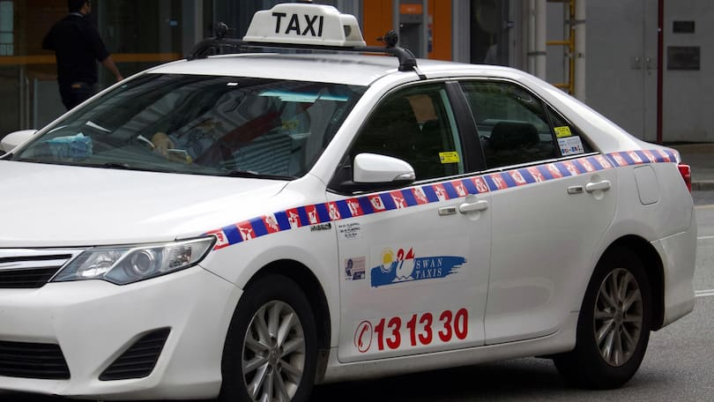

**The taxi industry before rideshare competition (before 2015)**

Why had this been happening? Market analysis can explain some of this. Let’s take a look at the Taxi Market prior to the introduction of other competitors. In all states of Australia, Taxi licence restrictions existed reducing the supply of taxis available per person across Australia. The cost of a Taxi licence was in excess of $300000 so it was a difficult market for potential suppliers to penetrate. The government restrictions and the growing population contributed to an excess in demand. A long wait for any service including taxis could be caused by rising demand for the service itself. A rising population in the city of Perth could have accounted for a rising demand for public transport including taxis.

D1

Quantity of taxis available

1400

p2

p1

S

D2

Taxi fare

1800

SHORTAGE

Let’s assume that there are 1400 taxis on the road at any one time. According to the diagram opposite demand for taxis is initially 1400 at price p1. Assume the demand for taxis increased to 1800 at the given price due to a higher population. This would result in a shortage of 400 taxis at price p1. This is because the flagfall (initial payment) and taxi fare is fixed.

If the taxi driver could have charged the fare they desired, then they would charge a patron the price p2 for the same taxi ride. This would eliminate the 400 patrons that are willing to pay a taxi fare between price p1 and p2 and the shortage would be eliminated.

This is because some revellers (400 in total) do not value the taxi service as highly as the other 1400 patrons willing to pay the higher price. Because taxi prices are fixed by the State Government, and monitored by the Department of Planning and Infrastructure, the shortage continued to exist during this peak period.

S2

Quantity of taxis available

1400

p2

p1

S1

D2

Taxi fare

1800

SHORTAGE

Another factor could be the fact that the time in question (1am-4am on Friday and Saturday nights) is not the most enticing time for taxi drivers to operate. This may result in fewer taxis on the road and an inferior service being provided for Perth.

Also if other overhead costs (e.g. licensing, leasing costs) were cut so that taxi drivers could have enjoyed a reasonable wage then perhaps more taxi drivers would have been enticed to work. A reduction in licensing and leasing costs could increase the amount of taxi drivers operating at any time (from S1 to S2) and would result in a more efficient use of the existing taxi fleet. The shortage of taxis could have been eliminated and taxi fares could be left unchanged. Perhaps the amount of taxis would not need to increase, only the amount of drivers.

In an effort to solve the taxi shortage, in February 2008 the WA State Government announced a plan to issue 100 peak period plates, which cost $50 a week, and 185 new full-time plates at $250 per week as part of a 12-month trial. The Government believed the new issued during the peak plate trial were needed because an unsatisfactory number of jobs on weekday mornings were not being met. It seems difficult to believe with record high demand for taxis, fares comparable to the Eastern States and an equitable cost structure; it is difficult to understand how drivers were not making good money. The Government could also introduce measures to make the job safer and more financially viable for drivers. Alternatively, some taxi drivers were enticed to stop driving taxis due to too many plates were being issued and that Perth patrons were too reliant on taxis on weekends as a substitute for inadequate public transport.

**The taxi industry after the introduction of rideshare competition (since 2015)**

Uber’s launch in Australia in October 2012 was met with enthusiasm from consumers and prospective drivers but also resistance from the taxi industry. State and territory governments considered issues like customer safety, transport access, competition, impact on the taxi industry, and productivity implications in their response to the emergence of ridesharing

India’s largest cab-hailing app Ola, announced its entry into Australia in January 2018 with a soft launch in Perth. As a part of the offer, Perth-based customers were given their first two rides free up to the value of $10 per ride. The introductory soft launch also included offers for the drivers including a 7.5% driver commissions as compared to around 20% charged by Uber.

 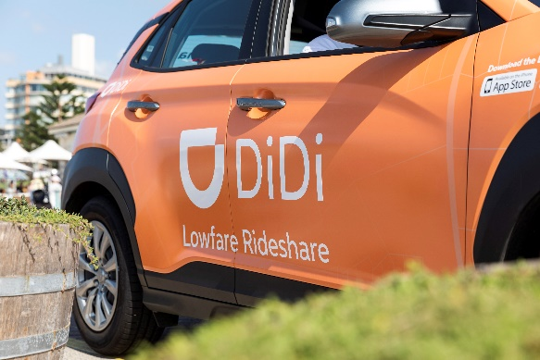

The Chinese rideshare platform, Didi first launched in Australia in May 2018, beginning in Geelong before heading to Melbourne, Newcastle, Brisbane, the Gold and Sunshine Coasts, and Perth. The platform had intended to launch in Sydney on March 2020. According to its website Didi claims it is 10% cheaper than other ridesharing companies like Uber and Ola.

In April 2019, the biggest taxi provider in WA, Swan Taxis — with its pool of 1400 cars on the road and 3500 drivers dropped its base standard fare prices. The company made the change due to a levy being imposed by the State Government for all on-demand transport operators as a way to fund a buyback of taxi plates. The changes by Swan Taxis set a precedent for the rest of the industry after fears the introduction of the levy would drive up prices for passengers. The levy was brought in after the rise in on-demand services such as Uber and Shoafer in Perth disrupted the market.

Later in 2019, Swan Taxis had announced a $15 million expansion to upgrade and substantially expand its fleet with more hybrid vehicles, following a similar investment by its Singapore-based owner Comfort DelGro Corporation.

The introduction of these competing services has seen the industry transfer in a number areas including increase services', range of vehicles, lower fares, more locations, changing fee structure, payment options, discounts just to name a few.

The biggest impact on the market has been a change in the supply conditions. Taxi regulations resulted in a fixed supply of taxis. This resulted in a fixed supply (Sr) and higher prices (p1). With less regulation it allows firms to enter the market more freely and respond to market conditions. A competitive taxi market allows for a more elastic supply curve (Sc) and a price (p2) closer to where demand meets supply in the market.

Sc

Quantity of drivers available

1400

P1

P2

Sr

D

Taxi fare

1800

SHORTAGE

Deadweight Loss

**Question 1 – Taxi Industry before competition**

1. Identify the type of imperfect market that existed in Australia for the taxi industry prior to 2015. (1 mark)
2. Describe the meaning of ‘barriers to entry’ with reference to the Australian taxi industry.

(2 marks)

1. Outline the reasons why there was a shortage in taxis prior to the introduction of rideshare competition. (3 marks)
2. Using a demand/supply model, demonstrate and explain the impact a rise in fares would have on the demand and/or supply of taxis before deregulation? (4 marks)

**Question 2 – Taxi industry after the introduction of rideshare services**

Other than the issuing of new taxi plates to boost supply of taxis, discuss three policies or action demonstrating how the government could promote competition in the rideshare market. Use the demand/supply model to show the impact of these actions on market efficiency. (12 marks)

|  |  |
| --- | --- |
| **Sample marking key** | |
| **Question 1** | |
| **Description** | Marks |
| a) Identify the type of imperfect market that existed in Australia for the taxi industry prior to 2015. | |
| Identification of the correct type of market | 1 |
| Total | **1** |
| Answers should include:MonopolyDuopoly | |
| **Description** | Marks |
| 1. Describe the meaning of ‘barriers to entry’ with reference to the Australian taxi industry. | |
| Correctly defines the meaning of ‘barriers to entry’ | 1 |
| Uses an appropriate barrier to entry experienced in the Australian taxi industry. | 1 |
| **Total** | 2 |
| Answers should include:Barriers to entry – anything that restricts or blocks the entry of new firms into an industry or marketA government licence granting a legal monopoly – issuing taxi licence plates | |
| **Description** | Marks |
| c) Outline the reasons why there was a shortage in taxis prior to the introduction of rideshare competition. | |
| Uses sound economic reasoning outlining why the increase in supply of taxis did not reduce the shortage in demand. | 3 |
| Identifies more than one reason as to why a shortage in taxis existed. | 2 |
| Identifies a reason outlining why a shortage of taxis existed. | 1 |
| **Total** | 3 |
| Answers should include:  * This is because some passengers value the taxi service more than other patrons and are willing to pay the higher price. * Taxi prices are fixed by the State Government, so those not willing to pay what would be a ‘market price’ are not priced out of the market due to price fixing. * Therefore a shortage will continue to exist during peak periods. | |
| **Description** | Marks |
| d) Using a demand/supply model, demonstrate and explain the impact a rise in fares would have on the demand and supply of taxis before deregulation? | |
| Explanation | |
| Explains the impact a rise in fares would have on the demand and supply of taxis before deregulation | 2 |
| Describes the impact a rise in fares would have on the demand or supply of taxis before deregulation | 1 |
| **Subtotal** | **2** |
| Model | |
| Fully labelled demand/supply model correctly showing both a contraction in demand for taxis due to the price increase. Supply of taxis will increase due to increased incentive to work due to the price increase. | 2 |
| Outlines the demand/supply model with change in the supply curve due to the price effect. | 1 |
| **Subtotal** | **2** |
| **Total** | **4** |
| Answers could include:A rightward shift of the supply curve and an increase in fare from p1 to p2A fall in demand from Q2 to Q1 Quantity of taxis available  Q1  p2  p1  S1  Dt  Taxi fare  Q2  Surplus  S2 A surplus of (Q2-Q1) taxis | |
| **Question 2** | |
| **Description** | Marks |
| Other than the issuing of new taxi plates to boost supply of taxis, discuss three policies or action demonstrating how the government could promote competition in the rideshare market. Use the demand/supply model to show the impact of these actions on market efficiency. | |
| For each suggested government policy or action (x3) the student: |  |
| Detailed discussion of a relevant policy or action that promotes promote competition in the rideshare market citing recent examples and includes details of its impact on the macroeconomy | 3 |
| Describes a relevant policy that promotes promote competition in the rideshare market citing recent examples (the last ten years) | 2 |
| Identifies a relevant policy that promotes promote competition in the rideshare market | 1 |
| Subtotal | **9** |
| Model | |
| Fully labelled demand/supply model correctly showing a rightward shift of the supply curve resulting in lower prices, higher quantities of passengers as drivers increase and the market become more efficient. | 3 |
| Mostly correct demand supply model showing changes in demand and supply and an increase rideshare services | 2 |
| Outlines demand/supply model with an increase in demand or supply | 1 |
| Subtotal | **3** |
| Total | **12** |
| Answers could include, but are not limited to:  Policies and Actions   * Deregulation of the market – removing barriers to entry * Government subsidies to support a ‘state owned’ taxi service to ensure it can match its competitors * A competitive taxi market allows for a more elastic supply curve (Sc) and a price (p2) closer to where demand meets supply in the market.   Impact of these actions/policies   * The introduction of these competing services has seen the industry transfer in a number areas including increase services' including:   + Increased range of vehicles   + lower fares (p1 to p2)   + services to more locations   + changing fee structure   + different payment options,   + discounts for new customers   + Loyalty rewards. * The biggest impact on the market has been a change in the supply conditions. * Taxi regulations resulted in a fixed supply of taxis. This resulted in a fixed supply (Sr) and higher prices (p1). With less regulation it allows firms to enter the market more freely and respond to market conditions.   Demand/Supply Model  Sc  Quantity of drivers available  1400  P1  P2  Sr  D  Taxi fare  1800  SHORTAGE  Deadweight Loss | |
| **Total Marks** | **22** |