### Markets, demand, supply and equilibrium

**Market Economy** is an economic system in which private organizations own all of the resources and make their decisions independently on what, how to, how much and for whom to produce based on the demands of the consumers which is evident based on what and how much they are buying of certain type of product.

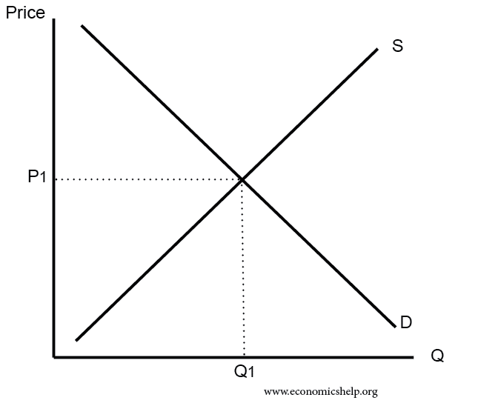**A Factor Market** as opposed to a product market sells the factors of production to other producers which allows for the production of consumer goods. It is essentially the product market for producers in which they buy the materials necessary to produce their own products. An example would be a farmer buying seeds from which will allow him to grow his crops which he can sell to consumers. Households sell their labor to producers on the factor market in return for a salary from which they can buy products with to satisfy wants and needs.

**The Law of Demand** states that there is an inverse relation between demand and price. Meaning that as price rises, demand for the product at that time will fall ceteris paribus (all other factors being held still). Demand can be defined as the amount of a good that consumers are willing and able to buy at a given point of time. *Individual Demand* is the demand of an individual while *market demand* is the demands of the whole market.

There are many **factors effecting demand** which can be separated into the *price factor* and *non-price factors*.

*Price Factor* is referring to a change in price of the product and thus influencing demand. If demand were to be graphed (as above), a change in pric2we would involve a shift along the demand curve with a higher price obviously reducing demand ceteris paribus. Another term for it is contraction (moving on the demand curve towards the left) and expansion (moving along the demand curve towards the right).

There are several *non-price factors* which can affect demand. This effect shifts the demand curve to the left or right, left due to a negative factor, right due to a positive effect (something good) ceteris paribus. These factors include:

* *Preferences, Tastes* of the consumer vary and can be change sometimes rapidly. These tastes can be influenced by news and advertising companies. Tastes in favor of a product will shift the graph of that product towards the right and vice versa.
* *Changes in consumer’s money income* while influence demand of certain products, there are certain products which increase in demand when a person’s income rises which are usually luxury products, this kind of goods are called *normal goods.* A product which decreases in demand with an increase of income are called *inferior goods* and an example is budget or value variants of goods.
* *Expectations in changes about future pricing of goods*. If the consumer expects that the price of a good will go up or down in the future, they’ll buy more or less of the product accordingly, depending on the good. If the price is expected to fall, they will hold out from buying it if they can until the price falls to save money, although essential goods such as water aren’t really affected by this. If the consumer expects the price to rise, they’ll generally increase demand and buy more of the good now so that they don’t have to pay more later, certain products such as short-term perishable goods aren’t significantly affected by this.
* *Availability of credit facilities and hire purchases,* an increase in the availability or ease of accessing loans will lead to an increase in demand as consumers will find that they are able to purchase now and pay overtime later.
* *A Change in price of related goods.* A product has varying influences on goods in which it is related too, these relationships are:
  + *Substitutes (competing),* it satisfies the same want as another good so if there is an increase in price of a good, it’s substitute will increase in demand as consumers will see it of better value
  + *Complement goods,* this is a kind of good which is purchased with another good to satisfy a want or need. If the price rises on a good, it’s complement will fall in demand as well. An example would be petrol and a car.
  + *Derived demand,* one good is used to make another. A change in demand for the final product will exact a similar effect on demand for the derived good
* *Seasonal Factors* on demand are ones which are influenced by time of year. For example, in winter, winter clothing is in higher demand then if it were summer.
* *Population,* an increase in population will cause an increase in demand, especially for goods which are considered as necessities.

**Supply** can be defined as the amount of a good a producer is willing and able to supply in a certain period of time, ceteris paribus. The **law of supply** states that there is a direct relationship between supply and price. *Individual supply* is the amount of a good that an individual producer produces whereas *market supply* considers all producers within a set market.

There are many **factors effecting supply** which can be separated into the *price factor* and *non-price factors*.

*Price Factor* is referring to a change in price of the product and thus influencing supply. If supply were to be graphed (as above), a change in price would involve a shift along the supply curve with a higher price obviously increasing supply as producers would want to capitalize on the higher price to make as much money as they can.

There are several *non-price factors* which can affect supply. This effect shifts the supply curve to the left or right, left due to a negative factor, right due to a positive effect (something good) ceteris paribus. These factors include:

* *Changes in production/price of related goods*. A product has varying influences on goods in which it is related too, these relationships are:
  + *Competitive supply (substitute in supply),* when a product is made from the same material as another good it is in competitive supply. An increase in production of one good would result in the decrease of the other as less resources available. This generally occurs when the price of a good rises and thus producers try to capitalize on this by increasing supply of the good resulting in a decrease of supply for other competitive goods. An example would be cheese and butter.
  + *Joint supply,* when the production of one good results in the production of another as well. An increase in production of beef results in an increase in production of leather.
* *Changes in price of factors of inputs.* Factor prices refers to a change in the price of the factors of production. As producers want to make a profit, they will try to reduce the cost of the factors of production. An increase in will cost will result in a reduction in supply
* *Expectations of Future Price Changes.* If producers expect the price of a good to change, they will change their supply accordingly. If price is expected to increase, they will reduce supply now stockpiling and then increase supply later. If price is expected to fall, they will sell more now while it is more profitable.
* *Changes in state of technology.* Improvements of technology will obviously lead to improvements in efficiency of production and thus supply
* *Changes in government policy.* Goverments can enforce taxes and subsidies on producers which can directly or indirectly effect producers, increasing or reducing supply. Taxes decrease supply, if a tax is applied to one of the factors of production within a product (for example steel needed for cars) it will indirectly increase the cost of production of the product.
* *Changes in weather conditions.* Natural disasters can destroy production facilities reducing supply. There can also be favorable natural conditions which increase supply, such as an unusually large crop.
* *Changes in seasonal conditions.* Certain goods have an increased supply during a certain period. For example, winter clothing has an increased supply during winter when that kind of good is most effective
* *Changes in number of suppliers*. An increase of suppliers within a market will increase the market supply of the market. Suppliers may enter or leave the market depending on business outlook.

A Market is at **Equilibrium** when quantity demanded equals quantity supplied. It is also known as the market clearing price. A **Disequilibrium** in the market occurs when it is does not equal causing either a shortage or surplus. In a free market economy, a disequilibrium will always adjust back to equilibrium through a mechanism called the price mechanism.

A **surplus** occurs when supply is higher than demand, in response, producers will reduce their prices to entice consumers to buy more due to better value, thus increasing demand and reducing supply to equilibrium.

A **Shortage** occurs when supply is less then demand, in response, consumers will start to bid up the price as they are willing to pay more for the good. Thus, due to the higher price, more producers will want to produce more of the good thus resulting in increasing supply and falling demand and thus a return to equilibrium.

|  |  |  |  |
| --- | --- | --- | --- |
| **Change in Supply** | **Change in Demand** | **Change in equilibrium price** | **Change in equilibrium of quantity demanded/produced** |
| Increase | Decrease | Decrease | Inconclusive  If equal change then: no change  If demand decrease is more than supply increase, then: decrease  If demand decrease is less, then supply increase then: increase |
| Decrease | Increase | Increase | Inconclusive  If change is equal only price changes  If demand increase is more than supply decrease, then price increases and quantity demanded slightly increases.  If demand increase is less, then supply decrease then price increases and quantity demanded decreases. |
| Increase | Increase | Inconclusive  If supply increase is more than demand, then: decrease  If supply increase is less, then demand then: increase  If supply increase equals demand: no change | Increase |
| Decrease | Decrease | Inconclusive  If supply decrease is equal to demand decrease, then: no change  If supply decrease is more than demand decrease, then: price increase  If supply decrease is less, then demand decrease then: price decrease | Decrease |

### Elasticity

For something to be **inelastic** is for a factor to be unresponsive to a change in another factor. For exmaple the demand for cigarettes is inelastic to a change in price.

For something to be **elastic** is for a factor to be responsive to a change in another factor. For example the demand for a certain product is elastic to a change in price.

**Price Elasticity of Demand (PED)** is defined as the responsiveness of quantity demanded to a change in price of that good or service. If there is a significant change in demand upon price change then it the product is considered price elastic while if there is little change in demand to a price change then the good is considered price inelastic.

To calculate PED via the point method (called that because we are calculating the elasticity for a single point on the demand curve), the formula is the percentage change in the quantity divided by percentage change in price. If the percentage change in quantity is less then percentage change in price then the answer known as the elasticity coefficient will be less than one indicating that demand for the good is inelastic. Vice versa, if percentage change in quantity is more then percentage change in price will result in an elasticity coefficient greater then one meaning that demand for the good is elastic to price change. If percentage change in price equals to percentage change in quantity demanded then the elasticity coefficient will equal one, the good is called unitary elastic.

To measure the price demand elasticity between two points we use the midpoint method which is taking the average of the price and quantity and from there applying the point method.

Theoretically PED can range from zero to infinity where if PED equals zero then a change in price will have no effect on quantity demanded as thus perfectly inelastic (resulting in vertical line when graphed) while if PED equals infinity then a change in price will result in quantity dropping absolutely (when graphed is a perfectly horizontal line), this kind of scenario would occur if there was a perfect substitute.

There are several key factors which **determine the price elasticity of a good:**

* The availability of substitutes

The greater the number of close substitutes (within a similar price range) then the more elastic the good is. This is because a good with close substitutes increases it’s price, consumers will be able to easily change over to one of the substitutes as they be perceived as better value and thus the good is more elastic. The less close substitutes a good has, the more inelastic it is.

* Wether the good is a necessity or a luxury

Goods which are considered necessities such as basic food items are more inelastic because they are essential for living. Luxury goods on the other hand will be more price elastic which are lower priority. Although what is perceived as necessities and luxury goods are varies from person to person and income level with those with higher income levels generally consider what would be a luxury for lower income individuals as a necessity.

* Definition of the market

The demand for a good in a broadly defined market will be more inelastic while the demand for a good will be more elastic in a narrowly define market. An example of a broadly define market is petrol while a particular brand which sells petrol is a narrowly defined market and thus more price elastic. A generalization is that consumers or more likely to change from brand to brand then from completely switching to another good (substitute).

* Proportion of income spent on the good

Expensive goods are relatively more price elastic due to the larger proportion of the individual’s income. This is because the money they may save by switching to something cheaper would be significant thus offering a large incentive for individual’s to readily switch. Good which makes up a very small proportion of an individual’s income will be relatively price inelastic. Because the amount of money which they may save by changing consumed good is relatively little compared to the effort put in thus there is little incentive to change.

* Time

The more time that consumers have to respond to a change in price the more price elastic the good will be. If the change is in the short run then the good would be price inelastic as consumers do not have time to become aware of the change, find potential substitutes and overall adjust to the change.

* Consumer habits

As humans, consumers will form habits in buying which may not be the most efficent but does reduce the necessary effort when purchasing goods. Goods which are particularly habit forming or addictive such as cigarettes and alchol will be more price inelastic whereas those which don’t.

PED is a significant concept as it link the concepts of **total revenue (TR)** of producers and **total expenditure (TE)** of consumers. TR or TE for a particular good is calculated by price of good multiplied by quantity sold of the good. TR can also be calculated using the demand curve, total revenue is represented by the area formed by using the price point and quantity demanded point to create a rectangle underneath the demand curve. If two prices on the same good is compared, two rectangles are created which over lap at a certain point, by comparing the difference in area, it can be determined how elastic a good is and thus at what price point would be most profitable for a producer. A general trend is that a good which is price elastic, the money lost when reducing the price is relatively little compared to the money gained by the increase in quantity demanded thus an increase in total revenue, if the price is increased there will be a total revenue lost. If a good is price inelastic, the income lost due to price decrease is more then the income gained from the increase in quantity demanded, if price decreases, there is a decrease in total revenue, if price increases then there is an increase in total revenue. By knowing total revenue, it can be predicted the change to total revenue to change in price, for this reason producers sometime hold sales if they believe the good is elastic. If the PED was unitary, TR will be consistent regardless of price because an increase in price and thus increase in revenue and will result in an equally opposite value due to decrease in quantity demanded.

To summarize the relationship between PED and TR:

* When demand is elastic, price and TR move in opposite directions
* When demand is inelastic, price and TR move in the same direction
* When demand is unitary elastic, a change in price does not change total revenue

**Price discrimination** is the practice of setting prices to specific social groups in order to maximize TR as different societal groups have different demand curves and elasticity. For example students and seniors, their demand is generally more elastic due to smaller income thus firms will charge lower prices for them.

**Price Elasticity of Supply (PES)** measures the responsiveness of quantity supplied by producers to a change in price for that good.

To calculate PES, it is the percentage change in quantity supplied divided by percentage change in price. If percentage change in quantity supplied is greater then percentage change in price then supply is price elastic and thus the elasticity coefficient is greater then one. For example if the price of a good increases, quantity supplied will increase by a greater amount. If percentage change in quantity supplied less then percentage change in price then supply is price inelastic and thus the elasticity coefficient is less then one. An example is that if the price of a good increases, the quantity supplied will increase at a lesser amount. The elasticity coefficient can also range from zero to infinity. If PES equals zero then supply is perfectly price inelastic and thus a change in price will have no change in quantity supplied. If PES equals to infinity then supply is perfectly price elastic so that a change in price will result in an absolute change in quantity supplied.

Factors which **influences the elasticity of supply** include:

* Time

The more time that a producer has to adjust to a price change, the more elastic the supply will be. In the short run it will be difficult for suppliers to adjust to price increase as it is difficult to suddenly increase production output especially if the producer is already working at maximum efficiency. In some cases where producers are not able to adjust at all then supply would be perfectly price inelastic.

* Nature of the industry

Certain industries have characteristic supply elasticity level. For example agricultural products tend to be more price inelastic as producing the goods require a significant amount of time to produce. Manufactured or digital goods on the other hand, their supply is more price elastic as it is much faster generally to produce.

* Ability to store inventories

Inventories refers to stocks that a producer keeps stored for future sale. If a producer has the ability to store it goods effectively indefinitely then it can respond to price change quickly by releasing that stock and thus the supply for that good is price elastic. If a good cannot be stored for a long period of time such as agricultural goods then there will be little stock in which to respond with if there is an increase in price and thus that good is more price inelastic.

The **significance of PES**

**Income Elasticity of Demand (YED)** measures the responsiveness of demand to a change in consumer income.

To calculate YED, the formula is the percentage change in quantity demanded divided by the percentage change in income. A normal good has an income elasticity greater then zero while an inferior good has an income elasticity less then zero. Normal goods can be further subdivided into income elastic which is more then one and income inelastic which is less then one but more then zero. An example of an income inelastic good are luxury goods while income elastic goods are necessities. Often goods which are income elastic are also price elastic such as luxury goods and necessities. The main factor which influences YED is the nature of the good, wether it is a luxury or necessity although what is considered either varies from person to person with those with varying incomes having varying standards.

**YED is important to producers** as it allows them to decide what kind of goods to stock and how much based upon the countries economics conditions. YED will influence how their products are marketed.

**Cross Elasticity of Demand (XED)** measures the responsiveness of the demand of a good to a change in the price of another good.

This can be calculated by the percentage change in demand of good A (effected) divided by percentage change in good B (cause). XED can reveal wether two goods are substitutes or complements. Substitutes will have an elasticity coefficient greater then zero with any value between zero and one being inelastic (less related) and above elastic (closely related) while complementary goods will have an income coefficient less then zero.

The concept of elasticity when **applied in the real world** explains how markets work and how consumers and producers respond to change in both demand and supply.

An example of elasticity applied in life is the agricultural sector, as demand is inelastic due to it being a necessity, as time progressed and technology has improved resulting in greater quantity supplied at the equivalent price, due to demand being inelastic, the resulting fall in price has not increased the quantity sold to the point in which revenue gained is more then revenue lost through this price decrease, as such there has been a fall in producers.

Another example is the housing industry, the supply is inelastic as the rate production is limited by the long period of time to produce homes. Despite the high demand, production cannot increase to match it as it normally would if it were elastic, as a result there is a significant increase in price while quantity supplied is relatively little.

Another application of price elasticity is in **government taxing** on goods and services. A tax increases the price paid by consumers to raise revenue for the government to spend on beneficial things to society. Although this has the adverse affect on the industry being taxed by decreasing the revenue of producers and reducing overall quantity sold thus having a negative impact on the industry. Certain taxes known as excise tax are much larger and are levied upon goods which have inelastic demand such as cigarettes. This is because due the inelasticity of the good, an increase in price as result of the tax will not change quantity demanded significantly. The general affect of taxes is that it will always increase the market equilibrium price and decrease the equilibrium quantity. How much price or quantity rises or falls is dependent on the price elasticity of the good. When demand is elastic, there is a heavier burden on the producer but when demand is inelastic the burden is on the consumer.

There is a clear economic reason to tax inelastic goods more heavily then elastic as it increases tax revenue while having only a slight effect on quantity demanded. If heavier taxed were placed on elastic goods, price will only increase slightly while there is a significant decrease in quantity supplied as elastic goods generally have substitutes allowing consumer to easily switch thus reducing overall tax revenue.

### Efficiency and Equity

**Efficiency** is defined as when all goods and factors of production are distributed in their most valuable uses and waste (inefficiency) is eliminated or minimized. Generally reflected when a good is able to be produced at it’s lowest possible cost.

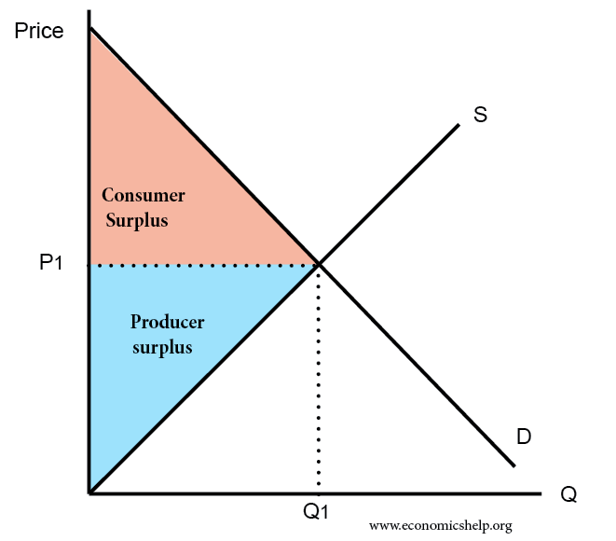**The consumer surplus** is the maximum amount a buyer is willing to pay for a good subtracted by the amount they pay, it measures the benefits of a consumer participating in a market economy. This maximum value is called the marginal benefit corresponding to maximum amount consumers are willing to pay The consumer surplus can also be measured by the area below of the demand curve and above the price level, as such a lower price will result in a higher consumer surplus and more demand for a product will result in a greater consumer surplus. Consumer surplus reflects economics well being of a market as helping people make informed decisions about how a decision will influence the desirability of a good.

**Producer surplus** is the price producers are willing to have (the minimum amount to cover costs) subtracted from actual amount they receive (usually more), this reflects the profits that producers get. The total price sold for a certain quantity of a good is the area beneath the curve. A point on the curve measures the marginal cost measures the price that a quantity was sold at. Producer surplus also can be calculated by the area of below of price point stopping at the demand curve, below the demand that area represents the cost of production. Producer’s total revenue is composed of cost of production and producer surplus with profits being determined by producer surplus subtracted from costs of production. An greater producer surplus as a result of greater demand for the product will result in more producers producing more and thus producers profit more because of the increased quantity sold and greater price.

The **total surplus** is the a measure of the average (net) benefits to soceity from the production and consumption which is the sum of both consumer and producer surplus as well as the total costs. Another way to calculate is total benefits subtracted from total costs. The general aim of a society is to increase total surplus as it is a measure of economic efficiency, if it can be maximized in all markets all resources can be considered to be used efficently. Another way to calculate it from a graph is the combined area of consumer and producer surplus.

Total surplus is only ever maximized at an **equilibrium** where supply meets demand, and thus can be reasoned that only in a competitive market scarce resource can be allocated most efficently. total surplus and thus overall efficiency is reduced when there is an under or overproduction, this loss is called the deadweight loss. A deadweight loss refers to an avoidable decrease in total surplus. A shift in equilibrium is not necessarily a deadweight loss, along as the market is able to adjust to it.

**Equity** is about how what society produces is divided amongst the people whereas efficiency is considered with increasing or maximizing production. A competitive market does not result in a fair distribution of income across a population where as equitable does allowing everyone to be able to satisfy at least their basic needs and wants and have an adequate standard of living. A general trend is that an increase in efficiency results in a decrease in equity. Equity can be split into two types. Vertical equity concerning the rich and poor, those who are rich may have worked for it or may just have been lucky. A common method is to tax money from those who are rich to give to the poorer although this reduces the incentive to work harder then necessary if the graduated tax rates are too high. Another perspective on equity is horizontal equity where everyone should be given the same opportunity to succeed and earn money, putting the responsibility of wether they succeed or not firmly in the individual’s hands. The generally considered best method of approaching horizontal equity is to have a democratic society with equal human rights and to have property rights upheld.

The role of the government is to maximize welfare of all its citizens. For consumers they to maximize consumer surplus so that there are lower prices. For producers they aim to maximize producer surplus to protect their income and for soceity as a whole they aim to maximize societal welfare done so by reducing dead weight loss. as a purely competitive market does not fairly distribute wealth amongst the population, the government has to step in with economic policies to make things more equitable. Types of goverment policies which can influence the markets include:

* Price controls

Price controls set by the government regulate either the maximum or minimum equilibrium price of a good. The two types are:

* + **Price ceiling** is the maximum legal price which if effective is generally set below the equilibrium price. An effective price ceiling will always result in a shortage of the good, decrease in price, an increase in consumer surplus, a fall in producer surplus, deadweight loss and potentially government expenditure depending on type of good.

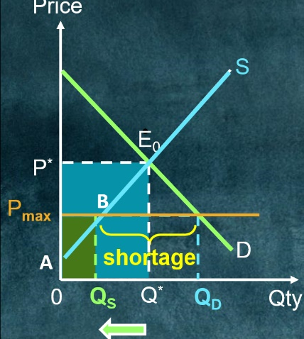The main positive affect of a price ceiling is that it protects consumers by keeping prices low particularly for essential goods.

If a price ceiling and its effects were to be graphed, these will be its main features:

* + - A shortage of the good
    - TR for the consumer falls (yellow rectangle)
    - Increased consumer surplus

Due to the shortage caused by the price ceiling, a black market may come into existence which sells illegally above the price ceiling as certain consumers are willing and able to purchase the goods. Profits can be made by buying at the controlled price and selling at the black market price. The more inelastic the PED the higher the black market price.

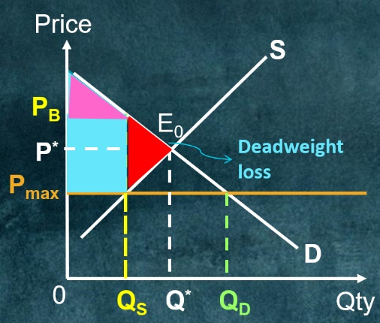If a price ceiling and its effects were to be graphed, these will be its main features:

* + - Profits of the black market providers (blue rectangle)
    - New consumer surplus (purple triangle)
    - Deadweight loss (red triangle)

Having a price ceiling is not necessarily equitable as it reduces quantity consumed and does not guarantee low income individuals will be able to benefit from it.

* + **A price floor** is a legal minimum price that is if it were to be effective is set above the current equilibrium price. A effective floor price will always result in an increase in price, a surplus of goods, a fall in consumer surplus, an increase in producer surplus, increased expenditure of the government to buy up the surplus goods and a deadweight loss resulting in inefficiency.

The two main positive affects of a price floor which the government exploits when implementing it is to protect producer incomes when the price has fallen to an unsustainable level for the producer (agricultural sector) as well as a deterrent to consumers from buying a product which may be perceived as harmful or results in costing the government (cigarettes).

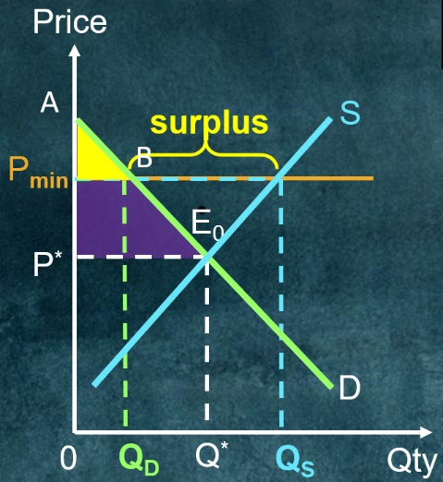How much a producer benefits from a price floor (wether there is an increase in TR) is dependent on the PED of the good. If it is elastic, an effective price floor will result in a slight increase in revenue from the price increase but a significant loss due to quantity demanded fall which is typically due to there being substitutes available for people to switch to; overall a loss in TR. If the good is inelastic, an increase in price will have a significant gain in revenue while there is an insignificant loss in quantity demanded; overall increase in TR for the producer.

If a price floor were to graphed these would be its main features:

* + - Price floor forces price above equilibrium (E0) resulting in a surplus of the good
    - Consumer surplus is reduced as highlighted by the purple and yellow triangles.
    - 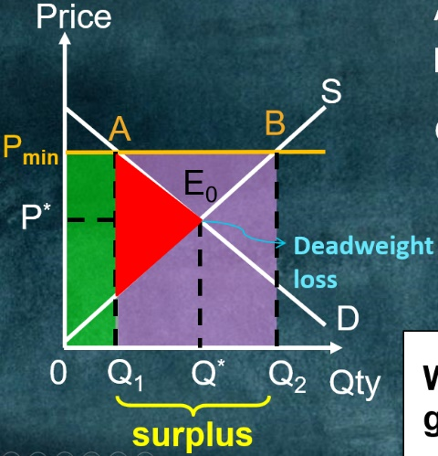While a price floor will increase producer surplus (green rectangle) it will also result in a significant deadweight loss (red triangle) which results in inefficiency.
    - Due to surplus caused price floor, government need to buy up this surplus resulting in government expenditure paid for by taxes set by the government.

An example of a price floor is the minimum wage. The reason for the minimum wage is an equitable one, to reduce the income gap between the rich and poor as well as making sure that those in society with the lowest income will still be able to afford a decent standard of living. While it may increase the wage that the individuals get, it will reduce the number of workers. The higher the elasticity of PES the greater the unemployment rate as well as the greater expense on the government who have to support those unemployed with welfare.

* 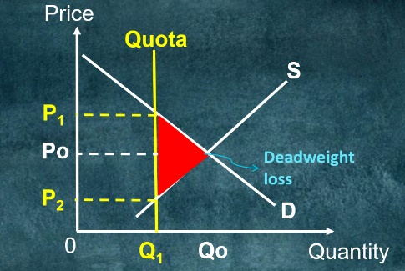Quality control

Sets an upper limit on the amount of good that can be bought or sold.

Results in a decrease in production but an increase in price for the consumer. Results in a deadweight loss represented by triangle.

* Taxes on goods and services

There are two types of tax which can be levied upon goods and services:

* + 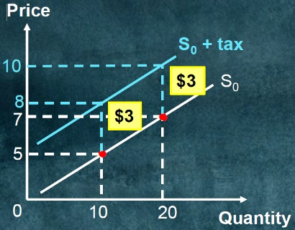Direct tax

It is a direct tax on the income and health of a household paid directly to the government.

* + Indirect tax

it is a tax on goods and services which is paid indirectly to the government via the sellers of the good. There are two types of indirect tax which include:

* + - Specific tax

The good or service is taxed a specific amount per unit.

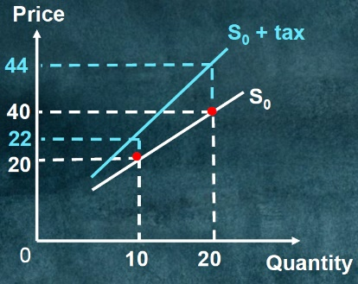A specific tax results in a parallel shift upwards on the supply curve based on the amount of the tax.

* + - Ad valorem taxz

The good or service is taxed a percentage based on the value of the product, the higher the price of the product the higher the tax.

An Ad Valorem tax results in a skew upward shift in supply curve.

* Subsidies

Paid to producers with the intent of reducing production costs and increasing output. The effects are a reduce in price, increase in quantity produced, increase in consumer and producer surplus, dead weight loss and subsidy cost.

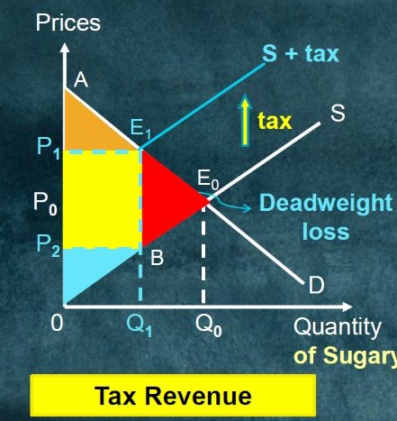The **impact of tax** is on whoever the tax is levied first while the **incidence of tax** is the eventual distribution of the tax burden. For example when a government charges an tax on a producer, the impact is on the producer while the incidence is on both the producer and consumer as the producer increases their prices in response.

Due to the higher price as a result of the tax it causes a shortage and thus a reduction in consumption. It reduces both consumer and producer surplus while increase tax revenue (calculated by the difference in price multiplied by the new quantity). The tax also results in a deadweight loss as welfare benefits that are lost to soceity because resources were not allocated efficently, represented by the red triangle.

Taxes are levied on goods and services in order to raise revenue for the goverment to spend. A tax is levied based on a certain percentage of the price of the good resulting a greater price thus a decrease in quantity demanded. This has the affect of reducing consumer and producer surplus. While the tax does bring in revenue to be spent on welfare programs and similar such things, it is still less then the loss in total surplus and thus a deadweight loss. while taxes do cause a deadweight loss, they are necessary to fund government spending which are essential in a number of things, as such the objective is to tax goods but to minimize dead weight loss. an additional factor to calculating the deadweight loss other then the level of taxing is the how elastic the good is, if the good is inelastic to price change then a change in price will do little to change demand. An example would be cigarettes.

* Subsidies payed to certain industries.

Goverments pay subsidies to certain groups in society with the purpose of reducing costs and increasing output. By applying a subsidy it reduces the cost of production and thus price, resulting in an expansion in quantity produced and consumed. Consumers are better off due to lower prices and greater quantity as well as producers who are able to profit more due to lower cost and sell more of the good. Cost of the subsidy is greater then that of the total surplus increase resulting in a deadweight loss and meaning that it is inefficient.